HUMAN RIGHTS AND EQUAL OPPORTUNITY COMMISSION
SEX DISCRIMINATION ACT 1984 (Cth), Section 44(1)
NOTICE OF REFUSAL OF A TEMPORARY EXEMPTION
By this instrument, the Human Rights and Equal Opportunity Commission (‘HREOC’) rejects the application of Griffith City Council (trading as Griffith Regional Aquatic Leisure Centre) (‘the Applicant’) for a temporary exemption pursuant to s 44(1) of the Sex Discrimination Act 1984 (Cth) (‘SDA’).
BACKGROUND
Nature of the application
Mr Rodney Harris, on behalf of the Applicant, has applied for an exemption from the SDA to allow the Applicant to restrict access to its gymnasium and swimming pool to women only for regular 2 and a half (2.5) hour sessions, outside of the Applicant’s ordinary operating hours. The Applicant proposes to conduct the women-only sessions on Saturdays from 6:00pm-8:30pm:
- on a weekly basis in summer (December – February);
- on the first Saturday of the month in winter (June - August); and
- on the first and last Saturday of the month during spring and autumn.
The Applicant has applied for an exemption for five years.
About the Applicant
The Applicant operates the Griffith Regional Aquatic Leisure Centre (‘the Leisure Centre’), which is a fitness and recreation centre. According to the Applicant, it is the only public swimming facility in the Griffith regional area (pop. 25,000).
Applicant’s reasons for requesting an exemption
The Applicant claims that the lack of women-only fitness facilities in the Griffith regional area is a significant factor in deterring local women from engaging in health and fitness activities. In particular, the Applicant notes that many of women in the Griffith regional area have religious beliefs that would exclude them from participating in recreational activities such as swimming in a mixed-sex environment. The Applicant notes that the Griffith regional area is home to 40 distinctive cultural groups.
On 8 March 2008, the Applicant hosted a ‘come and try’ day at the Leisure Centre for women to mark International Women’s Day. The Applicant administered a survey on the day and 25 of the 27 surveyed women participants indicated that the availability of a ‘women only’ session was an important consideration for their attendance on that day and in the future at the Leisure Centre.
Further information sought by the Commission
HREOC sought further information from the Applicant in relation regarding the ‘women only’ sessions proposal at the Leisure Centre.
The Applicant responded that:
- the Leisure Centre wished to provide its services to a local women’s refuge, whose residents were victims of rape, abuse and intimidation by men. The residents at the refuge may not attend the facility under ordinary circumstances due to sensitivity to the presence of men;
- providing ‘women only’ sessions would, for the first time, allow members of certain religious and ethnic communities to use the Leisure Centre;
- there is no other recreational club in the area offering women-only swimming and fitness facilities;
- women with body-image issues (including arising from post-operative )would feel more comfortable engaging swimming and other fitness activities if men were not present; and
- women often feel intimidated in the male-dominated weights room and thus desist from using the free-weights.
REASONS FOR DECISION
HREOC has decided to reject the application. HREOC is of the view that the Applicant’s proposal constitutes a special measure intended to achieve substantive equality between men and women, in accordance with section 7D(1)(a) of the SDA. Section 7D(2) provides that such special measures do not constitute discrimination. As such, no exemption is required to conduct the regular ‘women only’ session at the Leisure Centre.
HREOC accepts the Applicant’s submission that a purpose of its proposal is to provide women of certain religious and ethnic backgrounds the opportunity to access fitness facilities that they would otherwise be unable to use. This satisfies the requirement of section 7D(3) that the purported special measure be for the purpose of achieving equality between men and women, whether or not that purpose is the dominant or substantial one.
APPLICATION FOR REVIEW
Subject to the Administrative Appeals Tribunal Act 1975 (Cth), any person whose interests are affected by this decision may apply to the Administrative Appeals Tribunal for a review of the decision.
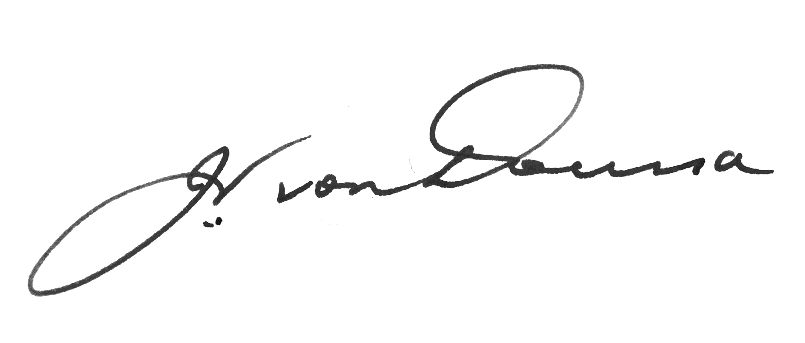
Dated this 20th day of June 2008

Signed by the President, John von Doussa QC, on behalf of HREOC.

