HUMAN RIGHTS AND EQUAL OPPORTUNITY COMMISSION
SEX DISCRIMINATION ACT 1984 (Cth)
Section 44(1)
NOTICE OF GRANT OF A TEMPORARY EXEMPTION
By this instrument, the Human Rights and Equal Opportunity Commission (‘the Commission’) grants to Ballarat Health and Fitness Pty Ltd a temporary exemption pursuant to s 44(1) of the Sex Discrimination Act (Cth) 1984 (‘the SDA’) in the terms set out in section 3 below.
- BACKGROUND
  - Ms Melynda Tempest has made an application, on behalf of Ballarat Health and Fitness Pty Ltd (‘the applicant’), for an exemption from the SDA to enable the applicant to operate an exercise and health centre for males from 16 years of age. The exemption is sought so that the applicant can:
- provide health and fitness services to men only; and
- employ only men as instructors to provide such services.
  - It is claimed for the applicant that the centre would provide services for men who have been ‘unable to join other facilities’ because of issues such as embarrassment caused by being overweight, poor self-esteem and the pressure of media and ‘body image’.
  - Ms Tempest also states that there is a general failure by men to look after their health leading to increased problems of stress, heart disease and obesity. She states that a male only facility would address the above issues.
  - Ms Tempest goes on to state:
I have meet many males during the last 2 years who have come from sudden broken marriages, they come in with very poor self esteem and even in some cases have broken down and cried, and these are males in their 30s, I have come across males who have had health scares or their friends have passed away, there are men who have highly stressed careers and want a more private place to exercise. I suppose there are many reasons why we need a men's only facility but the most important thing we need is to acknowledge men, their health and contribution to society.
The facility would be approximately 300sqmts we would run fitness testing such as blood pressure testing, strength testing, posture analysis and refer clients to other professionals such as physiotherapist and doctors. We would run specific classes for males only using machines designed for non intimidating exercises, men would workout out in a group of 20 for a period of 30 minutes several times a week they would also have access to a smaller area to use bikes and treadmills. We would like to advertise so that it appeals to males who have wanted to start exercising and feel that this place will be a safe and non intimidating place to be.
  - The applicant states that there are presently no other male-only facilities in Ballarat. There are, however, two female-only gyms in the town and the proposed site for the centre would be near one of them. There are four other ‘mixed’ gyms in Ballarat.
  - Ms Tempest subsequently provided the Commission with three letters from members of the Ballarat community, expressing their support for the applicant’s plans to run a male-only gym.
  - The applicant also sought an exemption under the Equal Opportunity Act 1985 (Vic) to enable it to operate the male-only facility, to employ only men to staff the facility and to advertise those matters. That application was granted by the Victorian Civil and Administrative Tribunal (VCAT) on 19 September 2005. As a part of that process, the applicant was required to advertise the exemption application in the Ballarat Courier newspaper. No submissions were received (for or against the application) by either the applicant or VCAT.
  - The applicant provided the Commission with a copy of the decision of VCAT for its consideration. The decision of the Deputy President states:
In my view there is a clear public interest in improving the health both of men and women. I accept that some men for religious or other reasons, may feel uncomfortable about exercising in a mixed men’s and women’s environment, and indeed may not attend. Without a single sex facilities [sic] such as the one which is proposed, these men would not have the opportunity to undertake regular and supervised exercise. The exemption seeks to provide for men a similar choice which is provided by the women’s only facilities for women. That choice is either to attend a single sex facility or to attend a mixed sex facility. In this way the exemption promotes that objective of the Equal Opportunity Act which speaks of the acceptance and recognition of everyone’s right to equality of opportunity. This facility will also contribute to health education of men by providing various health tests and classes about fitness and nutrition.
  - The Commission is obviously not bound by the decision of VCAT and must exercise its discretion under s 44 of the SDA independently. The Commission has nevertheless considered the reasons of VCAT for granting the applicant an exemption under the Victorian legislation.
  - The Commission sought further information from the applicant in relation to that part of the application that proposed discrimination against women in employment. In particular, the applicant was asked why it is necessary to exclude appropriately qualified women from the staff of the facility.
  - In response, Ms Tempest told the Commission that the gym was intended to be ‘male only’ and it would ‘defeat the purpose’ to have women working as instructors. Ms Tempest also stated that all of the women’s gyms in Ballarat have only women employed as instructors and that it is intimidating for some men to be in a mixed environment and this includes having women present as instructors.
- REASONS FOR DECISION
  - The Commission has decided to grant an exemption to allow the applicant to provide services to men only.
  - The Commission has decided not to grant an exemption in relation to the employment of men only in providing those services.
Exemption Granted: Services for Men Only
  - The Commission has considered whether the proposed activity raises an arguable case of unlawful discrimination under the SDA. If it does not, it is not necessary for the Commission to grant an exemption.
  - The Commission is of the view that the proposal to offer health and fitness services only to men as part of a commercial enterprise does raise an arguable case of discrimination. Section 22 of the SDA provides, relevantly, that it is unlawful for a person to discriminate on the ground of sex in the provision of services by refusing to provide a person with those services. It would appear that none of the permanent exemptions to the SDA, contained in Part II Division 4, apply to the present case.
  - The Commission has also considered whether or not the proposed centre might constitute a ‘special measure’ as provided for by s 7D of the SDA. The relevant effect of that section is that a person does not discriminate against another person on the basis of sex by taking a ‘special measure for the purpose of achieving substantive equality’ between men and women. The Commission is not satisfied that the measure proposed should be understood in terms of substantive gender equality. While the apparent purpose of the centre is to address a particular disadvantage claimed by the applicant, this disadvantage is described by the applicant as being a feature of a range of social factors relating to matters such as relationship breakdown, stress and poor self-esteem, rather than a matter of substantive equality between men and women. The Commission is therefore of the view that the proposed fitness centre is not a ‘special measure’.
  - The Commission accepts, however, that some men may face difficulties in exercising in a ‘mixed’ environment for reasons such as poor self-esteem, obesity or ‘body image’. While anecdotal, the Commission accepts that this is a problem that Ms Tempest has identified through her experience working as a health and fitness centre proprietor. The Commission finds that a ‘male only’ facility would provide an opportunity for such men to improve their health and fitness and this will be a benefit to them.
  - Significantly, members of the Ballarat community have access to a number of other health and fitness facilities. There are four ‘mixed’ gyms and two gyms for women only. Therefore the discrimination proposed by the applicant will not, in the Commission’s view, create or perpetuate inequality between men and women or disadvantage women. Women excluded from the centre proposed by the applicant will be able to seek access to equivalent facilities in a number of other places in Ballarat. The Commission has taken this into account in assessing the reasonableness of the exemption sought.
  - The Commission also notes that the applicant has advertised its intention to open a ‘male only’ centre and no objection has been raised.
Exemption Not Granted: Employment of Men Only
  - The applicant seeks to discriminate against women by employing only men as instructors in its centre. On its face, this would appear to constitute discrimination contrary to s 14 of the SDA which prohibits discrimination in employment on the ground of sex.
  - There is no issue of ‘special measures’ in relation to this aspect of the application as there is no suggestion that gender inequality has an impact upon male fitness instructors seeking employment.
  - The essence of the applicant’s argument is that it is an essential part of the service to be provided by the applicant that instructors be male. If this is so, the proposed discrimination would seem to fall within the exemption provided for by s 30(1) of the SDA and is accordingly not unlawful. Section 30(1) provides, relevantly, that it is not unlawful to discriminate against people of one sex in determining who should be offered employment ‘if it is a genuine occupational qualification to be a person of the opposite sex’. If this exemption is satisfied, it is not necessary for the Commission to grant the applicant a temporary exemption.
  - The Commission is not satisfied, however, on the evidence provided by the applicant, that it is a ‘genuine occupational qualification’ for all instructors in the proposed centre to be male. In particular, the Commission is not satisfied that appropriately qualified women would be unable to provide services in a manner that is sensitive to the problems that Ms Tempest has identified. The Commission is not satisfied that the mere presence of women as instructors acting in a professional capacity would prevent men from accessing the service proposed by the applicant.
  - The Commission has therefore decided that this aspect of the application should not be granted as it is not necessary for the applicant to achieve its purpose of providing health and fitness services to men. Either it is a ‘genuine occupational qualification’ that instructors be male, in which case s 30(1) applies, or it is not, in which case appropriately qualified women will be able to provide the services contemplated.
  - In considering the reasonableness of the exemption sought, the Commission has also taken into account that the discrimination proposed by this aspect of the application would disadvantage qualified women fitness instructors seeking employment in Ballarat. This is a factor that weighs against the granting of an exemption in relation to the employment of men only.
  - The Commission is of the view that the preferable approach is for the applicant to recruit for instructors based on their qualifications, which may include an awareness of the issues facing men identified in the application and possession of relevant professional skills and attributes to deal with such issues, rather than based on their sex. The Commission is not satisfied that women will necessarily lack the necessary qualifications.
  - It may be noted that while the Commission is not satisfied on the evidence before it that it is a ‘genuine occupational qualification’ for instructors in the proposed centre to be male, this does not prevent the applicant from relying on the exemption in s 30(1) should it maintain a contrary view.
- TERMS OF EXEMPTION
3.1 The Commission grants Ballarat Health and Fitness Pty Ltd an exemption from the operation of s 22 of the Sex Discrimination Act 1984 (Cth) for a period of five (5) years. This exemption applies in relation to the operation of one (1) centre in Ballarat, Victoria, to provide health and fitness services for men only.

Dated this 7th day of November 2005
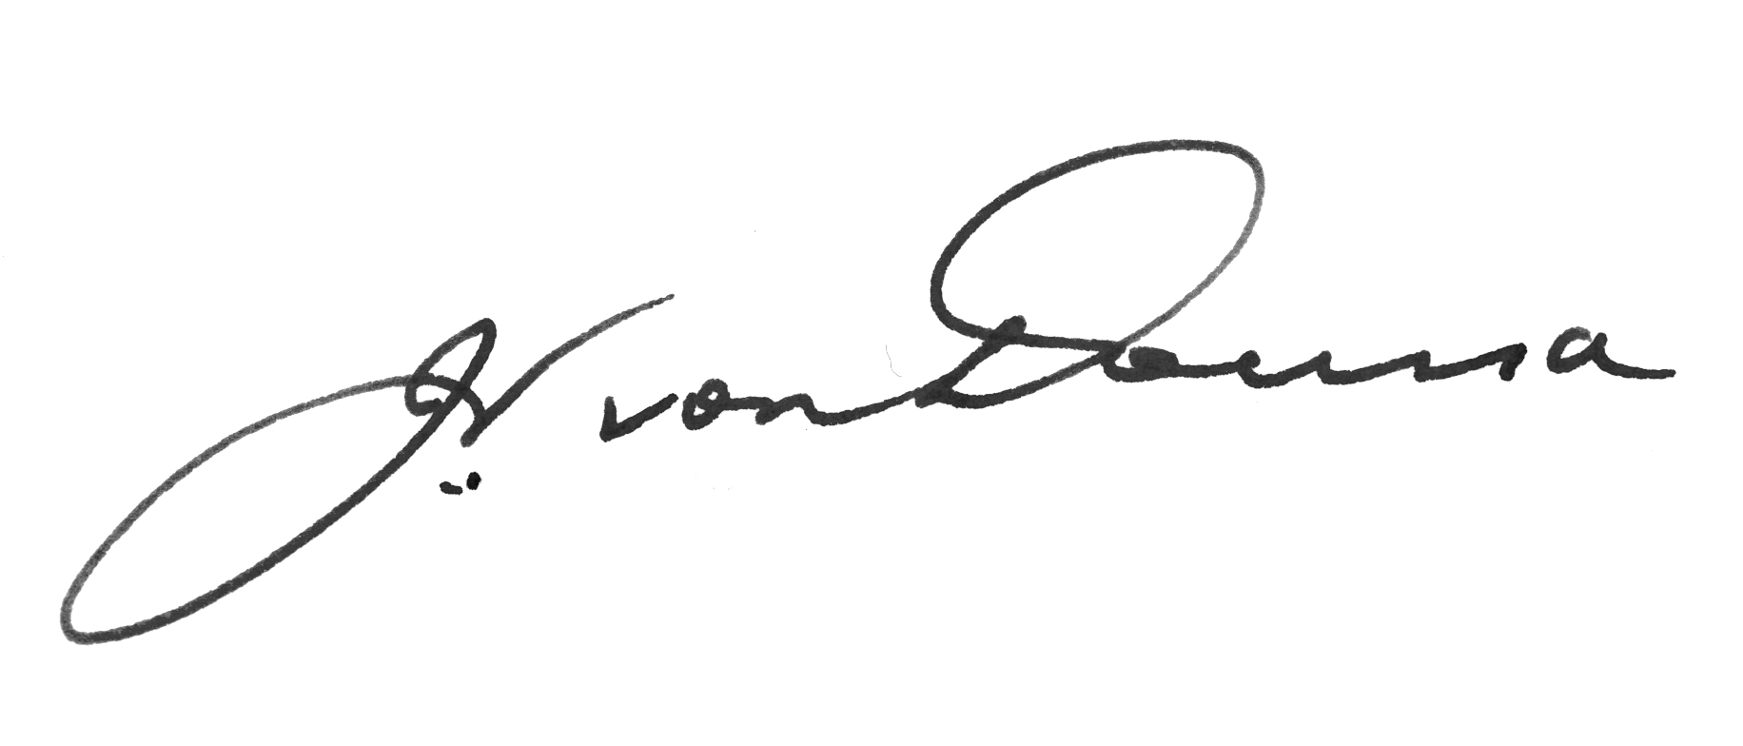
Signed by the President, John von Doussa QC, on behalf of the Commission.
Please note
Subject to the Administrative Appeals Tribunal Act 1975, application may be made to the Administrative Appeals Tribunal for a review of a decision to which this notice relates by or on behalf of any person or persons whose interests are affected by the decision.

