HUMAN RIGHTS AND EQUAL OPPORTUNITY COMMISSION
SEX DISCRIMINATION ACT 1984 (Cth), Section 44(1)
NOTICE OF GRANT OF A TEMPORARY EXEMPTION
By this instrument, the Human Rights and Equal Opportunity Commission (‘the Commission’) grants to Crisis Support Services Inc (‘the Applicant’) a temporary exemption pursuant to s 44(1) of the Sex Discrimination Act 1984 (Cth) (‘the SDA’) in the terms set out below.
BACKGROUND
Nature of the application
Mr Roger Levy has made an application, on behalf of the Applicant, for an exemption from the SDA to allow the Applicant to:
- Advertise nationally for and recruit male counsellors to join their Graduate Trainee Program (‘the Program’); and
- At the end of the Program, to offer employment to as many male counsellors who have completed the Program, as it considers appropriate.
About the Applicant
The Applicant is a non-profit organisation that provides a range of counselling and community support services.
One of the areas of community support that the Applicant offers is counselling for men, via both the Mensline Australia and Suicide Helpline services.
Applicant’s reasons for requesting an exemption
The Applicant claims that the need for male counsellors has arisen, particularly in relation to their Mensline and Suicide Helpline services, due to increased use of these phone line counselling services by men who often request to speak to a male counsellor.
In particular, the Applicant states that men from culturally and linguistically diverse ('CALD') backgrounds often wish to speak to a male, rather than a female, counsellor for a variety of cultural and religious reasons.
The Applicant claims it has experienced a shortage of suitably trained and experienced male counsellors to meet this need.
VCAT exemption granted
The Applicant also sought an exemption under the Equal Opportunity Act 1985 (Vic) from the Victorian Civil and Administrative Tribunal (‘VCAT’). On 23 August 2006, that application was granted.
The Commission is not bound by the decision of VCAT and must exercise its discretion under section 44 of the SDA independently. However, the Commission has considered the reasons given by VCAT for granting the exemption to the Applicant.
Further information sought by the Commission
The Commission sought further information from the Applicant in relation to a range of matters relevant to its application.
This included information on:
- The average number of requests made by callers to Mensline to speak to a male counsellor;
- The gender-ratio of staff currently working at Mensline;
- The actual numbers of staff currently working at Mensline;
- Evidence that men prefer to speak to a male rather than a female counsellor;
- The potential impact of an exemption on the Applicant’s recruitment and training of female counsellors; and
- Whether, under section 30 of the SDA, it is a ‘genuine occupational requirement’ to be male in order to perform the role of counsellor at Mensline.
REASONS FOR DECISION
The Commission has decided to grant the exemption for a period of one (1) year for the reasons set out below.
Arguable case of unlawful discrimination
The Commission concludes that the Applicant’s proposal to advertise nationally for and to recruit male counsellors to join its Graduate Trainee Program does raise an arguable case of discrimination under the SDA.
This conclusion is a pre-condition for an exemption to be necessary. If the proposed activity does not raise an arguable case of discrimination, an exemption will not be necessary.
In this respect, the Commission notes Section 14(1) of the SDA which makes it unlawful for an employer to discriminate against a person on the ground of, amongst other things, sex in determining who should be offered employment.
It would appear that none of the permanent exemptions to the SDA, contained in Part II Division 4, apply to the present case.
Capacity of Mensline staff to accommodate requests to speak to a male counsellor
The Commission accepts that Mensline is currently unable to accommodate the number of requests made by callers to speak to a male counsellor.
The Commission has reached this conclusion by taking into account the gender-ratio of staff at Mensline, in conjunction with the actual number of staff, and the number of requests made by callers to speak to a male counsellor.
The Applicant has informed the Commission as follows:
- The current gender ratio of counsellors working at Mensline is 35: 65 (male: female);
- On average, the total number of counsellors at Mensline is eight (8) people; and
- 3% of callers to Mensline (or around 105 callers per month) specifically request to speak to a male counsellor. This figure does not include the 40% of callers who hang up before a conversation has taken place.
Although the number of callers specifically requesting to speak to a male is small, the Commission accepts the Applicant’s claim that its staff of 8 (of whom less than 3 are, on average, male) will not always be capable of facilitating callers' requests to speak to a male counsellor. For example, the Commission notes that Mensline’s ability to meet such requests may fluctuate depending on rostering, staff absences or spikes in the number of requests.
The Commission also notes the Applicant’s concerns that it is not reasonable for a caller, whose request for a male counsellor can not be accommodated, to leave their details for a return call to be made. In particular, the Commission acknowledges reasons of spontaneity, confidentiality and frequent situations of emergency, as arguments against this approach.
Evidence that males prefer male counsellors
While the Commission accepts that some men will request to speak to a male counsellor, evidence supporting the general preference of males to speak to a male counsellor in times of crisis is equivocal and inconclusive.
Further, as far as the Commission is aware, little research in this area has been conducted recently.
The Commission has considered the information provided by the Applicant of a recent study commissioned by the Applicant in June 2006. This study indicated that men from CALD backgrounds often wish to speak to a male, rather than a female, counsellor.
On the other hand, the Commission also notes the evidence that, in some circumstances (for example sexual assault), men prefer to speak to a female, rather than a male, interviewer or counsellor. In particular, the Commission refers to its decision in August 2005 to grant a temporary exemption from the SDA to the Australian Bureau of Statistics on this basis.
Based on the above evidence, the Commission notes that an individual male caller’s preference to speak to either a male or female counsellor would seem to vary depending on the particular circumstances.
Given the inconclusive nature of the current evidence, and the fact that the Applicant proposes to research the impact of counsellor-gender on counselling in tandem with its proposed Graduate Trainee Program, the Commission has decided to grant the exemption for a shortened period of one year.
The Commission hopes that this more limited exemption will enable the Applicant to increase the number of male staff working for its counselling services to enable it to accommodate requests for male counsellors.
Summary: reasons for granting the exemption
On the evidence before it, the Commission is satisfied that the proposed activity raises an arguable case of unlawful discrimination under the SDA.
The Commission has considered the permanent exemptions to the SDA, contained in Part II Division 4, including the exemption of ‘genuine occupational qualification’. It concludes that none of the permanent exemptions apply in the present case.
The Commission accepts that, based on the gender-ratio and small number of staff at Mensline, it is currently unable to accommodate the number of requests it receives from men to speak to a male counsellor.
The Commission also accepts that some men, particularly those from CALD backgrounds, have difficulty seeking assistance or counselling from a female in times of crisis. The Commission acknowledges that this is a problem.
For these reason, and in the absence of stronger supporting evidence which might lead the Commission to consider granting the exemption for a longer period, the Commission grants the exemption for one year.
TERMS OF EXEMPTION
The Commission grants Crisis Support Services Inc an exemption from the operation of section 14(1) of the SDA for a period of one (1) year, commencing on 13 January 2007 and expiring on 12 January 2008.
This exemption operates for the purpose of enabling the Applicant to advertise nationally for and recruit male counsellors to join its Graduate Trainee Program and, at the end of the Program, to offer employment to as many male counsellors who have completed the Program as it considers appropriate.
APPLICATION FOR REVIEW
Subject to the Administrative Appeals Tribunal Act 1975 (Cth), any person whose interests are affected by this decision may apply to the Administrative Appeals Tribunal for a review of the decision.
Dated this 12th day of January 2007

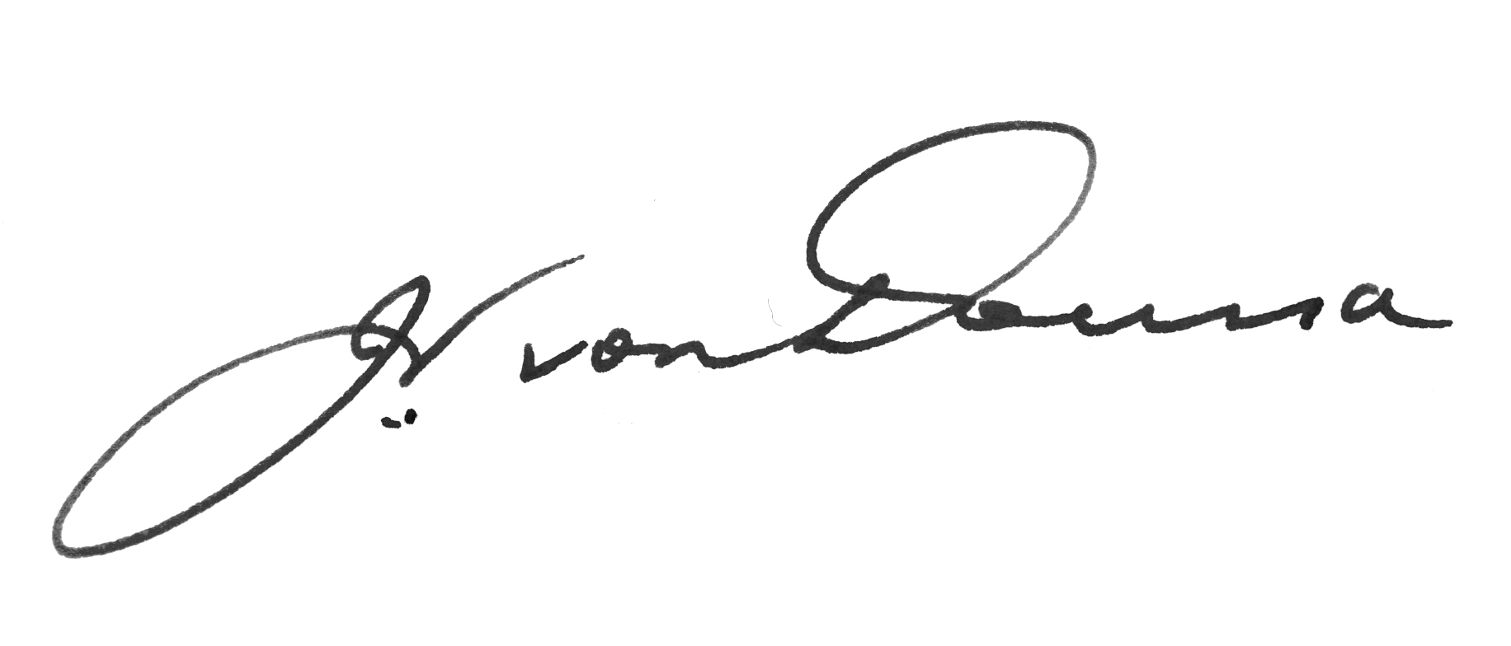
Signed by the President, John von Doussa QC, on behalf of the Commission.

