Chapter 4: The ADF Workforce Pipeline: Women’s representation and critical issues –
Section 4.3 Retention

Contents
Appendix H: Chapter 4: The ADF Workforce Pipeline:
Women’s representation and critical issues – Section 4.3 Retention 1
Appendix H.1: Rates by Services 2
Appendix H.2: Appendix H.2 – First-Term Completion by Occupation
Group and Sex 4
Appendix H.3: Appendix H.3 ADF Initiatives aimed at retaining personnel 6

Rates by Services83
This data is based on three year average length of service data and assumes that 100 men and women commence in the Service at the same time. The graphs show what percentage will be remaining at yearly intervals.

Figure 1: Navy Retention Profiles (Male v Female)
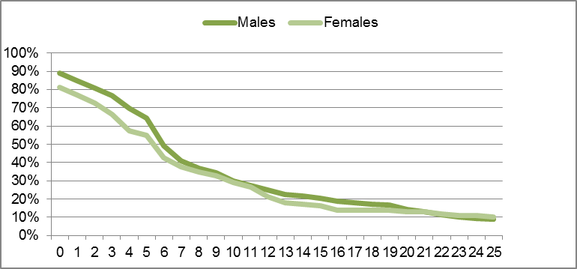
Years of Service

Figure 2: Army Retention Profiles (Male v Female)
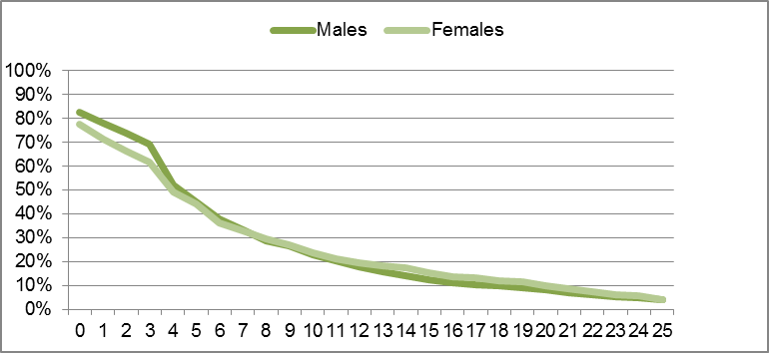
Years of Service

Figure 3: Air Force Retention Profiles (Males v Females)
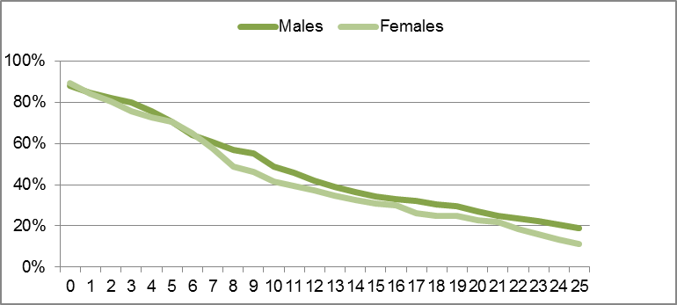
Years of Service

Appendix H.2 – First-Term Completion
by Occupation Group and Sex
The separation rate of personnel differs across the various categories of each Service. Following is a table illustrating the percentage of personnel in other ranks who have completed their Initial Mandatory Period of Service (IMPS) by category and shows some differences between men and women, as well as differences between retention across different Services for similar kinds of work.84 Given the small sample size, the figures are not conclusive, however they do point to some interesting differences that the Review suggests the ADF could investigate further using a larger data pool generated by examining trends over several years.

Figure 1: First-term completion by gender, Service and occupation
Enlistment Occupation Group | RAN |  |  | ARA |  |  | RAAF |  |  | ADF
Enlistment Occupation Group | M | F | Total | M | F | Total | M | F | Total | M | F | Total
Aviation |  |  |  | 87.1% | 85.7% | 87.0% | 100%85 | 76.2% | 78.3% | 87.5% | 78.6% | 84.8%
Communication, Intelligence and Surveillance | 70.3% | 59.7% | 65.3% | 67.1% | 55.0% | 66.1% | 81.2% | 81.8% | 81.3% | 72.1% | 64.6% | 70.5%
Engineering, Construction and Maintenance | 67.8% | 55.4% | 67.0% | 73.8% | 80.0% | 74.0% | 83.5% | 83.3% | 83.5% | 73.0% | 62.2% | 72.5%
Ground Combat |  |  |  | 67.9% |  | 67.9% |  |  |  | 67.9% |  | 67.9%
Health | 60.0% | 62.8% | 61.8% | 77.5% | 65.4% | 71.9% | 66.7% | 63.6% | 64.1% | 73.3% | 64.3% | 68.2%
Logistics and Administration | 70.2% | 66.3% | 68.3% | 71.2% | 71.2% | 71.2% | 79.7% | 81.4% | 80.6% | 72.2% | 72.5% | 72.2%
Musician | 96.0% | 76.9% | 89.5% | 81.8% | 77.8% | 80.6% | 88.2% | 100.0% | 90.5% | 87.2% | 80.0% | 85.1%
Sea Combat | 59.9% | 59.1% | 59.8% |  |  |  |  |  |  | 59.9% | 59.1% | 59.8%
Service Police and Airfield Defence |  |  |  | 50.0% |  | 50.0% | 72.5% | 90.5% | 74.5% | 72.2% | 90.5% | 74.2%
Total | 66.2% | 62.5% | 65.3% | 67.5% | 66.9% | 67.4% | 80.7% | 80.5% | 80.7% | 68.9% | 68.5% | 68.8%

Ground Combat and Sea Combat exhibit lower first-term completion odds than occupations such as Health, Logistics and Administration. The Air Force appears able to retain a higher proportion of their Communications, Intelligence and Surveillance personnel as well as their Engineering, Construction and Maintenance, Logistics and Administration and Service Police and Airfield Defence personnel, than either Navy or Army.
There is a lower completion rate for women in several categories such as Communications, Intelligence and Surveillance in both Navy and Army, Health in Army, and Engineering, Construction and Maintenance and Musician in Navy. The most significant variance in Air Force is in Aviation where 25% less women completed first-term completion than men.
The precise reasons for the differences in attrition across categories are not known by the ADF and could be a combination of factors including the nature of the positions and the personal and psychological attributes of the personnel (including the kinds of personnel attracted to particular categories).86

Appendix H.3 ADF Initiatives aimed
at retaining personnel

Project LASER87
Project LASER (Longitudinal ADF Study Evaluating Retention) aims to build a better understanding of the retention drivers that influence members to stay or leave the ADF during their initial period of service. The focus of Project LASER is on providing empirical data to the Services to support the development of retention initiatives. Project LASER captures members at entry into the organisation, at regular intervals and then upon exit from the organisation. This provides the vital link between reported turnover intentions and actual turnover behaviour for members during their initial period of service. LASER enables identification of the differences between ‘stayers’ (members who stay in the ADF) and ‘leavers’ (members who leave the ADF). This will lead to a better understanding of why members choose to stay or leave and in turn will allow the Services to determine how best to convert ‘leavers’ into ‘stayers’ with targeted evidence-based retention strategies and initiatives.
The latest report, a 2011 Report based on all Other Ranks LASER respondents who joined in 2010, includes the following key findings:88
- Physical fitness is a key challenge for females joining the Army.
- Fewer friends and relatives are encouraging females to join the Navy in 2010 than in 2009.
- Separation from family/partners presents challenges for recruits in training completion.
- Dissatisfaction with branch/trade is still associated with higher attrition.
- There was a large amount of feedback about recruitment process and information provided throughout the process.
- There has been a reduction in observations and experiences of unacceptable behaviour.

Retention and Recruitment (R2) Program
R2, a major recruitment and retention project aimed at improving recruitment and retention into the ADF, included several initiatives aimed at reducing the separation rate of personnel including the use of retention bonuses and bonuses for critical categories and occupations (such as for submariners). An evaluation of the program demonstrates its apparent success in reducing separation rates across the ADF (see Appendix G.4 for further details).89 However, an examination of the specific impact on women’s retention was not conducted as part of this evaluation and so it is not clear which of the initiatives had the greatest impact on women’s retention. Furthermore, given the majority of the measures in R2 did not address structural and systemic issues or the issues of most concern to women (such as addressing the need for greater flexibility and locational stability), it seems unlikely that the impact of R2 initiatives on women’s retention would be profound or long-term.

Plan SUAKIN90
As part of the Strategic Reform Program, an extensive study into the Reserve forces known as Plan SUAKIN was initiated, aimed at exploring how the Reserve forces can better contribute to a cost efficient and effective force 2030. Plan SUAKIN recommends capitalising on the capability and willingness to work more days within the Reserve forces to enhance ADF capability. In doing so, it recommends a complete reform of Defence’s current workforce model. Key recommendations include:
- To establish a spectrum of employment options including full-time, part-time and casual service across the permanent and Reserve forces (seven different employment models in all). This will allow Defence members to move between different employment models as their life circumstances change.
- To create attractive remuneration packages including superannuation for Reserve service.
- Ensure meaningful career management of Reserve forces.
The benefits of the reforms proposed under Plan SUAKIN could be significant for the attraction and retention of women (and men) in the ADF:
- Men and women juggling work/family responsibilities will have far greater options for part-time and flexible work and, significantly, the ability to move between part-time and permanent employment with greater ease to suit their different needs at any one time.
- Efforts to address many of the structural and cultural barriers to personnel accessing part-time and flexible work will be made such as:
The stigma and guilt associated with accessing part-time work because of difficulty in backfilling permanent positions.
Attitudes towards part-time work as ‘lesser’, ‘uncommitted’.
- Superannuation will be offered for part-time work.
The implementation of Plan SUAKIN was approved by the Chiefs of Service Committee on 25 May 2012.

Navy initiatives
Navy has trialled and implemented several initiatives aimed at addressing the high separation rates, particularly among sailors, as a result of strains on work-life balance caused by sea-going requirements.91 Under the impetus of the Seachange Workforce Renewal Project, alternative crewing strategies used by other Navies and commercial enterprises were investigated, and some trials were conducted on Navy vessels. ‘Alternative crewing’ arrangements are focused on increasing locational stability and a balance between work and home for Navy personnel while ensuring operational effectiveness. They include the following crewing arrangements:
- Enhanced crewing—a form of traditional crewing where enhanced shore support relieves sailors of their duties while alongside (such as duty-watch, force protection and routine maintenance)
- Supplementation (flexi-crewing)—additional personnel are posted to a crew to increase flexibility for sailors to be released for leave, respite and training
- Multi-crewing—multiple complete crews rotate between platforms
- Modular crewing—a minimum core crew can be supplemented by specialist, mission specific teams (referred to as ‘capability bricks’)
- Civilian crewing—RAN crews are replaced by civilian personnel from the Merchant marine. Such systems are already successfully employed in the Royal Navy (Royal Fleet Auxiliary) and United States Navy (Military Sealift Command).
Navy has trialled ‘multi-crewing’ – the rotation of multiple complete crews between platforms/vessels – on several kinds of vessels in different operational environments. Navy currently multi-crews on Hydrographic (Hydro) and Patrol vessels (PB) and has multi-crewed Mine Countermeasure vessels (MHC) on two occasions in recent years.92 An evaluation of the use of multi-crewing in Patrol Boat and Hydrographic fleet has shown these to be successful and well-established.93
The Navy has also implemented a ‘Minimum Duty Watch’ aimed at reducing the level of duty watch required of personnel posted to vessels alongside homeport.94 Additionally, Navy has trialled fly-in/fly-out (FIFO) arrangements including on MHCs with platforms rotating between being ‘on station’ and in maintenance.95
Alternative crewing arrangements have generally been met positively by members and address many of the core concerns of women that leave the ADF. Evaluations of the initiatives make concrete proposals for overcoming many of the difficulties that arose during the trials such as perceived inequality in workloads.96
Additionally, the Submarine Whole of Capability Workforce Review resulted in implementation of a series of initiatives aimed at improving submariners’ work/life balance, including:97
- Suitably qualified civilian contractors were hired to replace some members of the ship's Duty Watch, thus freeing up some crew members to take leave and reducing the watch keeping workload for the entire crew.
- Increasing crew sizes from 46 to 58 people providing the Commanding Officer with more flexibility within the crew to manage short-term personnel deficiencies.
- Establishment of a Submarine Support Group (SSG) of 27 people to provide 'fly in, fly out’ support services to submarines in port.
- Provision of internet and intranet access to submarines.
- Relocation of the Submarine Communications Centre from the east to Fleet Base West at HMAS Stirling, to provide twelve additional shore-based jobs in the west, resulting in improved posting stability and incentives to remain in the Navy for submarine communications sailors and their families.
- A new 'try before you buy' internal recruiting program aimed at attracting more junior sailors and junior officers into the submarine service.
- Retention bonuses.98
The financial implications of implementing many of these measures are a consideration, however, some of the costs appear to be countered by reduced expense on relocation of personnel and their families, and the longer-term impact on retention among other savings.99

Air Force initiatives100
Project WINTER was initiated in 2011, in response to ongoing ministerial direction for the Services to increase their overall participation of women in the ADF. The largest employment groups in Air Force in terms of personnel numbers also have the lowest overall representation of women aircrew (4.7%), technical trades (2%) and engineering (8%). Project WINTER was instigated in acknowledgement that even small gains in female representation in these 'non-traditional' fields for women will result in significant gains in overall female representation in Air Force.
Project WINTER has already implemented, or is in the process of implementing, a range of initiatives focusing on the education, retention, support and progression of women in non-traditional employment roles. It includes a series of initiatives ranging from marketing to alternative career pathways for women. The next stage of development – designing a specialised marketing and recruiting campaign that will encourage higher numbers of women to pursue non-traditional careers within Air Force – was approved by the Chiefs of Service Committee on 29 May 2012, with a budget of $600,000.101
The initiatives under Project WINTER appear to take a holistic approach to women’s attraction and retention in ‘non-traditional’ fields of employment for women, recognising that factors such as lack of breastfeeding facilities, flexible work and initiatives to support diversity within Air Force is needed for the success and sustainability of the project. The fact that the initiative is specifically tailored towards the retention of women means that it addresses women’s specific needs and concerns in a way that more general retention initiatives do not.

- ‘PTS by Gender 1 May 2012 – Full Breakdown.xls’ provided to the Review by CMDR
A Westwood, 1 June 2012.
- ‘Response to Broderick Review Phase 2 Task 428’ provided to the Review by CMDR
A Westwood, 1 June 2012. Note, the sample size varies greatly by sex: male n=9,668; female n=1,704.
- Sample size n=2.
- ‘Response to Broderick Review Phase 2 Task 283’ provided to the Review by SQNLDR
F James, 10 April 2012.
- ‘Project LASER- Retention 2010 Cohort Results’ provided to the Review by CMDR A Westwood, 16 March 2012.
- ‘Project LASER- Retention 2010 Cohort Results’, above.
- Department of Defence, People Strategies and Policy Group, Review of the Australian Defence Force Retention and Recruitment (R2) Program, note 56, vol 1, p 26.
- ‘Section 1 Executive Summary 111223’, ‘Section 2 Case for Change and Future Vision FINAL’, ‘Section 3 Change Overview FINAL’ provided to the Review by CMDR A Westwood,
14 February 2012; Meeting with Plan SUAKIN Representatives.
- ‘SC FEG crewing options paper final.DOC’ and ‘FIFO issues brief.DOC’ provided to the Review by SQNLDR F James, 12 June 2012.
- CMDR A Westwood, email to the Review, 12 March 2012.
- Royal Australian Navy, Sea Talk Spring 2007/Navy Sea Change Program, http://www.navy.gov.au/Publication:Sea_Talk_Spring_2007/Navy_Sea_Change_Program (viewed 6 July 2012). See also CMDR A Westwood, email to the Review, 12 March 2012.
- ‘Sea Talk Article – Harbour Watch Reform pdf; http_intranet-defence-gov-au_navyweb_sites_chkDoc-asp_S_9586_D_92808_URL_docs_FC_Personal_Memo_08-08-Minimum_Duty-Watch.pdf’ provided to the Review by CMDR A Westwood, 29 May 2012.
- CMDR A Westwood, email to the Review, 12 March 2012.
- See for example, ‘WAR FCT Exit Report’ provided to the Review by SQNLDR F James,
12 June 2012.
- Royal Australian Navy, Navy’s Response to the Submarine Workforce Sustainability Review (Moffitt Report), 8 April 2009. At http://www.navy.gov.au/Publication:Submarine_Workforce_Sustainability_Review (viewed
15 June 2012). Also provided to the Review by CMDR A Westwood, 12 February 2012.
- Royal Australian Navy, Navy Action Plan Unveiled to Strengthen Submarine Fleet, http://www.navy.gov.au/Navy_Action_Plan_Unveiled_to_Strengthen_Submarine_Fleet (viewed 15 June 2012).
- See for example, ‘NWPC FIFO Paper.DOC’ and ‘FIFO Issues brief.DOC’ provided to the Review by SQNLDR F James, 12 June 2012.
- ‘120411 – Decision Brief for CAF – Air Force Women Pilot Recruitment Strategy – Graduate Pilot Scheme (GPS).pdf’ provided to the Review by SQNLDR F James, 30 May 2012; ‘120524 – Brief for CAF – Women in Non Traditional Employment Roles (Winter) Marketing Campaign.pdf’, provided to Review by SQNLDR F James, 30 May 2012.
- SQNLDR F James, email to the Review, 30 May 2012.

