Chapter 5: The ADF Workforce
Structure: Opportunities, Pathways and Barriers – Section 5.1 Occupational Segregation

Contents
Appendix J: Chapter 5: The ADF Workforce Structure: Opportunities,
Pathways and Barriers – Section 5.1 Occupational Segregation 1
Appendix J.1: Number of men and women in each category in order
of most highly represented by women 2
Appendix J.2: Changes in the percentage of women by category
(in order of most high represented by women) over the last 6 years 4
Appendix J.3: Distribution of ranks within categories 6
Appendix J.4: ADF initiatives to address occupational segregation 9

Number of men and women in each category
in order of most highly represented by women110

Figure 1: Navy – Number of men and women in each category in order
of most highly represented by women
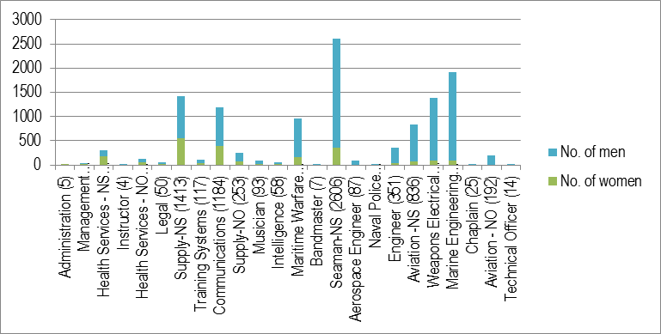

Figure 2: Army – Number of men and women in each category in order
of most highly represented by women
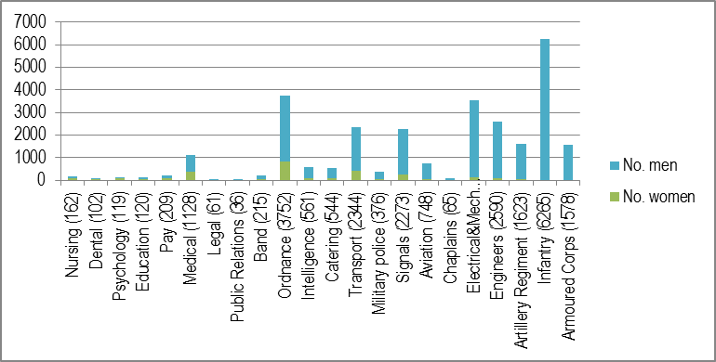

Figure 3: Air Force – Number of men and women in each category in
order of most highly represented by women
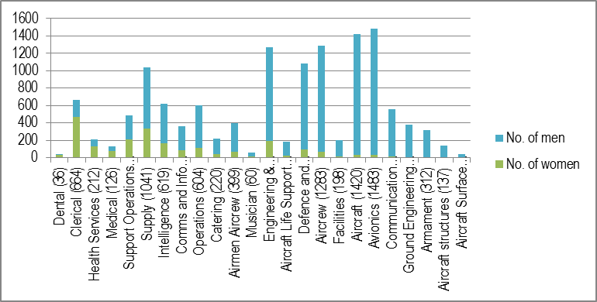

Changes in the percentage of women by
category (in order of most high represented by women) over
the last 6 years111

Figure 1: Navy – Changes in the percentage of women by category
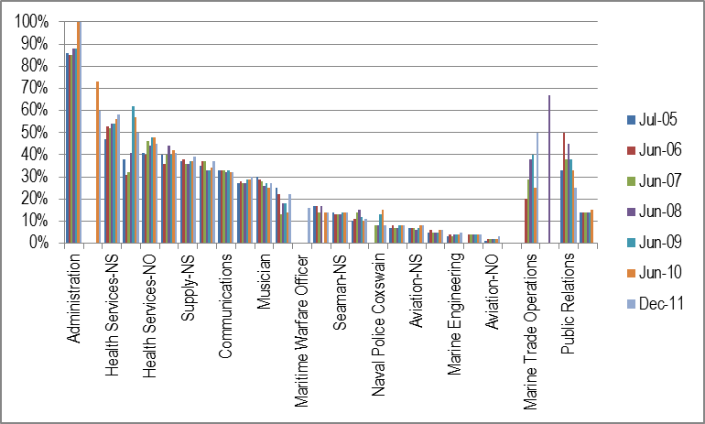

Figure 2: Army – Changes in the percentage of women by category
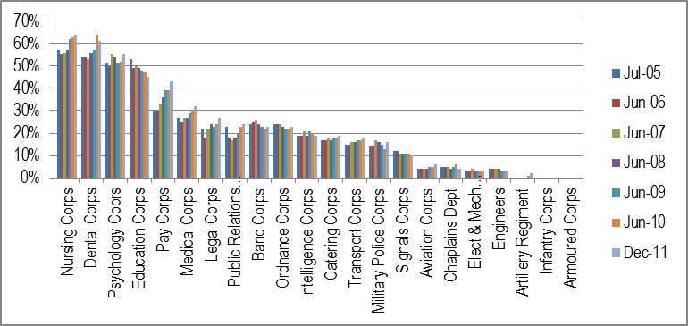

Figure 3: Air Force – Changes in the percentage of women by category
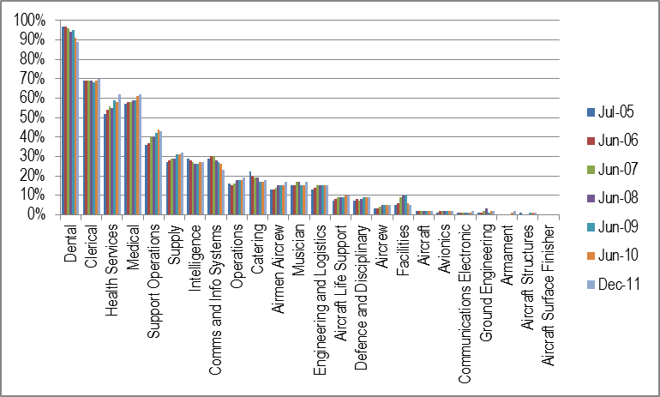

Distribution of ranks within categories112

Figure 1: Distribution of ranks within categories – Navy non-commissioned officers (other ranks)
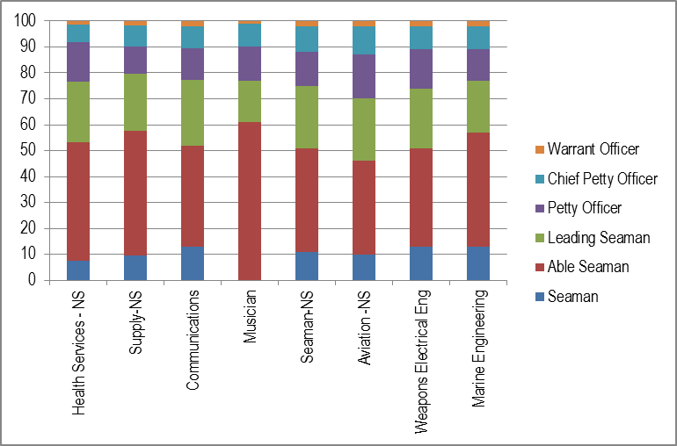

Figure 2: Distribution of ranks within categories – Navy officers ranks
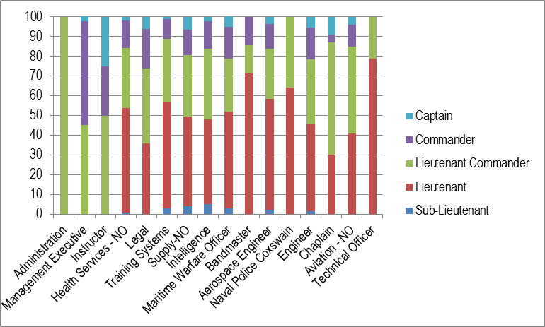

Figure 3: Distribution of ranks within categories – Army non-commissioned officers (other ranks)
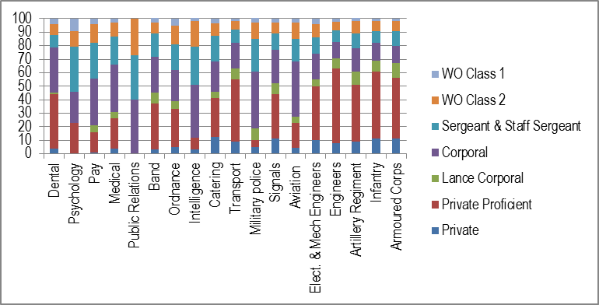

Figure 4: Distribution of ranks within categories – Army officer ranks
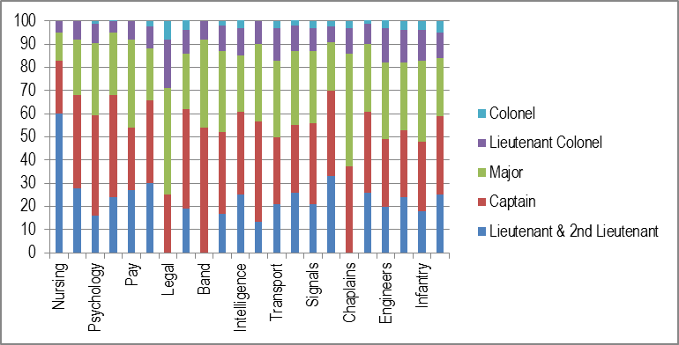

Figure 5: Distribution of ranks within categories – Air Force non-commissioned officers (other ranks)
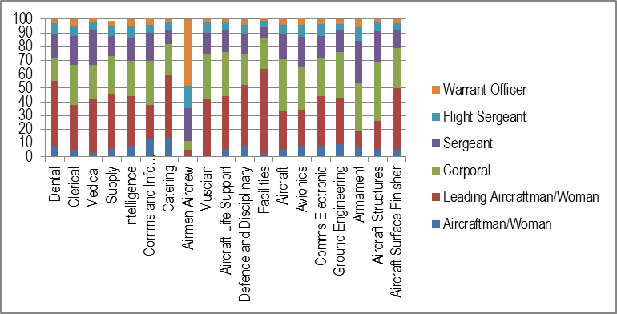

Figure 6: Distribution of ranks within categories – Air Force officer ranks
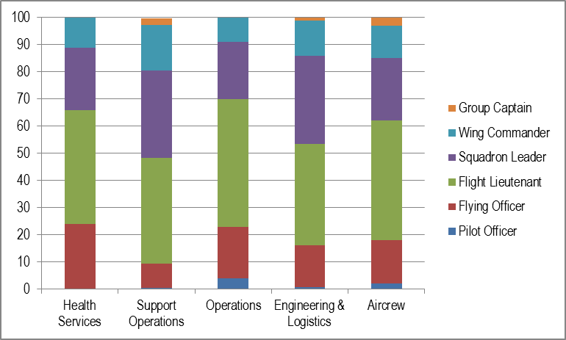

ADF initiatives to address occupational segregation
The ADF has implemented a number of initiatives that have either aimed to attract women to non-traditional occupations in the ADF or have had this unintended effect. Many of these initiatives are detailed in Appendix G.4. Following is a brief overview of the key aspects of these initiatives that are relevant to addressing occupational segregation.

The ADF Recruitment of Women Strategy (RoWS)
This strategy was launched in 2008 with the aim of increasing the percentage of women among overall recruit intakes annually – with an end goal of achieving a 20% intake of women by Financial Year (FY) 2009-10. The strategy aims at demystifying military life. Although not specifically targeted towards attracting women to technical trades, it is does encourage women to consider non-traditional careers through the development of promotional material highlighting the diversity of jobs that women do in the ADF. Initiatives include an Alumni Visits program (visits by servicewomen to schools and community groups in their posted regions) women’s mentoring program, and a library of ‘Women in the ADF profiles’ and other promotional material (with a focus on the range of opportunities open to women in the ADF).

Retention and Recruitment Program (R2)
The R2 Program includes a suite of initiatives aimed at the recruitment and retention of personnel. The Defence Technical Scholarship is granted to students undertaking technically-oriented subjects in years 11 and 12, without any obligation to Defence at the completion of their studies. While not specifically targeted at women, recipients are ‘encouraged to consider a trade career in the ADF’ through visits and other ADF-oriented activities.
The Gap Year program (See Appendix G.6) exposed young people to Defence Force employment without having to commit to extensive training and return of service. It was very successful in attracting young women to the ADF, particularly in Army, and also enabled women to experience employment in ‘non-traditional’ fields.

Initiatives of Army

Reduced ‘Initial Minimum Period of Service’ obligations113
As a consequence of the Gap Year (which showed that women were more attracted to shorter periods of service), Army has trialled various reduced ‘Initial Minimum Period of Service’ in trade categories where skills were needed. Currently, there is a reduced ‘Initial Minimum Period of Service’ from 4 years to 1 year for the following trades:
- Operator Supply
- Driver Specialist
- Operator Administration
- Operator Movements
- Preventative Medicine
- Military Policeman
- Cargo Specialist
- Cook
- Dispatch Air
- Ground Crewman (Mission Support)
- Clerk Finance and
- Dental Assistant.

Other initiatives
The removal of gender-restriction on combat related roles will enable women to enter all positions in Army (an additional 14.6% of positions). These positions are in ‘non-traditional’ areas of employment for women.

Initiatives of Air Force

Project WINTER114 (See also Appendix H)
Project WINTER aims to implement a vast range of activities designed to increase women’s overall representation in Air Force, by targeting those employment fields that are not traditionally attractive to women joining the Air Force. It is currently focused on the recruitment, support, retention and progression of women Pilots, Air Combat Officers, Technicians, Engineers and women intending to pursue careers in ground defence roles. It includes a series of initiatives ranging from marketing to alternative career pathways for women.
Importantly, Project WINTER is part of a holistic approach to attracting women into these occupations, recognising that factors such as lack of breast-feeding facilities, flexible work and initiatives to support diversity within Air Force is needed for the success and sustainability of the project.

Initiatives of Navy
Navy’s current initiatives focus on recruitment and include:115
- Women's web page on defence jobs website
- Development of a web forum for online discussion
- Navy support to recruitment seminars and trades shows targeting females in trades
- Fitness and wellbeing apps
- Merchandise through DFR
- Conscious placement of females in all advertising/testimonials in non-traditional roles.

- ‘ADO High Level v1.xls’ provided to the Review by SQNLDR F James, 30 January 2012.
- ‘ADF Specialisation RFI 155.xls’ provided to the Review by CMDR A Westwood, 24 January 2012. In 2011 there are no personnel in the following categories: Seaman NO, Marine Trade Operations, Psychology and Public Relations.
- These graphs represent the distribution of ranks (of non-training personnel) up to the Captain (Navy), Colonel (Army) and Group Captain (Air Force): ‘ADO High Level v1.xls’, note 110.
- Director General Personnel – Army, Minute, ‘Trial of 12 months IMPS for selected ARA trades’, 12 April 2012, provided to the Review by SQNLDR F James, 18 April 2012.
- ‘120411 – Decision Brief for CAF – Air Force Women Pilot Recruitment Strategy – Graduate Pilot Scheme (GPS).pdf’, note 100; ‘120524 – Brief for CAF – Women in Non Traditional Employment Roles (Winter) Marketing Campaign.pdf’, note 100.
- SQNLDR F James, email to the Review, 18 April 2012.

