Chapter 4: The ADF Workforce Pipeline:
Women’s representation and critical issues

Contents
Chapter 4: The ADF Workforce Pipeline: Women’s representation
and critical issues 1
4.1 Representation 5
4.2 Recruitment 28
4.3 Retention 55
4.4 Career management and progression 72

The ADF workforce provides opportunities unlike any experienced in the civilian environment, while also imposing very specific parameters on its workers. All workforces face their own challenges and many still grapple with achieving a significant representation of women. The particular nature of the ADF workforce, the complex requirements of its overall mission and its highly defined career pipeline, can compound these challenges. Understanding this pipeline and the forces that affect it is essential to achieving meaningful organisational change.
This Chapter will examine the representation of women across the ADF workforce, analysing recruitment and retention efforts and trends, as well as the ways in which career management processes impact upon women’s progression.

Overview of the ADF Workforce Pipeline
The ADF workforce is primarily built upon ab initio or entry level, recruitment. This means that the bulk of ADF recruits come from the civilian environment, with no previous military experience, and enter the base training rank. Most are from the
17-24 year old age bracket, often straight out of school or tertiary institutions. Ab initio recruiting is seen as the best way to ‘progressively train individuals for the specific category and capability requirements’ of the Service.1
Applicants select their preferred occupations at recruiting and are allocated a position in a particular corps/mustering/category. They then commit to an Initial Minimum Period of Service, Return of Service Obligation or similar, which requires them to complete a certain number of years in the ADF or, alternatively, pay back a proportion of their training costs should they discharge at an earlier date. Opportunities for progression vary within these occupations, with some categories having what is known as a ‘low rank ceiling’ – that is where the most senior position in a certain category will be at a relatively junior level.
As later sections will discuss, promotion through the ranks is determined not only by performance, but also by a length of ‘time in rank’ that must be served before a member is eligible to be considered for promotion. Promotions are considered after members have served this time, rather than after specific application to more senior positions. This means that, rather than considering members’ suitability for a particular role, a Service specific promotions board considers their elevation in general terms on the basis of time served, performance reports received and how well they have functioned in comparison to their peers according to well defined metrics.
In other words, the ADF’s pipeline – a concept often used in relation to an organisation’s workforce – follows a rigid and linear path, with recruits and junior personnel entering at one end, and the organisation’s leadership emerging at the other.2 This Chapter provides an analysis of the representation of women within this ADF pipeline, while Chapter 5 will examine some of the structural and systemic barriers that women may encounter along the way.

Workforce structure – the basics
The ADF workforce is comprised of ‘officers’ and ‘other ranks’. Officer positions are management focussed, requiring team leadership and decision-making. Other rank positions tend to be more trade related and team oriented. The other ranks include technical positions (e.g. mechanics, electricians, carpenters) and non-technical positions (e.g. cooks, dental assistants, drivers).
There are fewer officers than other ranks, and while each workforce component has its own hierarchy, the most senior leadership positions in the ADF are occupied by officers. Ranks O07-O10 are the most senior leaders in the ADF, and are known as ‘star ranks’.
The rank hierarchies and inter-Service equivalents are listed below.3 The following Chapter discusses these ranks and uses the abbreviations listed.

Table 4.1: Other ranks hierarchy and inter-Service equivalents
Code | Navy | Army | Air Force
E00 | Recruit (RCT) | Recruit (PTE REC) | Aircraftman/Woman Recruit (AC/W REC)
E01 | Seaman* (SMN*) | Private Trainee (PTE TRN) | Aircraftman/Woman Trainee (AC/W TRN)
E02 | Seaman (SMN) | Private (PTE) | Aircraftman/Woman (AC/W)
E03 | Able Seaman (AB) | Private Proficient (PTE(P)) | Leading Aircraftman/Woman (LAC/W)
E04 |  | Lance Corporal (LCPL)
E05 | Leading Seaman (LS) | Corporal (CPL) | Corporal (CPL)
E51 |  |  | Non-commissioned Officer Cadet (NCOCDT)
E06 | Petty Officer (PO) | Sergeant (SGT) | Sergeant (SGT)
E07 |  | Staff Sergeant (SSGT)
E08 | Chief Petty Officer (CPO) | Warrant Officer Class 2 (WO2) | Flight Sergeant (FSGT)
E09 | Warrant Officer (WO) | Warrant Officer Class 1 (WO1) | Warrant Officer (WOFF)
E10 | Warrant Officer of the Navy (WO-N) | Regimental Sergeant Major of the Army  (RSM-A) | Warrant Officer of the Air Force  (WOFF-AF)

Table 4.2: Officer ranks hierarchy and inter-Service equivalents
Code | Navy | Army | Air Force
O00 | Midshipman (MIDN) | Officer Cadet (OCDT) | Officer Cadet (OFFCDT)
O01 | Acting Sub Lieutenant (ASLT) | Second Lieutenant (2LT) | Pilot Officer (PLTOFF)
O02 | Sub Lieutenant (SBLT) | Lieutenant (LT) | Flying Officer (FLGOFF)
O03 | Lieutenant (LEUT) | Captain (CAPT) | Flight Lieutenant (FLTLT)
O04 | Lieutenant Commander (LCDR) | Major (MAJ) | Squadron Leader (SQNLDR)
O05 | Commander (CMDR) | Lieutenant Colonel (LTCOL) | Wing Commander (WGCDR)
O06 | Captain (CAPT) | Colonel (COL) | Group Captain (GPCAPT)
O07 | Commodore (CDRE) | Brigadier (BRIG) | Air Commodore (AIRCDRE)
O08 | Rear Admiral (RADM) | Major General (MAJGEN) | Air Vice-Marshal (AVM)
O09 | Vice Admiral (VADM) | Lieutenant General (LTGEN) | Air Marshal (AIRMSHL)
O10 | Admiral (ADML) | General (GEN) | Air Chief Marshal (ACM)

Representation
In summary
Women are under-represented across most areas of the ADF and vastly under-represented in senior leadership positions in the organisation.
At the end of 2010/11 women comprised 13.8% of all ADF personnel (17.4% of all officers, and 12.6% of all other ranks).
By Service, women make up 18.5% of Navy, 9.9% of Army and 17.1% of Air Force.4
Women make up less than 5% of star ranks, and less than 8% of warrant officers.
Better recruiting practices and developmental pathways are required to address the under-representation of women in the ADF and leadership.
The lack of diversity, including gender diversity, will increasingly impact on the ADF’s overall capability and operational effectiveness.
This section maps the representation of women in different parts of each Navy, Army and Air Force, in order to identify areas where women are progressing, as well as those where they are encountering hurdles. Without this information, a solid understanding of the barriers and opportunities that women face cannot be reached.
An examination of the ADF pipeline requires a number of analyses. As described above, the ADF is organisationally comprised of three separately managed Services (Navy, Army, Air Force), each of which has an officers and other ranks component. In addition, a number of ADF personnel are posted to tri-service establishments, such as Headquarters Joint Operations Command. Each of the single services’ workforce components has its own senior leadership positions, drawn from its own ranks. For this reason, this section will conduct separate analysis of each of these six workforce components.
At the outset, it is important to note that broad similarities apply across all three Services:
- Women are under-represented in most categories across the ADF, and make up 13.8% of ADF personnel overall.5
- Women are vastly under-represented at the most senior levels of each Service in comparison to their overall representation, making up less than 5% of all star ranks (senior officers), and less than 8% of warrant officers (senior other ranks).6
- There is a higher proportion of women in each Service’s officer corps compared to the other ranks. Overall, women make up 17.4% of all officers, and 12.6% of all other ranks.7
In general, women progress better through the other ranks than the officer ranks.
There are also significant differences between the Services. Disaggregated by Service, the figures show that:
- Navy has the highest overall representation of women (18.5%), but has issues with the progression of women beyond its junior ranks.
- Army has the lowest overall representation of women (9.9%), but is doing comparatively well with women’s progression, particularly in its other ranks.8
Air Force falls somewhere between the other two Services with regards to both the representation (17.1%) and progression, but has had the best proportional improvements in the representation of women over the period examined.
The Review’s research reveals that underlying issues which are contributing to the low representation of women include:
- The failure of gender-related initiatives to increase the proportion of women being recruited into the ADF.
- The lack of a critical mass of women within the ADF, reducing the opportunity to create sustainable cultural reform in a number of areas.
- Occupational segregation and the traditional structure of the workforce, which has acted as a barrier to the progression of women into the most senior ranks of each Service.
Real or perceived lack of support in the context of work/life balance, leaving many women feeling they must choose between their career and family.
As later areas of this Report will explain, the Review believes that addressing issues of recruitment, the lack of critical mass, occupational segregation and work/family balance will help the ADF address some of the areas of concern within its workforce pipelines.

Methodology
The baseline data used in this section is end of financial year 2004/05 to 2010/11 snapshot figures provided to the Review by the Workforce Planning Branch.9 These figures are broken down by gender and rank for each Service.10 Further data, commentary and clarification by ADF workforce and career management personnel is also used, and cited as appropriate.
The analysis below examines each of the six ADF pipelines. Each subsection begins with three key graphs:
1. Women as a proportion of each rank over time, from 2004/05 to 2010/11. This time period is used because of the availability of comparable data over this period. It illustrates patterns and changes over the period.
2. Women and men as a proportion of each rank, end of financial year 2010/11. This graph indicates the representation per rank for women and men from the most recent information in this data-set.
3. Number and proportional representation of women in senior ranks. This graph focuses in on the number and proportional representation of women at the most senior ranks at each end of the data sample – 2004/05 and 2010/11 – to illustrate any changes that have occurred over this time.

Army, other ranks

Figure 4.1: Proportional representation of women, Army other ranks, financial years 2004/05 to 2010/11
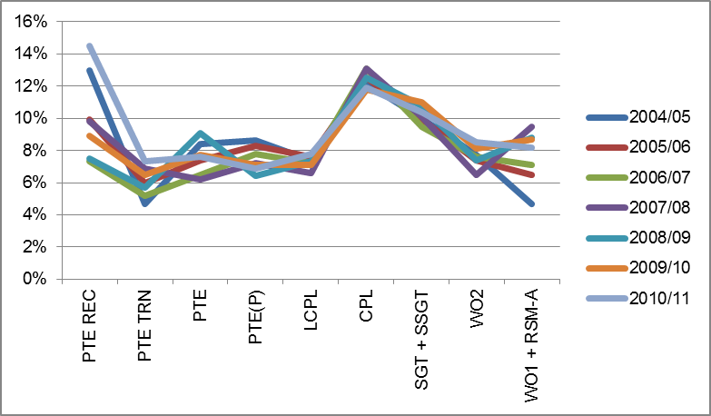

Figure 4.1 shows the representation of women as a proportion of each other rank in Army over the previous seven financial years. The fact that representation at various ranks is tracking similarly over this time indicates that these patterns are well established.

Figure 4.2: Proportion of women and men, Army other ranks, financial
year 2010/11
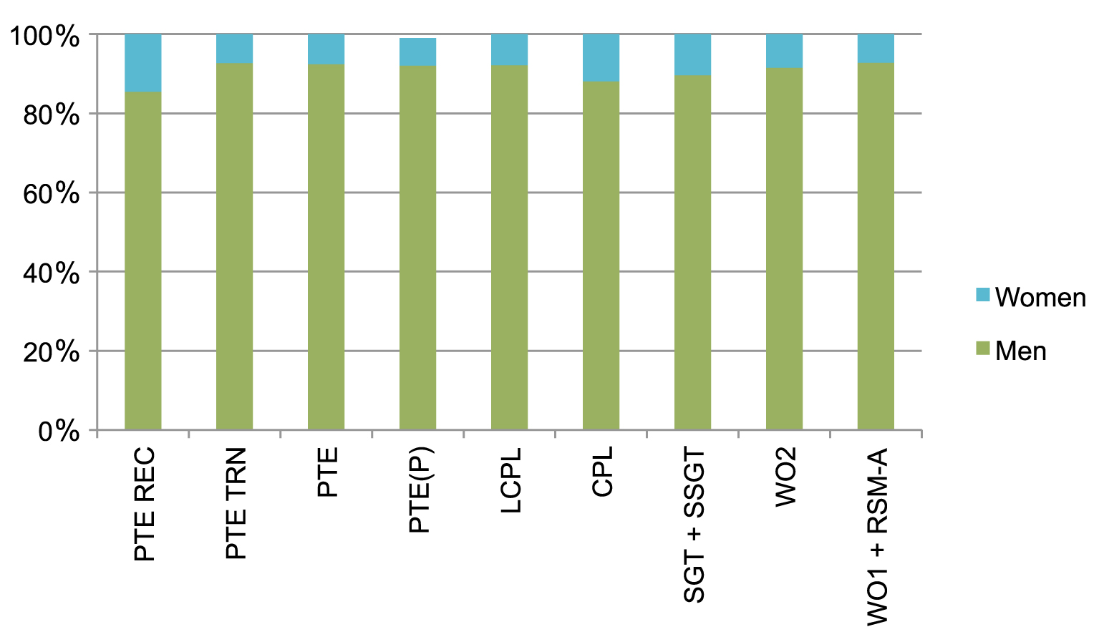
Figure 4.2 shows the breakdown of women and men in each rank at the end of financial year 2010/11. In financial year 2010/11 women made up 8.7% of all Army other ranks (2,020 out of a total 23,335).11 This compares with 2004/05 when women made up 9.1% (1,800 out of a total of 19,844). While the total number of women has increased, the proportional representation has decreased.

Figure 4.3: Army women senior non-commissioned officers, 2004/05
and 2010/11
RANK | 2004/5  Number and proportion of total women (and men) / rank |  | 2010/11  Number and proportion of total women (and men) / rank
SGT + SSGT | 260 (men 2,342) | 10.0% | 293 (men 2,512) | 10.4%
WO2 | 142 (men 1,705) | 7.7% | 169 (men 1,822) | 8.5%
WO1 + RSM-A | 25 (men 503) | 4.7% | 56 (men 629) | 8.2%
Figure 4.3 shows the number and proportional representation of women at senior Army non-commissioned ranks in 2004/5 and 2010/11.12 There are more women in these senior ranks, particularly at the rank of WO1, in 2010/11 compared to 2004/05.

Overall representation
The overall representation of women in Army’s other ranks is low. At 8.7%, it is proportionally about half the representation in Navy (17.9%) and Air Force’s (16%) other ranks.13
It should be noted however, that Army contains several large categories – for example infantry and parts of artillery – which are not currently open to women.14 Setting aside the categories from which women are excluded, women’s participation rate in the open parts of the workforce rises to nearly 13%.15 However, when the exclusion is lifted, women’s representation by both measures (absolute and open categories) will be closer to 9% than 13% if current recruitment and retention trends remain in place.16
As the largest sector of the ADF, the low representation rates for women in Army’s other ranks has a large impact on women’s representation in the ADF as a whole. Improvements in this part of the Force will be favourably reflected within the wider ADF.

Progression
The overall representation, representation at senior ranks, and separation and movement figures illustrate that women have been progressing through Army’s other ranks in a relatively equitable fashion.
In 2010/11 women made up 8.5% of all warrant officer class 2s and 8.2% of all warrant officer class 1s. These figures compare favourably to women’s overall representation at 8.7% of all other ranks.17
Women are equitably represented in both the separations and movements (promotions minus demotions, or net promotions) totals for financial year 2010/11, in comparison to their overall representation. Women made up 192 of the 2,142 (or 9%) total separations from Army’s other ranks and 796 of the 9,393 net movements per rank (8.5%).18 Women made up a higher proportion of separations from the corporal (15.9%) and sergeant (12.7%) ranks, but also a higher proportion of movements into lance corporal (10.5%) and corporal (11.6%).19 As figure 4.1 shows, women have been more highly represented at the rank of corporal than any other rank throughout the period examined, and so higher figures at and around this rank are also to be expected. Beyond the rank of corporal, representation begins to trend downwards again.
Figure 4.3 also indicates that there has been an improvement in the number of women progressing to the most senior ranks in this part of the Service between 2004/05 and 2010/11.

Conclusion and issues
Currently, the representation of women in Army’s other ranks is stable but low. The main obstacle is recruitment.
The Review understands that Army and Defence Force Recruiting are currently seeking to address this issue by streamlining the recruitment process, and increasing the conversion rate between the number of enquiries (which they see as ‘healthy’) and recruits (which could be improved).20 These initiatives are commendable, and the Review has made recommendations about other innovative recruitment strategies that should be trialled or adopted in order to increase the number of female recruits.
Analysis of enlistments and separations from the rank of recruit also indicates that retention of female recruits may be an issue.21 A higher separation rate for women at recruit schools may be due to a number of factors, such as the absence of a critical mass of women, and the strict gender segregation in much of recruit training which can isolate women and fail to provide them the support network that is available to men.22 Given Army will be expecting more female recruits in the future, it should examine ways to provide ongoing support structures to its new recruits, to make sure they are well equipped to deal with the challenges of recruit school, and progress through the early stages of their careers.
Finally, figure 4.1 indicates a spike in women’s representation at corporal over the entire period examined by the Review. This is acknowledged by Defence, but neither the ADF nor the Review have a hypothesis as to why this might be at this time.23 An examination of this, and whether there are particular barriers facing women at the rank of corporal, as well as any similar areas of interest in the workforce pipeline would be beneficial to the goal of increasing leadership pathways for women.

Army, officers

Figure 4.4: Proportional representation of women, Army officer ranks,
financial years 2004/05 to 2010/11
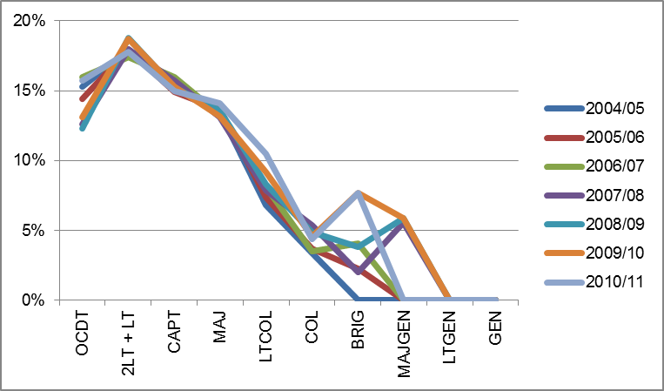
Figure 4.4 shows the representation of women as a proportion of each officer rank in Army over the previous seven financial years. As with other ranks, the patterns here are similar across the period, indicating established trends. There are some discrepancies at the more senior ranks, which are a result of the very small numbers of personnel involved, and the fact that individual promotions and retirements subsequently result in visible graphical shifts. There are no women in the most senior ranks, indicating a barrier at this level.

Figure 4.5: Women and men as a proportion of each Army officer rank, financial year 2010/11
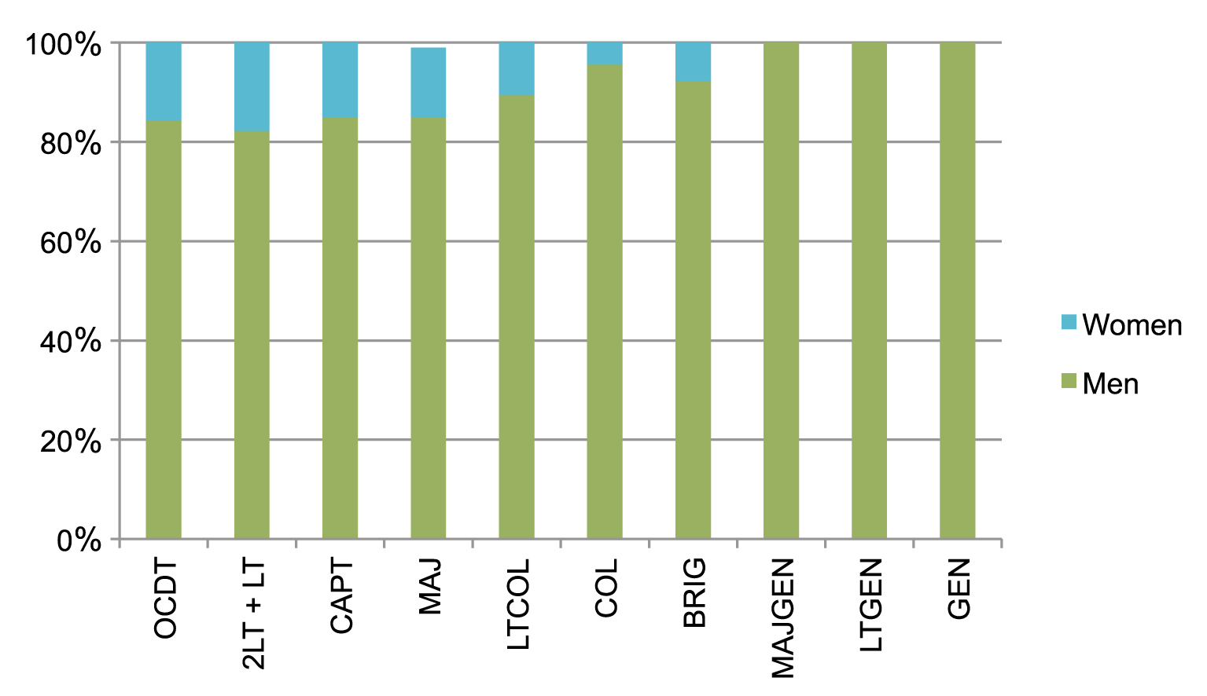
Figure 4.5 shows the breakdown of women and men in each rank at the end of financial year 2010/11. In financial year 2010/11 women made up 14.5% of all Army officer personnel (897 out of a total 6,166).24 This compares with 2004/05 when women made up 14.2% of Army officer ranks (746 out of 5,262).

Figure 4.6: Army women senior officers, 2004/05 and 2010/11
RANK | 2004/5  Number and proportion of total women (and men) / rank |  | 2010/11  Number and proportion of total women (and men) / rank
MAJ | 177 (men 1,130) | 13.5% | 228 (men 1,385) | 14.1%
LTCOL | 32 (men 437) | 6.8% | 62 (men 527) | 10.5%
COL | 4 (men 115) | 3.4% | 7 (men 152) | 4.4%
BRIG | 0 (men 40) | 0% | 4 (men 48) | 7.7%
Figure 4.6 shows the number and proportional representation of women at senior Army officer ranks in 2004/5 and 2010/11.25 Although representation has improved, particularly at lieutenant colonel and brigadier level, it remains very low, and there are no women at the most senior ranks.

Overall representation
Women make up 14.5% of Army officer ranks, a much higher proportion compared to other ranks (8.7%). This figure is much closer to women’s representation in the other Services’ officer corps (Navy 20.3%, Air Force 19.3%), and indicates that women’s lower representation in Army as a whole is largely a result of the low representation in its other ranks.
There are a number of Army officer roles which are not open to women, although these restrictions are soon to be lifted.26 If the categories from which women were excluded at the end of 2011 are set aside, women’s participation rate among Army officer ranks rises to over 17%, a figure more in line with women’s representation in the other Services.27

Progression
Women are not progressing into Army’s senior ranks in numbers commensurate to their overall representation in the Service. Figures 4.4 and 4.5 show that the representation of women falls away as rank increases. In 2010/11, women made up 17.8% of lieutenants but only 4.4% of colonels, with a steady decline in representation between these ranks.28 At the most senior three levels of Army, there are no women.
In 2010/11 women made up 60 of the 457 (or 13.1%) separations across all ranks, and 134 of the 915 net movements/promotions (14.1%).29 Between 2004 and 2010, women have been over-represented in separations from more junior ranks. Figures for calendar years 2004 – 2010 show that women comprise between 25% and 40% of separations from captain, and between 2007 and 2010, women made up between 16.5% and 20.5% of separations from major.30 As women are lost from the pipeline at these ranks, issues of critical mass become more obvious. While the representation of women is improving at more senior ranks (see figure 4.6) there remain very few star ranked women in Army. In 2010/11, women made up only 4.6% of all movements to colonel, and none of the 25 promotions to Brigadier (17) Major General (6) or Lieutenant General (2).31
An analysis of the most senior ranks in the ADF indicates that they are customarily filled by personnel from employment categories in which men are well represented and women less so, if at all. The same situation exists in mid-ranking career gateway positions. Recent figures indicate that women only occupy 4 out of 81 commanding officer positions within Army, and almost 30% of these positions are in categories that women have been precluded from occupying.32

Conclusion and issues
The workforce issues facing Army’s officer ranks differ from those facing the other ranks. Overall representation and attraction are less pressing issues, but progression through the ranks is more problematic.
At the end of 2010/11, women only made up 11 of the 211 colonels and brigadiers, and none of the 24 generals (ie. majors general, lieutenants general or generals).33 The small numbers of women in senior roles means that the critical mass of leaders that may assist in bringing about cultural change does not exist in this part of the ADF. Further, there is no clear or established pathway to which junior women can identify and aspire.
As it will be noted in Chapter 5, women are under-represented in key developmental roles such as command which act as gateways to leadership positions. As long as Army retains a workforce structure which draws its senior leadership from categories in which men are dominant, women will remain under-represented in its most senior ranks.

Navy, other ranks

Figure 4.7: Proportional representation of women, Navy other ranks, financial years 2004/05 to 2010/11
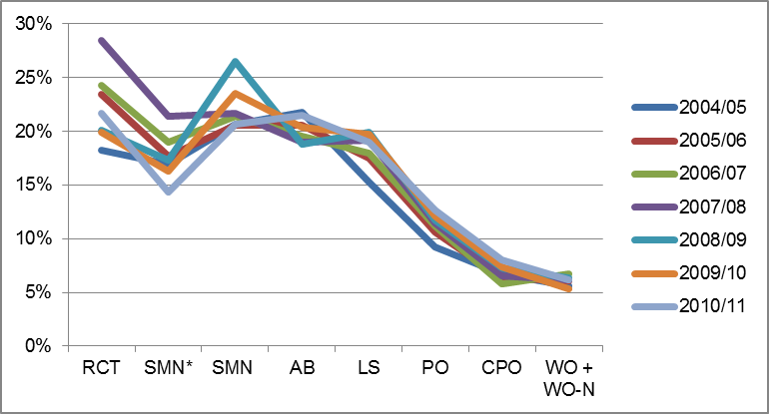
Figure 4.7 shows the representation of women as a proportion of each other rank in Navy over the previous seven financial years. The similar trends indicate that a critical point has existed around leading seaman over recent years, before which women’s representation is relatively steady, and after which it falls away.

Figure 4.8: Women and men as a proportion of each Navy other rank,
financial year 2010/11
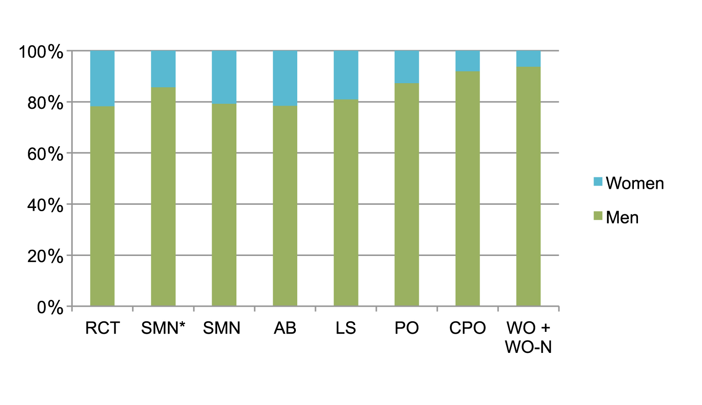
Figure 4.8 shows the breakdown of women and men in each rank at the end of financial year 2010/11. In 2010/11 women made up 17.9% of all Navy other ranks (1,940 out of a total of 10,818). This compares with 2004/05 when women made up 16.6% (1,659 out of a total of 10,014).

Figure 4.9: Navy women senior non-commissioned officers, 2004/05
and 2010/11
RANK | 2004/5  Number and proportion of total women (and men) / rank |  | 2010/11  Number and proportion of total women (and men) / rank
PO | 117 (men 1,160) | 9.2% | 162 (men 1,110) | 12.7%
CPO | 57 (men 789) | 6.7% | 74 (men 848) | 8.0%
WO + WO-N | 11 (men 185) | 5.6% | 11 (men 167) | 6.2%
Figure 4.9 shows the number and proportional representation of women senior non-commissioned officers in Navy in 2004/5 and 2010/11. It illustrates that women remain under-represented in the most senior ranks in comparison to their overall representation.

Overall representation
At 17.9%, the proportional representation of women in Navy’s other ranks is relatively strong, and more than twice the representation in Army’s other ranks.
At the end of 2011, 97.8% of all categories were open to women, with the remaining small number of categories associated with clearance diving.34 Removing the categories from which women were excluded in 2010/11 does not greatly alter the representation of women in Navy’s other ranks – the overall figure rising slightly to about 18.5%.35

Progression
Women progress through the junior other ranks at a similar proportional rate to their overall representation, but representation falls away starkly from the rank of leading seaman onwards.
Women are not reaching the most senior Navy other ranks in proportion to their overall representation. In 2010/11 women made up 8% of all chief petty officers and 6.2% of all warrant officers in Navy. These figures compare to women’s absolute representation of 17.9% of all other ranks. The issue again appears to be one of lack of progression rather than separations.
Women were slightly over-represented as a proportion of both the separations and movements/net promotions within Navy’s other ranks in financial year 2010/11. Women made up 171 of the 885 (or 19.3%) total separations from Navy’s other ranks, and 703 of the 3,584 net movements per rank (19.6%).36 When compared to overall representation per rank, women made up a slightly higher proportion of the separations from recruit (26.4%), leading seaman (24.1%) and warrant officer (14.3%); and also a higher proportion of promotions to petty officer (16.9%), chief petty officer (13.1%) and warrant officer (12.5%).37
The above figures are supportive of the trends seen in figures 4.7, 4.8 and 4.9. Women enter Navy’s other ranks at a comparatively high rate, but have high proportional rates of drop-outs between recruit and seaman*, and after the rank of leading seaman. These figures are also supportive of the slow trend of improvement in women’s representation at more senior ranks between 2004/05 and 2010/11.

Conclusion and issues
Navy is doing comparatively well with regards to attraction, and recruiting women into its other ranks workforce. The representation of women in all ranks up to leading seaman has hovered around 20% since 2004/05, with minor discrepancies from year to year. The issues in this part of Navy revolve around the promotion of women into senior ranks, especially beyond leading seaman. The Review believes that the difficulty of combining sea time with family responsibilities is a major issue contributing to this.
Female personnel in numerous focus groups, interviews and submissions have told the Review that they have experienced, or foresee experiencing, difficulties in balancing their careers in Navy (particularly in terms of sea service) with their families. The median age of women at leading seaman is 28, and women at this rank are about twice as likely to be married or have dependents compared to those at able seaman.38 This is also the rank at which women’s representation starts decreasing markedly, suggesting that the difficulties in balancing work and family at this particular stage of life and career play a part in this pipeline blockage for Navy’s female workforce.
It is notable that throughout Navy’s ranks women are much less likely than men to be married and/or have dependent children. This will be discussed further below.

Navy, officers

Figure 4.10: Proportional representation of women, Navy officer ranks, financial years 2004/05 to 2010/11
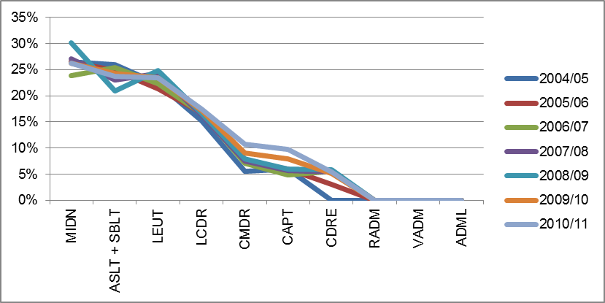
Figure 4.10 shows the representation of women as a proportion of each officer rank in Navy over the previous seven financial years. In a similarity to Navy’s other rank profile (Figure 4.7), representation for women is steady across the junior ranks, then falls away beyond lieutenant.

Figure 4.11: Women and men as a proportion of each Navy officer rank, financial year 2010/11
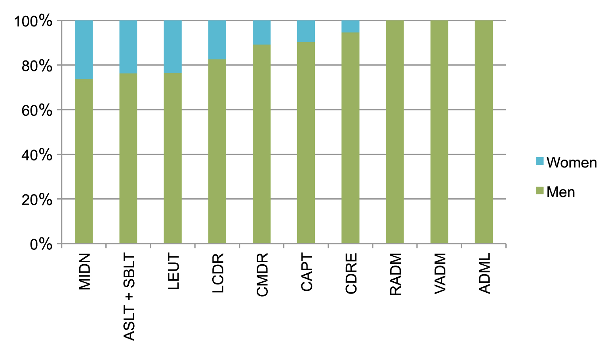
Figure 4.11 shows the breakdown of women and men in each rank at the end of financial year 2010/11. In financial year 2010/11 women made up 20.3% of all Navy officers (644 out of a total 3,172). This compares with 2004/05 when women made up 19.2% (543 out of 2,824).

Figure 4.12: Navy women senior officers, 2004/05 and 2010/11
RANK | 2004/5  Number and proportion of total women  (and men) / rank |  | 2010/11  Number and proportion of total women  (and men) / rank
LCDR | 106 (men 590) | 15.2% | 124 (men 587) | 17.4%
CMDR | 17 (men 286) | 5.6% | 38 (men 313) | 10.8%
CAPT | 5 (men 79) | 6.0% | 11 (men 102) | 9.7%
CDRE | 0 (men 27) | 0% | 2 (men 35) | 5.4%
Figure 4.12 shows the number and proportional representation of women at senior Navy officer ranks in 2004/5 and 2010/11.39 There have been improvements over this period, but representation remains low, and there are no women at the most senior ranks.40

Overall representation
Women make up 20.3% of Navy officer ranks. Navy does not have as much of a discrepancy between the proportional representation of women in its officer and other ranks (17.9%) as Army does (Army 14.5% officers, 8.7% other ranks). This is reflective of the fact that Navy, unlike Army, does not contain large categories from which women have been excluded, but it also speaks to the fact that Navy has been more effective in attracting and recruiting women in the past.41

Progression
As in Navy’s other ranks, the progression profile for Navy officer women is a mixed picture. Women are well represented across junior officer ranks, where representation is almost one-quarter of the workforce, but this falls away beyond lieutenant. In 2010/11 women made up 26.3% of all midshipmen, 23.7% of sub lieutenants and 23.4% of lieutenants but there were only two women among the 50 star ranked officers, and no female admirals.
In 2010/11 women were slightly over-represented as a proportion of the total separations and promotions. Women made up 37 of the 157 separations (or 23.6%) across all ranks, and 107 of the 432 movements/net promotions (24.8%).42 Recently women have made up a substantial proportion of separations from lieutenant in several years, contributing to the diminishing progression of women beyond this point.43 In 2010/11, women were proportionally well represented within promotions to commander (19.6%) and captain (16.7%), but did not feature in movements to or from the star ranks.44 The 23 separations at Commander and above were all men; and the seven promotions to commodore and above were all men.45
Figure 4.12 indicates a small increase in women’s representation at more senior officer ranks in Navy between 2004/05 and 2010/11, but there are still very few women overall in these senior positions.

Conclusion and issues
The issues present in Navy’s officer pipeline are very similar to those in its other ranks. The representation of women is strong at the most junior ranks, but falls away dramatically at a mid-career point that appears to correlate with increased work and family balance pressure.
The demographic profile of women at the rank of lieutenant (where officer representation begins to decline) is remarkably similar to that at leading seaman (where other rank representation begins to decline). The median age of women lieutenants is 29, and the marriage and dependents rates at this rank are more than double those at sub-lieutenant.46 Again, this appears to be the point in many members’ life cycle where they are starting families and have difficulty combining their competing responsibilities.
Figure 4.13 indicates that across Navy’s senior officer ranks, men are much more likely to be married and/or have children than women.47 These figures reflect the fact that women continue to be the primary care-givers in Australian society. If Navy is to achieve the goal of promoting women into its senior leadership, it will need to address the fact that work and family appears to be a major structural barrier for many women in its workforce.

Figure 4.13: Proportion of Navy personnel married, with dependents, 2011
(by gender)48
Rank | Women married percent | Men married percent | Women dependents percent | Men dependents percent
LEUT | 28.1% | 49.9% | 22.9% | 39.2%
LCDR | 53.8% | 80.6% | 49.5% | 69.5%
CMDR | 56.7% | 84.2% | 56.7% | 73.6%
CAPT or higher rank | Insufficient respondents | 84.8% | Insufficient respondents | 81.9%
This is not just an issue for Navy. Work and family balance issues are also felt by personnel in the other Services, and Figures 4.14 and 4.15 indicate that women in Army and Air Force are also less likely to be married and/or have dependent children than their male colleagues.49

Figure 4.14: Proportion of Army personnel married, with dependents,
2011 (by gender)50
RANK | Women married percent | Men married percent | Women dependents percent | Men dependents percent
CAPT | 27.5% | 59.7% | 26.8% | 45.7%
MAJ | 56.6% | 75.8% | 47.3% | 65.3%
LTCOL | 62.0% | 85.8% | 62.0% | 81.4%
COL or higher rank | Insufficient respondents | 86.1% | Insufficient respondents | 82.1%

Figure 4.15: Proportion of Air Force personnel married, with dependents,
2011 (by gender)51
RANK | Women married percent | Men married percent | Women dependents percent | Men dependents percent
FLTLT | 39.2% | 58.2% | 30.4% | 46.0%
SQNLDR | 65.6% | 81.4% | 60.0% | 74.2%
WGCDR | 65.2% | 87.1% | 67.4% | 74.3%
GPCAPT or higher rank | Insufficient respondents | 90.3% | Insufficient respondents | 70.3%

Air Force, other ranks

Figure 4.16: Proportional representation of women, Air Force other ranks, financial years 2004/05 to 2010/11
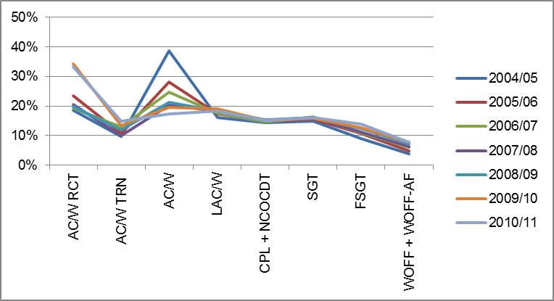
Figure 4.16 shows the representation of women as a proportion of each other rank in Air Force over the previous seven financial years. As is the case with the other Services’ other ranks, women are represented throughout the higher ranks, although representation falls away at the highest ranks.

Figure 4.17: Women and men as a proportion of each Air Force other rank, financial year 2010/11
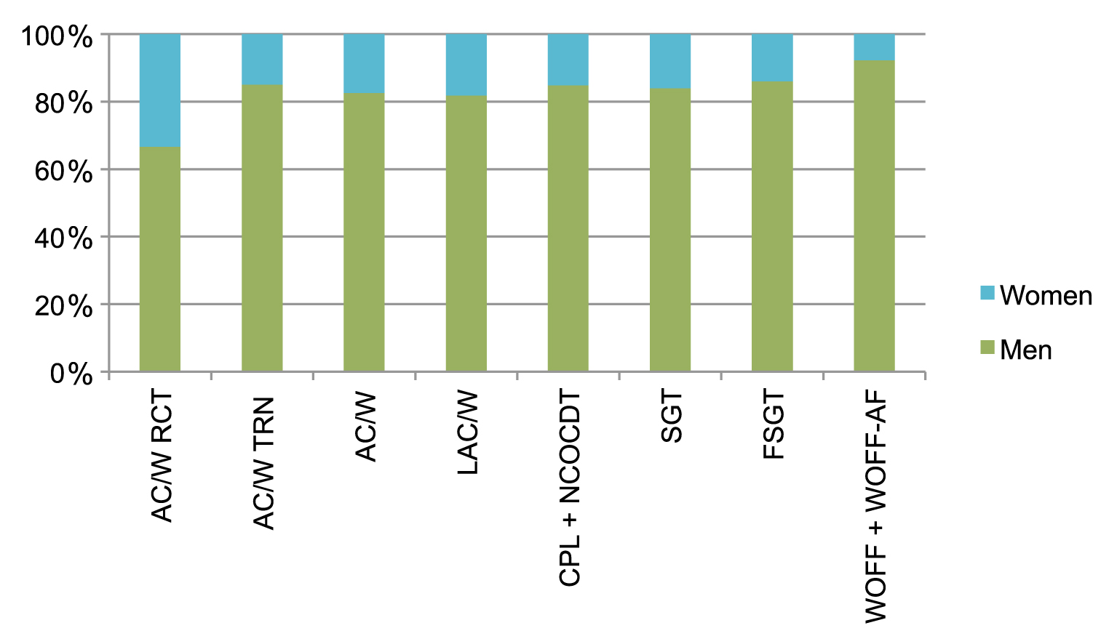
Figure 4.17 shows the breakdown of women and men in each rank at the end of financial year 2010/11. In financial year 2010/11 women made up 16% of all Air Force other ranks (1,605 out of a total of 10,019). This compares with 2004/05 when women made up 14.8% (1,363 out of a total of 9,191).

Figure 4.18: Air Force women senior non-commissioned officers, 2004/05
and 2010/11
RANK | 2004/5  Number and proportion of total women (and men) / rank |  | 2010/11  Number and proportion of total women (and men) / rank
SGT | 236 (men 1,349) | 14.9% | 283 (men 1,482) | 15.9%
FSGT | 59 (men 596) | 9.0% | 102 (men 624) | 12.7%
WOFF + WOFF-AF | 20 (men 492) | 3.9% | 44 (men 527) | 7.7%
Figure 4.18 shows the number and proportional representation of women at senior Air Force other ranks in 2004/5 and 2010/11. It shows some improvements over the period.

Overall representation
The representation of women in Air Force’s other ranks, at 16%, is almost as high as in Navy’s other ranks (17.9%) and well above Army (8.7%).
At the end of 2011, 97.8% of all categories in Air Force were open to women, with the remaining categories being Airfield Defence Guard (other ranks) and Ground Defence Officer (officer).52 Removing Airfield Defence Guard from 2010/11 workforce figures raises the representation of women slightly to about 16.7%.53

Progression
The profile of women’s representation in Air Force bears similarities to elements of both Army and Navy. Overall representation is relatively strong (similar to Navy), as is progression through the ranks (similar to Army).
Women’s representation at the most senior non-commissioned officer ranks (flight sergeant and warrant officer) has increased in number and proportion over the period examined. In 2010/11, women made up 12.7% of all flight sergeants and 7.7% of all warrant officers in Air Force, compared with 9% and 3.9% in 2004/05. This is the most substantial proportional increase in any of the Services during this period.
Women were slightly over-represented as a proportion of separations and movements/net promotions within Air Force’s other ranks in financial year 2010/11. Women made up 121 of the 669 (or 18.1%) total separations, and 430 of the 2,252 net movements per rank (19.6%).54 Women comprised slightly higher proportions of the separations from leading aircraftman/woman (23.8%) and corporal (19.4%), and of the promotions to corporal (23%) and sergeant (21%). At higher ranks, women only made up 20.3% of promotions to flight sergeant, and 6.5% of promotions to warrant officer in 2010/11.55
Air Force’s career and diversity officers do not see any overt discrimination in the promotions processes, and view the initiatives being pursued in their Service over the recent past very positively. They have told the Review that ‘if there are positions there, women get there.’56 This flows to the issue of occupational segregation.
A disproportionately large number of warrant officers are drawn from the airman/aircrew and technical musterings in which women are not well represented.57 This anomaly appears to explain why women are proportionately represented throughout most of the other ranks, with a drop-away at warrant officer.

Conclusion and issues
Air Force other ranks is doing comparatively well with both attracting women into its pipeline, and facilitating progress through it. Further, there have been small improvements in the number and proportion of women among the other ranks over the period examined. As in all Services, the absolute number and proportion of women entering Air Force remains low, and the most senior ranks are more populated by male dominated workforce categories.

Air Force, officers

Figure 4.19: Proportional representation of women, Air Force officer ranks, financial years 2004/05 to 2010/11
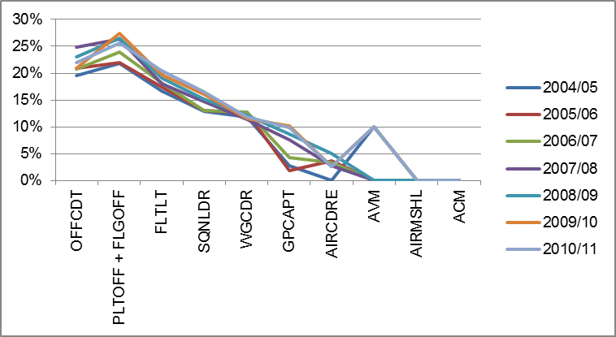
Figure 4.19 shows the representation of women as a proportion of each officer rank in Air Force over the previous seven financial years. The overall picture is one of steady decline throughout the ranks, with some fluctuations at the more senior levels. However, there have been small increases in representation across most ranks between 2004/05 and 2010/11.58

Figure 4.20: Women and men as a proportion of each Air Force officer rank, financial year 2010/11
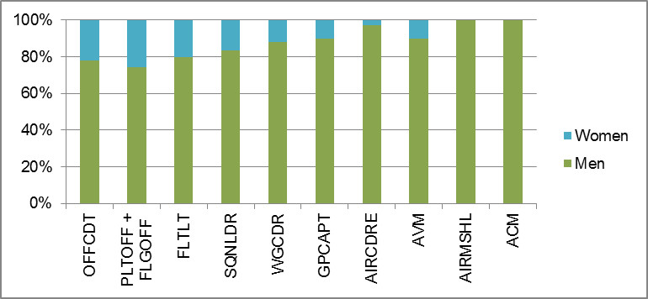

Figure 4.20 shows the breakdown of women and men in each rank at the end of financial year 2010/11. In financial year 2010/11 women made up 19.3% of all Air Force officers (894 out of a total 4,623). This compares with 2004/05 when women made up 16.2% (656 out of 4,044).

Figure 4.21: Air Force women senior officers, 2004/05 and 2010/11
Rank | 2004/5  Number and proportion of total women (and men) / rank |  | 2010/11  Number and proportion of total women (and men) / rank
SQNLDR | 110 (men 740) | 12.9% | 178 (men 896) | 16.6%
WGCDR | 45 (men 334) | 11.9% | 53 (men 397) | 11.8%
GPCAPT | 3 (men 105) | 2.8% | 12 (men 109) | 9.9%
AIRCDRE | 0 (men 27) | 0.0% | 1 (men 38) | 2.6%
AVM | 1 (men 9) | 10.0% | 1 (men 9) | 10.0%
Figure 4.21 is a comparison of the numbers and proportion of women in senior officer ranks in Air Force in 2004/05 and 2010/11. Air Force had a female two star officer in 2004/05 and in 2010/11, but representation in the star ranks has been low throughout this period.

Overall representation
Women make up 19.3% of Air Force officer ranks, a figure slightly higher than its other ranks (16%), and comparable to the figure for Navy officers (20.3%). At the end of 2011, there were only 63 Ground Defence Officers – the only category which was not open to women in Air Force – and removing these from the equation raises the participation rate of women among Air Force Officers only slightly (to 19.6%).59

Progression
The progression profile for women among Air Force officers shows a steady attrition in the representation of women as rank increases. In 2010/11 women made up 25.6% of pilot officers and flying officers, 20.4% of flight lieutenants, and 16.6% of squadron leaders. There is no particular point at which this decline deviates greatly but rather there is a steady decline prior to the star rank level, following which movement over time appears exaggerated due to the small numbers of personnel involved (figure 4.19).
In 2010/11 women in Air Force were slightly under-represented as a proportion of the total separations and slightly over-represented as a proportion of total movements/net promotions. Women made up 43 of the 243 separations (or 17.7%), and 170 of the 776 movements/net promotions (21.9%).60 In 2010/11, there were eight promotions to, and five separations from, Air Force’s star ranks. All of these were men.61 Aside from the near absence of women at star ranks in these movements, there are no particular patterns of note over the recent past.62
The numbers and proportion of women at Air Force’s most senior ranks has increased over time. Still, very few women are progressing beyond group captain, with leaders customarily drawn from categories which have historically been male dominated, such as aircrew and engineering.

Conclusion and issues
There has been a rise in the absolute number and proportion of women across most Air Force officer ranks between 2004/05 and 2010/11. However, there remains a general decline in women’s representation as rank increases. Occupational segregation, custom, and the current design of the Air Force workforce are the major reasons for this. At the end of 2010/11, there were only two women among the 51 star ranked RAAF officers.
Subsequent sections of this Chapter and Chapter 5 will examine the various ways in which issues relating to recruitment, retention, career progression, occupational segregation and leadership pathways all have an impact on the figures analysed above – and, if unaddressed, on the future representation of women in the ADF pipeline.

Recruitment
In summary
The ADF relies heavily on ab initio (entry level) recruitment. Fifty percent of ab initio recruited personnel leave the ADF after only a few years of service. The proportion of women ab initio enlistees has not changed significantly in the past decade.
Women are exiting at higher rates than men through the recruiting pipeline.
Workforce pressures and the ADF’s shrinking talent pool mean that current initiatives, such as the Recruitment of Women Strategy, are not sufficient. The ADF needs to draw on a broader cross section of the population or risk not meeting its future workforce needs.
The ADF should explore other innovative strategies in order to appeal to women at different ages and stages of their careers, and minimise the loss of women through the recruiting pipeline.
The cost of recruiting new personnel has dramatically increased over the past decade but the ADF has continued to fall short of its recruiting targets.
Increasing the number of women recruited to the ADF, particularly into non-traditional occupational areas, will require targeted intervention.
The Defence White Paper 2009: Force 2030 (‘2009 White Paper’) states that ‘people are at the heart of delivering the Defence capability’.63 In the last decade, however, the ADF has struggled to meet recruiting targets, particularly those in critical categories. Over the same period, recruitment costs have tripled. With ADF personnel leaving far earlier in their service than previous generations, pressure is increasing on a recruiting system that is already not achieving its targets.
It is clear that the ADF must draw on a broader talent pool in order to ensure its sustainability and operational effectiveness. Comprising almost half the wider workforce, women are a critical part of this broader talent pool. As this section will outline, however, the ADF’s efforts to date to increase the representation of women have stalled. Although some innovative strategies have successfully attracted more women to enlist, others continue to be lost through the recruiting pipeline. The ADF manages its workforce supply through a focus on attraction and recruitment of personnel on the one hand, and on retention of personnel on the other.

Recruiting policies and pressure points
The Defence workforce is made up of a mix of military (ie ADF members), civilian
(ie Defence APS) and contractor personnel. ADF members are employed within the Services but are also employed within non-Service groups, which assist in delivering operational capability.
The 2009 White Paper sets ADF workforce numbers.64 To support the increase in military equipment and systems envisaged in the White Paper, it estimated that the workforce would need to grow to 57,800 full time military members over the next decade.65
At initial glance, this is more than achievable as, at 30 June 2011, Defence had 58,139 permanent ADF members, and is currently over strength.66 This is largely because separation rates have been low in recent years, while there has also been increased recruitment from within the Services, transfers from the Reserve and prior service re-enlistment.
As the economy improves, however, separations are increasing again. At the same time, Australia’s demographics are changing and social and labour market pressures are intensifying. The 2009 White Paper identifies attracting and retaining the future workforce as one of the most significant challenges facing Defence, highlighting two key areas of focus:
- addressing trade shortfalls, which requires new ways to recruit and retain technical trades as well as key professional groups such as tradespeople and health professionals
ensuring that Defence reflects the composition of the broader Australian community. In particular, the attraction of women and Australians from Indigenous and more diverse ethnic backgrounds to the ADF are articulated as a priority.67

The Recruitment Process
In 2005, Defence established a dedicated Defence Force Recruiting (DFR) Branch to develop a long term recruiting strategy and manage the recruitment function for the ADF.68 Under this tri-service system, significant components of ADF recruiting activities are also outsourced to an external service provider.69
Defence Force Recruiting (‘DFR’) provides marketing and recruiting services to the ADF through a ‘public sector/private sector collaboration between Defence and Manpower Services (Australia) Pty Ltd’ (‘Manpower’).70 DFR’s stated mission is to ‘recruit the right people to sustain and enhance Defence capability’. This arrangement replaces the previous system where each Service was responsible for its own recruitment.
DFR is staffed by Service personnel, APS personnel and Manpower staff with 16 Defence Force Recruiting Centres around Australia.71 In the mid-1990s, approximately 1500 ADF and Defence APS personnel were involved in recruiting operations within the single Services.72 DFR now provides the ADF’s recruiting capability with around half that figure.
Recently, the ADF signed a five-year contract with Manpower covering ‘marketing, recruitment operations, medical and psychological assessments and the co-ordination of selection boards and employment offers’. Defence has stated that future renewal of the contract ‘fundamentally requires that the company delivers the numbers.’73
The ADF has key responsibilities for recruitment planning and activities through DFR, such as setting recruiting targets, entry standards and recruiting policy.74 ADF personnel undertake the key interviews during the recruitment process and are responsible for the final selection of candidates for enlistment.75
Manpower is responsible for providing recruiting services, including recruitment processing and managing candidates through the recruiting pipeline. As part of this model, Manpower operates the ‘Candidate Relationship Management Centre’ (‘CRMC’), a centralised call centre to provide for closer case management of candidates.
An overview of the key stages of the recruiting process is set out in Appendix G.5.

The recruiting supply
As explained at the beginning of this Chapter, the main source of new personnel for the ADF is through ab initio recruitment. In 2010-11, ab initio entrants (both men and women) made up approximately 87% of all categories of entry into the ADF.76
Some of the perceived benefits of ab initio recruitment include:
- more stability and control over workforce (because of defined minimum periods of service and return of service obligations, training timeframes and continuums)
- more predictability in terms of career progression and separations
less outside competition for labour as the ADF is able to recruit and train its own skilled labour force.77
This confidence in ab initio recruitment hides the concerning reality that, across the three Services, 50% of recruits are lost after only a few years of service (5-6 years in Navy, 4-5 years in Army and 7-10 years in Air Force, with women at the lower end of these timeframes in all three Services). This means that the ADF is under constant pressure to bring through new recruits.
A small percentage of personnel supply is made up of ‘lateral transfers’. In the ADF context, this refers to transfers from the Reserve to the permanent forces, inter- or intra-Service transfers, or transfers from overseas forces. As will be discussed later, lateral transfer from non-military workforces has not been a focus for ADF recruitment.78 Appendix G.1 shows the sources of recruitment supply for the 2010-11 financial year.79 Apart from the 87% of new personnel who were ab initio entrants:
- transfers from the Reserve made up 5.8% of entries
- transfers from Gap Year made up 2.2% of entries
- re-enlistees made up 2.7% of entries
- service transfers made up 1.6% of entries
overseas transfers made up 0.7% of entries.
As noted in Chapter 1, increasing competition for young talent and simultaneous reduction in the ADF’s primary target market means that the almost exclusive reliance on ab initio recruitment to deliver the ADF’s capability is unsustainable.

Failure to meet recruiting targets
Recruiting targets are developed by the ADF to meet its future capability requirements. The ADF has fallen below its recruiting targets for over a decade.80
As noted above, separation rates have been low in recent years, particularly for Air Force, driven largely by conditions created by the global financial crisis and a series of successful large-scale initiatives and bonuses directed towards retention of personnel. There has also been an increase in lateral recruitments and
re-enlistments.81
This overachievement in Average Funded Strength (‘AFS’) has meant that the ADF’s failure to meet recruiting targets has not been an immediate concern. In fact, this overachievement has created funding pressures for Defence.82 To help reduce the impact of this overachievement, ab initio recruiting targets have been lowered yearly, yet even these targets are not being met.83 This creates the risk that, if recruiting were to slow further, it would create future capability gaps for the ADF.
The Review was provided with a draft of the most recent ADF Recruiting Strategic Plan 2011-21 (‘RSP’), which states that ‘in the short term, Defence is well placed to recruit the number of personnel it needs to meet the workforce requirements of the 2009 Defence White Paper’.84 According to the RSP, Defence has competed for new labour ‘with increasing success’ since 2009, based on a number of factors:85
- the GFC came at a time when availability of labour with at least Year 12 qualification level (required for most jobs in the ADF) was high
- an increased recognition of post-secondary qualifications available through ADF employment
- improved recruitment into ‘critical categories’ and skill set areas through a range of initiatives, including targeted recruiting and accelerated processing of candidates and improving the ‘training pipeline’ to ensure that people are not lost through the long training continuums for these skill sets86
there has been greater scope for recruiters to redirect candidates toward hard to fill targets, because available targets for popular jobs have been filled.
The result has been improved ab initio recruitment across most job categories in 2009-10 to 92% of its target, which the ADF reports it has successfully sustained through to June 2011.87
Although this recruiting success is expected to continue in the short term, the RSP warns that it is unlikely to last. There were half the candidates in the recruiting pipeline in December 2010 than in June 2009.88 If there was a sudden need to increase recruiting targets, the RSP warns there would be insufficient candidates in the recruiting pipeline to meet such targets, due to the lower current enquiry rate and the lower rates of conversion from enquiry to actual enlistment.89
As the ADF’s strength returns to actual AFS guidance, a number of factors are expected to place increased pressure on recruiting performance:90
- separation rates of already qualified personnel are increasing, with demand for skilled workers in the labour market being matched with attractive remuneration conditions91
- winding up of the retention incentives are expected to cause a further rise in separations
demographic projections indicate that, although the Australian population will continue to grow, the size of the ADF’s traditional recruiting pool will shrink as a proportion of the rest of the population.92
This combination of factors will lead to workforce pressures which could impact on ADF capability.
A 2011 Defence Workforce Outlook report identified that ‘attracting enough candidates with the necessary skills and abilities’ will be a ‘significant challenge’ for the ADF:
Given the Australian demographic, educational and health profile over the next ten years, Defence will need to ensure its employment offer remains attractive if it is to retain its share of the applicant pool. The greatest recruitment risk is perhaps in the ten year period, when the demand for higher level skills and qualification is forecast to outstrip supply to unprecedented levels.93

The rising cost of attracting and recruiting personnel
The 2009 White Paper estimates that, on average, within the Defence workforce, full-time military personnel cost around 30% more than civilian personnel.94 The costs of recruiting personnel are also significant.
The Review was provided with the costs of recruitment in the form of total DFR Branch expenditure over the past decade, including:
- Defence (ADF and APS) staff costs
- costs of the recruiting services contract
- marketing and advertising costs
administrative and operating costs.95
In the last decade, the cost of recruiting each new member has tripled from approximately $7,000 to over $21,000 per enlistment.96 From 2001-02 to 2010-11, DFR’s spending had more than doubled from around $61 million to $142 million. The estimated expenditure for 2011-12 was provided as around $151 million.97 A further breakdown of DFR expenditure is provided in Appendix G.2.
To attract potential recruits, Defence relies heavily on mass media advertising to generate job enquiries, and this has a large budget allocation.98 There are also significant costs within the recruiting pipeline, particularly due to long processing times. As well as cost implications, these delays create problems for managing numbers through the pipeline and make it more likely that candidates will be lost to competitors.99
Despite this increased expenditure, enquiries have been decreasing.100 The Review was told that the recent drop in enquiries and applications was intended to ‘reflect lowered Service recruiting targets’ rather than reflecting a decline in interest in joining the ADF. DFR advised that the amount of money spent on advertising is calculated to ‘generate just enough enquiries to ensure a reliable supply of suitable recruiting candidates for available ADF jobs’.101
Although the ADF relies on the relatively stable proportion of those with a propensity to enlist within its core target market, competing for talent in an increasingly challenging recruiting environment is costing the ADF more overall to generate enquiries. The RSP notes:
Financial pressures by 2012-13 are unlikely to permit the advertising expenditures that precipitated the surge in enquiries from 2007-2010. With a gradually tightening labour market, fewer recruiting prospects will be available in any case.102

Narrowing recruitment pool
As noted above, the ADF relies on the fact that the proportion of its traditional target group who are predisposed to consider a career in the ADF has remained relatively steady over time, at around 25-29% over the past few years.103 Defence observes that:
This stability is likely to be at least partly attributable to the factors which motivate Australians to join the ADF, which are inherently enduring in nature.104
However, the recruiting process filters the recruitment pool further through health, fitness, aptitude and psychological requirements,105 while changing technology is also impacting on the type of recruit the ADF needs to attract. The need for low skill, manual labour has decreased, with ADF members increasingly required to work autonomously and needing skills in problem-solving and servicing stakeholders.106
This means that although improvements have been made in some ‘critical category’ areas, recruiting remains problematic in others:
Personnel with engineering, technical, intelligence and communication skills will be more difficult to attract and retain. The unique issues relating to securing sufficient personnel in the health domains will continue. If national skill shortages broaden… the wider elements of the ADF, such as management and logistics functions will also come under pressure at the 20 year mark.107
Meanwhile, the Australian labour market is continuing to change, based on factors such as a low national birth rate, ageing population, more women in the workforce and increasing ethnic diversity. As noted in Chapter 1, the RSP acknowledges that the ADF has been slow to reflect and capitalise on these demographic changes occurring in the Australian community.
At the same time, the primary ADF recruitment pool is predicted to decline as a proportion of the total population, along with a shortfall in the ability of Australia to meet the required student and labour market demand over 2015-2020.108 The 2009 People in Defence blueprint paper warns that reliance on the ADF’s traditional recruitment pool will not attract a sufficient share of the labour market if workforce numbers need to be increased. It concludes that ‘Defence must find new ways to attract talent from a broader portion of the community’.109 Clearly, this must include women.

Enlistment rates of women
In 2010-11, women represented 15.6% across all categories of enlistment into the ADF. Women made up 14.4% of general entry enlistees (other ranks) and 20.6% of officer entry enlistees.110 Though it is important to note that the proportion of women varies within each Service and job category, overall women are under-represented across enlistments in all three Services. For example, in 2010-11, women represented:
- 20.5% of all Navy enlistments
- 11.7% of all Army enlistments
18.5% of all Air Force enlistments.111
In terms of categories of enlistment, women represented 15.2% of ab initio entrants in 2010-11. When comparing the representation of women in other categories of entry for that financial year, women made up:
- 21.6% of transfers from the Reserve
- 33% of Gap Year transfers
- 9.9% of re-enlistees
- 7.8% service transfers
0% of overseas transfers.112
These figures show that, proportionately, there are certain avenues of entry which are more successful in attracting women to enlist than ab initio entry. For example, although the Gap Year program (discussed later in this section) only comprised 2.2% of all new entrants (men and women) for this period, a third of these Gap Year transfers were women, a significantly higher proportion than through any other form of entry. Women also made up a greater proportion of those transferring from the Reserve than ab initio entrants.113
Women had higher representation in officer ranks than other ranks across most entry categories (for example in 2010-11, women made up 21.5% of officer ab initio entrants but only 13.9% of other rank ab initio entrants). Of those transferring from the Gap Year program, however, there was a higher proportion of women in other ranks, indicating that the Program has been proportionately more successful in attracting women as general entry enlistees than other forms of entry. The proportion of women transferring from the Reserve was roughly the same for officer and other ranks.114
Despite efforts by the ADF to focus more attention on the recruitment of women in recent years, the proportion of women of all ab initio enlistees, which by far makes up the largest avenue of entry into the ADF, has not changed significantly since 2002-03.115

Barriers to attracting women to the ADF
The March 2012 Quarterly Defence Workforce Outlook report observes that addressing the ADF’s future recruiting vulnerability requires a focus on ‘broadening the recruiting base into areas where the labour force pool is either growing or stable’.116 However, significant barriers exist to broadening this pool and in particular, to attracting more women.
These include the historical under-representation of certain demographic groups in the ADF which, in part, is the result of policies such as the exclusion of women from employment categories, citizenship and English language proficiency requirements, and physical fitness requirements.
The strongest predictor of whether or not a person will join the ADF has traditionally been exposure to a family member or friend who has served, or is currently serving in the ADF.117 The historically low representation of particular demographic groups has flow on effects for future recruiting from those groups. It means that there will be fewer family members or others with service experience from these groups who can influence a person’s decision to seek an ADF career.
The lack of diversity also further perpetuates the perception that the ADF has a masculine culture, geared towards recruiting men, potentially steering women away from the recruitment pipeline.
Media reporting of incidents of sexual harassment, assault and victimisation, meanwhile, may compound this. One focus group participant observed in relation to the ADFA Skype incident:
It’s done huge damage to I would say female recruitment… It was going on whilst I was going through recruiting but people were like ‘do [we] really want to recruit during this whole Skype blow up?’118
As discussed in Chapter 3, another barrier is the belief that women are not suited for combat or are not naturally attracted to a military career, and that they make educational choices away from core Defence professions. The small proportion of women in the ADF is seen as the natural consequence of societal values about the role and nature of women and women’s work, and their choices around work and family.
The nature of the ADF’s war-fighting mission and emphasis on its ‘warrior culture’ perpetuates this belief, as has, until recently, the policy restriction on the employment of women in direct combat roles. The removal of this restriction means this formal policy barrier is gone, but the practical impact on women’s participation is less clear. Although it may have more significance for Army, the policy change will likely have limited impact on the percentage of women serving in the Navy and RAAF as there are very few categories remaining from which women have been restricted in these Services.119
Defence representatives told a parliamentary inquiry hearing in March 2012 that opening up the remaining 7% of trades to women was not expected to cause a significant increase in women wanting to join the ADF. However, the need to move beyond reliance on the traditional recruiting pool was stated to be an important consideration in the decision:
The experience of many of our allies is that there will only probably be about a three or four per cent participation rate in those combat trades, so that is the reality. But we are doing this because, to sustain the workforce into the future, we want to access our fair share of the talent in the Australian labour market, which is increasingly female.120

Experiences of the recruiting process
Finally, research on behalf of DFR has found that lower conversion rates of enquiries to enlistments for women stem from a number of issues with the recruiting process. The process of applying has itself provided a barrier to many women considering enlisting,121 some key factors identified being:
- call centre staff having limited knowledge, candidates not being able to speak to the same person, or being transferred
- a lack of responsiveness by recruiting staff, inconsistent answers to queries or failure to keep candidates updated on progress
- inflexibility and a lack of understanding in relation to needs of candidates (for example, calling or scheduling appointments at inconvenient or inappropriate times, not understanding candidates’ school or work commitments)

- frustration with delays, complexity and costs of the recruiting process
changing financial, personal or career opportunities arising from delays.
As part of its Recruitment of Women Strategy, the ADF has put in place some initiatives to address these barriers to recruitment of women, such as having current serving women visit schools and community events to share their experiences, a targeted Women in the ADF website profiling current serving ADF women and containing specific information and resources for women, and an online mentoring program to enable female candidates to communicate with serving female ADF members.122 The Review supports these initiatives.
In the course of its consultations, however, ADF members told the Review that, along with the barriers of occupational segregation, gender restrictions and beliefs about the proper role of men and women, many of these problems with the recruiting process still exist. There was a widespread perception that the recruiting process was effectively being run by ‘civilians’. This was seen to impact on the quality of candidates, as people were being recruited to fill ‘quotas’, despite the fact, for example, that they may not be able to meet requirements for training.123
Similarly, some members reported being provided with inadequate, or simply incorrect, information by recruiting staff about particular roles. Others felt they had been ‘pushed’ into jobs that were not their preference or misled about the ease with which they might transfer to another category. Other complaints concerned a lack of access to staff with knowledge about a candidate’s preferred Service or specialisation.124
Many of these more general complaints about the recruitment process and staff reflect the difficulties with an inflexible, ‘one size fits all’ recruiting system. For women, in particular, an inability to tailor the recruiting process to provide them with appropriate support can be a reason for women dropping out of the recruiting pipeline. For example, the DFR’s own research conducted in 2010 found that women felt discouraged from joining by reinforced perceptions of the ADF as a male dominated organisation, because in the early stages of the recruiting process they had largely dealt with ‘older male recruiters’ in some recruiting centres.125 In some focus groups, female participants said they had been told by DFR to apply for certain jobs because these were seen as being more appropriate for women:
They were saying ‘do a clerk position, be at a desk’… when I went through DFR again last year … I was questioning about the other things that I wanted [such as] plant operator and life support fitter, I was asking them what are these jobs? [They said] ‘I don’t know’.126
A couple of girls wanted to be techos or engineers and they got pushed into a clerk position as well.127
Recruiters play an important role in influencing which occupational branches a person may consider, meaning that the process for their selection and training is important. A recent evaluation of recruiting techniques in the Canadian Forces, for example, showed that recruiters were one of the most influential factors in the decision of potential personnel to join an organisation.128
The Review was told that ADF personnel considered for posting to DFR are required to undergo selection interviews to establish their suitability, and all military, civilian and contractor personnel posted to a DFR Centre receive training relevant to their roles.129
The role of the Defence Interviewer is to assess the candidate’s compatibility with the military and understanding of their designated role, or ‘organisational fit within the ADF’. However, research has found that, where organisations only seek the ‘right type of person’ to fit into an existing organisational culture, this can perpetuate a lack of diversity and make it even more difficult to create cultural change. In the case of the ADF:
They will also need to recognise that in applying selection standards that homogenise the workforce they may cause a large proportion of the population to disengage from the military, because the institution looks and feels too different from the wider social context.130
Although some recruits told the Review they had dealt with female recruiting staff, including female Defence Interviewers, there needs to be increased use of women as role models and as a ‘visible’ part of the recruiting process, including staff dedicated to marketing, mentoring and support for women. In the Netherlands, for example, qualified women have specifically been appointed as recruiting officers, visiting secondary schools to raise the profile of a defence career amongst potential future personnel.131 Focus group participants agreed that more visibility of women throughout the recruiting process would be beneficial:
I think that would influence a lot more women to join…You see someone in that position and …you want to mirror that…If you saw a woman out there who’s pretty powerful you know it’s like yeah, I want to be like that.132
The Review was told that the induction training modules for Defence Interviewers deal ‘specifically with the objective and appropriate treatment of recruiting candidates’. Additionally, Defence Interviewers undertake annual Equity and Diversity training. Given the pivotal role of recruiting staff, consideration should be given to specific inclusion of gender awareness and unconscious bias training to DFR staff, including ADF, civilian and contractor personnel.

Problems with delays in the recruiting process
There are several points in the recruiting pipeline where there are delays or bottlenecks. Delays in the recruitment process have the potential to reduce an applicant’s motivation to continue, risking the loss of candidates and also consuming more resources in management of the process.133
Conversion rates between the point where a person makes an enquiry to the point of enlistment show that candidates are dropping out of the recruiting pipeline, and women are dropping out at higher rates than men:
- In 2009, the conversion ratio from enquiry to enlistment for women was
20:1 compared to 11:1 for men.134
In 2011, the conversion ratio from enquiry to enlistment was approximately 12:1 for women compared to 7:1 for men.135
Surveys conducted of enlistees between September 2004-August 2005 showed that a significant majority were ‘very happy with the service’ at recruiting centres.136 However, 30% of respondents considered the delay within the recruiting process as ‘unreasonable’. The median length of time during this period was approximately
10 months for general enlistees and 13 months for officers. Focus group participants also commented on the lengthy delays for recruiting, with many candidates not kept informed about the progress of their application. Candidates may also be lost because of delays related to training intakes, when there is a mismatch between recruitment targets and available candidates.
Following the implementation of the New DFR model, discussed below, a national audit report on the DFR recruiting contract found that in 2009-10 the average time between enquiry and enlistment of a general entry candidate was more than 60% higher than it had been in 2006.137

Loss of women through the recruiting pipeline
As the conversion rates demonstrate, women are being lost at higher rates than men through the recruiting pipeline. This loss is concerning given the smaller numbers of women making enquiries in the first place, though identifying points where the attrition of women occurs in the recruiting pipeline is not straightforward with the data available. In part, the Review was advised that this is because recruiting data is collected through multiple different systems.138
For example, the Review requested data on pre-enlistment fitness assessment (PFA) performance by gender. DFR advised that their online system ‘Powerforce’ currently has no ‘capacity to provide detailed reporting in relation to candidate performance during the [PFA]’.139
If candidates continually fail their PFA they are withdrawn from the recruiting process. Because employment category targets are often linked to enlistment/appointment dates, delays due to repeated failures of the PFA can also mean that a candidate’s employment opportunity may pass without them being allocated to that target.
Physical fitness is an issue that also appears to contribute to attrition of women following their enlistment.140 For example, although fitness test failure rates during recruit training and the progress of recruits are tracked and monitored closely by Army at Kapooka, the Review was advised that, generally, fitness test failures at training are:
managed at a local level and no central database is kept…information regarding key drivers for failures is not available (other than 'people aren't fit enough'). Members are excused from conducting a [fitness test] if they are not medically fit to do so.141
There also appears to be some attrition of women occurring in the early stages of the recruiting pipeline. The Review heard that this was partly because candidates often visited recruiting centres with limited understanding of available ADF jobs and jobs for which they may be suitable. Following their initial session speaking to a careers counsellor and taking an aptitude test (known as the ‘YOU session’ – see Appendix G.5), candidates often had more information resulting in a job preference change or withdrawal from the recruiting pipeline altogether.142
The Defence Portfolio Budget Statements 2011-12 included ‘streamlining recruitment processes and improving recruitment outcomes’ as one of its priorities.143 The RSP provides that ideally the recruitment process needs to be practical, tailored to individual circumstances, and provide incentives for candidates to choose hard to fill employment categories.144
Improving recruitment processes to ensure that women are not lost at higher rates through the recruiting pipeline requires a more individualised process which better accommodates diverse needs. This might include establishing processes to accelerate, prioritise and support women through the recruiting pipeline, providing assistance with fitness, reviewing entry standards to remove/reduce unnecessary barriers to women’s enlistment and creating more flexibility in the enlistment/appointment timeframes. The ADF has adopted some specific initiatives which are considered below.

Current ADF initiatives to improve recruitment

Retention and Recruitment (R2) Program
As indicated above, the ADF has recently undertaken a major retention and recruitment program called R2 – a program aimed at improving recruitment and retention. R2 was approved in 2006, with the aim of expanding the ADF from around 51,000 full-time personnel (in 2005-06) to 57,000 by 2016-17. This target was revised to 59,000 in light of the 2009 White Paper and Strategic Reform Program.145
To meet this target, the R2 program contained 12 initiatives aimed at both increasing enlistment and reducing the separation rate.146 Over $3 billion has been allocated to these reforms.147 A large part of this has been directed to targeted retention bonuses. These are discussed further in section 4.3.
In 2010, there was an overall net increase in ADF enlistments compared with the five years prior to the implementation of R2.148 Army, in particular, significantly increased the number of permanent ab initio enlistments. However, this was still less than ADF enlistments achieved in 2001-02.
Key initiatives in the area of recruiting encompassed by R2 involved reform to DFR and the development of a ‘New Defence Force Recruiting Model’, marketing and branding, a technical trades strategy, the cadets program and the ADF Gap Year.
A summary of some of these recruiting related initiatives is provided in Appendix G.4.
Increasing participation rates of women in the ADF was not a focus of the R2 Program. Although evaluations of R2 initiatives have considered their success in improving recruiting and reducing separation rates across the ADF generally, their gender impact has not been evaluated in any systematic way.149

The Recruitment of Women Strategy
Despite this, Defence does have some specific programs to attract groups which are currently under-represented in the ADF.150
The ‘Recruitment of Women Strategy’ (RoWS) captures a series of programs, activities and initiatives targeted specifically at increasing attraction and recruitment rates of women by raising the ADF’s profile as an ‘employer of choice’. Although the strategy was initially developed in 2006-07, ongoing dedicated funding to implement these initiatives was not provided for until the 2009 White Paper, which allocated $3.16 million over 10 years.151
The aim of the RoWS is to increase the appeal of ADF careers to women and to counter stereotypical views which turn prospective candidates away. The RoWS initiatives, which are outlined in Appendix G.4 have two main points of focus:
- generating more enquiries from women by better promoting employment opportunities for women in the ADF
- addressing the significantly higher rate at which women drop out of the recruiting process compared to men.

Evaluating the success of the Recruitment of Women Strategy
A key thematic area of the CDF Action Plan for the Recruitment and Retention of Women is increasing the enlistment of women. Implementation of the RoWS is a central component of this.152 Progress reporting on the CDF Action Plan has indicated that implementation of the RoWS is ‘on track’, with each Service in the process of ongoing implementing RoWS initiatives led by Defence Force Recruiting (DFR).
There was some awareness in Review focus groups that the ADF was making efforts to include women in advertising and promotional campaigns, by ‘sending service women’ out to schools and ‘using women throughout the advertising product’:
They have a very rigorous Women in Defence program now. I’ve just come from recruiting and it’s good...It’s [a] significantly funded Women in Defence campaign, it’s a priority from the Chief.153
However, others said there was still a need to better target females in recruiting:
I went to an all-girls school and Defence recruiting didn’t come to my school. They went to my brother’s school…If you want to attract females, you actually need to ask for females and sell it to them and send some females.154
Targeted recruiting on women, showcasing women in Defence, I don’t think we do that. I think we do generalised recruiting.155
Others thought that the ADF could do better generally in communicating the range of job opportunities available. The ‘average person’ still perceived ADF jobs as confined to ‘infantry’ or being ‘a pilot or sailor’:156
The recruiting and marketing campaigns, that Defence have [are not] representative of all the jobs you can do in Defence.157
There were also strong views that advertising targeted towards women continued to focus too much on traditional roles:
The other problem with have with recruiting is that a lot of the areas will push a lot of administration jobs towards females…A lot of females don’t know that there are a lot more jobs.158
If you look at a lot of the advertisements the majority of the photos…[are] males doing other trades with females doing clerical jobs.159
The importance of promoting successful women role models and the ADF ‘lifestyle’ was also highlighted:
They also need to know that when we recruit, we sell a lifestyle so you can have a career, you can have a family, you can have a social life, you can have the experience of travelling abroad albeit to Afghanistan, a war torn country.160
It was also noted that some Services were better at ‘selling’ this package than others:
Navy went down a lifestyle path and it’s been our most successful campaign…It’s skyrocketed enquiries.161
Army in particular was not seen as successfully appealing to women. One submission suggested that Army needed to look at its recruitment strategies ‘through the eyes of civilian females’ and promote itself as being accessible to women by changing ‘the pre-conceived mindset the Army is only for those who are "rough and ready"’:
We are recruiting women who, in the large part, expect to be spending their days with a rifle in one hand and a grenade in the other…[W]hy not employ a recruitment strategy targeted at females that involves a tour of their local military base and interviews with females of all ranks/job roles within that base? Why not educate women prior to enlistment on the great maternity schemes etc., available to women?162
The original objective of the RoWS was to achieve a 1% increase each year in enlistment of women, to reach 20% annual enlistment of women by 2009-10.163 The Chiefs of Services Committee (COSC) endorsed the ADF Recruiting Strategic Plan 2007-17 to achieve this objective.164
In the first year of the RoWS (between 2006-07 to 2007-08) there was an ‘incremental improvement’ in the representation of women as full-time recruits from 13.5% to 15%.165 This improvement was seen to be due to more ‘female enquiries being converted into enlistment’.166
However, over the same period, it was found that the percentage of enquiries made by women had dropped (from 31% to 25%). A 2008 progress update on the RoWS concluded:
It is clear that the current RoWS target of 20% is unachievable in this timeframe. DFR is aiming to maintain 15% achievement at the end of FY 2008/09.167
The RoWS targets were revised to achieve 20% female recruitment into full-time ADF by 2012-13. In 2010, it was reported that the RoWS had contributed to the female participation rate amongst ab initio recruits rising to over 15%. More recent data provided to the Review shows that this reflects the current figure.168
The Review was provided data on enquiries and applications to join the ADF (Appendix G.1). According to this data, from 2007-08 to 2011-12:
- the percentage of total enquiries which are made by women has remained fairly stagnant between 24-26% over this period
the percentage of applications by women, over the same period, has gone down from 19.5% (in 2008-09) to 16.34% (in 2011-12).
The difficulties in improving women’s representation are not confined to the early enquiry and application stages of the recruiting process. Despite the ‘incremental improvements’ to women’s conversion rates, the 2008 RoWS Progress Report reported that 50% of all women receiving letters of offer for full-time positions were not converting to enlistees.169
The report suggested that this was due to physical fitness assessment failures, particularly as this correlated with higher average rates of injury amongst female Army recruits.170 The report argued that the RoWS fitness initiatives had the potential to assist in increasing female conversion rates as well as reducing compensation costs associated with enlistees who later fail at recruit school. However, as the program is still in its early stages, accurate data on its success is not available.171 Clearly, there should continue to be monitoring and evaluation of RoWS initiatives to see if they are increasing attraction/conversion of women through the recruiting pipeline.172
To date, the enquiry, application and conversion rates mean that it will be impossible to achieve the attraction and conversion rates within the revised RoWS timeframe. It is also clear that the RoWS initiatives in themselves will not be enough to improve the representation of women across the ADF. For example, along with the recruiting targets set out in the RoWS, COSC had also agreed in 2007 that the Services would put in place aspirational targets for female participation rates as follows:
- Navy – 32% female participation by 2017
- Army – 12% female participation by 2010
Air Force – 34% female participation by 2017.173
The 2008 progress report on the RoWS estimated that, to achieve these participation targets (assuming female retention remained similar), female recruitment rates in 2008-09 would need to be significantly higher than the RoWS target (closer to 42% for Navy, 16.6% for Army and 45% for RAAF).174 As the ADF has clearly fallen short of its target for recruiting women, its efforts will have to go far beyond the RoWS initiatives to impact on overall participation rates of women.

The ADF Gap Year Program
The ADF Gap Year program has had a very positive impact on recruitment of young women. The Gap Year program was announced in 2007 as a ‘$306 million investment in the youth of Australia’, as part of funding allocated to R2.175 It was intended to provide ‘an opportunity for young adults to experience military training and lifestyle within a 12-month program’, targeting 17-24 year olds who have completed Year 12 (or equivalent).176
On its introduction, the program provided for up to 1000 paid training, skills development and work experience positions for up to 12 months effective service, with no return of service obligation. Each Service developed its own program for participants, incorporating incentives and processes aimed at encouraging participants to transfer to the permanent or Reserve forces.177
The program was progressively scaled back due to capacity and cost considerations, and Air Force suspended it altogether. In the 2012/13 Federal Budget, it was announced that the Navy and Army Gap Year programs had also ceased, saving
$91 million as part of the ‘re-prioritisation’ of Defence expenditure.178

Key lessons from the program
Despite its cancellation, the Gap Year program revealed some interesting findings in relation to attraction of young women to an ADF career. A three year evaluation after its commencement found:
- There were more qualified applicants than available places in the program and it was successful in providing young people with an experience of ADF service.
- Participants had positive experiences of the program, gained a better understanding of career opportunities available, and were more willing to recommend the ADF to their family and friends.
Importantly, the report found that, in proportionate terms, ‘the program attracts more women than normal methods of recruitment’.179
In its first two years, the Gap Year attracted a higher proportion of female enlistees compared with other avenues of entry into the ADF:
- In 2007-08, women made up 28.1% of enlistments into the Gap Year Program but only 15% of General Entry enlistments.
In 2008-09, women made up 28.2% of enlistments into the Gap Year Program but only 14.8% of General Entry enlistments.180
The report suggested that the Program’s attraction to female enlistees related to a perception that the shorter period of service provided an option with lower risk for those contemplating an ADF career. Army feedback into a review of the Gap Year program was that ‘many females may be interested in an ADF career but are apprehensive serving four years in what could be perceived as a male dominated culture’. The option for Navy and Air Force to separate at short notice at any time during the Gap Year also provided a similar ‘comfort factor’.181
Women also consistently form a greater proportion of transfers from the Gap Year program into the permanent forces than any other form of entry into the permanent forces. For example, women made up 33% of transfers from Gap Year to the permanent forces in 2010-11, whereas women made up around 21% of transfers from the Reserve into permanent forces, and only 15% of ab initio recruits.182
This success was also conveyed to the Review. The Navy Gap Year program, for example, enhanced recruitment of women into the Navy by:
- offering a ‘twelve month work experience with no strings’
- providing experience of the variety and challenges offered by a Navy career
- providing first hand observation of successful career women
- providing opportunities to experience employment in fields not normally available to women in the private sector
- providing the realisation that, as Year 12 graduates, they can apply for officer entry into the ADF
- first hand observation of people dealing with both family responsibilities and a Navy career
engagement of families of participants.183
Although it has now ceased, the Gap Year program was reported as being ‘a significant new development through which to address the gender imbalance’.184
As one senior leader observed during a parliamentary hearing in March 2012:
We went and targeted all women who would join the organisation through the gap year, because we had had a 50 per cent participation rate for women in their gap year, as opposed to what is a 14 per cent general participation rate. We asked them, 'Why is it that you wanted to come for the gap year?' and it then was, 'Because it's only a 12-month period and I can sign up to anything for 12 months.' So we have been looking at our trades to see whether or not we can reduce a four-to-six-year engagement period to maybe a two-year period and therefore attract more women…185
Following this, Army implemented a trial enlistment program with a minimum service obligation of two years across five trades to encourage women interested in Gap Year to join the Army. Army has now rolled this out to a number of trades reducing the IMPS from a four year commitment to only one year.186 Although there are cost considerations for some service categories where significant training investments are made (such as in the long training times for pilots and medical professionals), this initiative has significant promise, with scope for similar schemes to be considered in Navy and Air Force.
The Review recommends that the ADF retain the successful principles of the Gap Year program by exploring innovative strategies, such as implementing a ‘try before you buy’ recruitment model (eg initial commitment of 12 months) and/or removal of Initial Minimum Period of Service. This should not be limited only to ab initio recruits but target enlistment mid-career to appeal to women at different ages and stages of their careers. Clearly, there are benefits to initiatives tailored to appeal to a broader pool of talent for the ADF.

The need for targets to address the recruitment of women
Currently, the ADF’s recruiting targets are not gender-differentiated and recruiting processes are managed identically for men and women. International best practice on improving diversity in recruiting into the military suggests that human resource policies should set specific diversity targets and time frames that can be monitored for creating a more diverse defence force.187
In line with this best practice, each Service would benefit from setting recruiting targets specifically for women. As noted in a submission to the Review, experiences in other fields show that targeted recruiting interventions, such as entry targets or supported entry pathways to increase ‘feminisation’ of non-traditional areas, have resulted in demographic shifts within these areas.188
The Chief of Army has already endorsed a program to increase the participation of women in the Army which includes increasing the number of females recruited to 660 for the 2012/2013 and 2013/2014 financial years.189 A targeted recruiting intervention through the introduction of targets specifically for women as a proportion of the overall target set for a particular intake or category, for example, would support this program. Where recruiting targets for women are not being achieved because of the barriers identified throughout this Chapter, such an intervention would also allow for the development of specific strategies to ensure that women only targets are achieved, including management of the recruiting process differently for women, as discussed above.

Providing incentives for the recruitment of women
As well as the introduction of diversity targets, recommendations in the private sector have gone one step further by suggesting that achievement against targets needs to be linked to ‘sanctions and rewards’ to ensure accountability for achieving diversity outcomes.190 Some have recommended that these sanctions and rewards ‘be made explicit in performance contracts’.191
A submission to the Review suggests that initiatives to increase attraction of women into the ADF in general, and non-traditional roles in particular, needs to be accompanied by strategic ADF-wide incentive-based recruiting interventions:
Under the current contract, DFR are paid a set amount to fill a vacant job target, and there is simply no tangible incentive for them to spend time and resources attracting women into roles where there may be sufficient numbers of male candidates, or where their target audience is most likely to be men.192
The Review agrees that targeted intervention through recruiting targets for women should be accompanied by financial incentives to DFR to achieve these targets. This could draw on the incentive framework currently used in relation to recruitment of ‘high value’ targets in DFR:
If DFR were paid more to source female and Indigenous candidates, noting they are already paid higher rates for ‘harder to fill’ or ‘high value’ employment roles, they would certainly be more inclined to apply further resources into those areas of the market.193
Strengthening this approach, the Review also suggests that the ADF consider embedding diversity principles as part of its agreement with its recruiting provider. This would have the benefit of committing the provider to supporting the ADF’s own diversity goals through all aspects of the recruiting process for which they have responsibility under the agreement. These principles could include providing gender metrics to track success as part of KPIs, such as reporting on the gender ratio at each critical point within the recruiting process.194

Improving opportunities to recruit women at different points of entry
As under-performance in recruiting continues, separations of skilled personnel increase, and the traditional recruiting pool diminishes, the ADF’s reliance on ab initio recruitment will be increasingly insufficient. As one senior leader stated, moving beyond the reliance on ab initio recruitment is vital for the ADF:
We have to slaughter that sacred cow and we have to be able to laterally recruit at different stages…We’ve done it in war time. We’re doing it in our specialty areas right now.195
Another senior member observed that ‘lack of ability to laterally recruit to senior levels means small numbers of women to replace leadership’.196
The longstanding emphasis on ab initio recruitment has meant that the potential for recruiting already skilled workers at later stages of their lives and careers has not been a focus and is under-utilised. One senior leader stated:
It’s quite an unusual organisation, Defence, because the recruitment’s ab initio and then we grow our own. Whereas most other organisations who’ve had this issue would be bringing them in mid-career.197
The CDF Action Plan required that Defence examine opportunities for mid-career entry points for men and women. The Services initially reported this task as completed because the Defence (Personnel) Regulations 2002 and existing personnel policies were viewed as providing a framework allowing for mid-career entry of personnel.
Yet, mid-career entry only appears to be available in limited categories for specialist officers or lateral transfer from within the ADF (or occasionally other militaries).198 The ongoing belief in ab initio recruiting, and corresponding lack of value placed on attracting people mid-career, is a significant cultural barrier to facilitating this across other categories. Even the former CDF has commented that Defence is ‘not a lateral recruiting organisation’:
It all has to be grown from the bottom up, and that is one of the realities of our organisation, which is quite different from the corporate world or any other.199
Similarly, another member explained that the ADF could ‘laterally recruit anyone into the civilian positions to do those support mechanisms’, but:
Those that are in uniform do actually need to grow through the system. We expect our people in uniform to have a wide breadth of experience and actually understand what it’s like to be on operations.200
Arguments about the cost implications of recruiting people as military personnel were also made. ADF personnel told the Review that where a particular skill set was needed it would be less costly to ‘purchase’ a person with that skill set as a civilian, where possible (eg, as Defence APS or contractor personnel) rather than ‘pay a premium’ to bring them in as a military member.201
The importance of maintaining the military command structure was also emphasised:
I can really see how civilian lateral rank hire would be such a conundrum…That order of respect and the need you have, at particular levels, to be able to tell other people what to do and they go out and do it, unquestioned…There has to be that building of those relationships over time.202
The CDF Action Plan focus on mid-career entry across all categories was described as ‘culturally and structurally’ an ‘unsustainable proposition’:
They’ll arrive at that conclusion, except for certain trades so specialist trades like legal, medical…education can be done. But if you were to say bring in a combat officer or a logistics officer at a certain level because they’re experienced, it is very difficult to acquire the sort of skill set required to do that piece of work.203
Other senior leaders agreed that the ADF needed to be more flexible and better facilitate lateral entry:
We have this shore blindness as to what’s really required to support our organisation, and we need a huge body of skills that may not have anything to do with actually fighting, tactically fighting on the front line, at sea … There’s a huge body of people who require specialist engineering, logistics, medical skills. Why can’t we laterally recruit into that?204
The reality is that 50% of ab initio recruited personnel leave the ADF after only a few years of Service. In contrast, retention data indicates that lateral recruits, on average, serve an additional three years in the ADF. With predicted shortfalls in the youth labour market, the trend for mature-aged Australians to continue working longer means it will be important to attract this broader talent pool. As many people pursue several careers in their lifetimes, there is also an opportunity for the ADF to attract people with a range of different work experiences. This includes women who may be re-entering the workforce after taking a break for family or other commitments.205

Facilitating re-entry of personnel
The cost of personnel turnover, both in financial terms and loss of expertise, is significant. In light of this, there is value in working with external industries to minimise ‘poaching’ and to facilitate the re-entry of personnel into the ADF after a time in the civilian workforce. The CDF has stated:
I am quite attracted to the idea that we have, if not sponsored positions, a deal that is struck with industry: 'We train them, we employ them and you guarantee them a job when they finish so that they can move into that,' or 'We bring them into your industry for a while, don't poach them and we give them back to you later on.' The issue is in getting to that bit about not poaching them when we have skilled them.206
To avoid continued loss of its most skilled personnel, the ADF needs to be more proactive about targeting eligible women and men with prior ADF experience for possible re-entry by ensuring that they are treated as valued candidates and that their prior experiences are recognised upon re-entry. This has also been recognised by the CDF:
Certainly, we need to continue the change in the message we send to our people in that if, for example, you go off and spend two or three years in the mining industry in north-western Australia, at the end of that time, when you may be sick of the fly-in-fly-out life and so forth, you are more than welcome back in the ADF. In the past we would have said, 'You've made your choice.'
I think that message really has to change.207

Appealing to women at different ages and stages of their careers
Key to recruiting and retention is the provision of an environment in which personnel are willing to maintain a commitment to the ADF. The White Paper notes that increasing Defence’s competitiveness in the recruitment marketplace means providing an employment offer package in which:
Defence will clearly articulate who it is, what it offers, how it fulfils its obligations, and why that should be attractive to its current and future workforce. Importantly, Defence must be clear about what it expects from the workforce in return, by clearly articulating the mutual responsibility of Defence and the individual employee or ADF member.208
The ‘Defence Employment Offer’ is described as the ‘tangible and intangible benefits’ offered to an individual as an ADF member, ranging from remuneration through to quality of leadership, though the RSP notes that the significance of these benefits for recruiting has not been properly explored:209
We think the way to target these particular skill sets into the future, for which we know we are going to struggle, is to try to differentiate that offer – to be able to ramp components of it up and down to motivate individuals to stay with us or to attract people to those particular trades.210
ADF marketing and advertising also appears to show little consideration to providing an attractive offer to potential candidates outside the ADF’s core target market. One person who had joined the ADF as a ‘mature age entrant’ commented that recruiting was almost exclusively geared towards young people:
They don’t try to tap into the older marketplace…Older women who’ve had their kids are not going to go on maternity leave…So you’re not going to have that gap created in the workplace by them not being available…They don’t tend to aim towards the more mature [person], and older women don’t feel that they’re welcome. 211
Defence has started collecting data to understand what its workforce values most in the Defence Employment Offer, and to provide an evidence-based approach as to where investments should be made to motivate people to stay longer and better deliver Defence’s required capability.212
The RSP states that increasing diversity in the recruiting pool requires research to identify the ‘appeal of the ADF elements of the Defence [E]mployment [O]ffer’ to groups which are under-represented, including women.213 As one senior ADF member explained:
The offer that the services provide is not highly attractive to most women in society so increasing that recruitment base is quite difficult. How many women want to change locations every 12 months sometimes?…They’d like to be close to family. My job is dirty. Weeks at a time without showers if I’m out field, that’s the reality of being in the Army. Deployment overseas in war torn countries, none of the amenities that you’re used to in society so let’s not forget the offer of what it is the services are trying to provide to recruit.214
Clearly there needs to be better targeting and promotion of the Defence Employment Offer to women, taking into consideration the key findings of this report in relation to what appeals to women at different ages and stages of their careers. Despite the package of financial and other benefits, the current model in which a person is recruited at one location, trained at another and then posted to a third, makes it particularly unattractive to women in established partnerships.215 As the primary care-givers in most families, they may be less likely to risk moving from a place where they have close support networks.
A ‘recruit-to-area’ model, whereby some women and men are recruited directly from the area where they will be posted for a set period (for example, for 3-6 years with the option to renegotiate this), may address this issue.216 Such a model may have greater appeal to experienced women seeking to return to the workforce after having children. This could also be accompanied by more flexibility in the duration and locations of training, particularly for those undertaking lengthy technical training courses.217 This model may result in cost savings for Defence in terms of funding removals and providing Defence housing, and sourcing personnel for ‘hard to fill’ regional positing locations.

Conclusion
Rising separations of skilled personnel, increasing competition for young workers and changing demographics mean that the ADF’s longstanding reliance on ab initio recruitment through its traditional talent pool is unsustainable. The ADF needs to draw on a broader talent pool or risk not meeting its future workforce needs.
Women are a critical part of this broader talent pool but the proportion of women enlisting ab initio has only made incremental improvements in the past decade. Although the ADF has implemented some strategies to increase the number of women being recruited, these are clearly not enough.
Specific intervention in the form of recruiting targets and strategies to support women within each Service is vital to enhance capability and operational effectiveness. The ADF needs to increase recruitment of experienced workers at later stages of their lives and careers, and consider innovative strategies to overcome the barriers to enlistment of women. In particular, the Review recommends consideration of a ‘try before you buy’ reduced minimum service obligation and ‘recruit to area’ model, as well as measures to reduce attrition of women through the recruiting pipeline, by allowing for a more flexible process which better accommodates their needs. Once women are in the pipeline, the further challenge is for the ADF to retain them.

Retention
In summary
The attrition of women from the ADF has a negative impact on the ADF’s ability to increase the representation of women overall, including within senior leadership positions.
The ADF relies primarily on ab initio recruitment so failure to retain members has significant financial and sustainability costs for the ADF.
The retention of women in the ADF is negatively affected by a series of factors including:
- lack of flexible and part-time work options
- lack of locational stability
- harassment and/or victimisation
- lack of mentoring and support for women, particularly in male-dominated occupations and as women enter senior leadership positions.
Women leave the permanent forces and move to the Reserve seeking greater workplace flexibility and locational stability. However there are many drawbacks of moving to the Reserve including a negative impact on career progression.
The ADF is losing a significant proportion of its workforce because it is failing to provide sufficient workplace and career flexibility to women (and men) who are trying to balance family and work commitments. The need to address the rigidity of the career continuum is paramount to the sustainability and competitiveness of the ADF workforce.
As discussed in the previous section, increasing the number of women recruited into the ADF is a critical challenge. Retaining them is another. This section examines the overall trends in men and women’s retention in the ADF, the reasons men and women leave, and the key initiatives of the ADF to retain women.
The attrition of women from the ADF not only impacts on the ADF’s efforts to increase the overall representation of women, but results in fewer women progressing through the pipeline. Further, as discussed in Chapter 1, the cost of turnover of personnel, both in terms of the financial cost and loss of expertise, is significant.
Women leave the ADF at a greater rate than men at particular stages of their careers, most notably, between 6-8 years of service in Army, 8-10 years of service in Air Force and between 10-11 and 12-14 of service in Navy. Qualitative data suggests that these attrition points align with times when women are seeking to establish and raise a family, resulting in their desire for greater workforce flexibility and locational stability. A significant proportion of women who take paid and unpaid maternity and parental leave separate from the ADF within 12 months of taking this leave. Many women, particularly in Navy and Air Force, also take an ‘off-ramp’ to the Reserve as a way of accessing workplace flexibility and location stability, yet figures show that only a small proportion of those who transfer from the permanent forces to the active Reserve then transfer back to the permanent forces.
This information points to the fact that the ADF is losing a significant proportion of its workforce by failing to provide sufficient workplace and career flexibility to women (and men) who are trying to combine family and work commitments. The need to address this rigidity is central to the sustainability and competitiveness of the ADF workforce.

Trends in women’s retention in the ADF
Overall, the number of women leaving the ADF is proportionate or slightly higher than their representation by Service compared to men.218 When compared to representation per rank and length of service, some notable differences between men and women emerge.

Separations of recruits
First, as noted earlier, the separation rate for recruits is higher for women than men, and is most noticeable in Army. For the period of financial years 2004/05 to 2010/11, separation rates for recruits by gender were:
- Army – women 17.8%, men 13.1%
- Navy – women 16.4%, men 14.5%
- Air Force – women 12.2%, men 11.2%.219

Retention rates by Service
There are some minor differences between men and women’s overall retention rates across the Services. For example, women in Navy and Air Force have a higher propensity to leave the Service than men while, in Army, female retention is slightly better than that of males after 5 years of service. The retention rates of men and women based on length of service are illustrated in Appendix H.1.220
However, the most significant finding to emerge from examination of this data is that all three Services lose 50% of their recruits after only a few years of Service (5-6 years in Navy, 4-5 years in Army and 8-10 years in Air Force, with women at the lower end of this scale in all Services). These figures point to a weighty financial and organisational loss for the ADF and calls into question the reliance on ab initio recruitment over lateral recruitment (including re-entry), which appears to provide greater return on investment for the ADF.221

Differences in retention rates between officers, non-technical
and technical222
Some noteworthy differences in the retention rate of men and women are evident when the retention of officers is compared to that of personnel in non-technical and technical trades in other ranks. As illustrated in the graphs below, across all Services, technical roles have a higher attrition rate following the completion of the Initial Minimum Period of Service obligations (IMPS) and this is higher again for women. For example, Navy and Army are only retaining approximately 35% of women in technical roles at 7 and 6 years of service respectively, with Air Force retaining only 22% of women in technical roles at 8 years of service. Further analysis of the differences in retention of personnel between officer, technical and non-technical roles, as well as between the Services, appears below.

Navy

Figure 4.22: Navy Retention Profiles (Male v Female) Officers223
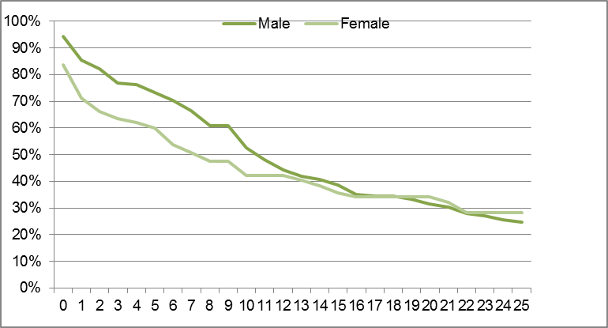
Years of Service

Figure 4.23: Navy Retention Profiles (Male v Female) Other Ranks
Non-technical224
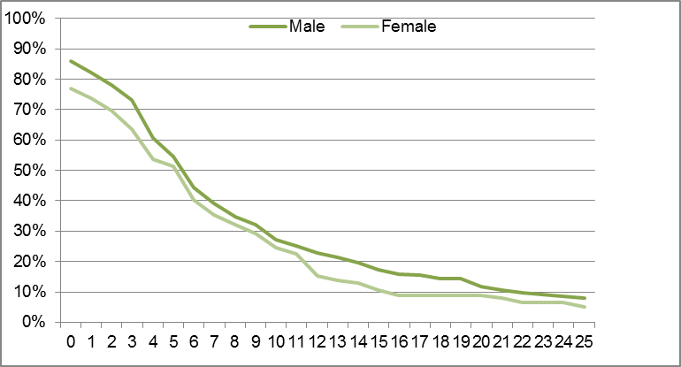
Years of Service

Figure 4.24: Navy Retention Profile (Male v Female) Other Ranks Technical225
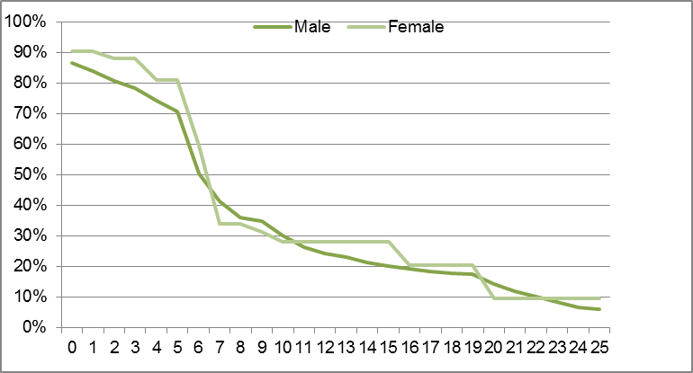
Years of Service
Women officers in Navy have a significantly higher attrition rate from the time they join until the 12 year mark. Another notable drop-off takes place in the technical trades between 5-7 years of service, with less than 35% of the original cohort of women in technical trades left at seven years of service. This is likely influenced by the completion of IMPS obligations.

Army

Figure 4.25: Army Retention Profiles (Male v Female) Officers226
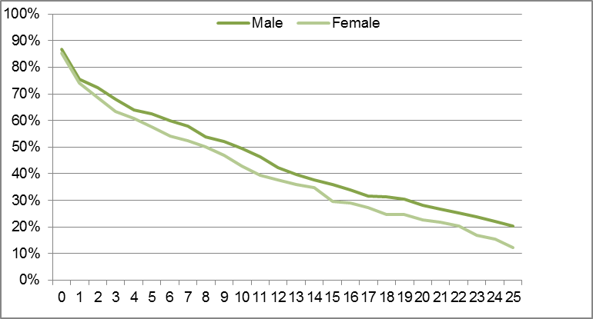
Years of Service

Figure 4.26: Army Retention Profiles (Male v Female) Other Ranks
Non-technical227
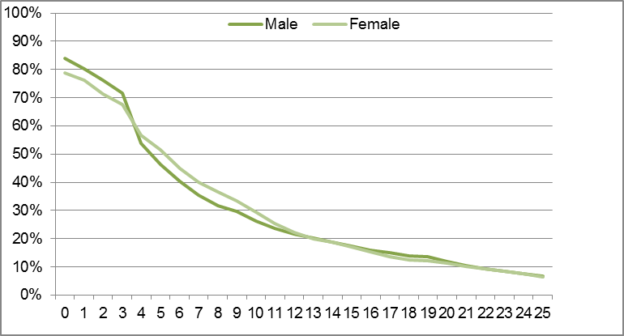
Years of Service

Figure 4.27: Army Retention Profiles (Male v Female) Other Ranks Technical228
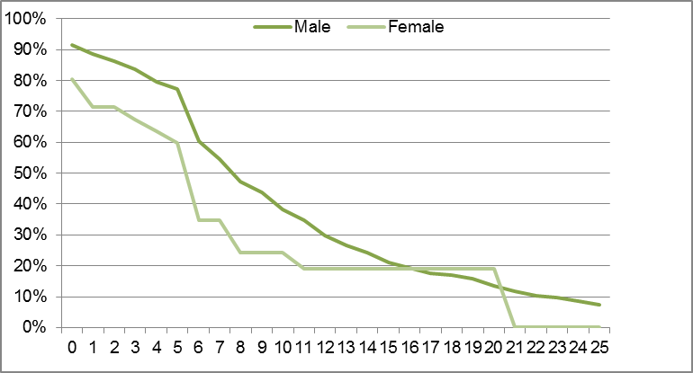
Years of Service
Women officers in Army have a higher attrition rate throughout their careers than men. Most dramatically, women in technical trades have a significantly higher attrition rate than men – by six years of service, the Army is only retaining 35% of women in technical trades.

Air Force

Figure 4.28: Air Force Retention Profiles (Male v Female) Officers229
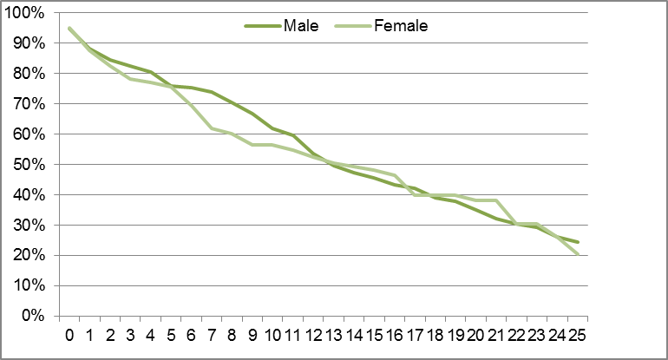
Years of Service

Figure 4.29: Air Force Retention Profiles (Male v Female) Other Ranks
Non-technical230
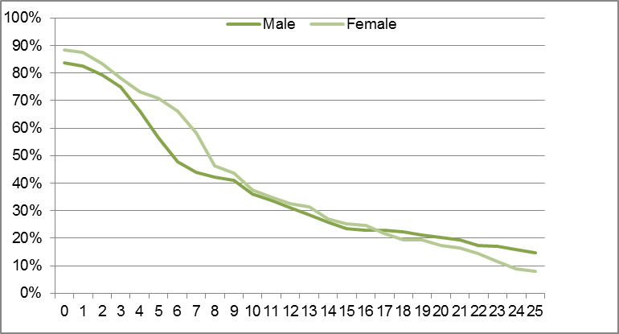
Years of Service

Figure 4.30: Air Force Retention Profiles (Male v Female) Other Ranks Technical231
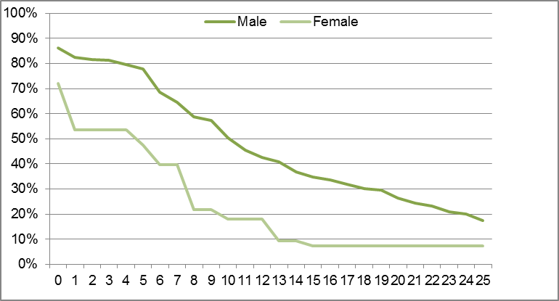
Years of Service
Most dramatic in Air Force is the greater attrition rate of women in technical trades, with 40% more women in technical trades leaving at the eight year mark and only 22% of the original cohort remaining. Women officers are also significantly more likely to leave Air Force between 5-10 years of service than men.

Propensity to leave by Service
The following charts provide Propensity to Leave (PtL) data by year of completed service, reporting the percentage of attrition from the total in each year cohort. These demonstrate several notable differences in points at which men and women are more or less likely to leave each Service.

Figure 4.31: Navy Propensity to Leave Rates by Sex232
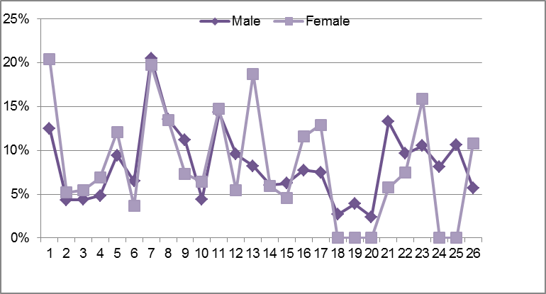
Years of Service

Figure 4.32: Army Propensity to Leave Rates by Sex233
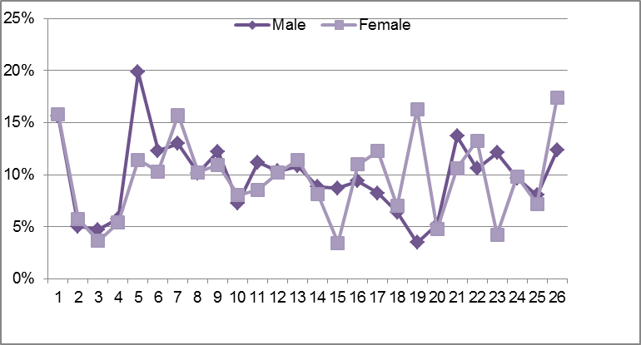
Years of Service

Figure 4.33: Air Force Propensity to Leave Rates by Sex234
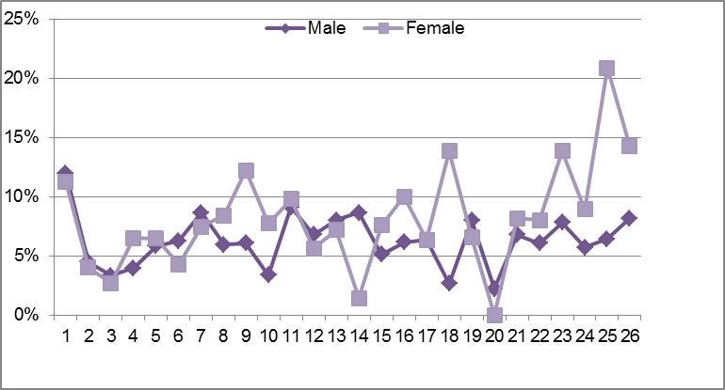
Years of Service
While a significant proportion of men and women leave after the first year of training in all Services, a significantly higher proportion of women leave the Navy after their first year (approximately 20% of women compared to 12% of men).
Trends in propensity of women to leave at the mid-career mark are also evident. For example, there is a notable spike in the propensity of women to leave Air Force between 8-10 years of Service (12% women and 6% men). Also notable, is the increased propensity of women to leave Army between 6-8 years of service (16% women and 13% men), and the propensity of both men and women to leave Navy after seven years of service (20%). These attrition points appear to coincide with a typical age when personnel, and particularly women, are starting a family.
They may also coincide with completion of Return of Service Obligations (ROSO) and Initial Minimum Periods of Service (IMPS)235 but, to date, the ADF has not conducted a detailed study of the relationship between ROSO and separation rates, meaning it is not possible to clearly distinguish which factor is at play in these findings. 236
Qualitative and quantitative data suggests that a major reason for separations from the ADF is the desire for more stability and a greater balance between work and family commitments. The ADF should examine the implications for its workforce, as a finding that women’s separation rate is predominantly related to establishing a family and not an alignment with ROSO and IMPS would enable the ADF to address women’s separation more strategically. This would then result in a significantly higher return on investment and make a clear case for increasing women’s representation in the ADF.
In Navy, another notable spike in women’s propensity to leave takes place around the 10-11 year mark and 12-14 year marks. This corresponds to the time when personnel are around 30 years of age and have frequently reached a point in their career when they are asked to return to sea following time ashore.237
While there has been no specific research conducted by the ADF investigating the links between separations and ROSO, the ADF has conducted research into separations aligning with IMPS.238 Data demonstrates a notable drop-off of personnel following completion of IMPS. For example, Navy loses approximately 50% of men and women following completion of IMPS.239
The separation rate of personnel differs across the various categories of each Service. Appendix H.2 outlines data illustrating the percentage of personnel in other ranks who have completed their IMPS by category and shows some differences between men and women, as well as differences in retention across the Services for similar kinds of work.240 For instance, there is a lower completion rate for women in several occupational groups such as Communications, Intelligence and Surveillance in both Navy and Army, Health in Army, and Engineering, Construction and Maintenance, and Musician in Navy. The most significant variance in Air Force is in Aviation where 25% less women completed their first-term than men. The significant differences in retention between men and women, across occupations as well as differences between Services for similar occupations, suggest further investigation is warranted.

Separation following paid and unpaid maternity and parental leave
A large proportion of women who take paid and unpaid maternity and parental leave do not return to work.241 Overall, 9.7% of personnel separate from the ADF immediately or within a year of taking paid and unpaid maternity or parental leave. This figure is much higher for women, with 21% separating immediately or within one year of taking paid or unpaid maternity or parental leave compared to 7.4% of men. Additionally, an analysis by Service shows that the trend of women being significantly more likely than men to separate within a year of maternity or parental leave is more prevalent in Navy and Army than in Air Force:
- In Navy, 28.5% of women do not return to service following maternity or parental leave, compared to 7.4% of men.
- In Army, 19.1% of women do not return to service following maternity and parental leave compared to 8.2% of men.
In Air Force, 16.2% of women do not return to service following maternity or parental leave compared to 6.2% of men.
These figures point to the heavy loss of women from the Services following maternity and parental leave, particularly in Navy and Army. Work and family issues, including maternity and parental leave, will be further discussed in Chapter 6.

Movement between Permanent Forces and the Active Reserve
Resoundingly, the Review observed the commitment of men and women in the ADF to their Service and to the ADF as a whole. This commitment was reflected again in the importance of being able to ‘continue to contribute’ in the motivations of men and women in joining the active Reserve.242
The ADF is seeking ways to make its workforce more adaptable, including facilitating the transfer of members between the permanent forces and the Reserve as members’ life circumstances change. However, analysis of the movement between the permanent forces and the active Reserve between 2008/09 and 2010/11 indicates that personnel are much more likely to transfer from the permanent forces to the active Reserve, than from the active Reserve to the permanent forces.
In the period 2008/2009 to 2010/2011, 5,076 personnel moved from the permanent forces to the active Reserve243 and 1,791 personnel moved from the active Reserve to the permanent forces.244 This demonstrates that for every 100 members that move from permanent forces to the active Reserve, only 35 members move from the active Reserve to the permanent forces. Women are relatively equitably represented in these movements in comparison to their overall representation in each Service. Specifically:
- In Navy, 1619 (21.3% women) transferred from permanent forces to the active Reserve245 and 313 (20.1% women) transferred from the active Reserve to permanent forces.246
- In Army, 2834 (11.9% women) transferred from permanent forces to the active Reserve247 and 1263 (11% women) transferred from the active Reserve to permanent forces.248
In Air Force, 626 (19.3% women) transferred from permanent forces to the active Reserve249 and 215 (16.7% women) transferred from the active Reserve to permanent forces.250
The average age when personnel move from the permanent forces to the active Reserve is 29 years for women and 32 years for men.251 This suggests that the movement does not correlate to retirement age but rather is at the mid-career mark and appears to align with the age when many women (and men) are seeking to establish a family. This is reinforced by other qualitative and quantitative data, that shows that many women choose to leave the permanent forces and move to the active Reserve (particularly in Navy and Air Force), when seeking greater flexibility and stability to have a family:252
- In Navy, 28% of women and 38% of men in the permanent force have children, compared to 55% of women and 73% of men in the active Reserve. Furthermore, women in the active Navy Reserve are much younger than their male counterparts – 44% of women are between the ages of 25-34 compared to just 20% of men.
In Air Force, 40% of women and 53% of men in the permanent force have children, compared to 65% of women and 80% of men in the active Reserve. Furthermore, women in the active Air Force Reserve are younger than their male counter-parts – 27% of women are between the ages of 25-34 compared to just 16% of men.
Women cited the desire for more flexible work arrangements as a key motivator in their decision to join the active Reserve.253 This was further reinforced by women from both the permanent forces and the Reserve in all three Services who told the Review that they see the Reserve as the only viable employment option within the ADF once they start a family as it gives them flexibility and locational stability:
[In the Reserves] you choose what you do and where you do it and how long you do it for.254
It’s flexible, it allows you to still take care of your children and have a career at the same time.255
I actually ended up getting out again because of my daughter and the number of schools and postings and all that sort of stuff and then in 2006…I thought I’ll come back and do 12 months Reserve work and here I am all these years later.256
Women in each of the Services stated that they would be more likely to stay in the permanent forces if they could move between the Reserve and full-time service as their circumstances change.257 Given the small number of people currently
re-entering the permanent forces (after an average length of roughly 2.5 years), the ADF is suffering a weighty loss of personnel.258 It seems likely that this loss would be higher if the numbers of personnel moving to the standby Reserve were also examined.

The impact of movement into the Reserve
While service in the active Reserve offers greater flexibility, control over the number of days/hours worked and locational stability, it does have its disadvantages.259
Negative impact on career is a particularly significant issue encountered by members who transfer to the Reserve. Members spoke of the following concerns:
- For women seeking to move back to the permanent forces after a time in the active Reserve, promotional opportunities will be impacted due in part to difficulties in accessing necessary training and maintaining skill currency while in the Reserve.
In Army, careers within the active Army Reserve run in parallel to the regular Army. A promotion within the Army Reserve may not translate into a comparable promotion within the regular Army therefore it is very difficult for active Reservists to move between the active Reserve and regular Army without severe detriment to their career, often demotion.
Other drawbacks include lack of certainty about tenure and guaranteed hours/days, lack of superannuation, negative attitudes towards Reservists by permanent members, menial/non-meaningful work, and little or no access to the Defence network and their Service.
Participants in focus groups confirmed many of these pitfalls:
I think a lot of the time Reserves feel like they’re second class citizens.260
I asked to transfer back [to the permanent forces]… We had to negotiate my seniority and I said no, I was a warrant officer, I’m definitely not going back to a petty officer.261
It’s a long journey to join as a recruit reservist or even transfer as a kellick and be promoted and especially in technical rank, because no one would pay you to go and do courses for six months. No way in the world would the Navy pay for you to do that. Won’t happen.262
For every promotion board there are certain things that you must have done, experience, courses, etc., etc., so again it comes back to the difficulty of a Reservist is getting that time to be able to do those courses.263
The Reserve is not a viable alternative to offering more flexible and stable employment options for men and women in the permanent forces. Other options that provide flexibility while enabling women to pursue a meaningful career are essential to retain men and women. Plan SUAKIN is an extensive study of the Reserve forces which has made recommendations for the reform of the ADF’s workforce model. As discussed below under ‘Defence initiatives aimed at retaining personnel’, the implementation of these recommendations will see a greater number of part-time and full-time work options, as well as measures to address many of the other drawbacks of reserve service and will likely address many of the above mentioned concerns. Further issues related to flexible work will also be discussed in greater detail in Chapter 6.

Other factors affecting the attrition of women from the ADF
Women leave the ADF, and many more consider leaving, following experiences of harassment, sexual harassment or inappropriate behaviour and/or the mismanagement of complaints relating to such incidences. Many women who had such experiences told the Review they had left the ADF, or were intending to leave the ADF, for a variety of reasons including feeling insecure, unsupported and disillusioned with the organisation. One member, in response to experiencing and witnessing several incidences of sexual harassment and indecent behaviour, said:
The crap reaction of the base, the poor systematic failings, I’m really appalled with the organisation so I can’t wait to leave, I’m counting down the months until I can get out.264
Others members told the Review:
To be educated on what is classed as abuse and being given a safe person to report that abuse to would have been the key to my retention in the Army and the key to feeling heard and understood.265
They found quite a few cigarette butts at most of the holes where the man had been smoking and semen stains next to the body imprints where the man had ejaculated whilst looking through the holes in the SAL's [showers and latrines] and my bedroom…The MPs [military police] came to my work place and interviewed everyone individually that worked there, after that no one wanted to be on shift with me, so I was made to work daytime, instead of shift work, and no one would speak to me. I felt isolated and alone for something that wasn't my fault…I was thinking of discharging at this point in time because this was not what I had signed up for...I firmly believe that this incident that occurred over an 11 month period shows that the effectiveness of a commander and retention of personnel are extremely closely linked. My situation was not well managed at all, and if I had have put my discharge in, then this would have all been swept under the carpet.266
Addressing the gaps in the ADF’s current complaints model and the support offered to personnel who face incidences of sexual harassment, assault and other misconduct as outlined Chapter 7 (‘Sexual Harassment, sex discrimination and sexual abuse’) are essential to the retention of many women in the ADF.
Mentoring and support for women is also an important retention tool. As outlined in section 5.4. (‘Mentoring, networking and sponsorship’) there is a wide body of evidence that mentoring, networking, coaching and sponsorship are essential for women’s progression in non-traditional workplaces. Personnel consulted during the Review affirmed the importance of mentoring and support to the retention of women.
In order to make female soldiers more likely to maintain a long term career in the Australian Army [especially Gap Year soldiers]I believe that in-service females need to play a more active role in the mentoring/training phase of new female soldiers.267
I am actually discharging because of the negative attitudes towards women at this particular unit and lack of help and support.268
The Review also found that the ADF’s posting and deployment cycle can have an impact on members’ decisions to discharge from the ADF. This is discussed further in Chapter 8.

Defence initiatives aimed at retaining personnel
The ADF has introduced several initiatives aimed at addressing the attrition of personnel from the ADF. Some of these have been ADF wide initiatives, while others have been Service specific. An overview of these initiatives and their varying success can be found at Appendix H.3.
Of significance are the initiatives under Plan SUAKIN that were recently approved by COSC.269 These are welcome reforms which, when implemented, will have significant positive benefits for both men and women and address several of the structural workforce model problems that currently plague the ADF. Particularly, the establishment of a spectrum of employment options including full-time, part-time and casual service across permanent and the Reserve will allow ADF members to move between different employment models as their life circumstances change.270 Given the solutions and recommendations in Plan SUAKIN were not developed with a particular focus on women, it will be essential to establish a process for assessing the de facto impact of the reforms on women, particularly during the implementation stage.
Analysis of other ADF initiatives indicates the benefits some of these can have on retention of women (and men). For example, in Navy (where sea time can be between 18-24 months) the use of alternative crewing arrangements, such as the rotation of multiple crews between platforms/vessels, allows personnel to spend less time on-board. These arrangements have the advantage of not limiting platform availability while still providing much needed respite and locational stability for personnel. While some concerns were raised about the impact on team cohesiveness and ensuring equity in rotation, generally both men and women in Navy support alternative crewing arrangements and noted the positive impact on work and family balance.271 Consequently, alternative crewing arrangements have been implemented on several vessels for over a decade. A portion of the additional financial and personnel costs required to implement these initiatives may be off-set by reduced expenditure on relocation as well as longer-term cost efficiencies resulting from increased retention of personnel. Given the challenges faced by members in juggling work and family commitments, expansion of these initiatives to a larger number of vessels would have a positive effect on retention of men and women in Navy.
The Review recommends that Navy strengthen efforts to implement alternative crewing arrangements on a wider range of vessels to increase workforce flexibility, address the impact on work life balance of personnel, and increase locational stability. Ensuring strong guidance and leadership to address team building, handover and equity in rotation will be important to the success of these initiatives.
By contrast, retention bonuses and bonuses for critical categories and occupations (such as submariners) are less likely to have a long-term positive impact on women’s retention in the ADF, as they do not address structural and systemic issues or the issues of most concern to women, such as the need for greater flexible work, career options and locational stability.

Conclusion
The attrition of women from the ADF has a negative impact on its ability to increase the representation of women overall, including within senior leadership positions. As in any workplace, and particularly workplaces of the size and complexity of the ADF, there are a range of reasons that personnel leave. However, the unique ADF working environment gives rise to particular themes relating to the retention of personnel, especially women.
While women’s overall retention rates are similar to men’s, women leave the ADF in larger numbers at specific points in their career, including at the age when women are typically establishing a family. Further, women who have experienced harassment or victimisation or who feel they are not adequately supported also leave the ADF.
Many more women (and men) move to the Reserve seeking greater workplace flexibility and locational stability. While the Reserve provides much of the flexibility and control over hours and location that is lacking in the permanent ADF, the Reserve is not a viable alternative to providing greater flexibility within the permanent forces, given the many pit-falls of Reserve service including the impact on career progression.
Given the ADF reliance on ab initio recruitment, when personnel leave the ADF because they cannot balance their work and family commitments, it takes a long time and a great deal of investment to recruit and train replacements. This means that flexibility in working arrangements is an important retention tool and critical to ensure the ADF’s capability. As the following section will outline, so is greater flexibility in the ADF pipeline’s rigid requirements for career progression.

Career management and progression
In summary
ADF career management is a vital part of ensuring the organisation’s capability and developing the careers and talents of individual serving members.
Regular posting, evaluation and promotions processes affect many aspects of the lives of ADF members, both women and men.
Reforming certain career management practices will improve the career satisfaction of ADF members. Deregulating tight career continuums will not only provide ADF members with career progression options, it will also help the ADF develop and obtain the most value out of more personnel.
Providing greater locational stability to personnel, reforming time in rank requirements, and providing longer term plans to personnel will assist the ADF achieve its goal of attracting and retaining the best talent.
Defence is one of the largest employers in Australia, with a diverse workforce comprised of about 60,000 permanent military staff, plus tens of thousands more reserves and civilian staff.272 These individuals undertake the complex task of managing their careers with the assistance of ADF career management agencies. Regular posting, evaluation and promotions processes mean that personnel have an ongoing involvement with career management during their time in the ADF.
ADF career management is a vital part of ensuring the organisation’s capability. It delivers people where they are needed within the organisation, and manages the needs and expectations of ADF personnel. As the Strategic Career Management Framework Report of 2007 notes, the ADF’s career management agencies ‘do good work within the constraints of their current systems,’ though some structural reform of the system could lead to better outcomes for all stakeholders.273 Such reform would make the ADF a more attractive workplace for women, men and families, and would improve pathways for increased representation of women in the senior ranks of the ADF.
The Review’s recommendations to this end include providing greater locational stability to personnel, reforming time in rank requirements, and building more flexibility into the entire career management system so that career managers are able to provide longer term advice and mentoring to personnel.
This section will examine the career management policies and practices within the ADF. It focuses on permanent ADF members, and how they are affected by the postings and promotions systems.274

Career management agencies
The ADF currently has four career management agencies, two for Army, and one each for Navy and Air Force, namely:
- Directorate of Officer Career Management – Army (DOCM-A)
- Directorate of Soldier Career Management Agency (DSCMA)
- Navy People Career Management Agency (NPCMA)
Directorate of Personnel – Air Force (DP-AF)275
Each agency has a number of career managers (sometimes referred to as careers advisors or personnel managers) who are the direct contact between individuals, their chains of command and their Service’s leaders (Chiefs and/or career management executives as the case may be). Career managers liaise with personnel about posting preferences and advise them about a range of career related matters. Career managers are ADF personnel who occupy these roles as part of the normal posting cycle.
Career managers undertake a difficult task, working long hours and balancing the sometimes divergent needs of the ADF and personnel. These challenges can be exacerbated by the fact that ADF career managers are not, in general, experts in human resources, and are liable to posting churn (i.e. spending a short period in the role before being moved onto another post) themselves.276 The appointment of generalist officers to career management positions reflects a desire to balance human resource expertise with a general knowledge of ADF operations and an ability to relate to personnel.277
All ADF career management agencies are mandated to undertake two broad tasks: to provide capability to their Service, and to manage the careers of ADF members.278 The Strategic Career Management Framework Report states:
[ADF career management] provides the right person, with the right skills, in the right place, at the right time to meet the Services’ capability needs; and it touches every Service member – my posting, my career, my children’s education, my spouse’s career, and so on.279
Tasks undertaken by career management agencies include but are not limited to, the administration of postings, promotions, leave and career counselling and development.280

Contact between career managers and personnel
Each Service’s career management policy requires periodic contact between career managers and personnel. Generally, ADF policy recommends annual meetings with members, but many members in focus groups said that they were either unaware of who their manager was, or had met with them much less frequently. One member believed that they were ‘not supposed to have direct access’ to their career manager, and another said that they had found it difficult to attend annually planned meetings with their career managers on account of their postings and placements.281 These were not isolated sentiments, and many personnel told the Review that they would appreciate more contact with their career manager. This is reinforced by the findings of the 2010 Defence Attitude Survey, which found that over 40% of all respondents did not agree that they had sufficient contact with their career management agency (32.1% disagreed, 11.8% were uncertain).282
Each career manager is responsible for, on average, over 300 individual members and sometimes many more. NPCMA currently has 58 career managers for 18,882 personnel, DOCM-A has 21 career managers for 6,065 personnel, DSCMA has
47 career managers for 21,466 personnel, and DP-AF has 49 personnel managers for 16,159 personnel.283 The significant workloads that career managers have can lead to the impression among personnel that their interests are of secondary concern, and that they are just pieces in a larger puzzle. One member, who reflected the view of many, told the Review that:
it’s very hard when you discuss [personal circumstances] with a career manager who’s managing a hundred other individuals. They don’t have the time to look very closely at your career.284
Under Navy policy, sailors are expected to meet with a career manager annually. Sailors should meet a career manager at their Local Career Management Centre ‘at least once, but preferably twice’ each year, and officers can meet with a career manager at the annual visits that career management officials make to all major posting localities in Australia.285 In Army, soldiers should meet with a career manager ‘at least once in a 24-month period’ while officers are expected to maintain ‘appropriate contact’ with their manager, defined as ‘at least once per year, [and] preferably in person.’286 Air Force personnel can meet with personnel managers on planned annual occasions, or any other time they visit Canberra.287
These meetings are used to discuss future postings and career plans for personnel. Members expressed a range of views about the value of these meetings. One noted that they had established ‘a good rapport through the interview process’ and was assisted in making career choices; another submission said that career managers ‘lack an understanding of inherent requirements of the professions they manage’; while others were more dismissive and hostile in their assessments of their career managers.288 Some female members spoke of career managers they believed to be exceptional, who had helped them strategically think about balancing careers with families, while others felt that sharing their intention to start a family with their career manager would reduce their job opportunities, or even be ‘career death’.289 This inconsistency is concerning.

Postings
The ADF has jobs and billets that need filling all around Australia and internationally. The career management agencies post personnel to these positions in order to satisfy capability requirements, for reasons of career development, and for personal preferences (in that order of importance).290 Career managers are required to keep themselves informed of the personal preferences of those they manage through meetings and other dialogue and try to balance these with Service needs. However, survey data indicates that less than half of all respondents believed that ‘the ADF considers [their] family circumstances when considering postings/deployment’.291
Each Service aims to provide personnel with some level of stability by offering three year postings in each role and back-to-back postings in the same geographic location.292 While this remains the aim, it does not always appear to be possible due to Service requirements. One fairly young member noted that he had experienced:
thirteen moves, never getting stability. Bought a house in Sydney thinking that would assist, I’m now on my second MWDU [member with dependent unaccompanied] posting out of three.293
Each Service aims to give personnel six months’ notice prior to the date of posting by policy, but this also does not appear to always happen.294 In the case of deployments, notice can be extremely short. One member told the Review that
you can be given three days’ notice…I have been told, on a Friday afternoon, pack your bags you’re going to the Gulf on Monday.295
One senior Air Force member reflected on the movement required in an ADF career and argued that it was not a palatable model for many women with families, noting that ‘it’s hard for men too, but in Australian society women tend to be the primary caregiver’ which created particular challenges.296 This member suggested that if the ADF committed to a model which guaranteed a longer period of stability in one area ‘our participation rates of women would be through the roof’.297
For some time, it has been a goal of ADF career management to offer members guaranteed longer term career plans, but no Service has embedded these as standard practice.298 For a period, sailors’ postings were based on formal Five Year Career Plans, but it seems that these are no longer used.299 The inability to be able to commit to longer term career plans is a deciding factor for many individuals with family and caring responsibilities considering their career prospects within the ADF. Exit surveys have consistently noted the desire for greater stability, including a desire for less separation from family and many younger serving women do not believe that they would be able to balance a family with a career in the ADF.300 The Review’s recommendations in this area relate to the development of longer term career plans, and providing greater family support through the career management system.

Compassionate postings/preferential treatment
If an ADF member is unable to take up a posting to which they have been assigned, he or she can apply for a ‘compassionate posting’ (or ‘preferential treatment’ in the Air Force) for a limited amount of time. Compassionate postings appear to be quite exceptional and generally relate to health or family reasons.
Compassionate postings in Navy and Army are generally for a period of one year, although personnel can apply for an extension beyond this time.301 Preferential treatment in Air Force is available for up to two years.302 If a member requires special consideration beyond these periods, they can be counselled and/or face discharge proceedings.303
Members seeking a compassionate posting are required to provide supporting documentation such as a doctor’s, social worker’s or psychologist’s report.304 Being on a compassionate posting can be considered offering ‘ineffective service’ and members on compassionate postings are not normally considered for career development opportunities (e.g. postings, promotion, courses etc.).305
Most career management agencies do not keep detailed statistics about compassionate postings, however DSCMA noted that it had 1,072 total requests for ‘retention or reposting’ in the past year, and 181 of these were specifically for compassionate reasons. Of compassionate posting requests, 86.8% were for family or family health reasons, and 66.9% of all compassionate requests were approved.306

Individual readiness
A basic condition of employment – and a requirement for career development, certain postings and deployment – is that members must maintain an appropriate level of ‘individual readiness’. Each Service’s policy is a slight variation on the same theme, and each lists six components to readiness.307 They are:
1. Individual availability
2. Employment proficiency
3. Weapons proficiency
4. Medical fitness
5. Dental fitness
6. Physical fitness
Extended inability to meet the requirements can lead to a review of ongoing employment.308
The individual availability component requires personnel to be available for unrestricted service on short notice regardless of any other personal circumstances.309 Personnel can request special consideration on account of personal or compassionate circumstances, but of course, the above mentioned career implications apply to this.310
The Army and Air Force Individual Readiness Directives specifically mention pregnancy. The Air Force instruction notes that a pregnant member will be ‘temporarily non-deployable’ but must be ready for deployment ‘not less than six months from the date of the birth of the child/children.’311 Army requires pregnant members to remove their readiness badge, and they are excused from readiness requirements for 12 months from the date of delivery, or 90 days after returning to work (whichever is later).312
Health Directive 235 (Management of pregnant members of the Australian Defence Force) outlines the policy for pregnant women in the ADF and largely deals with safety issues and concerns.313 It notes that members with low risk pregnancies are ‘considered fit for new or routine posting within Australia up until 32 weeks gestation, as long as adequate access to medical and obstetric services can be assured’ and they can then be posted after six weeks post-partum.314 It also says that ‘pregnant women are not to be deployed on operations either within Australia or overseas’, and that pregnant women cannot serve at sea.315

Sea Service
The requirement for sea service is specific to Navy, but ties into compassionate postings and individual readiness issues. Personnel must spend periods at sea throughout their careers. Sea postings are generally 18-24 months long, but it should be noted that this does not equate to two straight years at sea, as all ships are subjected to a maximum number of days away from home port. NPCMA has informed the Review that sea postings can be negotiated ‘to accommodate both individual desires and corporate needs.’316
The sailors’ career manual notes that ‘an inherent requirement for all sailors serving in the RAN is their ability to serve at sea,’ and the officers’ career manual notes that officers who refuse sea service may be declared ineligible for promotion and may be subject to termination of appointment proceedings.’317 NPCMA notes that, while termination powers for refusal to go to sea do exist, this is not a ‘standard process.’318
As suggested in section 4.1, and further discussed in Chapter 6, sea service is an issue for many women who find it difficult (or perceive that they will find it difficult) to balance time at sea with their families, in turn affecting their progression to Navy’s higher ranks. A senior Navy officer suggested that a rotational system, where personnel could serve three months at sea, then three on shore throughout a posting would be much more manageable for those with family responsibilities than two years away, and could help Navy address the stark drop-off in women’s representation in Navy’s higher ranks.319
Sea service can present special difficulties for single parents. Sailors who are single parents are able to request a deferral of sea service obligations with the support of a Defence Social Worker’s report for a period of not more than 12 months.320 If the sailor is unable to take up their posting after this time, discharge proceedings may be initiated.321
The Review’s recommendations about increasing workforce flexibility may assist Navy in addressing members’ issues in this area.

Families
All career management agencies have an awareness of the stresses that the posting process can have on family life. For example, NPCMA informed the Review that ‘[a]ll career management decisions should be cognisant of the member’s family situation and the employment of the member’s partner is a key factor’. DSCMA has noted that the majority of compassionate posting requests were for family or family health reasons and DP-AF allows family members to participate in meetings with personnel managers.322
The policy documents also acknowledge a desire to post Service couples to the same location, but note that this can be difficult to achieve.323 NPCMA suggests that most requests are able to be accommodated, and in the cases where they are not, there would often be ‘large capability implications’ involved in the co-location.’324 Army notes that they attempt to organise co-location, but do not keep statistics in this area.325 Air Force has been able to accommodate nearly all personnel who have applied for co-location.326
Members of the same family may be posted to the same unit, but cannot serve in the same sub-unit or occupy positions in the same chain of command.
The simplification and formalisation of family support mechanisms, particularly at the time of posting, will help the career management agencies assist families dealing with the stresses of a move.

Promotion and career progression
In addition to the postings system, a large part of career management and progression in the ADF is built around promotions. One member told the Review that the ADF
very heavily values promotion and there’s this feeling that if you’re doing a good job you get promoted and if you get over looked for promotion a number of times, you start feeling like am I dead wood?327
In the ADF, promotion often equates to success. While this suits some, there are many members who add great value and continue to contribute within rank who do not wish to ‘climb the ladder’. Their job satisfaction derives from their role or from the decisions they have made to balance work and family or other commitments. Success in these terms is rarely acknowledged or celebrated.
As illustrated in section 4.1, women do not progress through the ADF’s ranks, in any Service, at the same rates as men. There are complex reasons for this, but one major factor is the rigidity of career structures. The ADF has strong and well understood organisational expectations about the age range within which certain promotional pathways and/or types of experience are to be attained. These unwritten expectations and assumptions need to be acknowledged and re-examined with a view to deregulation. Deregulating tight career continuums will provide ADF members with enhanced career progression options, while also helping the ADF develop and get the most value out of its people.
A discussion of several elements of the promotions process – (including time in rank provisions, annual performance appraisal reports (PAR), and promotions boards) and how these impact on the current workforce management follows.328

Time in rank
A central plank of the promotions process is the time in rank system, which requires members to provide a certain amount of service in order to be considered for promotion. The standard time in rank requirements which must be served before being considered for promotion are listed in the tables below.

Table 4.3: Time in rank requirements, other ranks329
Rank | Navy | Army | Air Force
Seaman/ Private/ Aircraftman/woman | one year | one year | two years
Able Seaman/ Private (P)/ Leading Aircraftman/woman | two years | one year | two years
Leading Seaman/ Corporal/ Corporal | four years | two years | two years
Petty Officer/ Sergeant/ Sergeant | four years | three years | two years
Chief Petty Officer/ Warrant Officer Class 2/ Flight Sergeant | three years | four years | two years

Table 4.4: Time in rank requirements, officers330
Rank | Navy | Army | Air Force
Below Lieutenant (eg. ADFA+ASLT+SBLT)/ Lieutenant/ Flight Officer | six years  (includes tertiary study pathway) | three years | two years
Lieutenant/ Captain/ Flight Lieutenant | five-and-a-half years | six years | two years
Lieutenant Commander/ Major/ Squadron Leader | four years | five years | two years
Commander/ Lieutenant Colonel/ Wing Commander | four years | six years | two years
At more senior levels, time in rank requirements become more flexible.331
Time in rank requirements must be satisfied with periods of ‘effective service’. This is defined in opposition to ‘ineffective service’ which can include various types of leave, compassionate postings, or other unsatisfactory service.332 In Navy, ineffective service includes maternity leave without pay, and part-time leave without pay (on a pro-rata basis).333 In Army, it includes long service leave, maternity leave or leave without pay of over six months for officers, or twelve months for soldiers. In addition, any period of part-time leave without pay leads to a pro rata reduction in seniority for Army officers, and after twelve months for soldiers.334 Air Force’s seniority provisions were reformed in 2007 so that, by policy, periods of leave (including part-time leave without pay) ‘no longer impact upon seniority or act as a barrier to promotion for those in the merit based promotion system.’335
It is clear that current time in rank and seniority provisions impact on the ADF’s ability to maximise value from its workforce, and remain a systemic barrier to the promotion of women.336 Women and men can – and do – have career breaks that may affect their progression, but the reality for many women is that they are more likely to need to access periods of leave and flexible working arrangements at different times of their careers. The Review heard that the way that time in rank rules and promotions currently worked meant that:
There are probably a lot of women out there who haven’t progressed in their careers because they were looking after children and they get to a point where they don’t really want to stick around because they don’t want to be that career lieutenant.337
The ADF operates on a goals and outcomes basis. ADF members do not typically work to a standard 9 to 5 weekday model, but rather have goals and tasks that need to be met and accomplished, whatever amount of time this takes.338 This is part of the training for entering deployed environments, where personnel are not at a desk for a fixed amount of time. Current time in rank provisions are the opposite of this, being predicated on a member needing to occupy a post for a particular amount of time before being considered for promotion.
A strict adherence to time in rank provisions will inevitably disadvantage individuals who may have different, otherwise valuable, or even superior experience and achievements compared to those providing more traditional full-time, unbroken service.339 This assumed link between unbroken service, competitiveness and competence is held by many personnel. As one member told the Review in a focus group:
This gentlemen here has done six years in his current rank. I’m a female and I’ve done four because I’ve taken two off. Personally, I don’t think I’m as competitive as him because he’s been in the workplace, has performed well, done those jobs and I haven’t.340
There is also a perception that successful personnel will be promoted near the minimum allowable times, in order to be able to progress as far as possible through the rank structure before they reach the ADF’s mandatory retirement age.341 This can have an ongoing effect for personnel who have missed one such ‘career gate’ and subsequently find themselves unfavourably compared to those who have more closely followed the strict traditional path. One Army officer outlined the pressure of meeting career gates in the following way:
You hit your Sub-Unit Command PAC [Personnel Advisory Committee], you need to be successful there. Twelve months later you’re up for Command and Staff College PAC, you’ve got to be successful there. Once you’re successful there, you’ve got two years before you go to your Lieutenant Colonel PAC and you can’t miss time in between.342
The perception that narrow career gates exist was not limited to Army. Many women told the Review about their struggle in juggling these gates with planning breaks to have children and balance their family responsibilities generally.343
A deregulation and simplification of the time in rank and seniority provisions, similar to the Air Force model, may remove what has been a structural impediment for many women, and improve the outcomes of the promotions system. In addition to allowing career management agencies to consider a broader range of individuals, such a reform would also begin to decouple the notion that:
if you stay in the system you keep moving along with the current…and the minute you step off… you’re being left behind.344
Given the reality that women (and increasingly men as well) will take time out of their careers at various ranks, a strict time in rank model predicated on traditional full-time unbroken service is an inefficient way for the ADF to develop and harness the potential of its entire workforce. Those taking career breaks will simply not have the ability to progress into senior leadership ranks, regardless of talent, because they will be precluded by time requirements. The Review recommends reforming time in rank requirements to decouple traditional career pathways and continuous service from promotions processes.

Performance appraisal reports and promotions
Performance appraisal reports (PAR) are also a key part of monitoring performance and potential, leading to postings and promotions. A PAR should assess the member’s performance over the reporting period to identify their strengths and weaknesses, provide feedback on performance and developmental needs, identify suitability for promotion courses and postings, and monitor performance levels.345 PARs are completed by a member’s chain of command (usually a direct supervisor, and that assessor’s supervisor) and submitted to the appropriate career management agency.
ADF members should typically receive one PAR each year, but must be observed for at least four months in the twelve month period for this to happen.346 A member accessing long service leave, maternity leave or leave without pay, undertaking courses, or being sick and absent from work for an extended period could lead to them forgoing a PAR, which can be a disadvantage in the highly competitive promotions process. As one member put it:
Someone whose got three PARs that are at exactly the same level as a person who had two, who was away for a year, it’s up to a board to sit there and go and who’s the most likely to be promoted?347
A member ineligible for a PAR can receive a supplementary report instead, but these are identified differently.
Promotions then occur for junior members (other ranks and officers) generally as they meet time in rank requirements, provided they satisfy appropriate training criteria and individual readiness levels.348 As indicated at the outset of this Chapter, the promotions process becomes competitive at more senior ranks and members are examined by a promotions board when they enter a promotion eligibility zone, rather than as they apply to an opportunity. This process is largely supply driven (as opposed to demand) and while this gives all members the opportunity to be assessed, it is resource intensive and reinforces the perception that there are certain promotion ‘gates’ that a typical, successful member must move through on their career continuum.

Promotion boards
Senior members (other ranks and officers) are examined by promotion boards after they have served their time in rank and enter a ‘promotion eligibility zone’. The boards are responsible for examining the history of a cohort of candidates, ranking them, and making recommendations for promotion, attendance at courses, and other career development.
The boards examine and review documentation for each candidate presented, and arrive at an ordering from most promotable candidate to least. The documentation includes several years’ worth of PARs and supplementary reports (usually three) and other documentation such as Medical Employment Classification reports, ADF or civilian qualifications and conduct records, honours, awards and education for each candidate.349 At more senior levels, candidates are also able to submit personal biographies to the board, and to participate in interviews with board members.350 Once the ordering has been settled, recommendations about candidates to promote are forwarded to career management agency executives or senior Service leaders as appropriate for further examination and award of promotions. A more in depth reflection on three boards attended by the Review is available in Appendix I.
Promotion boards are the forum in which the core value of ‘merit’ is judged and assessed within the ADF. Much effort has gone into regulating these boards to ensure that they equitably and fairly assess those that they are examining. At the boards attended by the Review, members were keen to avoid any subjective judgements, and quick to point out any conflicts of interest that they may have had (e.g. if they had worked with, socialised with or knew a candidate).351 The transparency and fairness of the system will also be improved by the unconscious bias training that the ADF is currently providing to its senior leaders.352
Boards were advised in sessions that part-time leave without pay should not be an obstacle to promotion. The Review did not witness any obvious or direct discrimination in the boards it attended, but it was plainly difficult for personnel who had worked part-time to compete with those who had not. Members who had accessed part-time work were prominently noted through the reporting system – either by a PAR or its absence, or through a supplementary report. In a highly competitive process (each board attended by the Review was supply driven, examining over 100 candidates for just a handful of positions) issues like having taken a career break, missing a PAR, or being noted as a part-time worker do not reflect well in a review system that has not been designed to consider such complications.
While each Service’s promotion board followed a broadly similar process, each also contained different innovative elements which may be of value to the other Services. These include Navy’s attempt to incorporate an assessment of values and behaviours into its promotions process, Army’s attempt to diversify leadership through its ‘pathways strategy’, and Air Force’s attempt to examine a broad range of candidates with a deregulation of time in rank rules. Each of these initiatives is briefly examined below.

Navy
Navy considered a candidate’s performance in displaying Navy’s signature behaviours and values.353 While this was a newer element of the process, and clearly not as well developed as other criteria, it stood out as the one moment in which the values and behaviours were overtly discussed as something against which members should be judged. Unfortunately, the board had little material for assessing candidates in this area other than attendance at mandatory courses and any conduct records.354 Further development of a means for assessing signature behaviours in Navy, and the adoption of similar elements in Army and Air Force, could be helpful in attaching more relevance to the meaningful practice of values and ethical behaviour for more personnel.

Army
Army’s ‘Pathways’ strategy aims to provide alternative career pathways for personnel, and enable Army to identify and retain a broader range of skills than its traditional model allows.355 After considering candidates through its traditional ‘command and leadership’ stream, the board can consider candidates for promotion through a number of other streams, including logistics, aviation, information management, capability and project management, personnel, operations, plans and training, intelligence, and specialist.356 ‘Pathways’ requires more development – there were significant differences of opinion about its aims, outcomes and worth at the board attended by the Review – but it does have potential to aid diversity and development in the Army, as well as in other Services if they were to adopt a similar model.

Air Force
Air Force’s deregulation of time in rank provisions has given it more scope than the other Services to consider a broad cross section of personnel for promotion. The Air Force board attended by the Review examined everyone who had achieved two years seniority in rank. Some further reforms of the system may improve its efficiency (for example, making promotions processes opt-in, and not listing seniority and service type in a way that can lead to an unconscious bias towards those who had served for what might have been considered optimal time lengths) but in its liberalisation of time in rank rules, Air Force is moving in a direction that may also be of use to the other Services.

Career gates and the Australian Command and Staff College
ADF career plans are set out for different categories. These tend to be well detailed and planned, but can also reinforce the lack of flexibility in the career continuum. They broadly adhere to the time in rank requirements noted above, and at each stage of a career, there are courses and basic requirements that members must satisfy in order to advance.357 One career gate of particular importance, for which members are recommended or otherwise by their career managers and promotion boards, is attendance at the Australian Command and Staff College (ACSC).
ACSC is a pivotal experience that prepares mid-level officers for progression into the ADF’s senior leadership ranks. A background briefing on ACSC notes that:
More than any other course or program of development…ACSC will determine the level of contribution [a member] will make to [their] Service and nation in the future.358
A particularly ‘tight window’ exists through which personnel need to pass at the O04/O05 level in order to navigate this career gate.359 This particular career gate often coincides with critical child-bearing years for women, and therefore poses a potential structural disadvantage to women’s career prospects. One woman told of cutting her maternity leave short to take up a position at ACSC which she believed would otherwise have been lost, while another said that she had:
never seen a group of women who plan their conception down to the actual day in the way that Army women do…I’ve got to have the baby then, because if
I don’t have the baby then I’m not going to get into staff college.360
Once personnel have successfully graduated from Command and Staff College, there is a perception that contacts and networking become more important aspects for further career progression. One senior officer told the Review that:
Within the more senior ranks it becomes more akin to a system of patronage to what you would find say in the US system…Having been through staff college recently as well, all they talked about is the need to manage your profile, to which my question is well, what about performance?361
Another senior officer similarly said that ‘despite the fact that we all try and promote the right people a lot of it is who you know.’362
While the ACSC was a career gate that was often raised with the Review, there are other career gateways (such as Centre for Defence and Strategic Studies and various Service gateways to sergeant and equivalent) that also form barriers for women. The Review recommends that critical career gates for progression into the senior ranks gateways be identified, and that targets be developed with the aim of opening up the career gates for a more diverse range of codes.

Conclusion
The ADF manages a large and diverse workforce. Dedicated career management agencies work hard in a difficult role to manage their workforces effectively. Policy changes would help the ADF get the most value out of its personnel, increase the representation of women in leadership roles, and increase the support of career management practices among many personnel.363
Providing guaranteed periods of locational stability would assist in more members being able to better balance their work and family responsibilities. While not all members will want to be a part of such a system, having a greater number of personnel who have guaranteed stability for at least two posting cycles could help counteract one of the major reasons given for separations in Exit Surveys.
Reforming time in rank requirements would also help to address the under-representation of women in leadership in the ADF.364 While some changes have occurred, the strictures of the career continuum and the current promotions process disadvantages those who take career breaks, and can potentially lead to conscious and unconscious bias against those who do not have a history of continuous full-time unbroken service. Decoupling traditional career pathways and continuous service from certain promotions processes may help the ADF discover and promote a broader range of talent within the organisation.
Reform of the ADF career management system will help the ADF operate at peak performance and achieve maximum capability.365 Reform will assist the ADF in its goals of promoting a diversity of talent, and improving pathways for increased representation of women in its senior ranks, as well as recognition of the value of those categories more frequently dominated by women.

- P Hoglin, ‘Why Ab Initio?’ (2011) 8(2) Australian Army Journal 157, p 158.
- See, for example, J A Conger and R M Fulmer, ‘Developing your leadership pipeline’ (2003) Harvard Business Review 76.
- These ranks and their badges are listed in the Glossary.
- The data used in this Chapter is end of financial year 2010/11 snapshot figures provided to the Review by the Workforce Planning Branch: ‘ADO_PERSONNEL by Sex and Rank FY0405 to FY1011 v2’ provided to the Review by E Chalker, 15 November 2011. At the time of publication, the Review received select 2011/12 data from each Service. Where appropriate, the 2011/12 data is included in endnotes that correspond with its 2010/11 data in the main body of the text. In 2011/12, the representation of women in Army was 10.1%. Advice received from the ADF,
16 July 2012.
- Department of Defence, Defence Annual Report 2010-11. At http://www.defence.gov.au/Budget/10-11/dar/index.htm (viewed 8 November 2011).
- As at the end of 2010-11 there were eight women among the 178 Star ranks, and 111 women among the 1,435 WO/WO1/WOFFs. Figures from ‘ADO_PERSONNEL by Sex and Rank FY0405 to FY1011 v2’, note 4.
- At the end of FY 2010-11, there were 2,435 women among the total of 13,961 officers, and 5,565 women among the total 44,169 other ranks: ‘ADO_PERSONNEL by Sex and Rank FY0405 to FY1011 v2’, note 4.
- In 2011/12, the representation of women in Army had risen to 10.1%: Advice received from the ADF, 16 July 2012.
- ‘ADO_PERSONNEL by Sex and Rank FY0405 to FY1011 v2’, note 4.
- The entire pipelines are charted, but in three instances, ranks are combined where they are either specific to one Service, or part of the pipeline that not all personnel are required to move through. The ranks that have been combined for the purposes of analysis are SGT and SSGT in Army, CPL and NCO Officer Cadet in Air Force, and 2LT(E) and LT(E) across all Services.
- In 2011/12 women made up 8.8% of Army other ranks (2,005 of 22,667): Advice received from the ADF, 16 July 2012.
- In 2011/12 women made up 10.3% of SGT+SSGT (280 women, 2,446 men); 8.8% of WO2
(169 women, 1,746 men); 8.7% of WO1+RSM-A (57 women, 597 men): Advice received from the ADF, 16 July 2012.
- The 2011/12 proportion of women in Army other ranks was 8.8%, up from 8.7% the previous year: Advice received from the ADF, 16 July 2012.
- As at 31 December 2011, Army had 185 categories, of which 85.4% were open to men and women. Of the 132 roles open to both men and women that are currently occupied by personnel, women are currently employed in only 119 (90%) of roles. Categories from which women were legislatively excluded include the Infantry Corp, the Armoured Corp, various specialisations within the Artillery Regiments, Explosive Ordinance Disposal Engineers, and certain trainee positions: Information from ‘Broderick Review Phase 2 Task 202 – percentage of women in open roles’ [BR 187] provided to the Review by SQNLDR F James, 1 February 2012.
- Information from ‘Broderick Review Phase 2 Task 202 – percentage of women in open roles’ [BR 187], above, indicates that at the end of 2011, there were 7,673 Other Rank positions in these categories only available to men. Taking this number away from the total FY2011/12 figures gives a representation for women in the rest of Other Rank positions of just below 13%.
- LTCOL P Conroy, Presentation to Chief of Army Women’s Networking Forum: Physical Employment Standards Implementation, 5 December 2011. It was suggested that the ADF does not expect to see large numbers of women applying for, or entering combat categories when restrictions are lifted.
- The 2011/12 figures are WO2 – 8.8%, WO1 – 8.7%, overall – 8.8%. Advice received from the ADF, 16 July 2012.
- 2010/11 data from ‘RFI 183 – Data for pipeline model – snapshot counts, ab initio recruitments, lateral entries per rank, promotions per rank, separations per rank’ provided to the Review by CMDR A Westwood, 6 February 2012. In 2011/12 women made up 8.1% of the total separations (237 of 2,911) and 10.3% of the net movements (706 of 6,874). Advice received from the ADF, 16 July 2012.
- ‘RFI 183 – Data for pipeline model – snapshot counts, ab initio recruitments, lateral entries per rank, promotions per rank, separations per rank’, above. In 2011/12 women made up 9.1% of the separations from corporal and 8.2% of the separations from sergeant; women also made up 11% of the promotions to lance corporal and 11.8% of the promotions to corporal. Advice received from the ADF, 16 July 2012.
- Meeting with Army career management representatives.
- Between 2004/05 and 2010/11 women have been separating as Recruits at a proportionally higher rate than men. 18.4% of all female recruits were separating, compared with 13.7% of all male Recruits: see Appendix F.
- For example, in a group of 50 recruits, there will be on average about 5 women. While the 45 men in this group will be able to move in and out of each other’s living spaces, small groups of women will be placed together, and not have such an extensive support network. Strict fraternisation rules can also be isolating for the small numbers of women in a training group.
- Meeting with Army career management representatives.
- In 2011/12 women made up 14.8% of all Army officer personnel (911 of 6,168). Advice received from the ADF, 16 July 2012.
- In 2011/12 women made up 14% of majors (226 women, 1,391 men) 10.2% of lieutenant colonels (63 women, 556 men) 7.5% of colonels (12 women, 149 men) 9.3% of brigadiers (five women, 49 men). Advice received from the ADF, 16 July 2012.
- ‘Broderick Review Phase 2 Task 202 – percentage of women in open roles’ [BR 187], note 14.
- This proportion is derived by taking the figures quoted under Figure 5, and subtracting the 1,084 officer positions only available to men (as per ‘Broderick Review Phase 2 Task 202 – percentage of women in open roles’ [BR 187], note 14) from the total pool.
- In 2011/12 women made up 18.5% of lieutenants and 7.5% of colonels. Advice received from the ADF, 16 July 2012.
- 2010/11 data from ‘RFI 183 – Data for pipeline model – snapshot counts, ab initio recruitments, lateral entries per rank, promotions per rank, separations per rank’, note 18; In 2011/12 women made up 17.3% of separations (83 of 480) and 15.6% of promotions (128 of 822). Advice received from the ADF, 16 July 2012.
- ‘Separations by gender, calendar year and rank’ provided to the Review by CMDR
A Westwood, 15 November 2011.
- 2010/11 data from ‘RFI 183 – Data for pipeline model – snapshot counts, ab initio recruitments, lateral entries per rank, promotions per rank, separations per rank’, note 18; In 2011/12 women made up 24% of all movements to colonel and one of the five movements to brigadier. Advice received from the ADF, 16 July 2012.
- 24 out of 81 (29.6%) are in categories women have been precluded from occupying. Information from BR Request 232, provided to the Review by SQNLDR F James, 12 March 2012.
- In 2011/12 women made up 17 of 215 colonels and brigadiers. Advice received from the ADF, 16 July 2012.
- ‘Broderick Review Phase 2 Task 202 – percentage of women in open roles’ [BR 187], note 14.
- This proportion is derived by taking the figures quoted under Figure 8, and subtracting the 310 other rank positions only available to men (as per ‘Broderick Review Phase 2 Task 202 – percentage of women in open roles’ [BR 187], note 14) from the total pool.
- ‘RFI 183 – Data for pipeline model – snapshot counts, ab initio recruitments, lateral entries per rank, promotions per rank, separations per rank’, note 18.
- ‘RFI 183 – Data for pipeline model – snapshot counts, ab initio recruitments, lateral entries per rank, promotions per rank, separations per rank’, note 18.
- ‘Broderick Review Phase 2 Tasks 242 and 246 – Demographic data' provided to the Review by SQNLDR F James, 10 February 2012.
- At 1 July 2012 women made up 13% of all Captains (15 of 115): Advice received from the ADF, 16 July 2012.
- These figures rely on 2010/11 data, but at the time of writing, Navy does have one female Rear Admiral. Advice received from the ADF, 16 July 2012.
- Department of Defence, Draft 2011 Census Public Report, provided to the Review by SQNLDR F James, p 6, notes that ‘In the Navy, there has been a progressive shift in the gender balance with a steady decrease in the proportion of males since 1991: 87% in 1991; 86% in 1995; 85% in 1999; 83% in 2003 and 2007; 81% in 2011.’
- ‘RFI 183 – Data for pipeline model – snapshot counts, ab initio recruitments, lateral entries per rank, promotions per rank, separations per rank’, note 18.
- By calendar year the figures are 28.6% (2010), 22.8% (2009), 23.9% (2008), 17.4% (2007), 30.3% (2006), 28.4% (2005), 25.7% (2004): ‘Separations by gender, calendar year and rank’, note 30. This compares with an overall representation of between 21.3 and 24.8% at Lieutenant during this period.
- ‘RFI 183 – Data for pipeline model – snapshot counts, ab initio recruitments, lateral entries per rank, promotions per rank, separations per rank’, note 18.
- ‘RFI 183 – Data for pipeline model – snapshot counts, ab initio recruitments, lateral entries per rank, promotions per rank, separations per rank’, note 18.
- ‘Broderick Review Phase 2 Tasks 242 and 246 – Demographic data', note 40.
- ‘Broderick Review Phase 2 Tasks 242 and 246 – Demographic data', note 40. Note that in any instances where there are less than 20 respondents, data was not provided to the Review in order to protect the confidentiality of the respondents.
- ‘Broderick Review Phase 2 Tasks 242 and 246 – Demographic data', note 40.
- 41.1% of all men in the permanent ADF are married, compared to 26.5% of women; and 39.2% of men have dependent children, compared to 27.9% of women: From ‘Broderick Review Phase 2 Tasks 242 and 246 – Demographic data', note 40.
- ‘Broderick Review Phase 2 Tasks 242 and 246 – Demographic data', note 40.
- ‘Broderick Review Phase 2 Tasks 242 and 246 – Demographic data', note 40.
- ‘Broderick Review Phase 2 Task 202 – percentage of women in open roles’ [BR 187], note 14.
- This proportion is derived by taking the figures quoted under Figure 15, and subtracting the 415 ADG positions only available to men in 2011 (as per ‘Broderick Review Phase 2 Task 202 – percentage of women in open roles’ [BR 187], note 14) from the total pool.
- ‘RFI 183 – Data for pipeline model – snapshot counts, ab initio recruitments, lateral entries per rank, promotions per rank, separations per rank’, note 18.
- ‘RFI 183 – Data for pipeline model – snapshot counts, ab initio recruitments, lateral entries per rank, promotions per rank, separations per rank’, note 18.
- Meeting with Air Force career management and personnel representatives.
- Occupational segregation is further examined in section 5.1.
- In 2011/12 the proportional representation of women per officer ranks was: PLTOFF+FLGOFF 24.2%, FLTLT 19.5%, SQNLDR 18% WGCDR 12.7%, GPCAPT 8.1%, AIRCDRE 2.6%, AVM, 9.1%: Advice received from the ADF, 16 July 2012.
- This proportion is derived by subtracting the 63 GDOs (as per ‘Broderick Review Phase 2 Task 202 – percentage of women in open roles’ [BR 187], note 14) from the total pool.
- ‘RFI 183 – Data for pipeline model – snapshot counts, ab initio recruitments, lateral entries per rank, promotions per rank, separations per rank’, note 18.
- ‘RFI 183 – Data for pipeline model – snapshot counts, ab initio recruitments, lateral entries per rank, promotions per rank, separations per rank’, note 18.
- Based on ‘Separations by gender, calendar year and rank’, note 30.
- Department of Defence, Defending Australia in the Asia-Pacific Century: Force 2030 (2009),
p 113. At http://www.defence.gov.au/whitepaper/docs/defence_white_paper_2009.pdf (viewed 17 June 2012).
- In May 2012, the Prime Minister and Defence Minister announced that a new Defence White Paper would be delivered in the first half of 2013. The new White Paper will adjust reform programs and will take account of Australia's emerging strategic and fiscal environment: Prime Minister, Minister for Defence, ‘New Defence White Paper 2013’ (Media Release, 3 May 2012). At http://www.pm.gov.au/press-office/new-defence-white-paper-2013 (viewed 21 May 2012); Department of Defence, Portfolio Budget Statements 2012-13. At http://www.defence.gov.au/budget/12-13/pbs/index.htm (viewed 17 June 2012).
- Department of Defence, Defending Australia in the Asia-Pacific Century: Force 2030, note 63,
p 113.
- This figure excluded those undertaking the ADF Gap Year: Department of Defence, Annual Report 2010-11, p 269. At http://www.defence.gov.au/Budget/10-11/dar/index.htm (viewed 17 June 2012).
- Department of Defence, Defending Australia in the Asia-Pacific Century: Force 2030, note 63,
p 113.
- Historically, the single Services were responsible for recruitment and selection of their own personnel. In 2003, these arrangements were merged into a tri-service recruiting system under Defence Force Recruiting (DFR).
- ‘Defence Force Recruiting Branch Background’ provided to the Review by Defence Force Recruiting representatives, 16 November 2011.
- The collaboration is defined by the terms of a ‘Collaborative Contract for the Provision of Recruiting Services to the Australian Defence Force between the Commonwealth of Australia and Manpower Services (Australia) Pty Ltd’ dated 14 November 2002: Department of Defence, Defence Instruction (General) PERS 29-1 ‘Defence Force Recruiting’, 6 August 2003, para 1 (‘DI(G) PERS 29-1’).
- The Review was advised that there are 221 full-time and 86 part-time ADF personnel,
28 Defence APS personnel and 365 contracted personnel (including psychology and medical personnel Defence Force Recruiting Branch Background’, note 69.
- ‘Defence Force Recruiting Branch Background’, note 69.
- ‘Paying Attention to More Numbers’, Sunday Times Perth, Sunday 13 May 2012, p 58.
- DI(G) PERS 29-1, note 70.
- Australian National Audit Office, Contracting for Defence Recruiting Services, Audit Report No. 45 (2009-10), p 19. At www.anao.gov.au/Publications/Audit-Reports/2009-2010/Contracting-for-Defence-Force-Recruiting-Services (viewed 31 May 2012).
- See Appendix G.1.
- Hoglin, note 1, pp 162-266.
- Note that in April 2011, Navy reported that ‘NGN Culture Project 12 is addressing mid-career entry activities’, and subsequently advised the Review that Nous Group has been engaged as part of Navy’s NGN work to address this issue: ‘Annex C (Navy)’, input to CDF Action Plan April 2011 Quarterly report, COSC Agendum 99-11, provided to the Review by T WGCDR T Saunder, 2 May 2011; Advice received from the ADF, 16 July 2012.
- 'ADF Enlistments by Classification FY0203 to FY1011v2.xls' provided to the Review by
E Chalker, 15 November 2011.
- See Chapter 1; Department of Defence, Defence Annual Report 2010-11, note 5, vol 1, pp 282, 351; K Thomas and S Bell, ‘Competing for the Best and Brightest: Recruitment and Retention in the Australian Defence Force’ (2007) 3(1) Security Challenges 97.
- For example, in May 2010, the separation rate was 7.1%, the lowest in its history (the 10 year rolling average is around 10%): Evidence to the Parliamentary Joint Committee on Foreign Affairs, Defence and Trade, Canberra, Friday 16 March 2012, p 22 (MAJGEN Fogarty).
- Department of Defence, ‘Incoming Government Brief’, FOI Disclosure Log 101/10/11, 8 February 2011. At http://www.defence.gov.au/foi/disclosure_log_201011.cfm (viewed 15 May 2012).
- For example, in 2008-09 the ADF achieved 76% of its ab initio target of 7,139. In 2009-10, the target was cut to 6,063 but the ADF achieved only 91%. In 2010-11, the recruiting target was cut further to 4,731 and again only 91% of this was achieved: Department of Defence, Defence Annual Report 2009-10, p 351. At http://www.defence.gov.au/Budget/09-10/dar/index.htm (viewed 8 November 2011); Department of Defence, Defence Annual Report 2010-11, note 5,
p 282.
- ‘ADF Recruiting Strategic Plan 2011-21’, 11 November 2011 (draft version) provided to the Review by Defence Force Recruiting representatives, 16 November 2011.
- ‘ADF Recruiting Strategic Plan 2011-21’, 11 November 2011 (draft version), above.
- Evidence to the Parliamentary Joint Committee on Foreign Affairs, Defence and Trade, Canberra, Friday 16 March 2012, p 29 (MAJGEN Fogarty).
- ‘ADF Recruiting Strategic Plan 2011-21’, 11 November 2011 (draft version), note 84.
- ‘ADF Recruiting Strategic Plan 2011-21’, 11 November 2011 (draft version), note 84, p 17.
- The rise in the 12 month rolling separation rate (e.g., from 7.1% in 2009-10 to 7.8% by 1 June 2011) has not necessitated a higher recruiting target being set yet, because it is a small increase and the ADF was 1376 over its Average Funded Strength (AFS) guidance in June 2011: ‘ADF Recruiting Strategic Plan 2011-21’, 11 November 2011 (draft version), note 84, p 8.
- ‘ADF Recruiting Strategic Plan 2011-21’, 11 November 2011 (draft version), note 84, pp 8-9.
- Separations rose to 9.3% in March 2012: Evidence to the Parliamentary Joint Committee on Foreign Affairs, Defence and Trade, Canberra, Friday 16 March 2012, p 22 (MAJGEN Fogarty); Department of Defence, Workforce Outlook (March 2012), p 3, provided to the Review by CMDR A Westwood, 16 May 2012.
- Department of Defence, Workforce Outlook (March 2012), above, p 5.
- Department of Defence, Workforce Outlook (March 2011), p 2, provided to the Review by CMDR A Westwood, 6 December 2011.
- Department of Defence, Defending Australia in the Asia-Pacific Century: Force 2030 (2009), note 63, p 120.
- Defence Force Recruiting, ‘Background Brief: Defence Force Recruiting Expenditure and the Cost of ADF Recruiting, Attachment 2 to RFI 366’ provided to the Review by CMDR A Westwood, 20 March 2012; Defence Force Recruiting, ‘Attachment 1 to Defence response to RFI 366’ provided to the Review by CMDR A Westwood, 20 March 2012. Appendix G.2 provides total direct expenditure for Defence Recruiting Branch (or Directorate prior to formation of the Branch). As DFR is a joint organisation that recruits for the ADF as a whole, the Review was advised that it was not possible to break down expenditure by Service.
- Defence Force Recruiting, ‘Attachment 1 to Defence response to RFI 366’ above.
- The RSP noted that the overall level of funding for ADF recruitment should remain at its current levels to 2012-13: ‘ADF Recruiting Strategic Plan 2011-21’, 11 November 2011 (draft version), note 84, p 14.
- ‘ADF Recruiting Strategic Plan 2011-21’, 11 November 2011 (draft version), note 84, p 14.
- ‘ADF Recruiting Strategic Plan 2011-21’, 11 November 2011 (draft version), note 84, pp 15-16.
- See Appendix G.1.
- Defence Force Recruiting, ‘Response to Request for Information (RFI) Numbers 301 and 302’ provided to the Review by SQNLDR F James, 7 March 2012.
- ‘ADF Recruiting Strategic Plan 2011-21’, 11 November 2011 (draft version), note 84, p 17.
- Department of Defence, Workforce Outlook (March 2011), note 93, p 5.
- Defence Force Recruiting, ‘Response to Request for Information (RFI) Numbers 301 and 302’ provided to the Review by SQNLDR F James, 7 March 2012.
- Department of Defence, People in Defence – Generating the Capability for the Future Force (2009), p 10, provided to the Review by SQNLDR F James, 12 December 2011. For example, the minimum age for voluntary recruitment in the ADF is 17 years, in line with Australia’s international obligations. The maximum age at which a person can join the ADF is determined by the length of service required for a return on the investment made in their training (the Initial Minimum Period of Service (IMPS)). This varies between the Services and job categories: Department of Defence, Defence Instruction (General) PERS 33-5, ‘Arrangements for Service in the ADF’, 6 December 2005.
- Department of Defence, External Workforce Drivers 2030, Defence People Discussion Paper 02/08 (2008) cited in ‘ADF Recruiting Strategic Plan 2011-21’, 11 November 2011 (draft version), note 84, p 10.
- Department of Defence, Quarterly Workforce Outlook (March 2012), note 91, p 5.
- Department of Defence, Quarterly Workforce Outlook (March 2012), note 91, p 5.
- Department of Defence, People in Defence – Generating the Capability for the Future Force, note 92, p 8.
- See Appendix G.1.
- In 2011/12, women represented 12.7% of Army enlistments; Advice received from the ADF,
16 July 2012; Appendix G.1.
- Appendix G.1; Advice received from the ADF, 16 July 2012.
- Appendix G.1; Advice received from the ADF, 16 July 2012.
- Appendix G.1; Advice received from the ADF, 16 July 2012.
- Between 2002-03 and 2010-11, the highest percentage of women as ab initio enlistees was 16.8% (in 2002-03) and the lowest was 13.3% (in 2008-09). See Appendix G.1.
- Department of Defence, Workforce Outlook (March 2012), note 91, pp 3, 6, provided to the Review by CMDR A Westwood, 16 May 2012.
- Department of Defence, People in Defence – Generating the Capability for the Future Force, note 109, p 8.
- Focus group 24D.
- See sections 5.1 and 5.3.
- Evidence to the Parliamentary Joint Committee on Foreign Affairs, Defence and Trade, Canberra, Friday 16 March 2012, p 27 (MAJGEN Fogarty).
- The Open Mind Research Group, ‘Attracting Women to the Defence Forces’, Research Report, 21 November 2005, provided to the Review by Defence Force Recruiting representatives,
16 November 2011; GfK Bluemoon, ‘Women and the ADF’ (April 2010) provided to the Review by CMDR Alison Westwood, 15 November 2011.
- The Recruitment of Women Strategy is discussed later in this section and in Appendix G.5.
- Focus groups, 4B, 41A, 14A.
- Focus groups 41C, 32B, 41A, 4B, 4D, 6A.
- GfK Bluemoon, note 121, p 68.
- Focus group 24D.
- Focus group 10A.
- Cited in L Williams, M LeBlanc, T Takas, Canadian Forces Recruiting Survey: Results for the First Quarter of 2011, Director General Military Personnel Research and Analysis, Technical Memorandum, DGMPRA TM 2012-003, February 2012, p 21, provided to the Review, 4 March 2012.
- The Review was informed that recruiting staff have knowledge of jobs across different Services. Training for all DFR staff includes a mandatory one week basic Induction training program with additional training workshops for staff members whose job roles and duties require additional specific skills (e.g Defence Interviewer, Career Counsellors, Career Promotion Team): ‘Response to RFI 365 – DFR Training’ provided to the Review by SQNLDR F James, 27 March 2012.
- Thomas and Bell, note 80, p 109.
- R Moelker and J Bolsch, Hidden Women: Women in the Netherlands Armed Forces, Publications of the Faculty of Military Science, No. 2008/01, Netherlands Defence Academy (2008), p 31. At hbo-kennisbank.uvt.nl/cgi/nda/show.cgi?fid=1721 (viewed 15 July 2011).
- Focus group 4D.
- Australian National Audit Office, Contracting for Defence Recruiting Services, note 75.
- ‘Action Plan for Improving Recruitment and Retention of Women’, Chiefs of Service Committee, Agendum Paper 04/09 (21 July 2009), Attachment 3, Enclosure 1, para 14, provided to the Review.
- ‘Response to RFIs 182 & 183, February 2012 – Breakdown by gender of the data in Slide 10 of the DFR brief on 7 Dec 2011 (the ratio of conversions from enquiry to enlistment)’ provided to the Review by CMDR A Westwood, 6 February 2012.
- Department of Defence, Defence Personnel Environment Scan 2025 (2006), p 29. At http://www.defence.gov.au/dpe/dpe_site/publications/DPES2025/index.htm (viewed 19 June 2012) citing N Barton, The Australian Defence Force Entrant Opinion Survey: September 2004-August 2005 Reporting Period, DSPPR Research Report 1/2006, Department of Defence (2006).
- In the six months to December 2009, the average length of time taken to process applications for general enlistment was high (49 weeks from enquiry to enlistment although the target for 2009-10 had been 6 weeks). This delay had increased from an average of 30 weeks in 2006, although it was noted that there had been a substantial increase in enquiries prior to that period, extending processing times: Australian National Audit Office, Contracting for Defence Recruiting Services, note 75. In some cases, these delays were caused by factors outside of DFR’s direct control (such as where a candidate delayed in following through with their application after making an enquiry, or where a candidate was required to wait for a training intake before enlisting). Focusing specifically on the period of recruitment processing activity between the YOU session and a letter of offer being sent to a candidate, however, there was still a 21% increase in recruitment processing times. Overall, the report considered a number of effectiveness and efficiency targets to measure the success of the new recruitment model from 2007 up to 2010, such as whether or not:
• there was an increase in the percentage of full time enlistments
• the conversion ratio from enquiry to application to enlistment had improved
• the cost per recruit was maintained
• the time taken to process applications had been reduced.
- The Review was told: ‘the difficulty with the recruiting data is because we use a contractor to do our recruiting, they use multiple different systems to collect data so you could get recruit information by gender from the different … training establishments but whether you can get it through Manpower or Defence Force Recruiting, I don’t know that you can. To get that kind of information that actually means someone going back through scanned copies of applications forms…. A lot of that information won’t be held in a database’: Meeting with Defence Workforce Planning representatives.
- ‘Response to Request for Information (RFI) Number 45 – Detailed data from each Service about enquiries, recruitment, performance in physical tests by gender last 5 years’ provided to the Review by Defence Force Recruiting, 9 December 2011.
- As has been noted, there is also a higher failure rate for female Army recruits in the early stages of recruit training. For example, Army reported in April 2011 that the Physical Fitness Test failure rate for female Army candidates was 30.34% (compared to 3.26% for males): ‘Annex D (Army) input to CDF Action Plan April 2011 Quarterly report’, COSC Agendum 99-11, provided to the Review by T WGCDR T Saunder, 2 May 2011; also see Department of Defence, ‘Project LASER- Retention 2010 Cohort Results’, Report 10/2011, provided to the Review by CMDR
A Westwood, 16 March 2012.
- SQNLDR F James, email to the Review, 11 April 2012.
- Overall, the Review was advised that loss of candidates from the recruiting pipeline between enquiry to YOU session and assessment resulted in an overall conversion ratio from enquiry to enlistment of approximately 12:1 for women and approximately 7:1 for men. However, the data did not clearly show how these conversion rates may vary for different avenues of entry, or job preferences. The Review was advised that because of the numerous variables and ‘cross flow factors’ involved ‘the confidence level associated with conclusions drawn from any analysis of individual avenues of entry is necessarily low’: CMDR D Hardy, email to the Review, 13 March 2012.
- Department of Defence, Portfolio Budget Statements 2011-12, Budget Related Paper no 1.5A (2011), p 38. At http://www.defence.gov.au/budget/11-12/pbs/index.htm (viewed 25 June 2012).
- ‘ADF Recruiting Strategic Plan 2011-21’, 11 November 2011 (draft version), note 84.
- Department of Defence, People Strategies and Policy Group, Review of the Australian Defence Force Retention and Recruitment (R2) Program (2010) vol 2, p 4. At http://www.defence.gov.au/foi/docs/disclosures/234_110520_PSPG_Review_August_2010_V1andV2.pdf (viewed 27 October 2011).
- At the commencement of R2, the enlistment target was increased from around 4,700 a year to around 6,500 and the target separation rate was set to reduce from 11% a year to below 10%: Department of Defence, Defence Strategic Workforce Plan 2007 – 2017, p 14, cited in Noetic Solutions, Review of the Australian Defence Force Retention and Recruitment Strategy (May 2010), p 13. At www.defence.gov.au/foi/docs/disclosures/234_110520_Neotic_Evaluation_Report_May_2010.pdf (viewed 17 June 2012).
- Noetic Solutions, Review of the Australian Defence Force Retention and Recruitment Strategy, above, p 4.
- Department of Defence, People Strategies and Policy Group, Review of the Australian Defence Force Retention and Recruitment (R2) Program, note 145, vol 2, p 8.
- See generally: Department of Defence, People Strategies and Policy Group, Review of the Australian Defence Force Retention and Recruitment (R2) Program, note 145, vol 2.
- These programs include the ADF Indigenous Recruitment Strategy (eg Defence Reconciliation Action Plan 2010-14) and the ADF Multicultural Recruitment Strategy (now Multicultural Recruitment and Retention Strategy).
- Defence Force Recruiting, email to the Review, 14 March 2012; Department of Defence (Defence Force Recruiting Strategic Consultative Group), ‘Recruitment of Women Strategy (ROWS) Fitness Initiatives’, Agendum 04/2010, 16 November 2010, para 3, provided to the Review by Defence Force Recruiting representatives, 16 November 2011. Note that in a 2008 RoWS progress report, it was noted that: ‘In November 2008, DFR was allocated $0.240m of dedicated funding for the RoWS, for FY 2008/09. DFR intends to use this opportunity funding to increase Alumni Visits activity and trial an online tool for mentoring, during the current FY’: Department of Defence (Personnel Steering Group), ‘Progress Report on the ADF Recruitment of Women Strategy’, Agendum Paper 37/2008, 28 November 2008, para 9, provided to the Review.
- See Chapter 2.
- Focus group 40A.
- Focus group 40A.
- Focus group 9A.
- Focus group 40A.
- Focus group 6A.
- Focus group 6A.
- Focus group 6A.
- Focus group 40A.
- Focus group 40A.
- Public submission 32 Ward.
- Department of Defence (Personnel Steering Group), ‘Progress Report on the ADF Recruitment of Women Strategy’, note 151; Defence Force Recruiting, ‘Recruitment of Women Strategy (ROWS) Fitness Initiatives’, 16 November 2010, Attachment A, provided to the Review.
- The 2008 Personnel Steering Group Progress Report on the RoWS notes that the ADF Recruiting Strategic Plan 2007-17 aimed to ‘increase the percentage of females recruited into the full-time ADF from 15% to 20% by FY 2009-10’: Department of Defence (Personnel Steering Group), ‘Progress Report on the ADF Recruitment of Women Strategy’, note 151.
- Navy had the greatest increase from 19.8% to 23.19%; Army had a minor increase from 8.1% to 8.43%; Air Force had an increase from 19.8% to 21.94%; recruitment into Reserves also achieved a higher rate of enlistments. Incorporating the Gap Year program, the percentage increase for each Service went up to 10% for Army, 23% for Air Force and 25% for Navy. There was an increase in part-time enlistees for Air Force and Navy, but recruitment in this area remained stagnant for Army: Department of Defence (Personnel Steering Group), ‘Progress Report on the ADF Recruitment of Women Strategy’, note 151.
- Department of Defence (Personnel Steering Group), ‘Progress Report on the ADF Recruitment of Women Strategy’, note 151.
- Department of Defence (Personnel Steering Group), ‘Progress Report on the ADF Recruitment of Women Strategy’, note 151.
- ‘CDF Action Plan Quarterly Report’, August 2010, Annex B, provided to the Review; 'ADF Enlistments by Classification FY0203 to FY1011v2.xls', note 79.
- Department of Defence (Personnel Steering Group), ‘Progress Report on the ADF Recruitment of Women Strategy’, note 151, para 21.
- As noted, despite anecdotal evidence that this was a significant contributor, DFR could not confirm that PFA failure was the only reason for the loss of candidates: Department of Defence (Personnel Steering Group), ‘Progress Report on the ADF Recruitment of Women Strategy’, note 151, para 22. Candidates can attempt the PFA numerous times and failure is not recorded as a reason for withdrawal. Rather, following failed attempts, candidates can remain in the recruiting system for months.
- The 2008 Progress Report noted that the success of the fitness initiatives would be assessed by changes in enquiry, conversion, and enlistment rates. However, as several RoWS initiatives would be implemented at the same time, the report cautioned that results for individual initiatives ‘may be difficult to determine’: Department of Defence (Personnel Steering Group), ‘Progress Report on the ADF Recruitment of Women Strategy’, note 151; and see Defence Force Recruiting, ‘Recruitment of Women Strategy (ROWS) Fitness Initiatives’, 16 November 2010, Agendum 04/2010, Attachment A, para 26, provided to the Review.
- The Review notes that a Research Fellowship is currently being conducted by MAJ Jenelle Lawson evaluating the RoWS: ‘Achieving the Recruitment of Women Strategy: How to recruit the ideal ADF Service Woman’. The proposed research aims to identify key factors that influence women to join the ADF using social science research methodology and motivation theories to build the profile of the ‘right’ or most suitable prospective ADF Service woman. Additionally, the research will seek to review the Defence Employment Offer and its effect on the women as part of the target audience: MAJ J Lawson, email to the Review, 23 November 2011.
- Agreement by COSC following DGFR’s submission on Retention of Women in the Australian Defence Force, 23 July 2007, referred to in Department of Defence (Personnel Steering Group), ‘Progress Report on the ADF Recruitment of Women Strategy’, note 151, para 12.
- Department of Defence (Personnel Steering Group), ‘Progress Report on the ADF Recruitment of Women Strategy’, note 151.
- Department of Defence, People Strategies and Policy Group, Review of the Australian Defence Force Retention and Recruitment (R2) Program, note 145, vol 1, p 24; Department of Defence, ‘ADF Gap Year Program’, Fact Sheet, 9 August 2007. At http://www.defence.gov.au/media/download/2007/aug/20070809/Gap_Yearfactsheet.pdf (viewed 25 June 2012).
- Department of Defence, Defence Instruction (General) PERS 5-10, ‘Australian Defence Force Gap Year’, 27 May 2011.
- As an incentive to rejoin the full-time ADF after completion of Gap Year service, participants will receive an educational bonus of $10 000 if they attain a recognised civilian tertiary/trade qualification and rejoin the ADF within five years of completing their Gap Year. A description of each of the Services’ Gap Year programs are in Appendix G.6.
- ‘ADF Gap Year closed’, ADF Education, DefenceJobs website, http://www.defencejobs.gov.au/education/gapyear/ (viewed 5 July 2012).
- Noetic Solutions, Evaluation of the Australian Defence Force Gap Year Program (2010), p 9. At www.defence.gov.au/foi/docs/disclosures/234_110520_Neotic_Evaluation_Report_April_2010.pdf (viewed 17 June 2012).
- Department of Defence, Annual Report 2007-08 (2008) vol 1, p 104 referred to in Noetic Solutions Pty Ltd, Evaluation of the Australian Defence Force Gap Year Program (2010), p 37. At www.defence.gov.au/foi/docs/disclosures/234_110520_Neotic_Evaluation_Report_April_2010.pdf (viewed 17 June 2012).
- Noetic Solutions, Evaluation of the Australian Defence Force Gap Year Program (2010), note 179, p 39.
- See Appendix G.1.
- ‘Navy Gap Year Information’ provided to the Review at HMAS Cerberus, 6 December 2011.
- Evidence to the Parliamentary Joint Committee on Foreign Affairs, Defence and Trade, Canberra, Friday 16 March 2012, p 70 (MAJGEN Fogarty). At the time of the evaluation of the program, it was noted that data on Gap Year participants who return to enlist in the ADF after attaining qualifications would not be available until 2012 when the first cohort (from 2008) would have completed 3 years of study following Gap Year service. In addition, although a large proportion of respondents indicated they would not have joined the ADF if the ADF Gap Year had not been introduced (indicating the program’s attraction to a broader recruitment pool), the report found ‘the demographic of ADF Gap Year recruits remains relatively homogeneous (in terms of country of birth) with 91 percent of all ADF Gap Year applicants born in Australia’: Noetic Solutions, Evaluation of the Australian Defence Force Gap Year Program, note 179,
p 36.
- Evidence to the Parliamentary Joint Committee on Foreign Affairs, Defence and Trade, Canberra, Friday 16 March 2012, p 27 (MAJGEN Fogarty).
- The trades include drivers, operators, military police, cooks, clerks and dental assistants, among others: Director General Personnel – Army, Minute, ‘Trial of 12 months IMPS for selected ARA trades’, 12 April 2012, provided to the Review by SQNLDR F James, 18 April 2012.
- C Hendricks and L Hutton, Defence Reform and Gender, Gender and Security Reform Toolkit (2008), p 13. At http://www.osce.org/odihr/30669 (viewed 5 June 2012).
- Confidential submission 25.
- Director General Personnel – Army, Minute, ‘Trial of 12 months IMPS for selected ARA trades’, note 186.
- Department of Defence, ‘Implementing Cultural Change to Improve Retention of Servicewomen’ (2008), p 12, provided to the Review.
- Department of Defence, ‘Implementing Cultural Change to Improve Retention of Servicewomen’, above.
- Confidential submission 25.
- Confidential submission 25.
- Australian Human Rights Commission, ‘Our experiences in elevating the representation of women in leadership. A letter from business leaders’ (October 2011), pp 20-21. At http://www.humanrights.gov.au/sex_discrimination/publication/mcc/index.html (viewed
2 May 2012).
- Focus group 1A.
- Meeting with career management representatives.
- Focus group 1A.
- For example, for Navy, mid-career entry points are available for specialist (Dental, Legal, Medical) and non-specialist officers (Seaman, Pilot, Observer, Supply) up to the rank of LEUT determined on assessment of academic and post graduate work experience. For sailors, civilian trade qualifications are recognised but enlistment is mainly at Seaman/Able Seaman ranks: ‘Annex C (Navy)’, input to CDF Action Plan April 2011 Quarterly report, COSC Agendum 99-11, provided to the Review by T WGCDR T Saunder, 2 May 2011. Army allows mid-career entry points as an Army Officer Graduate for personnel with professional or technical qualifications in a wide range of disciplines including IT, Science, Medicine, Law and Engineering. Within Army, some of these occupations have higher than average female representation: ‘Annex D (Army)’, input to CDF Action Plan April 2011 Quarterly report, COSC Agendum 99-11, provided to the Review by T WGCDR T Saunder, 2 May 2011. Air Force reported that it has a ‘mid-career recruitment policy in place’ and ‘has avoided a punitive structure that reduces rank on return and recognises skills and knowledge acquired in outside employment’: ‘Annex E (Air Force)’, input to CDF Action Plan April 2011 Quarterly report, COSC Agendum 99-11, provided to the Review by T WGCDR T Saunder, 2 May 2011.
- Evidence to the Joint Standing Committee on Foreign Affairs, Defence and Trade (Defence Subcommittee), Canberra, 25 March 2011, p 32 (ACM Houston).
- Focus group 1A.
- Meeting with Plan SUAKIN representatives.
- Meeting with Plan SUAKIN representatives.
- Meeting with Plan SUAKIN representatives.
- Focus group 1A.
- ‘ADF Recruiting Strategic Plan 2007-2017’, p 17, provided to the Review by Defence Force Recruiting representatives, 16 November 2011.
- Evidence to the Parliamentary Joint Committee on Foreign Affairs, Defence and Trade, Canberra, Friday 16 March 2012, p 30 (GEN Hurley).
- Evidence to the Parliamentary Joint Committee on Foreign Affairs, Defence and Trade, Canberra, Friday 16 March 2012, p 30 (GEN Hurley).
- Department of Defence, People in Defence – Generating the Capability for the Future Force, note 92.
- ‘ADF Recruiting Strategic Plan 2011-21’, 11 November 2011 (draft version), note 84, p 8.
- Evidence to the Parliamentary Joint Committee on Foreign Affairs, Defence and Trade, Canberra, Friday 16 March 2012, p 29 (MAJGEN Fogarty).
- Focus group 7A.
- Evidence to the Parliamentary Joint Committee on Foreign Affairs, Defence and Trade, Canberra, Friday 16 March 2012, p 29 (MAJGEN Fogarty); Department of Defence, Workforce Outlook (March 2012), note 91, p v.
- ‘ADF Recruiting Strategic Plan 2011-21’, 11 November 2011 (draft version), note 84, p 9.
- Meeting with career management representatives.
- Confidential submission 25.
- Confidential submission 25.
- It was suggested that ‘some components of training (initial and/or post graduate) might be done locally or in shorter ‘blocks components’ (eg two weeks at a time), much in the same manner as we currently train our reserve forces’: Confidential submission 25.
- 2011 separation rates show that 9% of separations in Army were women, while 20% of separations in Air Force and Navy were women: ‘RFI 383 CY2003 – 2011 Seps Profile’ provided to the Review by SQNLDR F James, 10 April 2012.
- These conversion rates are calculated from annual ab initio enlistment and 12 month rolling separation figures provided to the Review by the Workforce Planning Branch: 'ADF Enlistments by Classification FY2003 to FY1011v2.xls', note 80; 'ADF Separations by Rank' provided to the Review by CMDR A Westwood, 4 December 2011.
- ‘PTS Males v Females 1 May 2012’ provided to the Review by SQNLDR F James,
30 May 2012.
- ‘Broderick 400 v4’ provided to the review by SQNLDR F James, 7 June 2012.
- The below figures are based on how each Service classifies the various occupations within the Service. Therefore there are some differences in how occupations are classified. For example, Electrician is classified as Technical in Army and Navy but non-technical in Air Force
- ‘PTS By Gender 1 May 2012 – Full Breakdown’ provided to the Review by CMDR A Westwood, 1 June 2012.
- ‘PTS By Gender 1 May 2012 – Full Breakdown’, above.
- ‘PTS By Gender 1 May 2012 – Full Breakdown’, above.
- ‘PTS By Gender 1 May 2012 – Full Breakdown’, above.
- ‘PTS By Gender 1 May 2012 – Full Breakdown’, above.
- ‘PTS By Gender 1 May 2012 – Full Breakdown’, above.
- ‘PTS By Gender 1 May 2012 – Full Breakdown’, above.
- ‘PTS By Gender 1 May 2012 – Full Breakdown’, above.
- ‘PTS By Gender 1 May 2012 – Full Breakdown’, above.
- ‘PTL as at 1Jan12’ provided to the Review by CMDR A Westwood, 18 January 2012.
- ‘PTL as at 1Jan12’, above.
- ‘PTL as at 1Jan12’, above.
- The term Return Of Service Obligation (ROSO) is generally used with reference to Officer ranks and refers to a period of time that a member is contractually required to serve in return for receiving training or qualifications from the ADF. The term Initial Mandatory Period of Service (IMPS) is used to refer to the same period of service for Other Ranks personnel. BR Request 345, ‘RESPONSE TO BRODERICK REVIEW PHASE 2 TASK 383 – PART 3’ provided to the Review by SQNLDR F James, 10 April 2012.
- The ADF has informed the Review that at present, there is no data available regarding the completion of ROSO for Officers. ROSO for Officers varies by avenue of entry, mode of study and qualification received therefore data collation and analysis for Officers would be a major undertaking. ‘Response to Broderick Review Phase 2 task 428’ provided to the Review by CMDR A Westwood, 1 June 2012; ‘RESPONSE TO BRODERICK REVIEW PHASE 2 TASK 383 – PART 3’, note 235.
- Meeting with career management representatives.
- In response to a key challenge identified in the Defence Strategic Workforce Plan 2007-17, the Directorate of Workforce Intelligence (DWIntel) initiated a project to investigate the relationship between demographic and psychological test variables on IMPS completion. The DWIntel ADF IMPS Attrition Project aims to utilise existing data to evaluate attrition in the ADF during the first term of service and to assist the relevant Defence training and policy agencies to develop and implement policies and programs to reduce these losses and thereby improve the return on investment in ADF recruitment and training: ‘RESPONSE TO BRODERICK REVIEW PHASE 2 TASK 383 – PART 3’, note 235; ‘Project LASER-Retention 2010 Cohort Results’, provided to the Review by CMDR A Westwood, 16 March 2012.
- Meeting with career management representatives.
- ‘Response to Broderick Review Phase 2 Task 428’, note 236.
- These figures are based on separation on return from leave or within the 12 months following paid or unpaid maternity or parental leave. ‘Broderick 438 Response’ provided to the review by SQNLDR F James, 4 June 2012. It is noted that there were some errors in the data provided by the ADF, as several men were identified as accessing paid maternity leave (for which they are not entitled). The Review was advised that this is due to errors in the inputting of data into the personnel management system: R Philbey, email to the Review, 22 November 2011; CMDR
A Westwood, email to the Review, 31 May 2012.
- ‘Plan SUAKIN Data’ provided to the Review by Ernst and Young, 3 April 2012.
- ‘RFI 324’ provided to the Review by SQNLDR F James, 5 April 2012; ‘RFI 324 Follow Up’ provided to the Review by SQNLDR F James, 15 June 2012.
- ‘RFI 39 – ADF Enlistments by Classification FY0203 to FY1011.xls’ provided to the Review by SQNLDR F James, 13 April 2012.
- ‘RFI 324’, note 243.
- RFI 39 – ADF Enlistments by Classification FY0203 to FY1011.xls’, note 244.
- ‘RFI 324’, note 243.
- ‘RFI 39 – ADF Enlistments by Classification FY0203 to FY1011.xls’, note 244.
- ‘RFI 324’, note 243; ‘RFI 324 Follow Up’, note 244.
- RFI 39 – ADF Enlistments by Classification FY0203 to FY1011.xls’, note 231.
- ‘RFI 324’, note 243; ‘RFI 324 Follow Up’, note 244.
- 79% of women in Active Navy reserves and 46% of women in the Active Air force Reserves transferred from the permanent forces. ‘Plan SUAKIN Data’ provided to the Review by Ernst and Young, 3 April 2012.
- ‘Plan SUAKIN Data’, above. In Navy, 37% of women compared to 27% of men in the Active Naval Reserves cited their desire for more flexible work arrangements as a motivation for joining the Active Reserves. A ‘change in personal circumstances’ was also cited by 23% of women and 16% of men. In Air Force, 56% of women compared to 32% of men in the Active Air Force Reserves cited their desire for more flexible work arrangements as a motivation for joining the Active Reserves. A ‘change in personal circumstances’ was also cited by 32% of women compared to 11% of men. In Army, 41% of women compared to 25% of men cited their desire for more flexible work arrangements as a motivation for joining the Active Reserves.
- Focus group 26A.
- Focus group 25A.
- Focus group 25A.
- In Navy, 88% of women compared to 81% of men, in Air Force, 87% of women compared to 79% of men, and in Army, 86% of women compared to 79% of men. Men and women in the Active Reserves of all three Services also stated that flexibility to move between permanent and part-time service would be a key factor in retention. ‘Plan SUAKIN Data’, note 252.
- An analysis of the number of personnel that have moved from Permanent Forces to Reserves (Stand-By and Active) and back again, for the last 10 years, demonstrates that 1972 personnel that previously had been in the Permanent Forces, moved back to the Permanent Forces from the Reserves after an average period of roughly 2.5 years. Women make up 11.9% of this number which is just below their overall proportion in the ADF: SQNLDR F James, email to the Review, 6 June 2012.
- ‘Section 2 Case for Change and Future Vision FINAL’ provided to the Review by CMDR
A Westwood, 14 February 2012; Meeting with Plan SUAKIN Representatives; Focus group 13A; Focus group 13B; Focus group 25A; Focus group 25B; Focus group 26A.
- Focus group 25A.
- Focus group 26A.
- Focus group 26A.
- Focus group 26A.
- Focus group 16B.
- Public submission 9 Lang.
- Public submission 23 Smith.
- Public submission 32 Ward.
- Treatment of Women in the Australian Defence Force Survey.
- Plan SUAKIN is part of a body of work called Rethink Reserves. Rethink Reserves also encompasses other work being undertaken including Army’s work on Project Beersheba, Navy’s whole of capability workforce review, Air Force One Team, and PSP with the Defence Employment Offer: Meeting with Plan SUAKIN Representatives.
- ‘Section 1 Executive Summary 111223’, ‘Section 2 Case for Change and Future Vision FINAL’, ‘Section 3 Change Overview FINAL’ provided to the Review by CMDR A Westwood,
14 February 2012; Meeting with Plan SUAKIN representatives.
- Meeting with Senior Leadership; Focus group 9B; Focus group 17C.
- In 2010/11 there were 59,084 Permanent Force members, 21,339 Reserves, and 21,253 civilian staff. See Department of Defence, Defence Annual Report 2010-11, note 5, pp 43-4.
- Department of Defence, Strategic Career Management Framework Report: Creating a high performance career management system (2007), p 1.
- A wide range of sources have been consulted in compiling this overview, including the Department of Defence, Strategic Career Management Framework Report, above, key Defence Instructions, memos and advice provided to the Review by each career management agency, ADF research about career management, as well as the Review’s own primary research in the form of focus groups and consultations.
- Navy and Air Force reserves are managed by their Service’s respective career management agencies, and Army reserves are managed by two newly formed reserve directorates (DRSCM-A and DROCM-A) which operate under the same business roles as DSCMA and DOCM-A: ‘Career management questions – refer to Word doc for DOCM-A (BR advice request 199)’ provided to the Review by SQNLDR F James, 8 February 2012. NPCMA has its headquarters in Canberra, and Navy also has five Local Career Management Centres which provide ‘shop front’ advice to sailors, divisional staff and commands located at Fleet Base East, Fleet Base West, HMAS CAIRNS, HMAS COONAWARRA and in Canberra. DSCMA has its headquarters in Queenscliff, Victoria, and DOCM-A has its headquarters in Canberra. Army also has reserve career advisor groups in Townsville, Brisbane, Sydney, Melbourne, Hobart, Adelaide, Perth and Darwin. DP-AF has its headquarters in Canberra.
- Confidential meeting; Department of Defence, Strategic Career Management Framework Report, note 273, pp 65, 68.
- Meeting with Army career management representatives.
- ABR 10 notes that the sailor division is required ‘[t]o deliver employment and advancement opportunities that balance the career aspirations of our sailors with the operational requirements of the Service.’ ABR 6289 says that the officer division ‘is charged with facilitating the career management of officers’ while satisfying the ‘corporate requirements of the Navy’. See Department of Defence, ABR 10, Navy Sailors Career Management Manual, provided to the Review by CMDR A Westwood, 4 December 2011, Chapter 4, 4.3; Department of Defence, ABR 6289, Navy Officers Career Management Manual, provided to the Review by CMDR
A Westwood, 4 December 2011, Chapter 2, 2.1; 2.6; Department of Defence, Defence Instruction (Army) PERS 47-11, ‘Career management of soldiers in the Australian Regular Army and Army Reserve’, 20 December 2005, p 3 (DI(A) PERS-47-11’); Department of Defence, Defence Instruction (Army) PERS 47-1, ‘Career Management of Australian Army Officers’,
31 July 2008, p 1, (‘DI(A) PERS 47-1’); DP-AF posting guidelines, in ‘RAAF Officer Personnel Management System – Career Planning Guide (BR Advice request 197)’ provided to the Review by SQNLDR F James, 23 January 2012.
- Department of Defence, Strategic Career Management Framework Report, note 273: Creating a high performance career management system (2007), p 1.
- There are more complete but still not exhaustive lists of responsibilities at Department of Defence, ABR 10, Navy Sailors Career Management Manual, note 278, Chapter 4, 4.7, 4.10; Department of Defence, ABR 6289, Navy Officers Career Management Manual, note 278, Chapter 2, 2.3; DI(A) PERS 47-11, note 278, p 2; DI(A) PERS 47-1, note 278, p 1. Current list of DP-AF personnel manager tasks in ‘Information about the role of career managers in each Service and the ADF’s career management service (BR advice request 33)’ provided to the Review by SQNLDR F James, 29 November 2011.
- Focus group 20A; Focus group 12B.
- 58.9% of women and 55.6% of men agreed with the statement that ‘I have sufficient contact with the Navy/Army/Air Force career management agency’. 32.1% of all respondents disagreed and 11.8% were uncertain. From 2010 DAS, in DSPPR Brief 04/2011, Brief for Review Teams: Culture of the ADF and Defence, Department of Defence, 2011, p 3.
- NPCMA currently has 58 career managers for 18,882 personnel (including 4,709 reserves), at a ratio of one career manager for every 309 sailors, and one career manager for every 383 officers. The Strategic Reform Program requirements could soon push this ratio higher. DOCM-A has 21 career advisors managing 6,065 personnel (including 460 reserves) at a ratio of one career manager for every 312 officers. DSCMA has 47 career managers for 21,466 personnel (the Review has no number for the reserve component among this) at a ratio of one career manager for every 457 soldiers. DP-AF has 49 personnel managers (three of whom are part-time) for 16,159 personnel (including 2,820 active reserves and 473 specialist reserves) at a ratio of one personnel manager for the pool of permanent and reserve personnel. The three part time personnel managers are responsible for the 473 specialist reserves. Averages based on breakdowns from ‘Broderick Review Phase 2 Tasks 160 & 161- svcs by gender, CMA, service type’ Provided to the Review by SQNLDR F James, 8 February 2012;
- Focus group 23B.
- Department of Defence, ABR 10, Navy Sailors Career Management Manual, note 278,
Chapter 4, 4.21; Department of Defence, ABR 6289, Navy Officers Career Management Manual, note 278, Chapter 7, 7.5.
- DI(A) PERS 47-11, note 278, p 4; DI(A) PERS 47-1, note 278, p 4.
- DP-AF advice in ‘Broderick Review Phase 2 Task 384’ provided to the Review by CMDR
A Westwood, 2 April 2012.
- Focus group women 33A; Confidential submission 3; Focus group 20B.
- Focus group 27C; Focus group 23B; Focus group 18E; Focus group 30A.
- See Department of Defence, ABR 10, Navy Sailors Career Management Manual, note 278, Chapter 4, 4.44; Department of Defence, ABR 6289, Navy Officers Career Management Manual, note 278, 4 December 2011, Chapter 7, 7.2; DI(A) PERS 47-11, note 278, p 7; DI(A) PERS 47-1, note 278, p 14; Department of Defence, Defence Instruction (Air Force) PERS 3-1, ‘Postings, Attachment and Temporary Duty – Permanent Air Force’, 20 November 1997, Annex B, p B-1 (‘DI(AF) PERS 3-1’). Department of Defence, Defence Instruction (Air Force) PERS 3-9, ‘Airman Career Management System – Management of Postings’, 1 August 2000, pp 3-4 (‘DI(AF) PERS 3-9’).
- The Treatment of Women in the Australian Defence Force Survey found that 49% of women and 46% of men believed that the ADF considered their family when considering postings (electronic sample). Among the paper sample 49% of women and 41% of men believed that their family was considered.
- See Department of Defence, ABR 10, Navy Sailors Career Management Manual, note 278, Chapter 4, 4.28-4.30; Department of Defence, ABR 6289, Navy Officers Career Management Manual, note 278, Chapter 7, 7.6, 7.7; DI(A) PERS 47-11, note 278, p 9; DI(A) PERS 47-1, note 278, p 15; ‘RAAF Officer Personnel Management System – Career Planning Guide (BR Advice request 197)’ provided to the Review by SQNLDR F James, 23 January 2012.
- Focus group 23B.
- The Review heard of a number of examples of posting churn and short notice postings. For example, Confidential submission 15; Public submission 34 Close; Focus group 27C.
- Focus group 4B.
- Meeting with Air Force career management representatives.
- Meeting with Air Force career management representatives.
- Department of Defence, Strategic Career Management Framework Report, note 273, p 60; ‘Career management questions’ provided to the Review by SQNLDR F James, 30 January 2011.
- ABR 10 says that Five Year Career Plans are ‘the foundation document utilised for all sailors’ career management’: Department of Defence, ABR 10, Navy Sailors Career Management Manual, note 278, Chapter 4, 4.17-4.20; Navy focus group 4A.
- Directorate of Strategic Personnel Policy Research, 2010 Australian Defence Force Exit Survey Report Reasons for Leaving, DSPPR Report 14/2011, January 2012, p v; Directorate of Strategic Personnel Policy Research, 2009 Australian Defence Force Exit Survey Report Reasons for Leaving, DSPPR Report 59/2010, Oct 2010, p xi; Directorate of Strategic Personnel Policy Research, 2008 Australian Defence Force Exit Survey Report Reasons for Leaving, DSPPR Report 4/2009, July 2009, p xi.
- Department of Defence, ABR 10, Navy Sailors Career Management Manual, note 278,
Chapter 4, Annex F; DI(A) PERS 47-11, note 278, p 7; DI(A) PERS 47-1, note 278, p 16.
- DI(AF) PERS 3-1, note 290, Annex B.
- Department of Defence, ABR 10, Navy Sailors Career Management Manual, note 278,
Chapter 4, Annex F; DI(A) PERS 47-11, note 278, p 9; DI(AF) PERS 3-1, note 290, Annex B.
- See Department of Defence, ABR 6289, Navy Officers Career Management Manual, note 278, Chapter 4, 4.71; Department of Defence, ABR 6289, Navy Officers Career Management Manual, note 278, Chapter 7, 7.45; DI(A) PERS 47-11, note 278, p 7; DI(A) PERS 47-1, note 278, p 16; DI(AF) PERS 3-1, note 290, p 7; ‘Career management questions – refer to Word doc for DP-AF (BR advice request 199)’ provided to the Review by SQNLDR F James, 30 January 2011.
- See Department of Defence, ABR 10, Navy Sailors Career Management Manual, note 278, chapter 4; DI(A) PERS 47-11, note 278, p 7; DI(A) PERS 47-1, note 278, p 16; DI(AF) PERS
3-1, note 290, Annex B.
- ‘Career management questions – refer to Word doc for SCMA (BR advice request 199)’ provided to the Review by SQNLDR F James, 8 February 2012.
- Department of Defence, Defence Instruction (Navy) PERS 31-46, ‘Royal Australian Navy Policy on Individual Readiness’, 17 September 2009 (‘DI(N) PERS 31-46’); Department of Defence, Defence Instruction (Army) OPS 80-1, ‘Army Individual Readiness Notice’, 14 December 2008 (‘DI(A) OPS 80-1’); Department of Defence, Defence Instruction (Air Force) OPS 4-8, ‘Individual Readiness’, 27 April 2000 (‘DI(AF) OPS 4-8’).
- DI(N) PERS 31-46, note 307, p 3; DI(AF) OPS 4-8, note 307, p 5.
- DI(N) PERS 31-46, note 307, p 3; DI(N) PERS 31-46, note 307, p 3; DI(AF) OPS 4-8, note 307, p 3.
- DI(N) PERS 31-46, note 307, p 3; DI(N) PERS 31-46, note 307, p 3.
- DI(AF) OPS 4-8, note 307, p 6.
- DI(N) PERS 31-46, note 307, Annex C, p C-2.
- Department of Defence, Health Directive No 235, ‘Management of Pregnant Members in the Australian Defence Force’, 29 November 2011.
- Department of Defence, Health Directive No 235, ‘Management of Pregnant Members in the Australian Defence Force’, above, p 3.
- Department of Defence, Health Directive No 235, ‘Management of Pregnant Members in the Australian Defence Force’, above, pp 3, 6-7.
- ‘Career management questions – refer to Word doc for NPCMA (BR advice request 199)’ provided to the Review by SQNLDR F James, 14 February 2012.
- Department of Defence, ABR 6289, Navy Sailors Career Management Manual, note 278, chapter 4, 4.43; Department of Defence, ABR 6289, Navy Officers Career Management Manual, note 278, chapter 4, 4.18.
- ‘Career management questions – refer to Word doc for NPCMA (BR advice request 199)’ provided to the Review by SQNLDR F James, 14 February 2012.
- Confidential meeting; Also see earlier in this Chapter for discussion of women’s representation in Navy.
- Department of Defence, ABR 10, Navy Sailors Career Management Manual, note 278, chapter 4, Annex F; Department of Defence, ABR 6289, Navy Officers Career Management Manual, note 278, chapter 7, 7.43.
- Department of Defence, ABR 10, Navy Sailors Career Management Manual, note 278,
chapter 4, Annex F; Department of Defence, ABR 6289, Navy Officers Career Management Manual, note 278, chapter 7, 7.43.
- ‘Career management questions – refer to Word doc for NPCMA (BR advice request 199)’ Provided to the Review by SQNLDR F James, 14 February 2012; ‘Career management questions – refer to Word doc for SCMA (BR advice request 199)’ provided to the Review by SQNLDR F James, 8 February 2012; ‘Career Management questions – refer to Word doc for DP-AF(BR advice request 199)’, provided to the Review by SQNLDR F James, 30 January 2012.
- Department of Defence, ABR 6289, Navy Officers Career Management Manual, note 278, chapter 7, 7.42; DI(A) PERS 47-11, note 278, p 10; DI(A) PERS 47-1, note 278, p. 16, note 89; DI(AF) PERS 3-1, note 290, p 4.
- ‘Career management questions – refer to Word doc for NPCMA (BR advice request 199)’ provided to the Review by SQNLDR F James, 14 February 2012
- ‘Career management questions – refer to Word doc for SCMA (BR advice request 199)’ provided to the Review by SQNLDR F James, 8 February 2012; ‘Career management questions – refer to Word doc for DOCM-A (BR advice request 199)’ provided to the Review by SQNLDR F James, 8 February 2012.
- Of 1,379 permanent members who are married or in an interdependent relationship with another serving member, they have been able to co-locate 1,338, with the other 41 on Leave Without Pay Accompanying Serving Member. From ‘Career management questions – refer to Word doc for DP-AF (BR advice request 199)’ provided to the Review by SQNLDR F James, 30 January 2011.
- Focus group 23B.
- Discussion of basic elements of promotion policy in Department of Defence, ABR 6289, Navy Officers Career Management Manual, note 278, chapter 4, 4.16; Department of Defence, ABR 6289, Navy Officers Career Management Manual, note 278, chapter 8, 8.3; DI(A) PERS 47-11, note 278DI(A) PERS-47-11, note 278, p 14; DI(A) PERS 47-1, note 278, pp 6-7; Department of Defence, Defence Instruction (Air Force) PERS 5-1, ‘Airman and Airwoman Promotion System’, 31 August 2001, p 1 (‘DI(AF) PERS 5-1’); Department of Defence, Defence Instruction (Air Force) PERS 5-9, ‘Substantive Promotion Policy – Officers’, 17 November 2000 (‘DI(AF) PERS 5-9’), p 1.
- Information from Department of Defence, ABR 10, Navy Sailors Career Management Manual, provided to the Review by email, 4 December 2011, Chapter 5, 5.10, Chapter 6, 6.19, Chapter 8, 8.13; LTGEN P.F. Leahy, CA Directive 06/08, Army Standard Minimum Time in Rank, 2008, p 2; ‘Career management questions – refer to Word doc for DP-AF (BR advice request 199)’ provided to the Review by SQNLDR F James, 30 January 2011.
- Information from Department of Defence, ABR 6289, Navy Officers Career Management Manual, note 278, Chapter 13, Annex A; Department of Defence, ABR 6289, Navy Officers Career Management Manual, note 278, Chapter 13, 13.18; DI(A) PERS 47-1, note 278, p 10; ‘Career management questions – refer to Word doc for DP-AF (BR advice request 199)’ provided to the Review by SQNLDR F James, 30 January 2011.
- In Navy, time in rank provisions do not apply for promotion beyond Captain. In Army, time in rank for star ranks is four years, although this is subject to capability need and can be shortened. Air Force’s two year seniority rule applies to all ranks: ‘Broderick Review Phase 2 Task 384’, note 287.
- Department of Defence, ABR 10, Navy Sailors Career Management Manual, note 278, Annex A to Chapter 4; Department of Defence, ABR 6289, Navy Officers Career Management Manual, note 278, Chapter 13, 13.13; DI(A) PERS 47-1, note 278, p 9; DI(A) PERS-47-11, note 278,
p 16.
- ‘Career management questions – refer to Word doc for NPCMA (BR advice request 199)’ provided to the Review by SQNLDR F James, 14 February 2012.
- DI(A) PERS 47-1, note 278, p 9 refers to DI(G) PERS 49-3. DI(G) PERS 49-3 has been superseded by DI(G) PERS 49-4, which says that ‘For members on PTLWOP, seniority/time in rank will be calculated on a pro rata basis (10 days worked equates to 14 days).’ See Department of Defence, Defence Instruction (General) PERS 49-4, ‘Flexible Work Arrangements for Members of the ADF’, 25 June 2008, p 5, note 26; DI(A) PERS 47-11, note 278, p 16.
- For reduction in seniority provisions, see DI(AF) PERS 5-9, note 328, p 9; DP-AF’s current policy as related to the Review from ‘Policies and practices regarding promotion of members for all 3 services. (Broderick Review advice request No.3). Selection criteria for promotion and appointments for each service’ provided to the Review by CMDR A Westwood, 2 November 2011.
- This issue has previously been discussed in other reviews and forums, including by Clare Burton and Vicki McConachie. See V McConachie, The Military and Motherhood – the Effects of the Unstated Norm, provided to the Review by CMDR A Westwood, 1 May 2012.
- Focus group 23B.
- Confidential meeting.
- As Commodore Vicki McConachie noted ‘the system of time in rank is predicated upon assuming that those who did not take leave without pay have developmental experiences while those that take leave without pay do not.’ V McConachie, The Military and Motherhood – the Effects of the Unstated Norm, p 17, provided to the Review by CMDR Alison Westwood
1 May 2012.
- Focus group 28B.
- See C Burton, Women in the Australian Defence Force (1996), p 110; Meeting with Air Force career management representatives.
- Focus group 34C.
- Focus group 17A.
- Focus group 27C.
- Department of Defence, Defence Instruction (General) PERS 10-8, ‘Performance Appraisal Reporting in the Australian Defence Force’, 21 November 2005, p 1.
- ‘Career management questions’ provided to the Review by SQNLDR F James, 8 February 2012.
- Focus group 24E.
- Department of Defence, ABR 10, Navy Sailors Career Management Manual, note 278, Chapter 5, 5.5-5.10; DI(A) PERS 47-11, note 278, p 22; DI(AF) PERS 5-1, note 328, p 1.
- Department of Defence, ABR 10, Navy Sailors Career Management Manual, note 278, Chapter 5, 5.5-5.10; DI(A) PERS 47-11, note 278, p 22; DI(AF) PERS 5-1, note 328, p 1; Department of Defence, ABR 6289, Navy Officers Career Management Manual, note 278, Chapter 13; DI(A) PERS 47-11, note 278, pp 14-15; DI(A) PERS 47-1, note 278, p 7; DI(AF) PERS 5-9, note 328, p 3; DP-AF advice in ‘Broderick Review Phase 2 Task 384’, note 287.
- DI(A) PERS 47-1, note 278, Annex B, p B-1.
- The Review observed a promotion board from each Service. All boards were for promotion to mid-to-senior officer ranks – the Navy board was for promotion to Lieutenant Commander, the Army board for promotion to Colonel, and the Air Force board for promotion to Squadron Leader.
- Department of Defence, Pathway to Change: Evolving Defence Culture (2012), p 16. At http://www.defence.gov.au/culturereviews/docs/120302%20Pathway%20to%20Change%20-%20Evolving%20Defence%20Culture%20-%20web%20version%20with%20covers.pdf (viewed 31 May 2012).
- RAN A/CN RADM T N Jones, 2012 Promotion Board Guidance, 29 March 2012, provided to the Review by CMDR A Westwood, 3 April 2012.
- There were four ranking categories. Number 2 signified ‘An officer who has satisfactorily demonstrated Navy signature behaviours and is rated among the majority of their peers’. Category 1 was for those ranked ‘among the best’ and category 3 for those ‘below the majority’.
- ‘Broderick Review Phase 2 Tasks 378 and 380 – questions IRT Army Promotion Board visit’ provided to the Review by SQNLDR F James, 4 April 2012.
- COL G J Reynolds, CCM-A, Army Officer Career Pathway Strategy – Foundation Career Management Group, 23 Oct 2009, provided to the Review by SQNLDR F James, 4 April 2012.
- Select courses and materials provided to the Review include: ‘Leading Seaman Promotion Course (LSPC) – 208450’ provided to the Review by SQNLDR F James, 10 February 2012; ‘Petty Officer Promotion Course (POPC) – 208456’ provided to the Review by SQNLDR F James, 10 February 2012; ‘Chief Petty Officers Promotion Course (CPOPC) – 208889’ provided to the Review by SQNLDR F James, 10 February 2012; ‘Warrant Officers Promotion Course (WOPC) – 208890’ provided to the Review by SQNLDR F James, 10 February 2012; ‘Junior Officers Leadership Course (JOLC) – 101574’ provided to the Review by SQNLDR F James,
10 February 2012; ‘Lieutenant Commanders Promotion Course (LCPC) – 101574’ provided to the Review by SQNLDR F James, 10 February 2012; ‘JLC – ARA Leadership TMP’ provided to the Review by SQNLDR F James, 28 March 2012; ‘S1SA – ARA Leadership’ provided to the Review by SQNLDR F James, 28 March 2012; ‘S1WA Lead’ provided to the Review by SQNLDR F James, 28 March 2012; ‘ARA GSO FAC CLO 3.1 Define the Army Leadership Model (Level 3)’ provided to the Review by SQNLDR F James, 28 March 2012; ‘ARA All Corps CAPT Cse 2-1 Lead a Command Support Team’ provided to the Review by SQNLDR F James, 28 March 2012; ‘ARA All Corps MAJ Cse 1-2 Carry out the Leadership Responsibilities of an All Corps MAJ (Level 4)’ provided to the Review by SQNLDR F James, 28 March 2012; ‘Internal Evaluation Requirements and Post-Course Reporting for AFTG Units (AFTG si admin_2-4)’ provided to the Review by SQNLDR F James, 17 February 2012; ‘Training Evaluation (PERS_33-03_Training_Evaluation)’ provided to the Review by SQNLDR F James, 17 February 2012; ‘AF Professional Military Education and Training (PMET_09) AC-SQNLDR (PMET-2009 DRAFT DI – with Info Mngt comments cleared DDPMET 03 Feb 2012)’ provided to the Review by SQNLDR F James, 17 February 2012; ‘Air Force Professional Military Education and Training (PMET Brief for GBK 01 Feb 12)’ provided to the Review by SQNLDR F James,
17 February 2012; ‘Principles for PMET 2009 Delivery Model AC – SQNLDR (Principles Overview PMET 2009 Delivery Model AC-SNLDR Nov 09)’ provided to the Review by SQNLDR F James, 17 February 2012; ‘FLTLT Distance Course 2012 Leadership Module Study Guide- Officer Education Flight – Distance (FLDC Leadership Module Study Guide – 2012)’ provided to the Review by SQNLDR F James, 17 February 2012; ‘WOFF Distance Course 2011 Leadership Module Study Guide – Officer Distance Learning Flight (WOFF Distance Course Leadership Module Study Guide – 2011)’ provided to the Review by SQNLDR F James, 17 February 2012; ‘SQNLDR Distance Course 2011 – Leadership Module Study Guide – Officer Distance Learning Flight (SQNLDR Distance Course Leadership Module Study Guide – 2011)’ provided to the Review by SQNLDR F James, 17 February 2012; ‘Royal Australian Air Force Australian Air Publication – Manual of Training – Policy and Procedures (aap 2002.001 AM1)’ provided to the Review by SQNLDR F James, 17 February 2012.
- Australian Defence College, Australian Command and Staff College, http://www.defence.gov.au/adc/centres/acsc/acsc.html (viewed 5 July 2012).
- Focus group 6A.
- Focus group 9B; Focus group 34C.
- Focus group 27C.
- Focus group 3A.
- 50% of female respondents and 45.3% of male respondents agreed that ‘I am satisfied with the Navy/Army/Air Force career management process’. The level of respondent agreement for females in the 2010 DAS Survey has increased 9.7 percentage points from 1999 to 2008. From 2010 DAS, in Department of Defence, Brief for Review Teams: Culture of the ADF and Defence, DSPPR Brief 04/2011(2011), p 3.
- As early as 1996, Clare Burton noted in her report that ‘women are discriminated against by the effect of the time-in-rank rules’: Burton, note 341, p 109.
- As per the goal noted in Department of Defence, Pathway to Change: Evolving Defence Culture note 352, p 16.

