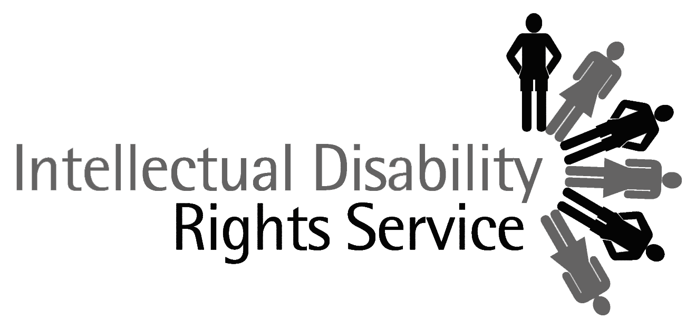

Disability Rights Unit
HREOC
GPO Box 5218
SYDNEY NSW 2001

Dear Sir/Madam

Possible public inquiry on employment and disability issues

Thank you for the opportunity to provide comments on the possible HREOC inquiry into employment and disability issues. The Intellectual Disability Rights Service (IDRS) would welcome such an inquiry.

As you may be aware, IDRS is a statewide community legal service for people with an intellectual disability in NSW. We provide legal advice and in some cases, representation for people with an intellectual disability in a variety of areas of law, including industrial and employment matters. As a result of our practice over a number of years we have identified the employment of people with an intellectual disability as an area of key concern.

- Business services

Approximately 15,000 people with disabilities are employed in business services funded under the Disability Services Act (Cth). There are a further 3,700 employed in combined business services and open employment outlets.

Historically, conditions of employment in business services were generally seen as secondary to the perceived purpose of these services in providing activities for people with disabilities outside their home. Many business services determined the wages of their employees with disabilities in accordance with the capacity of the business to pay or other arbitrary means rather than by reference to an award or other industrial instrument. Many business services do not operate at a profit or indeed break even. Many employers themselves conduct assessments of the productivity of workers with disabilities for the purpose of determining their rate of pay, rather than engaging an independent body to conduct such assessments.

The result of these and other factors has been that employees with disabilities are often paid incredibly low wages, and have limited or no opportunities for training or career advancement.

With the enactment of the DSA, the Commonwealth hoped to reform these workplaces, but the process of change appears to have been slow. Employers seeking funding under the DSA will now need to be certified that they meet the disability employment standards by 31 December 2004.

IDRS is concerned about the treatment of people with an intellectual disability in business services and would support a HREOC inquiry encompassing these issues.

- Other issues

Anecdotal evidence from our telephone legal advice service has given IDRS reason to believe that serious issues arise for people with an intellectual disability in both supported and open employment:

- Access to employment, training and opportunities for advancement

- Failure of employers to ensure safety of employees with an intellectual disability at work

- Failure of employers to accord workers with an intellectual disability their statutory entitlements, for example: leave entitlements

- Sexual harassment or assault of employees with an intellectual disability

- Intimidation, harassment and bullying of people with an intellectual disability

- Inappropriate discipline or unfair termination of employment

- Further contact

We would be most agreeable to expanding on the content of this letter. Please contact Linda Rogers, Senior Solicitor, at IDRS if you would like further information. Ms Rogers can be reached on Ph 9318 0144.

Yours faithfully,

Meredith MacDonald
Director
5 October 2004

According to the 2000 Disability Census.

