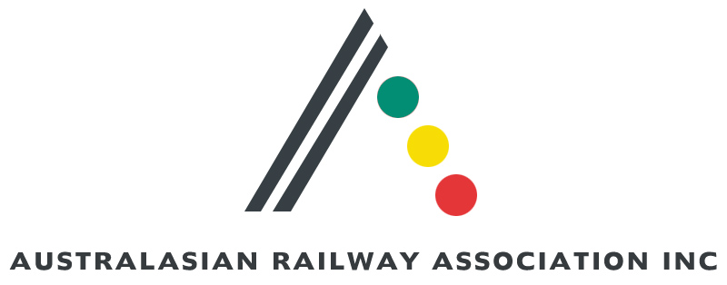

Human Rights and Equal Opportunity Commission
GPO Box 5218
SYDNEY NSW 1042

29 July 2005

Application for exemption under S 55 of the Disability Discrimination Act from parts of the Disability Standards for Accessible Public Transport 2002 and amendments.

The Australasian Railway Association (ARA) understands that the Disability Discrimination Act 1992 (DDA) makes it unlawful for service providers to discriminate against people with disabilities. It also understands the Disability Standards for Accessible Public Transport (the Standards) were designed to clarify DDA requirements for public transport service providers. ARA supports the intent of the Standards and intends to adopt them as part of a rail industry Code, but has concerns that some Transport Standards cannot be met as a result of technical, safety, and operational constraints unique to rail transport.
ARA is keen to resolve these issues and understands that the only way of doing so (at present) is by applying for an exemption to the Human Rights and Equal Opportunity Commission (HREOC). The five-year review by the Accessible Public Transport National Advisory Committee, which will start after 2007, is too late, particularly in view of the lead time required to achieve compliance targets. At present, most State Governments are purchasing new trains and trams and building or refurbishing stations. Rail operators and providers need the certainty of approved solutions to improve the accessibility of transport premises, infrastructure, and rolling stock. The rail industry is also eager to avoid imposing future costs on public funds and resources by any retrofit required owing to lack of certainty in the design process.
ARA convened a national rail industry workshop late in 2004 involving major rail operators and manufacturers to examine means to address the Standard where there are issues of impracticality. Information detailing rail operators’ technical, safety, and operational constraints in meeting the Standards for rolling stock and stations was collated. Where appropriate, alternative practical solutions to meet the intentions of the Standards were devised and documented.

The attached document constitutes an application for exemption from those clauses of the Standards that cannot be adopted in their current form. The document highlights exemptions and clauses not requiring any changes. In a number of clauses, the intention of the Standards remains the same, but words have been altered or additional information added to improve the clarity. For consistency, these clauses are included as part of the exemptions. Where relevant, extracts from the Guidelines to the Standards have been inserted.

In summary, practical solutions are needed where current Standards cannot reasonably be met. ARA requests exemption from relevant Standards listed in the document attached as the most effective means to address the needs of all stakeholders (community, public transport providers / operators, designers, equipment providers, and contractors).

ARA is keen to work with HREOC and the peak disability communities to achieve standards that can be implemented. ARA will then work to incorporate these Standards as a rail industry Code.

If you need any additional information please contact the ARA Project Manager Disability Standards Mr R. Balasekeran (Bala) on 07 32351724.

Phil Sochon

Deputy Chief Executive Officer
Australasian Railway Association

