Physical Disability Council of New South Wales

St. Helen’s Community Centre
3/184 Glebe Point Road
Glebe NSW 2037

Telephone (voice): 02 9552 1606
Telephone (TTY): 02 9552 1370
E.mail: pdcnsw@pdcnsw.org.au Fax: 02 9552 4644
Web Site: http://www.pdcnsw.org.au Freecall: 1800 688 831

David Mason
Director
Disability Rights Policy
HREOC Disability Rights Unit
Human Rights and Equal Opportunity Commission
GPO Box 5218
Sydney 1042

Monday, 12th September, 2005
Dear David,

I write to you in relation to the application made to the Human Rights and Equal Opportunity Commission by the Australian Railway Association (ARA) for exemption under section 55 of the Disability Discrimination Act.

PDCN wishes to lodge it’s strong opposition to the application.

In lodging our opposition, we strongly support points made in the submissions by the Physical Disability Council of Australia (PDCA) and the Australian Federation of Disability Organisations (AFDO).

The Physical Disability Council of New South Wales Inc (PDCN) provides a voice for people with a physical disability living in NSW with the goal of securing equal rights for people with disability.

Yours Sincerely,
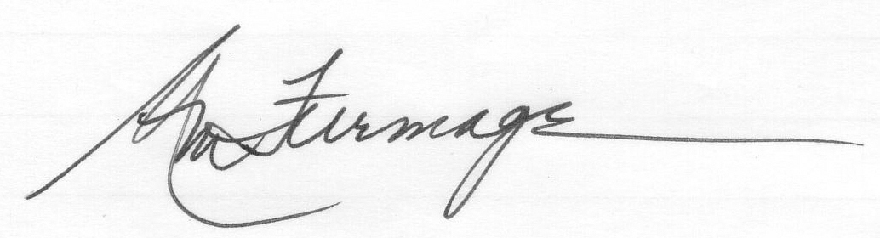
Ann-Mason Furmage

President, PDCN

