20 December 2001

Disability Rights Unit
Human Rights and Equal Opportunity Unit
GPO Box 5218
Sydney NSW 1042

TEMPORARY EXEMPTION APPLICATION UNDER DDA SECTION 55:
TACTILE GROUND SURFACE INDICATORS (QUEENSLAND RAIL).

National Express Group holds the franchises for public transport in Victoria to operate the Bayside Trains, Swanston Trams and V/Line Passenger on behalf of the Government of Victoria. National Express Group is committed to ensure that people with special needs have the freedom and independence to enjoy equivalent access to our services.

Railway Platforms

We believe that the use of TGSI’s at railway stations is an essential part of accessibility improvements for railway infrastructure. However, issues such as this where technical standards are required, care must be taken that in improving accessibility for one type of disability, others are not disadvantaged or endangered.

We also seek clarification of the Standards for a consistent approach. Following this report, we have attached the 3 styles of TGSI’s currently in place at Melbourne railway stations:
- 1989 – Kooyong and Prahran. These stations are located close to centres for people who are blind and vision impaired, and were designed in conjunction with representatives of the facilities at both locations. They have a single row of directional TGSI’s
- Early Ninties – Box Hill. This station was done similar to the 1989 stations, but with an adjacent row of hazard TGSI’s closer to the platform edge. This system has been strongly supported by passengers who are blind, and also by senior orientation and mobility instructors from Vision Australia Foundation. It has also received positive comments from other users. (This would also assist some of the case studies in the BCA Response)
- 2001 – St Albans. A new station built recently to the current standard.

At a BCA forum on public transport held in Melbourne in May this year, criticism was made of the Flinders Street Station platforms, which are in accordance with the current standard. The comments were that the platforms have features, such as ramps, escalators, lifts and kiosks, but with no directional tiles, they were unable to located. We take this comment to support the Box Hill example above.

We support the QR Application to establish a consistent approach to TGSI’s on platforms, rather than risk further change later when greater feedback and experience becomes available. Whilst the timeline above only spans 12 years, many stations in Victoria date from the 1800’s, and current installations will have a life of at least 30 to 50 years.

Light Rail Platforms

In regard to our tram infrastructure, platforms are currently being introduced to accommodate the new low floor trams. The introduction of any new rolling stock is a difficult process, but with trams that compete with traffic on major roads, the implications are very much greater. This means that light rail platform standards are still very much an issue that is untrialled. We understand that the draft standard to replace AS 1428.4 may include a design standard for light rail platforms. Note that as we have not seen this proposal, we may seek to extend this application to include light rail platforms.

Luminance Contrast

We have not been involved in research of this issue, but ask the following questions. Some may have been considered and resolved, but we believe this may be the correct forum in which to raise them.

- Is the test method only for plain surfaces which needs to be approximated for patterned surfaces?

- What allowances and tests are required for the different lighting conditions of bright light, dusk, artificial lighting and wash out in glare conditions?

- What allowances are made for dirty surfaces and colour fading over time (eg, blue fades a lot)?

- Is yellow a preferred colour for people with low vision and how extensively should it be used?

- How are Corporate signage and decals, and signs in general affected by this requirement? If two colours are used, matching is easy, but it becomes more difficult with more than two colours.

- Does the 30 % luminance contrast suit dark colours better, and may therefore not be as appropriate for lighter colours?

- Is an automated system available to make rapid checking available?

Conveyances

We support the QR application as it applies to conveyances. Unlike railway stations, conveyances are totally consistent in their layout, and a requirement for TGSI’s is not warranted.

In conclusion, National Express Group supports the installation of TGSI’s on platforms, but believe differing views exist on the best outcome from the broader accessibility perspective. In order to achieve a consistent approach, we support the QR application for a temporary exemption.

Yours sincerely,

BERNIE CAROLAN

COMMERCIAL DIRECTOR

TGSI’s at MELBOURNE RAILWAY STATIONS

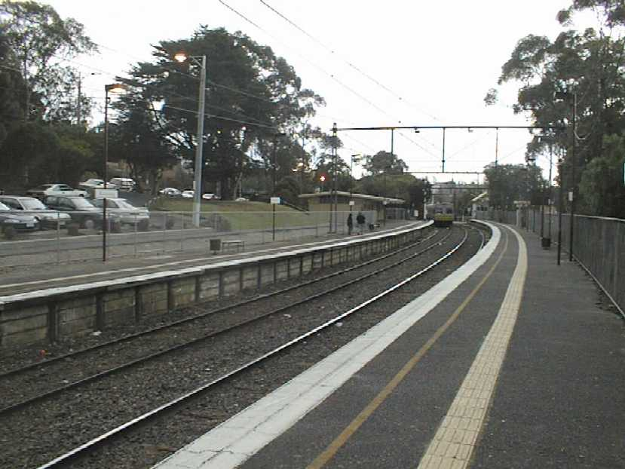 | 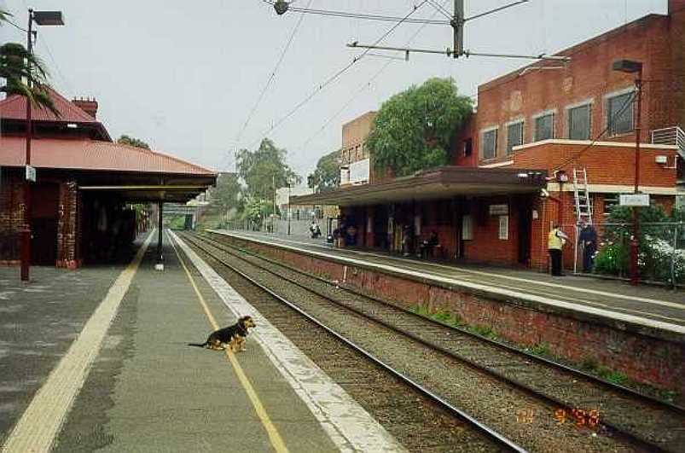
KOOYONG - 1989 | PRAHRAN - 1989

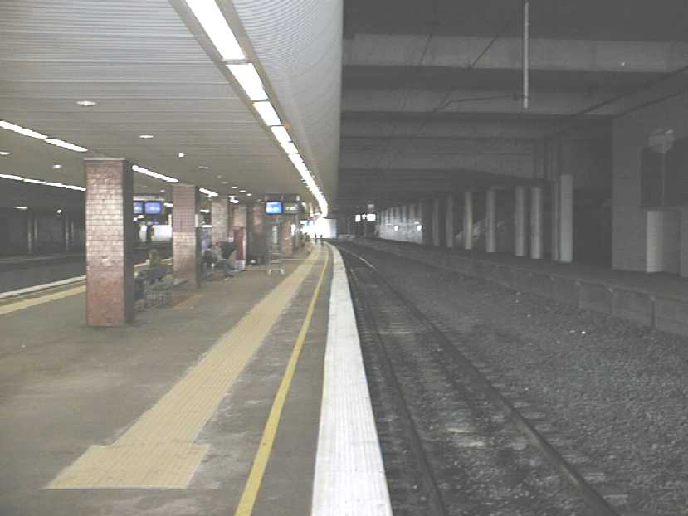 | 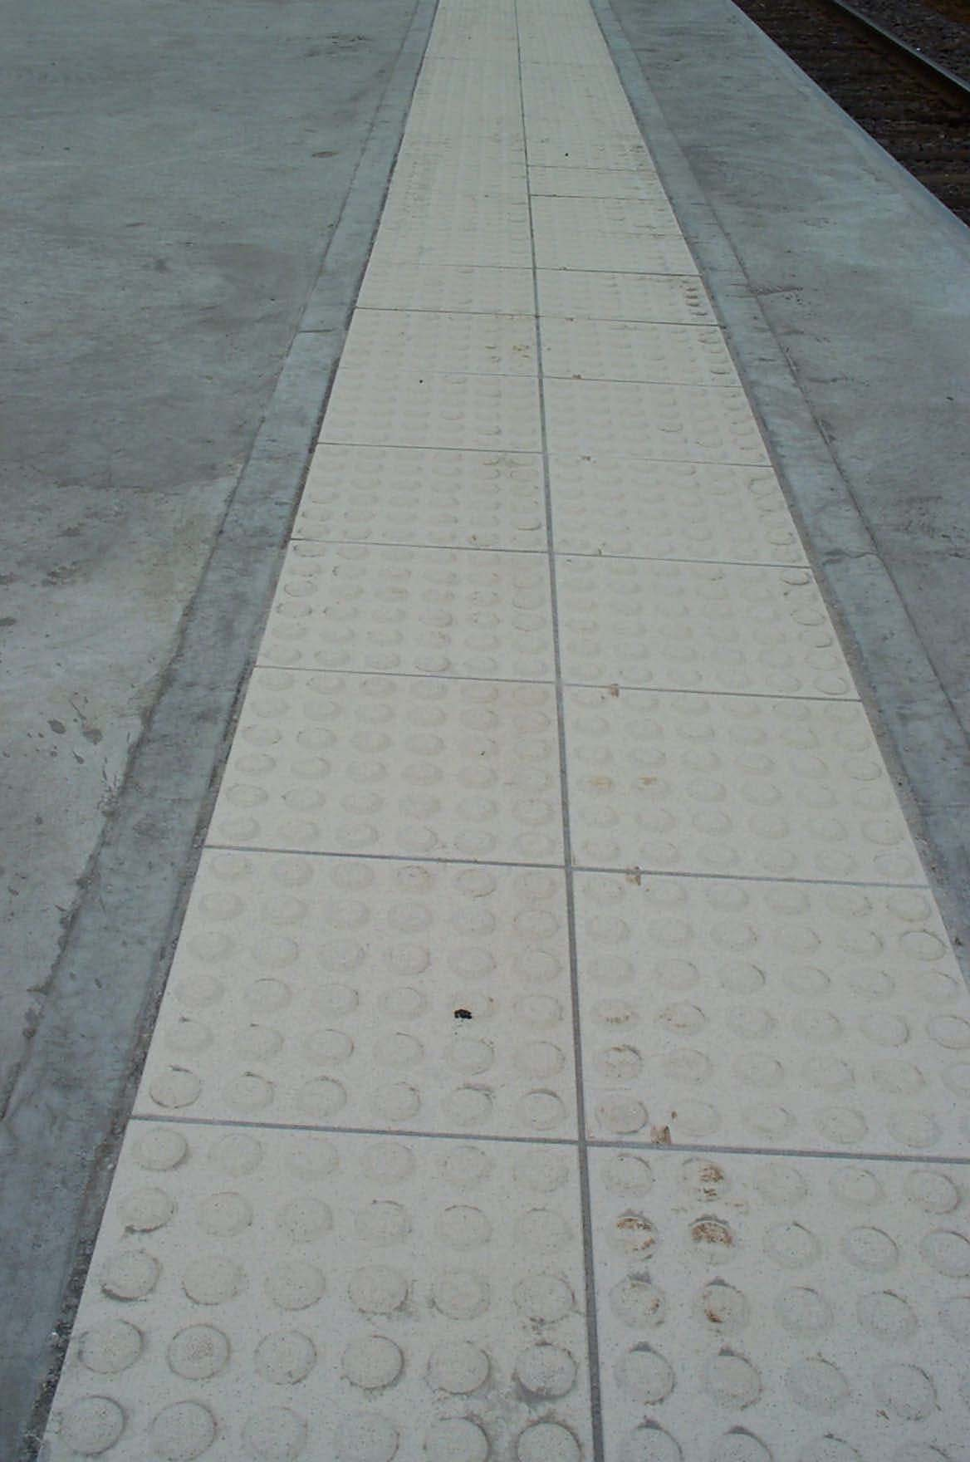
BOX HILL – EARLY NINTIES | ST ALBANS - 2001

