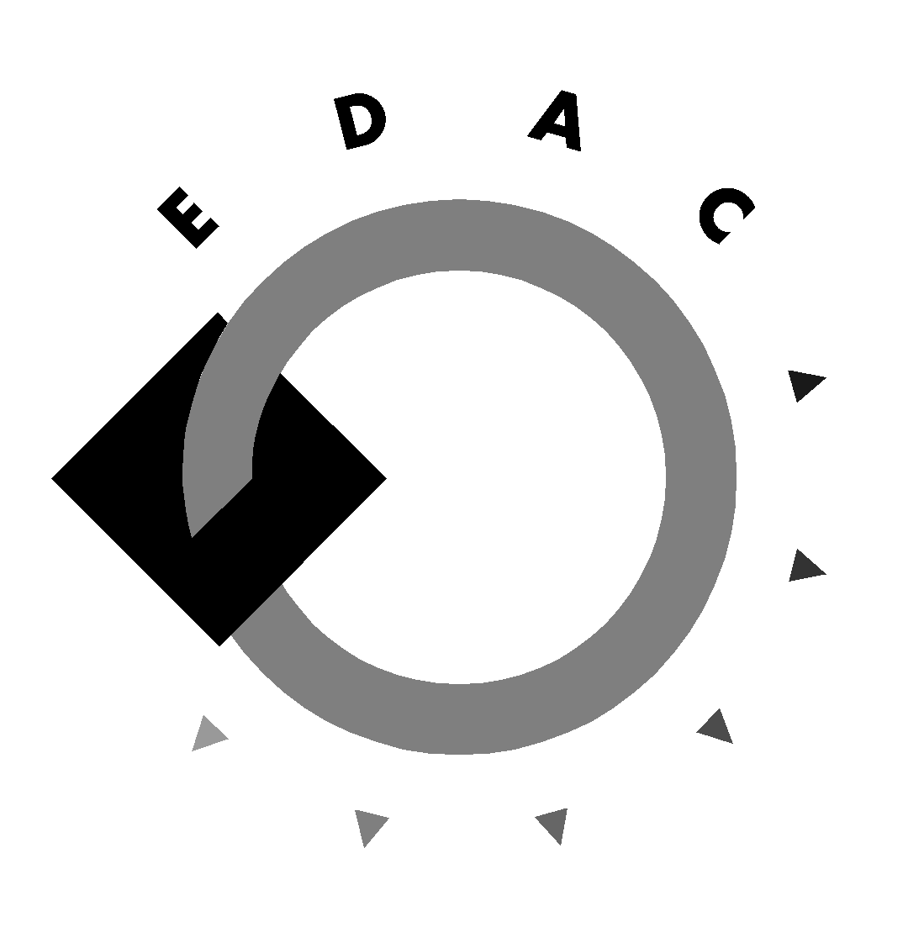

EDAC and MDAA Submission to the

HEROC Wheelchair Accessible Taxis Public Inquiry

Background:

MDAA and EDAC are community based advocacy organisations for people from NESB with disabilities operating in NSW and WA respectively.

MDAA aims to promote, protect and secure the rights of people from NESB with disability and their families carers in NSW. MDAA provides individual and systemic advocacy, as well as education and training.

EDAC advocates for the rights of people from NESB with disabilities and their families/ carers in Western Australia.

Introductory Comments:

The majority of issues facing people from NESB who use wheelchairs in relation to access to wheelchairs accessible taxis are the same as those encountered by Anglo- Australian Wheelchair users. MDAA and EDAC are confident that these issues will be raised by those community organisations, which have a particular focus and expertise on issues facing people with physical disability (such as PDC, NSW). MDAA supports the submission put to HREOC by PDC, NSW.
The two overall comments, EDAC and MDAA wish to make are that firstly, response times are completely unacceptable, and secondly, standards for a uniform taxi design and system that is fully accessible need to be developed and adopted within a reasonable timeframe.

Below, MDAA and EDAC limit our comments on some of the particular issues facing people from NESB in wheelchairs who access taxis.

Issues specifically relevant to wheelchair users from NESB

Knowledge of Taxi Subsidy Scheme

Overall the knowledge of Taxi Subsidy Scheme within NESB communities is at best scant and there have no or little efforts being made to promote that scheme. By default this means that the Scheme therefore limits access to people with adequate English language skills or with connections to people who have those skills.

Recommendations:

Resources be made available to promote the Taxi Subsidy Scheme in NESB communities, and the basic information pamphlet on Taxi subsidy scheme be made available in the top 10 languages

Cost of using Taxis
In general, people from NESB rank lower on the socio-economic scale than their Anglo-Australian counterparts. This is often explained by:
- Levels and recognition of educational qualifications
- Levels and recognition of work skills and experience
- English Language proficiency
In Australia, migrants with disability (except for those immigrating on humanitarian grounds) have to wait ten years before they can access income support.
Getting from A to B then becomes a luxury, a luxury which would not be one, if public transport was accessible to all of the public.
Even with the Taxi Subsidy Scheme, taxis are a luxury, especially for people living in outer metropolitan regions, such as the western suburbs of Sydney, were many migrants live.
Recommendation:
Funding be made available for taxi subsidy scheme users toy receive up to 75% subsidy of total cost of taxi fare across the country, in line with Western Australian subsidy regulations.

Booking systems

The booking system remains completely inaccessible unless a person has reasonably good command of the English language.

Recommendation:
Funding be made available to link TIS to the booking system.

Taxi drivers banning people with disabilities

MDAA is aware of several instances where people have been ‘banned” by taxi drivers because they are seen as ‘trouble makers’ and because they refused to participate in a system which they perceive as defrauding the Taxi Subsidy Scheme (ie. giving out more than one taxi subsidy voucher per trip).

MDAA also knows of incidences where people clearly identified that they were being defrauded, but they felt that they could not make a complaint, because they depend on the TAXI service. All of the instances occurred in Western Sydney, where accessible Taxis are even more scares than in the rest of Sydney. This does no only affect people from NESB with disability, but because of the high NESB population in the Western Suburbs of Sydney, it affects many people from NESB.

Variance in taxi charges

It is our understanding that there is an additional charge for loading time. Whilst such charges are quite legitimate and are usually incorporated into the general fare, our consumers have reported some inconsistencies. The loading cost can vary between $2 to $6. People with disabilities from NESB would be too frightened or unable due to language barriers to object or question the driver when there is a variance in the fares charged.

Recommendation:
A policy be developed and monitored on charges relating to loading and unloading of wheelchairs/

