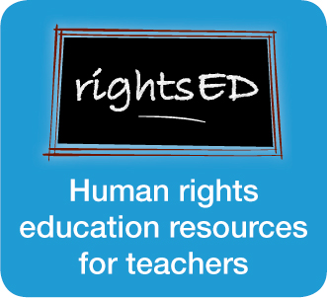

Child rights
Child rights
Subjects: Civics and Citizenship, Society and Environment (all)
Level: Year 5 and up (10 years and up)
Time needed: 1 – 4 lessons

Introduction
All people – no matter their age, sex, colour, religion or where they live – have the same basic needs to live a healthy life. These needs include food, shelter, education, healthcare and freedom from persecution and discrimination.
Through the Universal Declaration of Human Rights (UDHR), the governments of the world agreed that people have a right to have these basic needs met. Denying people their basic rights not only leads to the personal suffering of individuals – it can result in conflict and unrest in societies.
In addition to the rights in the UDHR, children have supplementary rights that recognise those things that they need to help them survive and develop to their full potential.
The Convention on the Rights of the Child (CRC) sets out these rights – and Australia, along with nearly every other country in the world, has agreed to protect these rights.

Aim
This series of activities will help students to:
- understand the difference between rights and wants
- research important aspects of the Convention on the Rights of the Child
- appreciate the important rights in their life
- consider the rights issues that children in Australian immigration detention centres faced prior to policy change.
The activities can be photocopied for class use and used individually or as an entire resource.

Learning outcomes
Students will have the opportunity to:
- discuss rules and laws that affect young people and assess these according to fairness and appropriateness
- identify key personnel within the legal system who protect peoples rights
- define and exercise personal and shared rights and responsibilities within local contexts.

Activities/resources
- Activity sheet: Rights and wants
- Resource sheet: Human rights images
- Activity sheet: Rights and wants
- Activity sheet: Getting to know the Convention on the Rights of the Child (Child friendly version)
- Activity sheet: A last resort
- Resource sheet: A last resort
- Activity sheet: A last resort

Teaching strategies
Teachers should familiarize themselves with the rights covered in both the UDHR and the CRC prior to the lesson. These are available for download at: http://www.un.org/cyberschoolbus/humanrights/resources/

Activity sheet
Rights and wants
- Provide students with picture cards from the Resource sheet: Human rights images. Ask students to brainstorm which human rights could be associated with the pictures (eg. right to vote, right to education). Make a list of rights on the whiteboard (they may think of others).
- Each student independently selects the five rights that are the most important to him/her and explains why to their partner. Each pair then works together to complete a list of their shared top three rights.
- Each pair then shares their list with the class, and these lists are recorded on the board. From this, construct a top three list for the class. (This could be done as a tallying exercise).
- Was it difficult to choose some rights over others?
- How did you decide which rights were more important than others?
- How much difference/ similarity is there between student choices?
- What are some reasons for those differences?
- Provide students with the Worksheet: Rights and wants. Students work in pairs to discuss the statements on this worksheet and decide whether each statement is a RIGHT or a WANT. The goal is to encourage students to give their immediate responses to the statements, as there are not necessarily always right or wrong answers.
- After completing this list, students share their answers with the class and explain why they think each statement is either a RIGHT or a WANT.
Note: Most of the statements could be argued to be a right by law, except where the student has breached those rights. New clothes, our own bedroom and the choice of going to school are wants, and as such would depend on consultation with parents/ guardians. Students should be encouraged to review the child friendly version of the Convention on the Rights of the Child to determine how the rights could be linked.

Extension
Students decide who is responsible for protecting each of the rights (eg. themselves, their parents, their teachers, or government). Students could then either brainstorm or research ideas about what other RIGHTS children have (depending on course requirements).

Research
A research task is suggested on the worksheet. Possible questions for discussion (before or after research activity) could include:
- Do all children have their rights met?
- Which children might not have their rights protected? Why/why not?

Resource sheet
Human rights images
The following images are a visual representation of various human rights. Some images may be associated with more than one right. Key rights that may be associated with images are equality, right to vote, nationality, identity, freedom from persecution, labour rights, freedom of speech, leisure, participation, education, shelter.
Pictures cards can be copied for educational purposes and cut as cards for distribution. Photo images are by Amanda Lim (2003 Human Rights Photography Competition), cartoon images are from Shutterstock Photos (http://www.shutterstock.com) and drawings are by Adam Hill
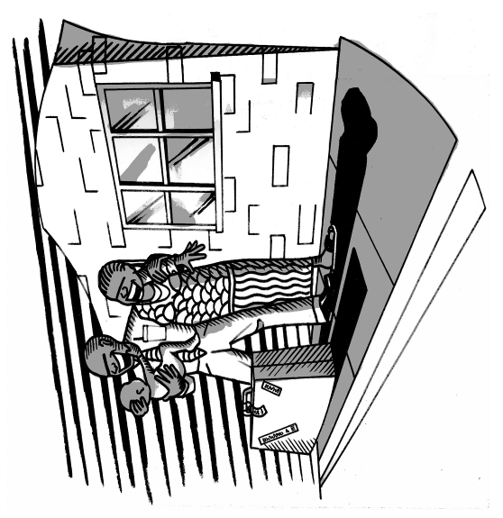 | 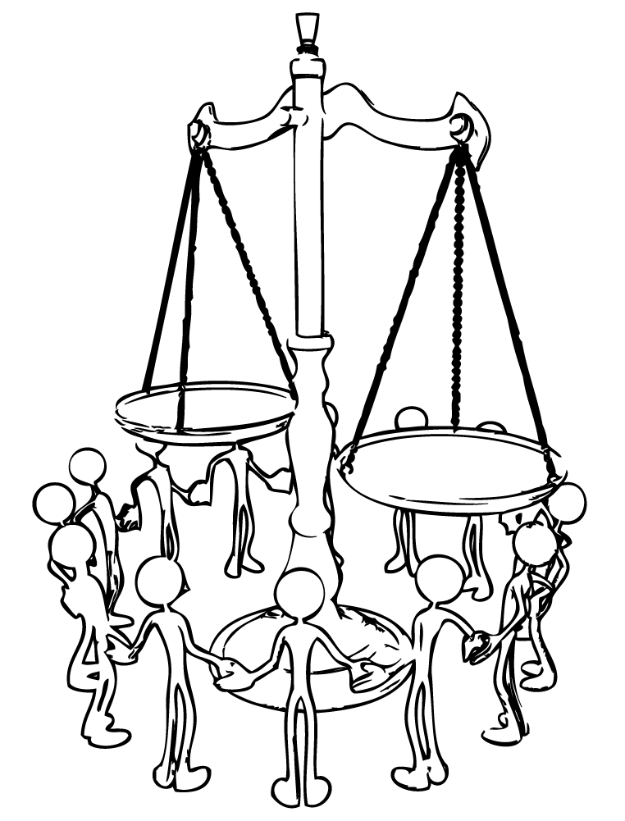
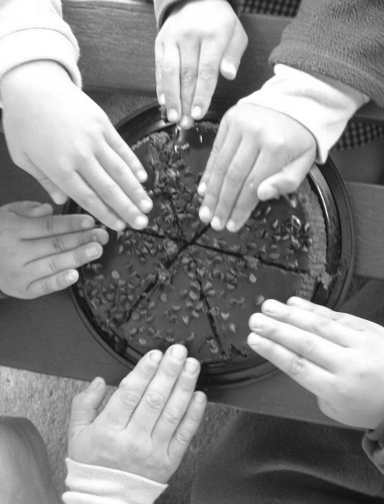 | 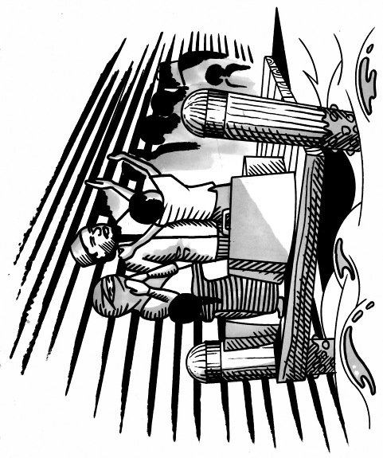

Resource sheet
Human rights images
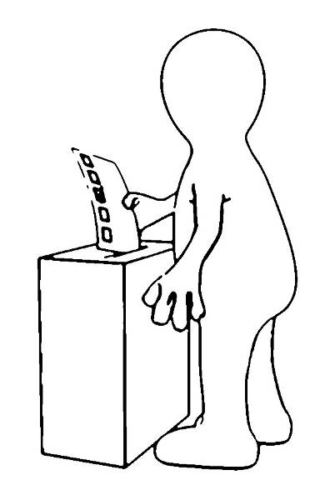 | 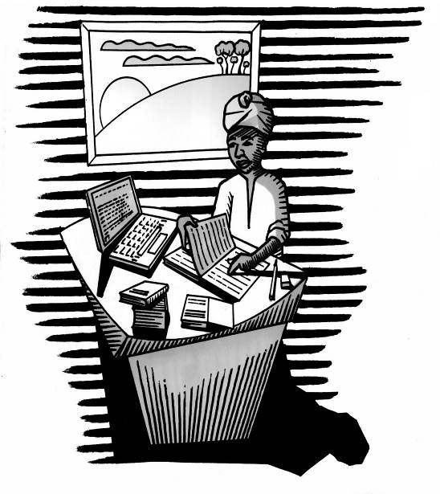
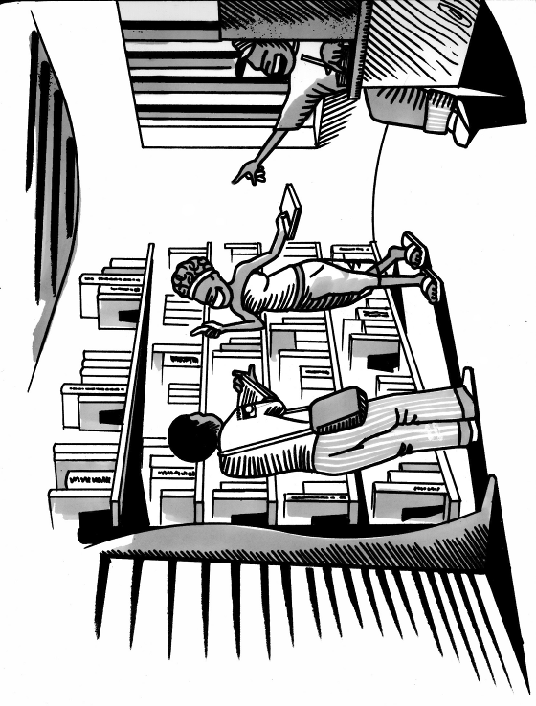 | 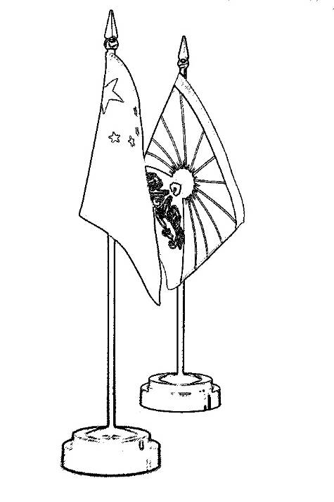

Resource sheet
Human rights images
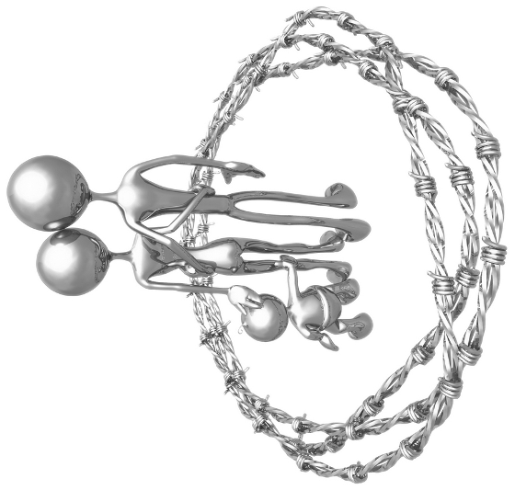 | 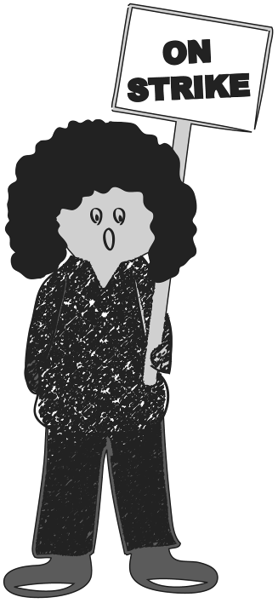
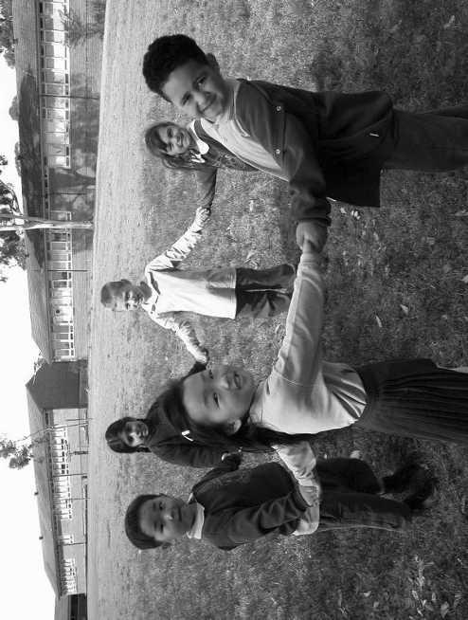 | 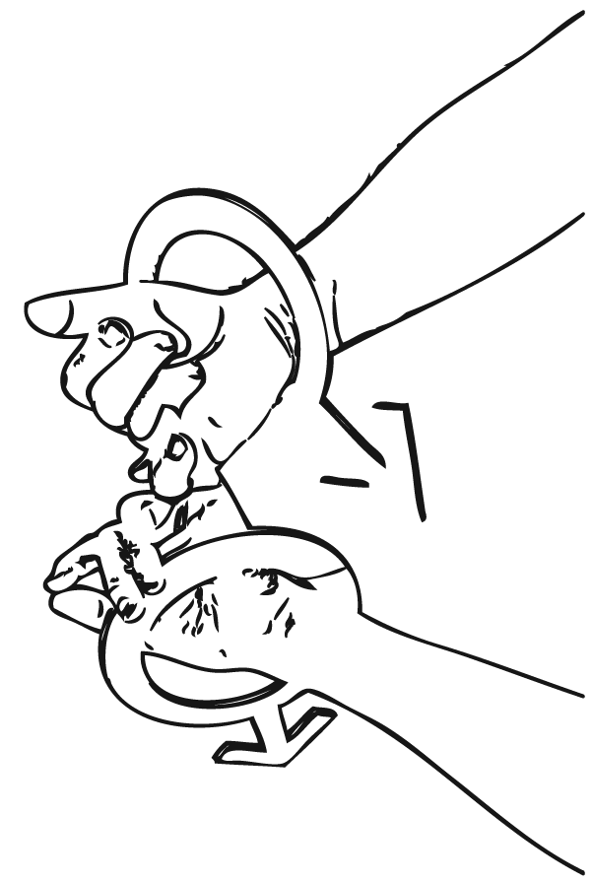

Activity sheet
Rights and wants
- Work in small groups to assess the following statements.
- Decide whether each statement is a RIGHT or a WANT of children and young people and place a tick in the appropriate box.

Statement | Right | Want
I have a right to a good education
I have a right to vote in government elections
I have a right to rest and play
I have a right to health care
I have a right to new clothes
I have a right to be cared for by my parents
I have a right to my own bedroom
I have a right to speak my own language
I have a right to be safe in the place where I live
I have a right to have my views taken seriously by adults
I have a right to choose whether or not I go to school
I have a right to choose my own friends and the groups I belong to
I have a right to special care if my parents can’t look after me
I have a right to enter the supermarket
I have a right to legal help so my rights can be protected
Share your answers with the class and explain why you think each statement is either a RIGHT or a WANT.

Extension
Write down next to each statement the people that are responsible for protecting each of the rights. For example: is it you, your parents, your teacher, the police or perhaps the government?

Research
Do all children have the same rights? Research the lives of other children in Australia and other countries. Find out:
- what they do during the day
- when/ where they go to school
- who they live with.
Compare your findings with others in your class.

Activity sheet
Getting to know the Convention on the Rights of the Child
Note that the Activity sheet: Rights and wants provides an introduction to this activity. Provide students with a copy of the (child friendly version) Convention on the Rights of the Child (available at: http://www.un.org/cyberschoolbus/humanrights/resources/plainchild.asp). Depending on knowledge levels, some discussion or overview may be required.
1. Students will need access to the internet (either at school or at home). Refer students to each of the following web links to so they are familiar with the purpose of each organisation:
- UNICEF (www.unicef.com.au)
- Australian Human Rights Commission (www.humanrights.gov.au)
- National Children’s and Youth Law Centre (www.lawstuff.org.au)
2. Ask students to research the topic of child rights in order to explore protection mechanisms for human rights in Australia. Suitable research questions could include:
- What is the Convention on the Rights of the Child? Who does it cover?
- Who decided what rights should be included in the Convention?
- How many countries have ratified the Convention? Who hasn’t ratified the Convention – and why not? What happens when a country ‘ratifies’ a Convention?
- Is there any monitoring of whether or not countries are doing their job to protect the rights of children?
- What is Australia’s record on protecting children’s rights? (Where do we find out?)
- Does the Convention take away from parents the right to raise their children in the way they think best?
- Article 3 says that any decisions that adults make that affect you have to take into account your ‘best interests’. What sort of decisions or situations might this cover?
- How does the Australian Human Rights Commission work to promote the rights of children:
- In Australian courts?
- In the United Nations system?
- In the community?
4. Groups share their answers with the rest of the class and discuss any issues that came up while doing the research.

Activity sheet
A last resort
The aim of this activity is to introduce students to the issues that faced children who were kept in Australian Immigration Detention Centres prior to the policy change in 2005.
Note: In June 2005 the Migration Act was amended so that children and their families could only be detained in immigration detention centres ‘as a measure of last resort’. Prior to this, children were automatically detained in detention centres.
Families and children have since been released from immigration detention facilities into community-based detention, which means that they can live in the community and participate in education and community life. For shorter periods of time, children and their families may be placed in residential housing centres or alternative detention arrangements.
For current Government policy refer students to http://www.immi.gov.au
1. Read the following case study to students as a listening exercise (or provide them with the text).
Case study
The year is 2002. Zarah is a 12 year old Iraqi girl being held in one of Australia’s immigration detention centres. She fled Iraq with her parents and younger brother because the family had received death threats and were afraid of political persecution. After a long and dangerous journey, the family arrived in Australia hoping to be accepted as refugees and to begin a new life. However, under previous Australian Government immigration policy, they were placed in an immigration detention centre while their application for refugee status was processed and finalised. Zarah and her family were in detention for almost 18 months.
2. Discussion questions:
- Who had the responsibility to protect Zarah’s rights while she was held in immigration detention?
- What do you think Zarah might list as her top three rights?
- Do you think that she would have been able to enjoy those rights? Why or why not?
- What impact do you think it would have on Zarah if she can’t enjoy those important rights?
3. Have students read through the quotes included in the Resource sheet: A last resort. These interviews were part of the Commission’s 2003 National Inquiry into Children in Immigration Detention.
4. Ask students to examine each quote and identify:
- the right(s) that have been denied to the young person
- the action that should have been taken to ensure that their rights were protected
- the groups that might have been involved in protecting those rights.
A grid is included with the Worksheet: A last resort to assist students to record their answers.
Additional research questions based on the National Inquiry could include:
- When did Australia change its policy on children in detention?
- What was the reason for changing the policy on children in detention?
- What happens to children arriving in Australia illegally today?
- What groups were involved in lobbying to protect children’s rights in detention centres?
- How did the Australian Human Rights Commission gather material about children in immigration detention?
- What groups spoke to the Commission about children in immigration detention?
- To what extent was Australia upholding its obligations under the Convention on the Rights of the Child before the change in policy in 2005?
For further information see the Summary Guide to A Last Resort at: www.humanrights.gov.au/human_rights/children_detention_report/summaryguide/index.html

Resource sheet
A last resort
Evidence from the 2003 National Inquiry into Children in Immigration Detention
Read through the following quotes. These are things that asylum seeker children told the Australian Human Rights Commission about their time in Australian immigration detention centres.

Quote 1
I think that the children should be free and when they are there for one year or two years they are just wasting their time, they could go to school and they could learn something. They could be free. Instead they are like a bird in a cage.

Ten-year-old Afghan girl found to be a refugee, Perth focus group, June 2002.

Quote 2
There are children who have been there for a very long time – two to three years – and they have done things that are very distressing, like they went up the trees and they wanted to throw themselves, trying to commit suicide. There were kids that actually stitched their mouths. Things that are so traumatic that we are now having nightmares on a daily basis.

Former detainee boy, Perth focus group, June 2002.

Quote 3
When we were in the detention centre and someone was sick, headache or sick and they would say, ‘Just drink water’. … My sister has a problem with her eyes. She said her eyes were so painful and she went to the doctor who said, ‘You just have to drink water’. Now we come to Sydney and the doctor says she has a problem in her eyes.

Teenage girl, Sydney focus group, September 2002.

Quote 4
In Port Hedland there is a school outside ... I used to stand on a chair and look out at them. I like to see what they looked like in their school uniform. There was an officer … and she pulled my shoulder down and put me on the ground and said, ‘You are not allowed to look at those people because they are different to you’. And I was like ‘Why are they different to me? Because they know English and they are Australian, does that make them better?’

Teenage boy, Perth focus group, June 2002.

Quote 5
After one month they brought one woman but you don’t know who she is – we are just UAMs (unaccompanied minors) with her. At this age we need mother and father – we not leave mother and father unless there are big things to make us leave our families.

Unaccompanied child, Woomera, January 2002.

Activity sheet
A last resort
After you have read the quotes, work in pairs to examine each quote and identify:
- the right(s) that have been denied to the young person
- the action that should have been taken to ensure that their rights were protected
- the groups that might have been involved in protecting those rights.
Use the grid below to record your answers.
 | Right(s) | Action | Groups
Quote 1
Quote 2
Quote 3
Quote 4
Quote 5
Compare your answers with your classmates.

