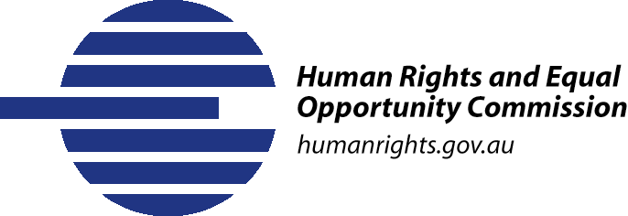
Same-Sex:
Same Entitlements

Background to the Inquiry
The Same-Sex: Same Entitlements Inquiry was launched by the Human Rights and Equal Opportunity Commission (HREOC) in April 2006. The final report of the Inquiry was completed in May 2007 and transmitted to the federal Attorney-General.
The Inquiry was guided by the following three goals:
- identify the federal laws which discriminate against same-sex couples and their children in the context of financial and work-related benefits and entitlements;
- describe the impact of those discriminatory laws on same-sex couples and their children; and
- make recommendations as to how to remove that discrimination.

Focus of the Inquiry
The Inquiry focussed on the following areas when conducting its audit of federal laws:
- employment
- workers’ compensation
- tax
- social security
- veterans’ entitlements
- health care
- family law
- superannuation
- aged care
- migration.
The Inquiry’s audit identified 58 federal laws which discriminate against same-sex couples and, in some cases, their children.

Discussion papers issued by the Inquiry
The Inquiry released several discussion papers as a way to encourage community responses and elicit further information from experts in the field. Copies of the discussion papers can be found at: http://www.humanrights.gov.au/samesex/papers.html
The final report incorporates the information in those discussion papers. It also includes information contained in the written and oral submissions received by the Inquiry and information gathered through additional research.

Consultations with the community
The Inquiry spent more than three months travelling around Australia holding public hearings and community forums to hear, first hand, about the impact of discriminatory laws on gay and lesbian couples.
The Inquiry held seven formal public hearings and 18 community forums around Australia between 26 July and 16 November 2006. For a list and summary of the hearings and community forums see: http://www.humanrights.gov.au/samesex/hearings.html
Those public consultations clearly revealed the financial and emotional strain placed on gay and lesbian couples who are trying to live their lives like everybody else in the community.
Submissions received by the Inquiry
The Inquiry received submissions from 680 different organisations and individuals including the following groups:
- employment bodies
- gay, lesbian, bisexual, transgender and intersex individuals and couples
- human rights, advocacy and legal bodies
- members of the public
- non-government organisations
- organisations representing gay, lesbian, bisexual, transgender and/or intersex people
- parents, friends or family members of same-sex couples
- peak bodies
- religious organisations
- state and territory government agencies
- state equal opportunity commissions
- unions
- universities and academics.

For a full list of those who made submissions and copies of selected submissions see: http://www.humanrights.gov.au/samesex/submissions.html
Further information
For further information about the Same-Sex: Same Entitlements Inquiry go to: http://www.humanrights.gov.au/samesex

