Chapter 6:
Aboriginal and Torres Strait Islander Social Justice
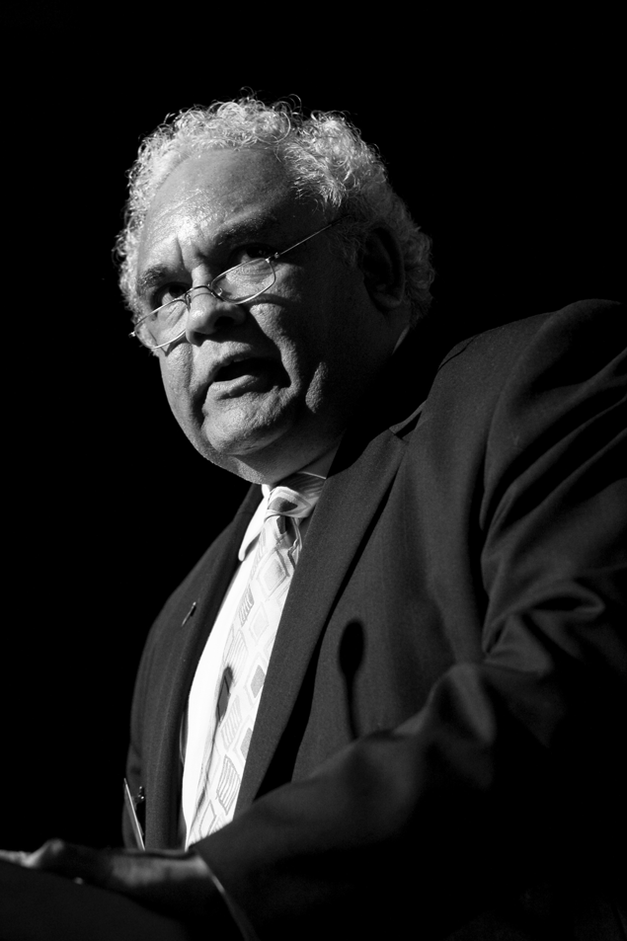
Mr Tom Calma, Aboriginal and Torres Strait Islander Social Justice Commissioner

6.1 Statement from the Commissioner
As the Social Justice Commissioner, this past year I have focused my energies on bearing witness to some of the self-evident truths in Aboriginal and Torres Strait Islander affairs. One of my core functions has been to take the voices and the truth of peoples’ lived experiences to government. It has been to ensure that the discussion and debate about Indigenous peoples and social justice is based on reality.
In this respect, the past year has been an important one for building stronger relationships between Indigenous and non-Indigenous Australians that are based on honesty, acknowledgment and understanding.
We still have a relatively new federal government, which has continually stated its desire to ‘reset the relationship’ with Indigenous peoples based on mutual respect and good faith. It has joined with all Australian governments to make extremely significant commitments to close the gap, including by working in new ways and with accountability processes that have never meaningfully existed in the past.
Even though it has not all been heading in the right direction, and at times there have been inconsistencies and contradictions in the approaches adopted, we are nevertheless moving forward. This past year has been the opportunity to build on the Apology, and move forward in re-negotiating the relationship between Indigenous peoples and governments.
The pinnacle for me of this emerging new relationship was the government’s commitment to formally support the United Nations Declaration on the Rights of Indigenous Peoples, which it did on 13 April 2009. It was a watershed moment in Australia’s relationship with Aboriginal and Torres Strait Islander peoples.
The Declaration’s strength is that it provides a set of internationally endorsed objective standards to guide the relationship with Indigenous peoples, and to promote actions that respect and protect Indigenous culture. In making this formal statement of support, the federal government is committing to a framework which fully respects Indigenous peoples’ rights and creates the opportunity for all Australians to be truly equal. The Declaration must now be the pre-eminent reference on all issues relating to Aboriginal and Torres Strait Islander peoples.
The government’s commitment to re-setting the relationship with Indigenous peoples was also evidenced this year by the steps taken towards the development of new Indigenous representative structures to ensure a seat at the table for Indigenous peoples in decisions that affect us.
I started the year with the release of an Issues Paper that identified what I believed were some of the issues that have to be considered in developing a new national representative body. Soon after, I was asked by the government to select a Steering Committee, consult with Aboriginal and Torres Strait Islander peoples and together, develop a model for a new national representative body. Through the course of the year we have brought representatives from communities all over Australia to be a part of the process of thinking through the issues and developing a model that is grounded in the strongest principles of integrity. The process has been an insightful and rewarding journey for everyone involved. A proposed model will be submitted to the government by end of July 2009.
Another area of important reforms has been that of native title. Under the current system, it continues to be a long, hard road for Traditional Owners to achieve what seems simple on paper: recognition of their pre-existing rights to their country.
Native title and connection to land and waters is at the core of spirituality and physical and emotional wellbeing for Indigenous Australians. After 15 years of native title and very little evidence of any marked improvement in the lives of Indigenous Australians, we now have the benefit of learning from what has gone and learning from past experience of engaging in this unique system.
Over this past year, I have welcomed the Attorney-General’s efforts to ensure that the behaviour and attitude of all parties facilitates effective negotiation and agreement- making through the systems established under the Act. However, in addition to making recommendations for the improvement of the Act, I have continued to comment on the need for greater transparency and proper consultation.
In the Native Title Report 2008, I discuss in detail the challenges that climate change and water resources create for Indigenous peoples, whose voices in these processes, to date, have been marginal at best. This is despite the fact that Indigenous knowledge and traditional practices can contribute much to mitigate the effects of climate change and to support Indigenous economies at the same time. The critical importance of ensuring engagement of Indigenous peoples in the climate change debate is but one example of what needs to occur if we are to reset the relationship in good faith.

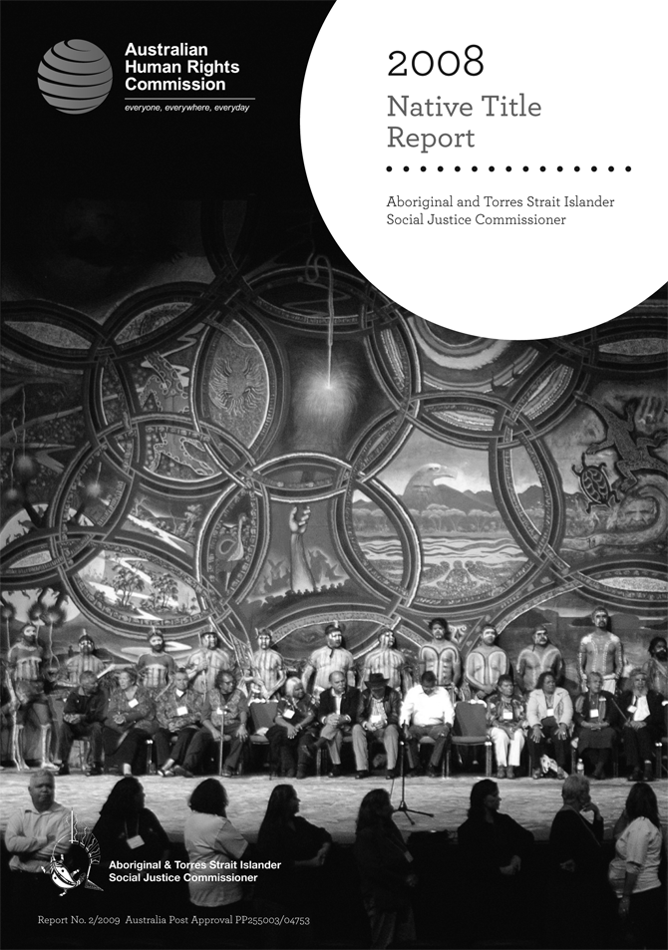
The Native Title Report 2008 includes detailed discussion of the challenges that climate change and water resources create for Indigenous peoples.
More broadly, in terms of Indigenous policy making, there emerged the strong need for a new direction. I agree with Lieutenant General John Sanderson, Chairman of the Indigenous Implementation Board in Western Australia, who said, ‘If you find yourself riding a dead horse, the best policy is to dismount’.
The relationships between Indigenous Australians and the Australian Government must be based on respect for culture and human rights, on the principles of justice, equality and non-discrimination. Responsible governance requires clear benchmarks and targets. Governments must be accountable for these benchmarks and targets. They must meet the commitments they make to Aboriginal and Torres Strait Islander peoples with all of the necessary funding, staffing and infrastructure support to ensure a possible success. And they must ensure that they work in real partnership with Aboriginal and Torres Strait Islander peoples.
The Council of Australian Governments (COAG) made significant inroads in putting in place the COAG National Indigenous Reform Agenda to overcome Indigenous disadvantage in the areas of health, housing and employment.
The Close the Gap Campaign Steering Committee for Indigenous Health Equality, of which the Aboriginal and Torres Strait Islander Social Justice Commissioner is Chair, has proactively engaged with many of the Indigenous and health reform processes initiated under the COAG National Reform Agenda. The Steering Committee has also engaged in the development of national health strategies for hospital reform, primary health care and preventative health care.
I am also pleased that there have now been preliminary discussions about how the ‘close the gap’ approach can be applied to Indigenous education. Already, the Australian Education Union, the National Centre for Indigenous Studies at the Australian National University, the National Indigenous Higher Education Council and senior Indigenous education professionals have started this conversation together. I hope we will see further developments in this regard in the coming year.
At the international level, Indigenous Australians made significant headway, which will in turn contribute to Indigenous development here in Australia. Indigenous Australians presented strongly at both the inaugural meeting of the UN Expert Mechanism on Right of Indigenous Peoples (August 2008) and at the Eighth Session of the UN Permanent Forum on Indigenous Issues – making interventions on Indigenous women, Indigenous youth, climate change, the compulsory acquisition of town camps and Indigenous economic and social development.
Finally, the Social Justice Report 2008 this year reflected on what are some of the fundamentals that we still need to address. These fundamentals are broadly as follows:
- ensuring our participation in decision making that affects us
- adequately protecting our human rights
- ensuring education is available to all of our children
- being proactive about crime prevention by investing in our
communities
- seeing native title as a core part of the social justice agenda.
To me, each of these should be self-evident. We must return to the truths that exist – in our relationships, and from our history. Only by doing this will we achieve social justice for Aboriginal and Torres Strait Islander peoples and in doing so, equality for all Australians.
I have been privileged to play a role in the constructive development of Indigenous affairs agendas at both the national and international level. But all of us, both government and community, benefit, if we can contribute together to the discussions on how Indigenous human rights can be better protected and realised in the laws, policies and programs.

6.2 Monitoring and reporting
A state-of-the-nation review of progress on Indigenous policy and human rights compliance is provided annually by the Social Justice Report and Native Title Report.
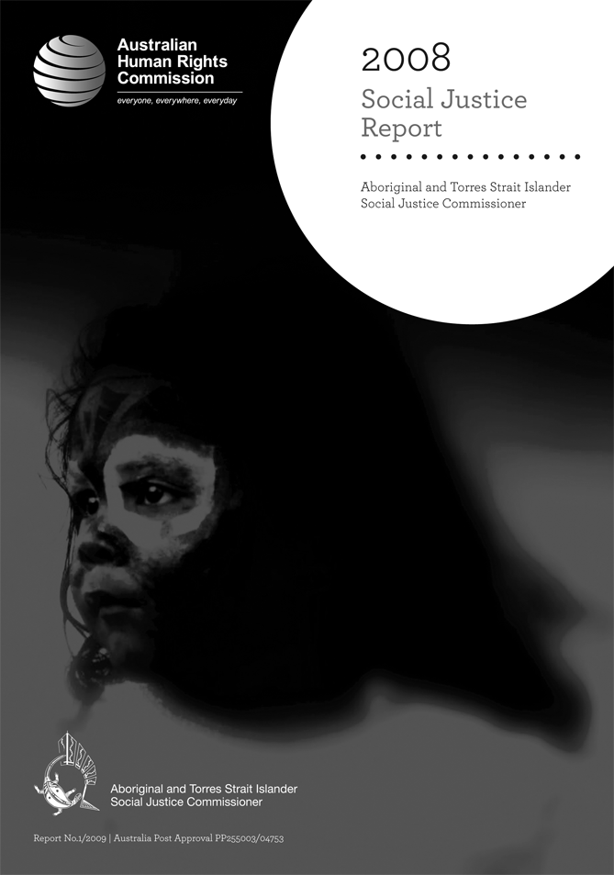
The Social Justice Report 2008 focuses on what is needed to improve Indigenous human rights protection, remote indigenous education, healing and health equality.

6.2.1 Social Justice Report 2008
Under section 46C(1)(a) of the Human Rights and Equal Opportunity Commission Act, the Commissioner, on behalf of the Commission, is required to submit a report annually to the Attorney-General on the exercise and enjoyment of human rights by Aboriginal persons and Torres Strait Islanders (the Social Justice Report).
This report analyses the major changes and challenges in Indigenous affairs over the past year. It also includes recommendations to government that promote and protect the rights of Indigenous Australians.
The Social Justice Report 2008 was transmitted to the Attorney-General on
6 February 2009 and tabled in the House of Representatives, out of session, on 29 April 2009. The report was officially launched on 4 May 2009 in Sydney at an event open to the media and the general community.
The Social Justice Report 2008 focuses on what is needed to improve Indigenous human rights protection, remote Indigenous education, healing and health equality. The report sets out some of the key steps that governments can take over the next 18 months to progress a new agenda for Indigenous affairs, including:
- establishing a credible national Indigenous representative body
- reinstating the protection of the Racial Discrimination Act in the Northern Territory
- making human rights a central part of the new relationship with Aboriginal and Torres Strait Islander peoples, by amending the Constitution, establishing a national Human Rights Act and formally supporting the UN Declaration on the Rights of Indigenous Peoples
- developing a remote Indigenous education strategy and accountability framework
- establishing an independent national Indigenous healing body
- putting in place a properly-funded, long-term plan of action to achieve Indigenous health equality and objectively monitoring its progress.
The Social Justice Report 2008, a community guide, a media kit and other information are available online at: humanrights.gov.au/social_justice/sj_report/sjreport08/index.html.

6.2.2 Native Title Report 2008
Under section 209 of the Native Title Act 1993 (Cth), the Commissioner is required to submit a report annually to the Attorney-General on the operation of the Native Title Act and the effect of the Act on the exercise and enjoyment of human rights of Aboriginal peoples and Torres Strait Islanders (the Native Title Report).
In accordance with section 46C(1)(a) of the Human Rights and Equal Opportunity Commission Act, the Commissioner also reports on the impact that changes to policy and legislation related to land and waters has on the enjoyment and exercise of human rights by Aboriginal and Torres Strait Islander peoples.
The Native Title Report 2008 was transmitted to the Attorney-General on
6 February 2009 and tabled in the House of Representatives, out of session, on 29 April 2009. The report was officially launched on 4 May 2009 in Sydney at an event open to the media and the general community.
The Native Title Report 2008 provides an overview of changes to native title law and policy, and considers the implications of various court decisions that were handed down during the reporting period. It also examines the topical issues of climate change and water management and the need to promote and protect Indigenous traditional knowledge which can be used to respond to these challenges. Two case studies were undertaken to show these impacts. One focused on the rights of Torres Strait Islanders, and the other on the rights of the First Nations of the Murray-Darling communities.
The Native Title Report 2008 provides over 30 recommendations to government on how it can better realise the rights of Aboriginal people and Torres Strait Islanders.
The Native Title Report 2008, community guides, a media kit and other information are available online at: humanrights.gov.au/social_justice/nt_report/ntreport08/index.html.

6.2.3 Community guide and CD-ROM
Two community guides were printed and made available on the Commission website. The first was a community guide to the Native Title Report 2008 and Social Justice Report 2008. The second, entitled Climate change, water and Indigenous knowledge: Community Guide outlines the issues arising for Indigenous communities in the context of climate change and the need for Indigenous Australians to be engaged in developing and advancing a national climate change policy.
The reports, community guide, media summaries and other materials, have also been made available on a CD-ROM.

6.2.4 Evaluation
Evaluation surveys for the Social Justice Report 2008 and the Native Title Report 2008 were developed and distributed through:
- online evaluation surveys made available through the Commission website from mid-May 2009 to 29 June 2009
- emailing and posting the evaluation surveys to over 1500 people on the report distribution lists, with a deadline of 29 June 2009
- and an alert, that was sent out to 1610 people on the Social Justice e-list on 21 May 2009, with a link to the online version of the evaluation surveys.
There were 33 responses to the Social Justice Report survey and 43 responses to the Native Title Report survey. The large majority of respondents were familiar with the reports and found this year’s reports to be ‘very useful’ and informative. Several suggestions for issues that could be covered in future reports were given. Most respondents indicated they would read future reports.

6.3 Research and policy
The Social Justice Commissioner advocates for the recognition of the rights of Indigenous Australians and seeks to promote respect and understanding of these rights among the broader Australian community.

6.3.1 A National Indigenous Representative Body
The Australian Government has committed to set up a new national representative body to provide an Aboriginal and Torres Strait Islander voice within government.
On 12 July 2008, the Aboriginal and Torres Strait Islander Social Justice Commissioner released an Issues Paper outlining key considerations in the development of a new National Indigenous Representative Body.
The government then undertook the first round of community consultations between July and December 2009. The government held 80 public meetings and received more than 100 written submissions.
In December 2008, the government requested the Aboriginal and Torres Strait Islander Social Justice Commissioner to convene an independent Indigenous steering committee to oversee the second stage of the process, led by Indigenous Australians. The Steering Committee was tasked with consultation for and development of a preferred model for a national representative body for Aboriginal and Torres Strait Islander peoples.
In March, the Steering Committee convened a national workshop in Adelaide to identify the key elements of a new national representative body. Consensus was reached at this workshop on a range of issues, but further consultation and discussion is needed to address four outstanding issues: how the body can best represent Aboriginal and Torres Strait Islander peoples in a way that includes local and regional issues; what should be the structure of the national representative body; what should its relationship be with Government and the Parliament; and how should it be funded.
The Steering Committee will report on a preferred model to the Australian Parliament by the end of July 2009, with an interim body commencing shortly after.
Copies of the Issues Papers and Community Guides are available at: humanrights.gov.au/social_justice/repbody/index.html.
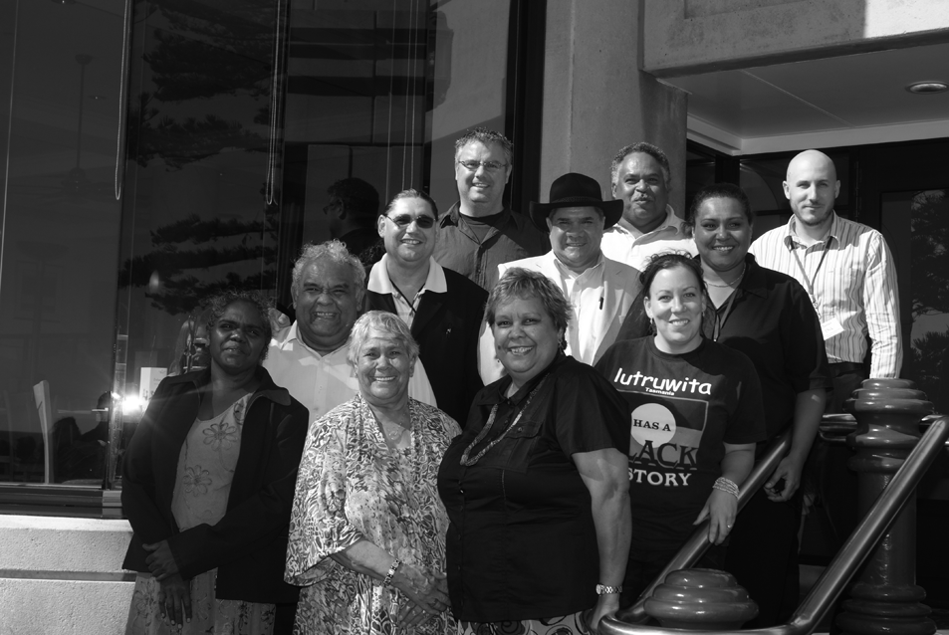
Members of the Steering Committee for the establishment of a new national representative body for Aboriginal and Torres Strait Islander peoples: (left to right from front) Yananymul Mununggurr, Dr Lowitja O’Donoghue (Patron), Dr Jackie Huggins AM, Tom Calma (Chair), Nala Mansell-McKenna, Dr Mark Bin-Bakar, Prof Mick Dodson (Expert advisor), Josephine Bourne (Secretariat), Jason Glanville, John (Toshi) Kris and Darren Dick (Secretariat).

6.3.2 Indigenous health equality
Over the period 1 July 2008 to 30 June 2009, the Close the Gap Campaign Steering Committee for Indigenous Health Equality (Committee) worked to consolidate the outcomes of the National Indigenous Health Equality Summit (Summit), held in Canberra from 18 to 20 March 2008. It also engaged with many of the Indigenous and health reform processes initiated under the COAG National Reform Agenda and by the Australian Labor Party since resuming government in November 2007.
The major outcome of the Summit was the Close the Gap Statement of Intent. It was signed by the Prime Minister, the Minister for Health and Ageing, the Minister for Indigenous Affairs and the Opposition leader, as well as the leaders of every peak Indigenous and non-Indigenous health and health professional body on the final day of the Summit. This was a ceremonial occasion held at Parliament House, Canberra on 20 March 2008.
Another major Summit outcome was the finalising of the Close the Gap Indigenous Health Equality Targets. These were developed by the Steering Committee with the help of Indigenous health experts over the months prior to the Summit and presented to the delegates there in draft form. The targets were presented by the Committee to the Minister for Health and Ageing on 28 July 2008. Thereafter, they were widely disseminated, including to every parliamentarian in Australia, and published on the Commission’s website.
The targets support the commitments in the Statement of Intent. The targets are specific, time-bound commitments that create a blueprint to achieve the goal of closing the gap between Indigenous and non-Indigenous life expectancy in a generation. The four categories of targets include: partnership targets, health status targets, primary health care and other health services targets and infrastructure targets.
The Committee continues to work with COAG and Australian governments to progress the adoption of the targets and their integration with a variety of monitoring frameworks.
The Committee convened a workshop in Sydney on 26 and 27 November 2008 to advance the commitments in the Statement of Intent and to consider how the health equality targets may contribute to a national action plan to achieve health equality.
The workshop was attended by senior bureaucrats from nearly every state and territory, as well as across federal government departments, and representatives of Indigenous health organisations and the Committee. There were five working sessions during the workshop that focused on the following themes:
- creating partnerships for change
- planning to achieve health equality by 2030
- coordinating our efforts
- monitoring and accountability for the achievement
of Indigenous health equality
- a way forward.
The workshop enabled participants to define what ‘partnership’ would mean in the context of achieving Indigenous health equality. A workshop report was circulated to the Minister for Health and Ageing, key bureaucrats and the participants.
The workshop saw the announcement of billion dollar investments by COAG in several National Partnerships for Indigenous Health. In total, since May 2008, $4.6 billion has been invested in improving Indigenous health outcomes (with a focus on chronic disease and child health) and the social determinants of Indigenous health (housing, education and employment). On several occasions, the Committee has been acknowledged by government ministers as being a primary driver of the making of these investments by COAG. This has heartened and energised the campaign partners, and given the campaign significant credibility.
A major focus of the Committee has been on building a partnership approach to allocations for the $1.6 billion National Partnership for Improving Indigenous Health outcomes.
Other Summit outcomes that came to fruition during 2008-09 include:
- the development of a Close the gap brochure based on the Social Justice Unit’s community guides to the Social Justice Report
- the second National Close the Gap Day in April 2009 – over 500 community events marked the day
- the Prime Minister’s first report on closing the Indigenous socio-economic (including health) gaps (April 2009)
- the signing of the Statement of Intent by the governments of Victoria, Queensland and Western Australia.
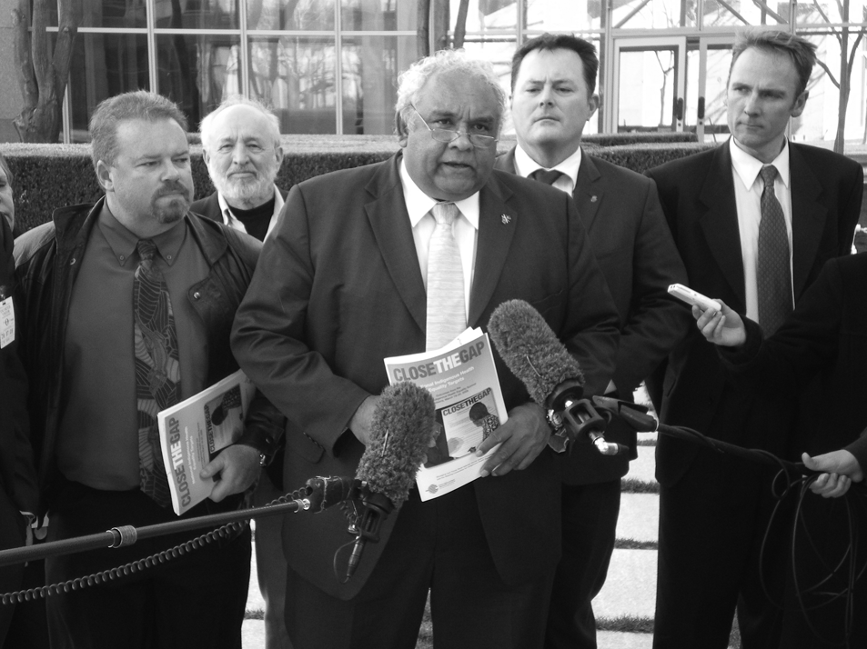
On 28 July 2008 at Parliament House in Canberra, Commissioner Calma talks to the media after the Close the Gap Indigenous Health Equality Targets were presented to the Minister for Health and Ageing.
The Aboriginal and Torres Strait Islander Social Justice Commissioner and Committee members continued to give many speeches promoting the campaign.
Political engagement to further partnership and national planning is now the major focus of the campaign. An ambitious agenda has been agreed upon for 2009-10.
Ongoing activities include:
- social and cultural determinants targets development – the latter,
in particular, stands to make a significant contribution to how Indigenous health and wellbeing is understood in Australia
- working with the $10 billion Health and Hospital Fund to secure significant allocations towards Indigenous health
- working with the National Rugby League to promote the Close the Gap campaign
- working to get the remaining states and territories to sign up to the Close the Gap Statement of Intent
- working to ensure that the budget for the maintenance of the Secretariat for Close the Gap is secured for the coming 18 months to two years.

6.3.3 Preventing crime and promoting rights for Indigenous young people with cognitive disabilities and mental health issues report
In November 2008, the Commission launched the Preventing crime and promoting rights for Indigenous young people with cognitive disabilities and mental health issues report. This research was funded by the Australian Government Attorney-General’s Department to investigate early intervention and diversion for Indigenous young people with cognitive disabilities and/or mental health problems who are at risk of involvement with the juvenile justice system.
This report builds on an earlier report by the Commission and considers the evidence on Indigenous young people with cognitive disabilities and/or mental health problems, maps some of the services currently available, and looks at a variety of case studies that point to a framework for early intervention and diversion.
The report identifies the very high needs of this particular group, as well as systemic failures and discrimination which impact on their life chances. Despite these high needs, there is very little research about this group and the specific interventions that can assist. The report starts to address this knowledge gap and has been well received by government and those working in the field.
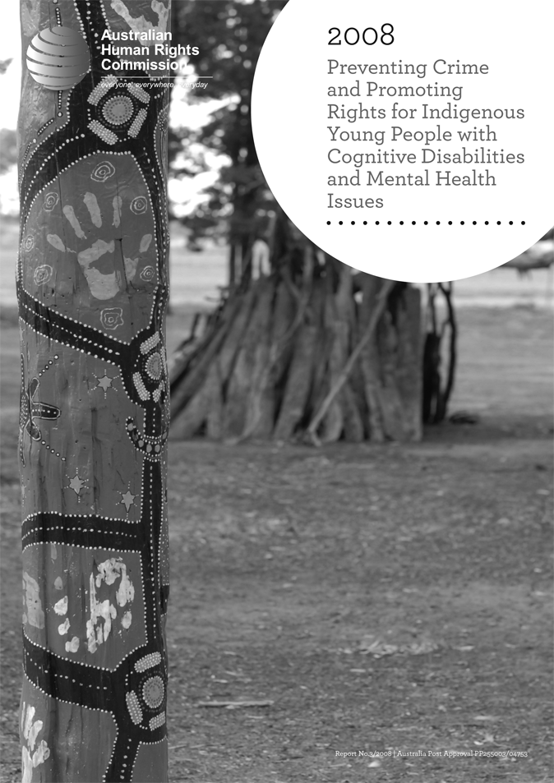
This report, released in November 2008, is the result of research into early intervention and diversion for Indigenous young people with cognitive disabilities and/or mental health problems who are at risk of involvement with the juvenile justice system.

6.3.4 National Indigenous Climate Change Working Group
On behalf of the Aboriginal and Torres Strait Islander Social Justice Commissioner, staff from the Commission attended meetings of the National Indigenous Climate Change Working Group in Melbourne on 12 September 2008 and 16 October 2008.
The purpose for the meeting was to develop a scoping/research exercise on the impacts and opportunities from climate change for Indigenous communities in four different climatic regions across Australia, and to ascertain how these communities might respond. Indentified project sites include the Kimberley, Cape York/Torres Strait Islands, Cooper Basin/South Australia and Southern Victoria/Tasmania.
Project partners include the CSIRO, Monash University and the four Indigenous regions.

6.3.5 Indigenous water rights forums
The Aboriginal and Torres Strait Islander Social Justice Commissioner has been engaged in a number of forums related to Indigenous peoples’ rights and interests in water.
- Commission staff attended a number of Australian Indigenous Water Focus Group meetings hosted by North Australian Indigenous Land and Sea Management Alliance, Murray Lower Darling Rivers Indigenous Nations and the National Water Commission. The primary objectives of the Australian Indigenous Water Focus Group are to:
- identify and overview specific water issues for Indigenous communities
- formulate strategic development of a future National Indigenous Water Roundtable dialogue and engagement at the national level
- examine guiding principles for Indigenous engagement in water planning
- consider the formation of a National Indigenous representative group
(a steering committee) to assist with advancing Indigenous water access entitlements and Indigenous engagement in water issues at the national level.
As a result of the Indigenous Water Focus Group meetings, Commission staff have been involved in the establishment of the First Peoples’ Water Engagement Council. Once fully established, this Council will aim to work with the National Water Commission to ensure an Indigenous perspective is incorporated into National Water Initiative processes and projects.

6.4 Education and promotion
In 2008, the Social Justice Commissioner and Commission staff undertook numerous actions to promote awareness of Indigenous rights. These included reports, speeches and seminars, media, the production of information materials on Indigenous rights and the development and delivery of human rights training. Copies of all speeches, media releases and information materials are available at: humanrights.gov.au/social_justice/index.html.
The Social Justice Commissioner also supported education activities conducted by a range of organisations. These included but were not limited to:
- patronage of the Wakakiri story festival
- support for the Dare to Lead organisation and Foundation
- involvement in the design and delivery of Diplomacy Training Programs for Indigenous peoples (including by linking to our international funding for UN participation).
This year the Social Justice Report 2008 contained a chapter dedicated to remote Indigenous education.

6.4.1 Community Legal Education
During 2008, the Commission delivered a second phase of training for predominantly Indigenous Community Legal Education (CLE) workers as preparation for their employment in Family Violence Prevention Legal Services. The training aimed to prepare workers to raise awareness amongst Indigenous Australians about the standards of Australian law that are relevant to family violence, and to clarify the relationship between Australian law and customary law.
The training program is underpinned by community development theory and practice and human rights frameworks. The principal aim of the program is to provide CLE workers with appropriate skills and knowledge for employment.

6.4.2 Indigenous Human Rights Network of Australia
Oxfam is providing $330 000 funding to the Commission over three years for engagement of a full-time person to establish and advance a network of Indigenous people to advocate for Indigenous rights. This project commenced in September 2008. A Network Coordinator was appointed in February 2009. The Network will be launched in late 2009.

6.5 Legislative development
The Social Justice Unit contributes to legislative development by making written and oral submissions to parliamentary and other inquiries, including reports to international human rights bodies and forums. These submissions are listed in Chapter 3: Monitoring Human Rights.

6.6 International activities

6.6.1 The UN Permanent Forum on Indigenous Issues
The Forum is one of two major annual United Nations events on Indigenous affairs. It has been described as the ‘marketplace’ or ‘fair’ at which much information and networks can be established in relation to issues affecting Indigenous peoples.
A major focus of the Forum in the past two years has been on the UN Declaration on the Rights of Indigenous Peoples. The Forum is named as having a key implementation role in Article 42 of the Declaration and has adopted the Declaration as the framework for its work.
The Social Justice Commissioner has participated in six of the eight sessions of the Forum. Since 2005, the Commission has also supported attendance at the forum by Indigenous organisations and coordinated their input through the Indigenous Peoples Organisations (IPO) Network. The IPO is an association of Aboriginal and Torres Strait Islander organisations established for the promotion and protection of the human rights of Aboriginal and Torres Strait Islander people in Australia.
The eighth session of the United Nations Permanent Forum on Indigenous Issues (UNPFII) was held in New York from 18 to 29 May 2009. Commissioner Calma attended with two Commission staff. For the eighth session, the Commission provided financial support to ten Indigenous organisations to assist with attendance costs for 12 Indigenous delegates.
Other indigenous organisations and delegates participated in the Permanent Forum session. Overall, including Commission-supported delegates, there were 40 representatives.
Commission staff provided technical support to all Australian Indigenous delegates at the session.
Delegates participated in the preparation and delivery of a number of interventions in accordance with the UNPFII agenda, and also provided reports to the UNPFII Members on the issues of Indigenous Women, and the Comprehensive Dialogue with UN Agencies. This involved a significant workload for Commission staff, who coordinated the preparation and presentation of interventions and recommendations while in New York.
Delegates also conducted a number of side events at the UNPFII.
On a number of occasions during the session, the Social Justice Commissioner and the IPO Network of Australia met with James Anaya, the Special Rapporteur on the situation of human rights and fundamental freedoms of indigenous people. At these meetings, preparations for a country visit to Australia in August 2009 were discussed. The IPO Organising Committee attended a number of meetings, and individual organisations were also provided with an opportunity to talk with Mr Anaya about issues of concern.
A joint statement between the Australian Government, the Commission and the IPO Network was drafted at the session, which was a major development. This was the first statement of its kind to be presented to the Permanent Forum. It identifies issues of common interest and agreement and focuses on positive developments over the past year. Issues of disagreement were incorporated into separate statements on different thematic issues during the course of the session.
Following UNPFII, the Commission coordinated and hosted the IPO Network Meeting to review the outcomes of the UNPFII, and to prepare for attendance at the Expert Mechanism on the Rights of Indigenous Peoples, which will be held in Geneva from 10 to 14 August 2009.

6.6.2 UN Expert Mechanism on Rights of Indigenous Peoples
The United Nations Expert Mechanism on Indigenous Issues is a subsidiary expert mechanism of the Human Rights Council with a specific mandate. Composed of five experts, the Expert Mechanism is established in accordance with resolution 6/36 of the Human Rights Council.
The Social Justice Commissioner and Commission staff attended the first session of the Expert Mechanism at the United Nations Office in Geneva from
1 to 3 October 2008. The Commission supported two other Indigenous delegates to attend: Brian Wyatt, the Chairperson of the National Native Title Council and Les Malezer, Chairperson of the Foundation for Aboriginal and Islander Research Action.
The first session considered the mandate of the Expert Mechanism. The mandate includes providing thematic expertise on the rights of Indigenous peoples to the Human Rights Council, primarily through providing studies and research-based advice. The Mechanism can also suggest proposals, that fall within the scope of its work, to the Council for its considerations and approval.
The Commissioner made an intervention at the meeting, supporting the provision for National Human Rights Institutions to participate and inform the work of the Expert Mechanism.

6.6.3 Indigenous Peoples Organisations – Special Commemorative Meeting
The IPO is supported by the Commission to meet twice a year to discuss issues of national interest and to coordinate Aboriginal and Torres Strait Islander contributions to relevant international human rights mechanisms.
On 3 December 2008, the IPO and the Commission held a public forum entitled, ‘The 60th Anniversary of the Universal Declaration on Human Rights: The situation of human rights and fundamental freedoms of the Aboriginal and Torres Strait Islander people in Australia’. Speakers on the day included:
- Professor James Anaya, UN Special Rapporteur on the human rights and fundamental freedoms of Indigenous peoples
- Commissioner Tom Calma, Aboriginal and Torres Strait Islander Social Justice Commissioner at the Australian Human Rights Commission
- Mr Les Malezer, Chair of the Pacific Indigenous Peoples Caucus.
The meeting was attended by approximately 30 representatives of Indigenous organisations, as well as government departments and staff of the Commission.

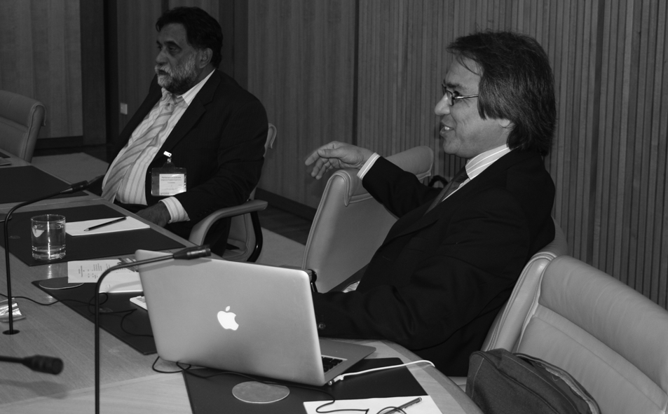
UN Special Rapporteur, Professor James Anaya and Chair of the Pacific Indigenous Peoples Caucus, Mr Les Malezer, were speakers at a public forum hosted by the IPO and the Commission on 3 December 2008.

6.7 Speeches
A selection of public addresses made by the Aboriginal and Torres Strait Islander Social Justice Commissioner during 2008-09 is listed below. Full speeches can be accessed on the Commission’s website at: www.humanrights.gov.au/about/media/speeches/social_justice/index.html.
Indigenous Studies and Indigenous Knowledge Conference – University of Tasmania, Hobart, 3 July 2008.
Essentials for Social Justice: Land and Culture – Economic Development – Department of the Environment, Water, Heritage and the Arts, Parkes, NSW, 7 July 2008.
Following on from the Apology – where to from here from a HREOC perspective – NSW Dept of Premier and Cabinet, Sydney, 10 July 2008.
NAIDOC Week 2008 – Ministerial Event – NSW Department of Aboriginal Affairs, Sydney, 10 July 2008.
Building a sustainable National Indigenous Representative Body – Australian Institute of Aboriginal and Torres Strait Islander Studies (AIATSIS) Seminar Series, AIATSIS, Canberra, 4 August 2008.
Caring for culture, caring for country – Indigenous Climate Change and Land Use Management Conference, Garma Festival of Traditional Culture, Gulkula, Northeast Arnhem Land, 8 August 2008.
‘Be Inspired’: Indigenous Education Reform – Victorian Association of State Secondary Principals Annual Conference, Melbourne, 18 August 2008.
Indigenous Affairs in Australia – Post the Apology – Orakei Marae, Auckland, 26 August 2008.
Human Rights and Reconciliation – Australian Human Rights Centre Annual Public Lecture, University of New South Wales, Sydney,
25 September 2008.
‘Still Riding for Freedom’ – An Aboriginal and Torres Strait Islander Human Rights Agenda for the Twenty-First Century – Charles Perkins Oration, University of Sydney, 23 October 2008.
Essentials for Social Justice: The Future – University of South Australia, Adelaide, 12 November 2008.
A human rights agenda for the Northern Territory – Northern Territory Parliament House, Darwin, 17 November 2008.
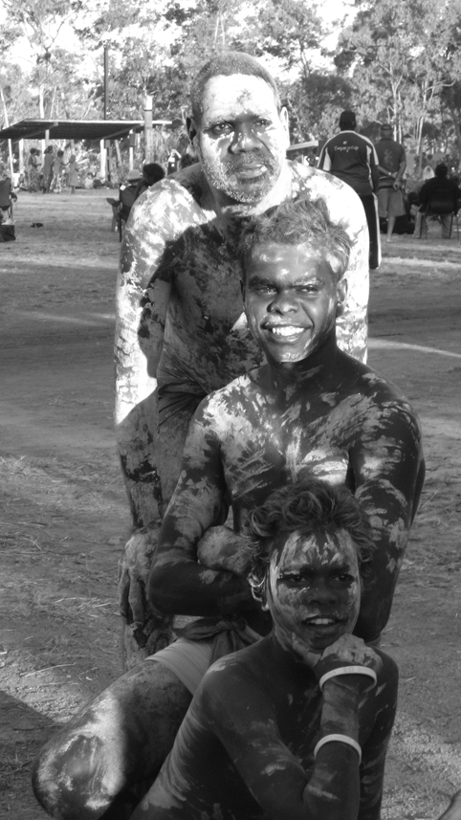
Performers pose at the Garma Festival of Traditional Culture, Gulkula, Northeast Arnhem Land. The Indigenous Economic Development Conference was held at the Festival in 2008, during which Commissioner Calma delivered a speech.
World Indigenous Peoples Conference on Education – Rod Laver Arena, Melbourne, 9 December 2008.
The Informa 3rd Annual Negotiating Native Title Forum – Savoy Hotel, Melbourne, 20 February 2009.
Indigenous Issues in the Durban Review – Monash University, Melbourne,
20 February 2009.
Launch of ‘Indigenous Legal Relations in Australia’ by Larissa Behrendt, Chris Cunneen and Terri Libesman – Tranby College, Glebe, 27 February 2009.
Native Title Reform – Where should we go from here? – Tranby College, Sydney, 8 April 2009.
Launch of Social Justice and Native Title Reports 2008 – Ultimo College, Sydney, 4 May 2009.
Maximising opportunities in a new era of Indigenous affairs – Philanthropy Forum, Grosvenor Place, Sydney, 5 May 2009.
Who’s driving the agenda? – Native Title Conference, Melbourne Cricket Ground, 3 June 2009.
From self-respect comes dignity, and from dignity comes hope: The Mabo Oration – Queensland Performing Arts Complex, Brisbane, 5 June 2009.
Partnership builds success: An Indigenous perspective of educational partnerships – Dare to Lead Conference, Adelaide, 14 June 2009.
They are our children, this is our community – AIATSIS Research Symposium on Bilingual Education, National Museum of Australia, Canberra, 26 June 2009.

Lieutenant General John Sanderson, AC. Speech at the Local Government and Indigenous Communities Conference, University of Western Australia. 29 April 2009.

