Chapter 8:
Human Rights
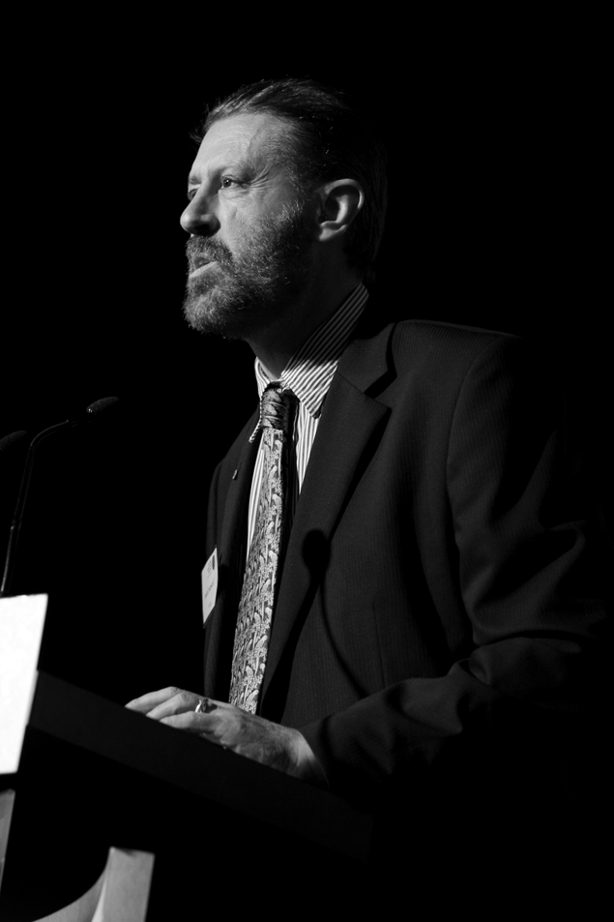
Mr Graeme Innes AM, Human Rights Commissioner

8.1 Statement from the Commissioner
2008-09 has been a year of positive developments in the human rights area. While many human rights challenges lie ahead, as Human Rights Commissioner, I have been excited by the progress that Australia has made in human rights, both domestically and internationally during the year.
It has been especially uplifting to witness the passage through the Australian Parliament of legislation removing discrimination against same-sex couples and their children. Parliament finally passed the Same-Sex Relationships (Equal Treatment in Commonwealth Laws – Superannuation) Act 2008 (Cth) and the omnibus Same-Sex Relationships (Equal Treatment in Commonwealth Laws – General Reform) Act 2008 (Cth) at the end of 2008. This legislation removes discriminatory provisions in a wide range of areas including taxation, social security, employment, Medicare, veteran’s affairs, superannuation, workers compensation and family law. The amendments were the culmination of the recommendations made in the Commission’s 2007 report of the Same-Sex: Same Entitlements Inquiry.
On the international front, on 19 May 2009, the Australian Government signed the Optional Protocol to the Convention against Torture and other Cruel, Inhuman or Degrading Treatment or Punishment (OPCAT). OPCAT is an international agreement which establishes a two-tiered system of inspections of places of detention, with the aim of preventing torture and cruel, inhuman or degrading treatment or punishment.
I welcome Australia’s significant step towards establishing greater oversight and inspection of its places of detention, including immigration detention, and I look forward to final ratification of the treaty.
The Commission has continued to monitor conditions of detention through my annual inspections of immigration detention facilities, and the publication of the 2008 Immigration detention report. In the report, we were especially concerned about the lack of substantial improvements at Villawood Stage One and the remoteness of the Christmas Island facilities, which will continue to make it difficult to ensure immigration detention meets human rights standards.
There have been many positive developments in immigration detention over the year, including the budget announcement that Villawood Stage One will be rebuilt, and the government’s stated commitment to pursuing a more humane approach to asylum seekers and immigration detainees. However, I am concerned that the increase in numbers of boat arrivals in 2009 will be seen as an excuse to politicise refugee issues.
The sex and gender diversity project commenced in 2008. The project was an opportunity to give voice to the human rights concerns of people who are sex and gender diverse. In the latter half of 2008, the project utilised a blog to gather the views of people in a non-confrontational way. The Concluding Paper from the project – Sex files – concentrated specifically on the legal recognition of sex in documents and government records. I hope it will place some of the concerns of this diverse, and often marginalised, group of communities on the government agenda.
Lastly, the National Human Rights Consultation, announced by the Attorney-General in December 2008, has made it an especially encouraging year. Conducted during the first half of 2009 by an independent Committee, the Consultation has presented a significant opportunity for the Commission and all people in Australia, to participate in a national conversation on human rights and how they can be better protected. The Commission dedicated itself to encouraging others to participate in the Consultation and to advocating for better human rights protections through a Human Rights Act. As Human Rights Commissioner, I was especially concerned with ensuring that children and young people had a voice in the Consultation. With the help of the Foundation for Young Australians, the Commission conducted a program of 26 workshops with children, young people and their advocates. Their stories and ideas for better human rights protections have been presented to the Consultation Committee in the hope that the final report of the Committee will reflect their views on human rights.
This is my final annual report as Human Rights Commissioner. I leave the position with a feeling of optimism and with strong expectations that progress in the human rights area will be achieved in the years to come.

8.2 Research and policy

8.2.1 Same-Sex: Same Entitlements
The Australian Parliament finally passed the Same-Sex Relationships (Equal Treatment in Commonwealth Laws – Superannuation) Act 2008 (Cth) and the omnibus Same-Sex Relationships (Equal Treatment in Commonwealth Laws – General Reform) Act 2008 (Cth) at the end of 2008. The amendments were the culmination of the recommendations made in our 2007 report of the Same-Sex: Same Entitlements Inquiry.
The Commission made submissions to, and appeared before inquiries into both of these Bills conducted by the Senate Legal and Constitutional Affairs Committee, as well as to a related inquiry into the Evidence Amendment Bill 2008.
The Commission also participated in community sector consultations about the implementation of reforms and raised concerns with the Attorney-General about the impact of the reforms on people on aged pensions.

8.2.2 The National Human Rights Consultation
Participation in the National Human Rights Consultation was a priority for the Commission this year.
The Commission decided that the most important role it could play would be to encourage as many people as possible to participate in the consultation process. The Commission developed a consultation toolkit, called Let’s talk about rights, which provided succinct information about human rights and a guide to making submissions to the Consultation. The toolkit was accompanied by a series of information sheets about specific human rights issues in Australia.
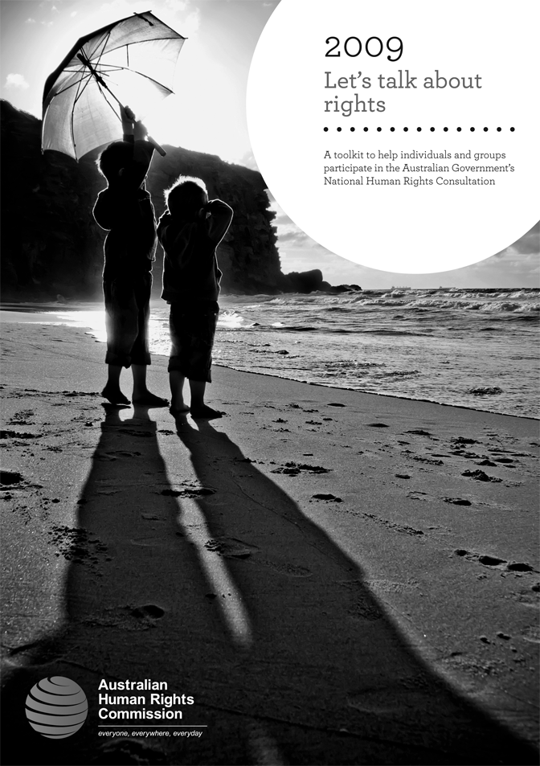
The Commission developed a toolkit designed to provide guidance to people and organisations that wished to make a submission to the Australian Government’s National Human Rights Consultation.
The Commission also developed materials to support the participation of children and young people in the Consultation.
Commission staff developed and delivered a national series of workshops to encourage community sector organisations to participate in the Consultation. In addition, the Commission conducted 26 workshops with children and young people around the country.

Finally, the Commission made a detailed submission to the Consultation which, among other things, advocated for a Human Rights Act for Australia. The Commission also made the following key recommendations to government:
- refer to the Australian Law Reform Commission for inquiry and report the question of how best to strengthen, simplify and streamline federal anti-discrimination laws
- begin a process of constitutional reform to protect the principle of equality for all people in Australia
- resource a significantly enhanced nation-wide human rights education program
- enhance the powers, functions and funding of the Australian Human Rights Commission, particularly if a Human Rights Act is adopted. Any new functions should be accompanied by appropriate funding.

8.2.3 Sex and gender diversity
The sex and gender diversity project developed out of consultations held during 2008 with members of sex and gender diverse communities about the discrimination they experience. One of their key human rights concerns was that many people who are sex and gender diverse are unable to change the sex markers in official documents or government records, for example birth certificates. Consequently, in July 2008, the Commission decided that the sex and gender diversity project would focus on the legal recognition of sex in official documents and government records.
As part of the project, the Human Rights Commissioner conducted public meetings in Brisbane, Canberra, Hobart, Melbourne, Perth and Sydney. These public meetings enabled the Commissioner to hear firsthand the difficulties faced by people who are sex and gender diverse in having their identity recognised.
On 8 August 2008, the Commission launched an online blog and discussion board known as Sex files. The Sex files blog aimed to consult further with the sex and gender diverse community about the legal recognition of sex in official documents and government records. The Sex files blog was used to gather information about the current system and seek feedback on how the system could work better. As the project concerned identity, an online consultation in cyberspace was an opportunity for participants to self-identify their sex or gender and escape scrutiny of their bodies and appearance.
In March 2009, the Commission launched the Concluding Paper of the sex and gender diversity project – Sex files: the legal recognition of sex on documents and government records – at Parliament House, Canberra. The paper identifies some problems with the existing systems for recognising sex identity in documents and government records. It also makes recommendations to the federal government for changing the system and provides options for implementing these changes.
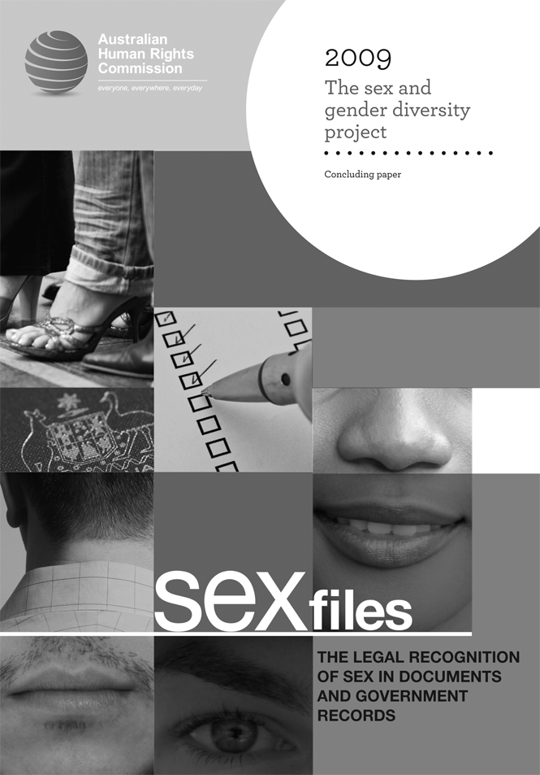
In March 2009, the Commission released its concluding paper for the Sex and gender diversity project.

8.3 Monitoring and adhering to human rights

8.3.1 Optional Protocol to the Convention against Torture and other Cruel, Inhuman or Degrading Treatment or Punishment
The Australian Government signed the OPCAT on 19 May 2009, but has not yet ratified the agreement.
Under the OPCAT, state parties agree to international inspections of places of detention by the Sub-Committee on the Prevention of Torture. State parties are also required to establish an independent National Preventive Mechanism (NPM) to conduct inspections of places of detention.
The Commission has recommended that the Australian Government should ratify the OPCAT and establish an independent NPM to conduct regular inspections of all places of detention, including immigration detention.
In late 2008, the Commission released a report of research it commissioned into options for implementing the OPCAT in Australia. The report suggests that Australia should establish a ‘mixed’ NPM model, with separate NPMs in each state and territory and a national coordinating NPM. The report suggests that, given its focus on Australia’s international human rights obligations, the Commission is the appropriate body to be the national coordinating NPM.

8.3.2 Immigration detention, refugees and asylum seekers
Since 2006, the Commission has conducted annual visits to immigration detention facilities to monitor conditions for detainees, with the aim of ensuring they meet internationally recognised human rights standards. In January 2009, the Commission released the 2008 Immigration detention report: summary of observations following visits to Australia’s immigration detention facilities. The report provides a summary of visits made to all immigration detention facilities in Australia, including Christmas Island, between June and September 2008. In addition to speaking to staff and detainees in secure facilities during the visit, the Commissioner and staff also spoke to a number of people in ‘community detention’ in several cities.
In the 2008 report, the Commission welcomed many of the government’s new immigration detention values, announced in July 2008. However, despite having observed improvements in Australia’s immigration detention facilities over the past few years, the Commission expressed significant ongoing concerns about the immigration detention system. In particular, the 2008 report noted that the legal architecture of the mandatory detention system remains in place, with some people still being held for long and indefinite periods. The report also expressed concerns with off-shore processing of asylum seekers on Christmas Island, in particular in the new immigration detention centre on the island. Further, while children are no longer held in immigration detention centres, they are still held in other closed immigration detention facilities, both on the mainland and on Christmas Island.
The report also reiterated concerns expressed in previous reports about the dilapidated and prison-like conditions of Stage One section of Villawood Immigration Detention Centre, and repeated recommendations that it should be demolished. There are also a number of other detailed recommendations, some being concerned with issues affecting all detention facilities and others being specific to individual facilities.
The Commission has also provided comment to the Department of Immigration on a variety of immigration-related policy documents and in consultative forums. These have included draft policy guidelines on the behavioural management of detainees, the exercise of Ministerial discretion and on the Government’s new directions in immigration detention.
In November 2008, the Commission hosted a seminar entitled, Complementary protection: meeting Australia’s obligations to people fleeing danger. The Commission subsequently provided comments to the Department of Immigration about the development of a system of complementary protection for people who do not fit the definition of refugee under the Refugee Convention, but to whom Australia has non-refoulement obligations.
In January 2009, the Commission published a background paper on immigration detention and visa cancellation under section 501 of the Migration Act (the ‘character’ provisions) on its website. This will be updated to reflect policy changes implemented by the Department of Immigration on 15 June 2009.
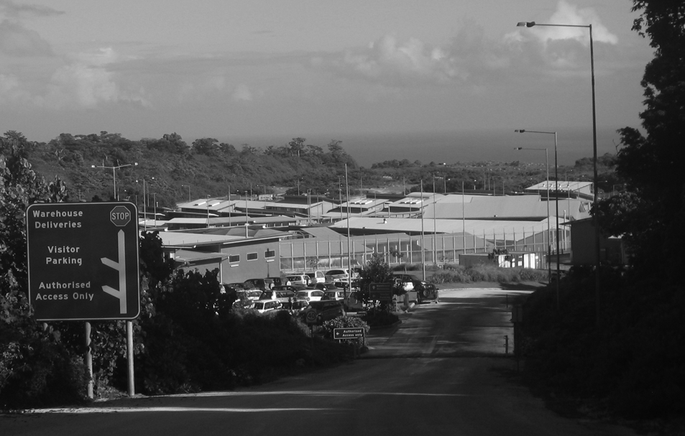
The Christmas Island Immigration Detention Centre. The Commission has visited immigration detention facilities each year since 2006 in order to monitor whether conditions for detainees adhere to internationally recognised human rights standards.

8.4 Education and promotion

8.4.1 Corporate social responsibility
In 2008-09, the Commission continued its project on corporate social responsibility by producing fact sheets on integrating human rights into Australian business practices.
The fact sheets set out five basic steps towards integrating human rights into everyday business practices. One fact sheet explains how human rights are relevant to Australian companies and the business case for integrating human rights. It also provides links to practical tools. The other fact sheets focus on the specific human rights issues and practical tools relevant to the Australian finance sector, the Australian mining and resources sector, and the Australian retail and manufacturing sectors.
The fact sheets are available on the Commission website and have also been printed and distributed to a database of about 100 business and human rights contacts. See: www.humanrights.gov.au/human_rights/corporate_social_responsibility/index.html.

8.5 Legislative development
The Commission contributes to legislative development by making written and oral submissions to parliamentary and other inquiries. Information about these submissions can be found in Chapter 3: Monitoring Human Rights.

8.6 International activities

8.6.1 Asia-Pacific Forum Workshop on Yogyakarta Principles
On 5-7 May 2009, the Commission participated in an Asia-Pacific Forum (APF) Workshop on National Human Rights Institutions (NHRIs) in the Promotion and Implementation of the Yogyakarta Principles. The workshop was held in Yogyakarta, Indonesia, and hosted by Komnas HAM, Indonesia’s national human rights institution.
The workshop brought together member institutions to discuss the role of NHRIs in promoting implementation of the Yogyakarta Principles on the implementation of international human rights law in relation to sexual orientation and gender identity.
The Human Rights Commissioner presented a brief paper on the role of the Commission in this area.
The workshop issued a concluding comment strongly deploring ‘all forms of stereotyping, exclusion, stigmatisation, prejudice, intolerance, discrimination and violence’ against gay, lesbian, bisexual and transgender people, and made recommendations for further work to be pursued by NHRIs and the APF in this area.

8.7 Speeches
In addition to the Commission’s workshops on the National Human Rights Consultation, the Human Rights Commissioner delivered a significant number of speeches during the year. Full transcripts of the speeches are available on the Commission website at: www.humanrights.gov.au/about/media/speeches/human_rights/index.html.
Monitoring the Convention on the Rights of the Child in Australia – International Conference on Child Labour and Child Exploitation, Cairns,
4 August 2008.
Speech about human rights in Australia – Henry Parkes Primary Schools Citizenship Convention, NSW Parliament, Sydney, 10 November 2008.
Does Australia Need a National Charter of Rights? – Law Institute of Victoria panel discussion, Melbourne, 13 November 2008.
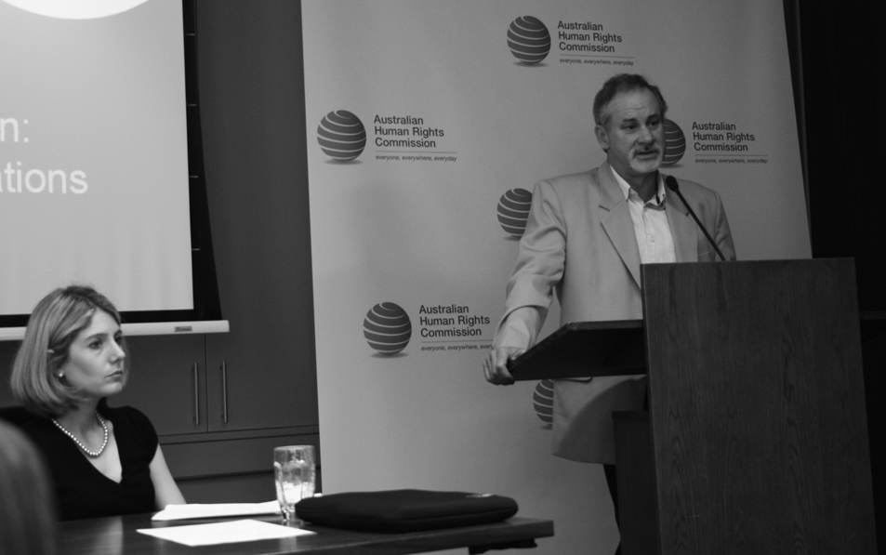
Senior Lecturer in the Faculty of Law, UNSW, Dr Jane McAdam and Director of the Edmund Rice Centre in Sydney, Mr Phil Glendenning, spoke on 3 November 2008 at the Commission’s seminar, Complementary protection: meeting Australia’s obligations to people fleeing danger (see 8.3.2).
Speech about the work of the Commission – Human Rights Defenders Program, Sydney, 26 November 2008.
Launch of Tasmanian Human Rights Week – Hobart Town Hall, Hobart,
1 December 2008.
Critical Community Engagement for Effective Accountability – Victorian Police Conference, Melbourne, 8 December 2008.
National Human Rights Bodies as Agents of Social Change: Legal Cases that Matter – Guest lecturer at Latrobe University Human Rights Masters course, Melbourne, 8 December 2008.
Evatt Lecture – Evatt Trophy United Nations Youth Association, Sydney,
9 December 2008.
Global to Local: Making Human Rights a Reality in Australia today – United Nations Association of Australia Conference, NSW Parliament, Sydney, 10 December 2008.
Australia Day Ambassador Address – Cessnock Shire Council, Cessnock,
26 January 2009.
A Human Rights Act for Australia – Queensland Charter Group Forum, Brisbane, 11 February 2009.
The National Human Rights Consultation: Your Chance to be a Human Rights Hero – NSW Parliament Schools Leadership Forum, Sydney,
6 March 2009.
Human Rights and Corporate Social Responsibility – Victorian Equal Opportunity and Human Rights ‘Everyday People, Everyday Rights’ Conference, Melbourne, 16 March 2009.
Launch of the Sex files: The Legal Recognition of Sex in Documents and Government Records Concluding Paper – Parliament House, Canberra,
17 March 2009.
Speech about the human rights consultation – Australian Lawyers Alliance Conference, Hunter Valley, 20 March 2009.
Launch of Diversity Week – University of Wollongong, Wollongong,
23 March 2009.
Human Rights of Children and Young People Across Australia – RMIT Conference, Melbourne, 29 May 2009.
Launch of Asylum Seeker Project – Melbourne, 12 June 2009.
Keynote address to the St Vincent De Paul CEO Sleepout – Luna Park, Sydney, 18 June 2009.

