Chapter 9:
Race Discrimination
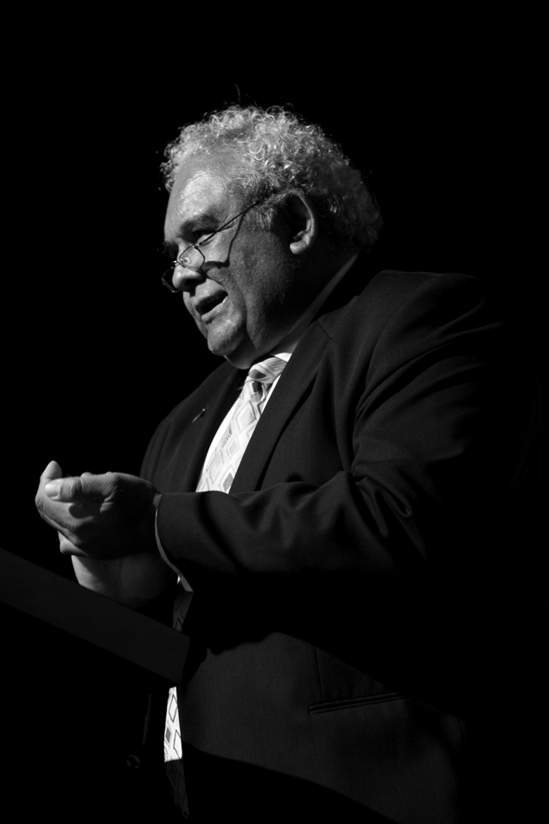
Mr Tom Calma, Race Discriminaton Commissioner

9.1 Statement from the Commissioner
This report covers my final year as the Race Discrimination Commissioner, a position I have occupied for five years alongside my position as the Aboriginal and Torres Strait Islander Social Justice Commissioner.
Something that is often asked of me in these roles, particularly following incidents involving racial tension or attacks, such as the Cronulla riot or the attacks on Indian students, is ‘Is Australia a racist country?’ I find this an interesting question to ask in such situations, more because of what it tells me about those posing the question, than the response it elicits. What it appears to be asking for is some reassurance that, despite the reports, despite how it looks on the news, the fundamental values of tolerance and a fair go are still operating and are still matters over which we can feel national pride.
What I say to this question is ‘yes’, these values are still part of our social framework and are still matters over which we can feel some pride. But I also say that we cannot go on indefinitely relying on our recent history as a tolerant multicultural society to support our present self image as a tolerant country.
We have to renew our national commitment to racial equality and respect for diversity. We have to take an active approach to maintaining these values as fundamental to our relations with each other.
Racism, like any anti-social practice, needs to be challenged to prevent it becoming an accepted norm. The real question we need to ask is not whether Australia is a racist country, but whether Australia is doing enough to stop racism becoming more prevalent.
In my view, the answer to that question is ‘No’.
We have no national action plan to combat racism, no multicultural policy since 2006 and little political commitment to the ideals of multiculturalism and racial equality before that. These ideals now need to be reaffirmed and reinvigorated so that they can meet the new challenges that a culturally diverse society continues to present.
What we need is a multilayered approach. In the short-term, we need to ensure the safety and security of those who are vulnerable to racially motivated hatred and attack. In order to secure their safety, we need to strengthen legal protections against serious racial vilification by making it an offence punishable by law which, despite our international obligations, it currently is not. This issue was discussed at a forum hosted by the Commission in November 2008 entitled, Words that wound: freedom of speech and race hate speech in Australia. Participants in the forum also discussed the new manifestation of hate speech taking place on the internet.
The longer-term solution is to work at the community and policy level to promote respect and tolerance. For example, the Commission’s participation in the Sport, Race and Diversity Conference, affirmed the potential of sport as a vehicle for anti-racism activities and promotion. We also need to look at how the media represents the diversity of the Australian community and seek to promote standards that prevent the demonisation of particular groups. The Commission’s publication of Face the facts in 2008 provides extensive factual information that can assist in this regard.
As part of a longer term strategy we also need to develop a policy framework to ensure that services such as education, aged care, housing and policing are delivered consistently with respect and tolerance. Reinvigorating our multicultural policy would provide benchmarks by which to evaluate these essential services against the human rights standards of equality and cultural diversity. Hand in hand with this policy development, we need further investment in social research which produces clear direction on where racism is occurring and how it can best be addressed. To this end the Commission is participating in the research being coordinated by the University of Western Sydney, entitled Constructing Regionally Appropriate Responses to Racism.
It is also timely to take a fresh look at the Racial Discrimination Act to ensure it remains relevant to contemporary Australian society. As the first federal anti-discrimination law in Australia, the Racial Discrimination Act declared unambiguously to the Australian people that racism and discrimination were no longer acceptable in our society. Over time, the Racial Discrimination Act has slipped behind similar racial equality legislation in other Western countries in its capacity to protect our citizens from racial discrimination and equality.
In the five years that I have been Race Discrimination Commissioner, little was done to maintain the infrastructure of tolerance and respect inherited from our previous national multicultural policies. Unless a concerted effort is made towards renewing this infrastructure, I’m afraid the next Race Discrimination Commissioner may not be able to give a positive response to the question of whether our fundamental values of tolerance and a fair go are still matters over which we can feel national pride.

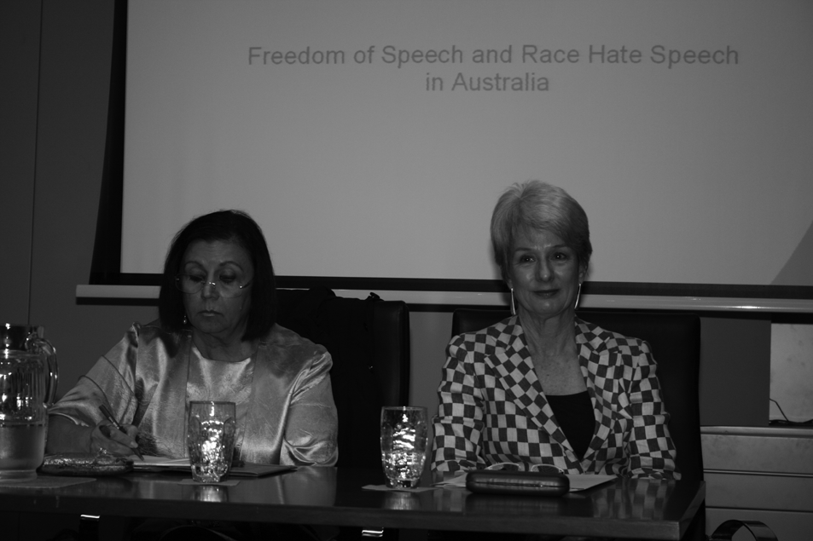
Author, Ms Hanifa Deen and Commission President, Catherine Branson QC were two of the three featured speakers at the Words that wound: freedom of speech and race hate speech in Australia seminar on 18 November 2008.

9.2 Research and policy

9.2.1 Constructing Regionally Appropriate Responses to Racism Project
The Commission, along with the South Australian Equal Opportunity Commission and the Victorian Equal Opportunity and Human Rights Commission, are official partners in the Constructing Regionally Appropriate Responses to Racism Project.
The project, which commenced in 2006 and is being conducted over four years, is coordinated by the University of Western Sydney. The research focuses on attitudes about race and peoples experiences of racism. Data has been collected through staggered national telephone surveys.
The purpose of this project is to:
- map racist attitudes and experiences of racism across Australia
- develop typologies of racism across Australia
- develop context sensitive anti-racism strategies to respond to
local variations of racism and intolerance.
Project data, racism typologies and anti-racism strategies will be available shortly on the University of Western Sydney website.

9.3 Education and promotion

9.3.1 Face the facts 2008
In 2008, the Commission launched the 2008 edition of Face the facts, a publication which provides answers to frequently asked questions regarding Aboriginal and Torres Strait Islander peoples, migrants, refugees and asylum seekers. The Commission also produced a teaching resource based on Face the facts, which is linked to curriculum requirements.
Face the facts is an evidence-based publication that contains current statistical and policy data from a number of sources, including the Australian Bureau of Statistics. It is one of the Commission’s most requested resources and is used widely by teachers, students, non-government organisations and state and federal government departments. Face the facts is available online at: www.humanrights.gov.au/racial_discrimination/face_facts/index.html.

9.3.2 Australia and New Zealand Annual Race Relations Roundtable
The annual Australia and New Zealand Race Relations Roundtable meeting was held at the University of Auckland, New Zealand on 27 August 2008. The meeting was co-chaired by the Australian Race Discrimination Commissioner and the New Zealand Race Relations Commissioner. Attendees included Commissioners and staff from Australian state and territory equal opportunity commissions.
The Roundtable meeting was held concurrently with the New Zealand Diversity Action Program and the UNESCO Roundtable on Religious Diversity.
A number of agenda items were discussed at the meeting, including developments in the Northern Territory Intervention, the Close the Gap Campaign, climate change, media and racism, international students and discrimination as well as the New Zealand Diversity Action Program model.
Two guest speakers delivered presentations to roundtable members. Dr Henare Manuka, Associated Dean, School of Maori and Pacific Development, University of Auckland, forecast a picture of success for Indigenous peoples from 2008 to 2028. Ms Nareen Young, Chief Executive Officer, Diversity Council Australia, presented research that focused on strategies for improving the employment retention rates of Indigenous peoples.

9.3.3 Sport, Race and Ethnicity Conference
The Sport, Race and Ethnicity Conference: Building a Global Understanding, was held from 30 November to 2 December 2008 in Sydney. The conference was co-hosted by the Commission, the Department of Immigration and Citizenship and the University of Technology, Sydney. It was attended by local and international academics, athletes, diversity practitioners, sports administrators and policymakers. Conference themes included:
- anti-racism initiatives in sport
- sport and social inclusion
- sport, race and identity
- sport, race and youth engagement
- race and gender in organised sport.
As part of the conference program, the Commission held a session that focused on persistent and emerging issues regarding sport and racism in Australia.

9.3.4 Universal Declaration of Human Rights
On 18 November 2008, as part of its promotion of the 60th Anniversary of the Universal Declaration of Human Rights, the Commission hosted a public seminar entitled Words that wound: freedom of speech and race hate speech in Australia.
Participants in the forum focused on the relationship between the right to freedom of expression and the right to non-discrimination on the basis of race and religion, both at international law and within the Racial Discrimination Act. Participants also discussed the new ways in which extreme forms of race hate were being expressed, particularly through the language of care, including care for the environment and care for national values. The forum attracted a diverse audience including community members, legal practitioners, media workers and government officers.

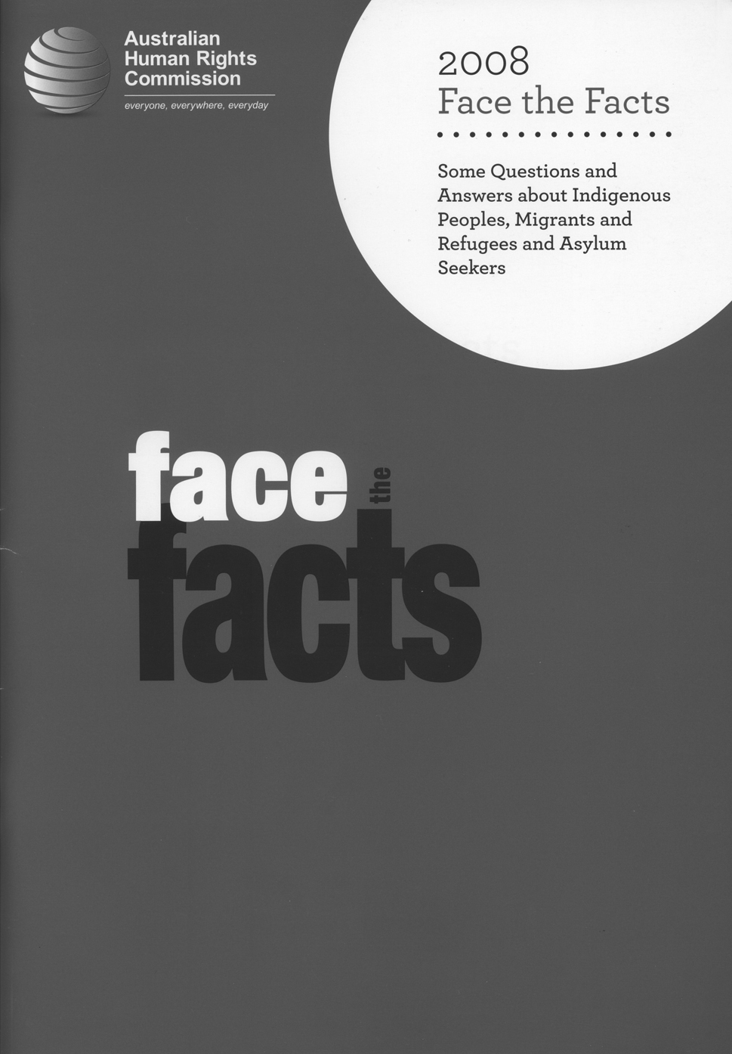
An updated 2008 edition of Face the facts was produced in late 2008.

9.4 International activities

9.4.1 Durban Review Conference
The Durban Review Conference took place from 20 to 24 April 2009 in Geneva, Switzerland. The Commission was one of 39 National Human Rights Institutions that attended the conference.
The Durban Declaration and Programme of Action (DDPA) and Outcome Document, adopted at the Conference, provided a comprehensive framework for states, NHRIs and civil society to work together to combat racism. For more information, see: www.un.org/durbanreview2009/ddpa.shtml.
The Commission participated in a number of events at the conference including:
- panel discussion and presentation on the role of National Human
Rights Institutions in implementing the Durban Declaration and DDPA
- panel discussion on the UN Declaration on the Rights of Indigenous Peoples and its contribution to the realisation of the DDPA
- panel discussion on policing in diverse societies.

9.5 Community Partnerships for Human Rights Program
In 2005, COAG examined the emerging issues around Australia’s social cohesion, harmony and security. This led the Ministerial Council on Immigration and Multicultural Affairs to develop a national action plan, which builds on recommendations and principles agreed between state and territory based Muslim communities and other faith and community leaders.
Building on the Commission’s substantial body of work in this area (such as the
Isma, Unlocking Doors and Living Spirit projects, referred to in earlier Annual Reports), the Commission received funding from the Australian Government’s four-year initiative to implement the National Action Plan to Build on Social Cohesion, Harmony and Security.
As a result, in early 2007, the Commission established a new Education and Partnerships Section as part of the Race Discrimination Unit. The role of the section is to implement the Commission’s National Action Plan activity in line with its functions through the Community Partnerships for Human Rights Program.

9.5.1 Program projects
The Commission, while broadly interpreting the National Action Plan and its role under this program, has a particular focus on two areas. These are: working with young Muslim Australians; and addressing issues related to law enforcement and the administration of justice.
In its work with young Muslim Australians, the Commission is developing education strategies and resources associated with civic responsibility, discrimination and human rights and responsibilities. It is exploring arts and culture as a means of positive engagement, and conducting research relevant to issues relating to Muslim youth. The Commission is working with law enforcement agencies across Australia to build their engagement with Muslim communities and to help address discrimination and vilification that is targeted at Muslim Australians.
The Commission is currently working on a wide range of innovative projects to implement these initiatives and help build community capacity and social inclusion. The Community Partnerships for Human Rights Program – Working with and for Muslim communities is active in a total of ten areas, some of which have multiple sub-projects. It includes evaluation processes and a community engagement strategy.
A summary of the Commission’s current Community Partnerships for Human Rights Program projects are given below. Up-to-date information about the projects can be read at: www.humanrights.gov.au/partnerships/projects.html.
- Adult English as a Second Language, Human Rights Curriculum Resources for New Arrivals: In partnership with Adult Multicultural Services Victoria, this project developed a new set of education resources for use by English as a Second Language teachers who teach English to non-English speakers. The resources are about human rights and discrimination of all types, and how Australian laws protect people. The materials also address where and how a complaint can be made if discrimination or vilification occurs. The resource, It’s your right!, was launched at the inaugural Settlement Council of Australia Conference in Canberra by the Attorney-General, the Hon Robert McClelland, on 28 May 2009. More information about this project, as well as a copy of the teaching resources, can be downloaded from the Commission’s website at: www.humanrights.gov.au/partnerships/projects/hrres_newarrivals.html.
- African Australians: their human rights and social inclusion: This project is the first national assessment, from a human rights perspective, of the experiences and issues faced by African communities. The project is about hearing the many voices of African communities and other stakeholders through national consultation processes. The final report will reflect these voices as well as research, findings and recommendations. The project is co-funded by several partner agencies: Australian Red Cross, the Department of Families, Housing, Community Services and Indigenous Affairs, the Adult Multicultural Education Service (Vic) and the Diversity Health Institute.

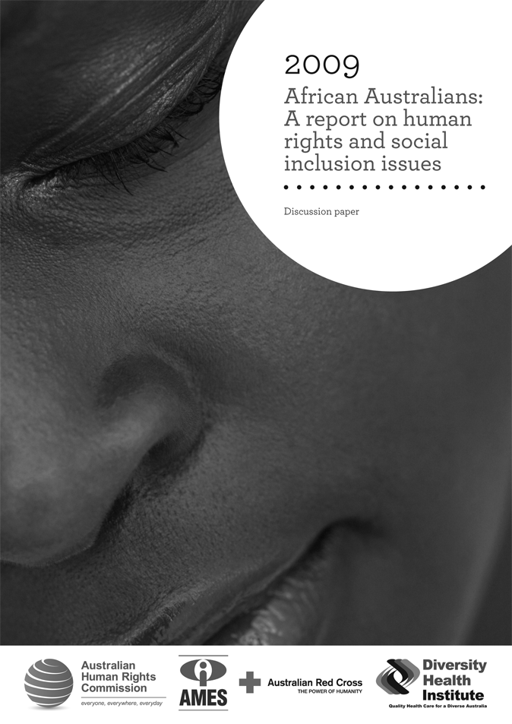
The African Australians project is the first national assessment, from a human rights perspective, of the experiences and issues faced by African communities in Australia.

- Human Rights E-Network: In partnership with the Institute for Cultural Diversity, this project establishes an electronic forum and clearing house to communicate across the community, government, service provision, non-government/advocacy, academic and other relevant sectors with an interest in racism, cultural and religious diversity and the promotion of human rights. There will be a specific focus on issues relevant to the Muslim community.
- Community Language Schools Human Rights Curriculum Resource and Campaign Project: This is another education-oriented project in which the Commission is partnering with Australia’s peak national body for community language schools, Community Languages Australia. The project is developing a learning–a-language-other-than-English resource about discrimination, human rights and cross-cultural respect. Over this year the project has established a Project Advisory Group, which has advised and supported the content development. The resource is called Being ME: Knowing You. Trialling of the story board and content with different stakeholders and audiences is underway.
- Community Policing Partnership Project: To Build Social Cohesion and Harmony with Australian Muslim Communities: This program is building partnerships between police and Muslim communities across Australia. It focuses on working with young Muslim Australians and law enforcement agencies to help address discrimination and vilification. It is anticipated that, through joint projects, local networks will be established and a stronger sense of social participation, respect and inclusion within communities will be established. In April 2008, the Race Discrimination Commissioner announced the first 19 community/police partnerships across Australia. Details of the projects can be found on the Commission’s website at:
www.humanrights.gov.au/partnerships/projects/projects_funded09.html.
- A Community Arts and Culture Initiative with Muslim Australians: Under this initiative, arts and community cultural development are being explored as a safe and constructive environment for self-expression and inclusion. Delivered over three years as a national partnership with the Australia Council for the Arts, the Commission is working with various organisations across Australia in different settings. The following projects are currently supported under this initiative:
- The Young Muslim Women’s Short Animation Film Project: The Commission has partnered with the Bankstown Area Multicultural Network for this project. This project has brought together ethnically-diverse young women to develop creative expression and skills in digital animation and produce a short film, Huriyya and Her Sisters, which is to be launched in July 2009 at the Arab Film Festival Australia.
- Arab Film Festival Australia: The Commission has partnered with the Information and Cultural Exchange for this project. The project includes the annual festival held in Sydney, as well as forums, workshops, and a national touring festival. Films in the festival reflect the diversity of identities and experiences within the Arab world and communities within the diaspora.
- The Islamic Spectrum in Australia project: The Commission has partnered with Nexus Multicultural Arts Centre for this project. It is a program of events that will explore the many faces of Islamic culture in Australia: art, architecture, food, religion, history and music.
- The Frontline Project: The Commission has partnered with Darwin Community Arts for this project. It will involve Muslim/African/African Muslim and Indigenous youth participation in locative media activities.
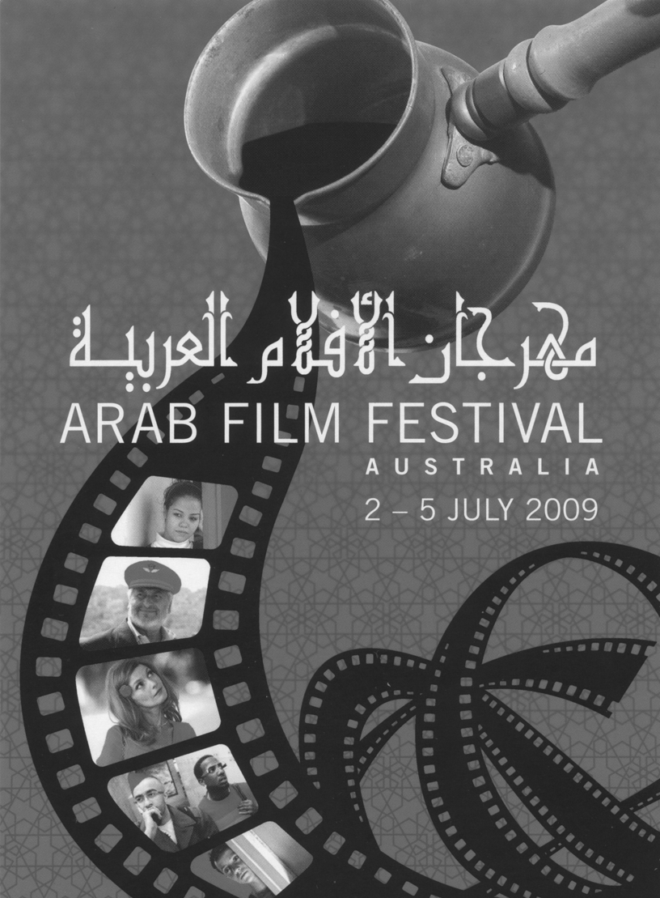
Held in Sydney in July, the Arab Film Festival is one of the Community Arts and Culture Initiatives with Muslim Australians, supported by the Commission in partnership with the Australia Council for the Arts.
- Evaluation Project: Evaluation plays a central role in the program. The evaluation project uses a program-logic approach and works across the eight initiatives. The evaluation will provide information that internal and external stakeholders will be able to use to make decisions about program design and delivery, accountability, strategic direction, policy and future funding. The Commission’s partnership and participatory approach has meant collaboratively creating the evaluation plans for the eight initiatives with its partners and stakeholders. The evaluation encompasses processes, impacts and outcomes across the main evaluation domains, which are implementation, scope, usage, reach, awareness, perceived value and quality achievement of objectives, changes in attitudes, confidence, skills, knowledge and behaviour.

- Intersections between the Law, Religion and Human Rights: a roundtable between judicial officers, academics, religious and community leaders. This project brings together members of the judiciary, key legal representatives, academics and religious and community leaders to examine religious and cultural accommodation in the Australian justice system through a series of roundtable meetings. Partnerships and collaborations have also been established with the Research Unit for the Study of Society, Law and Religion at Adelaide University; the Australasian Institute of Judicial Administration; the Department of Justice, Victoria; and the Victorian Multicultural Commission. The principal focus of the project is on issues affecting faith communities. Issues so far identified for further discussion include freedom of religion, anti-discrimination legislation and alternative dispute resolution.
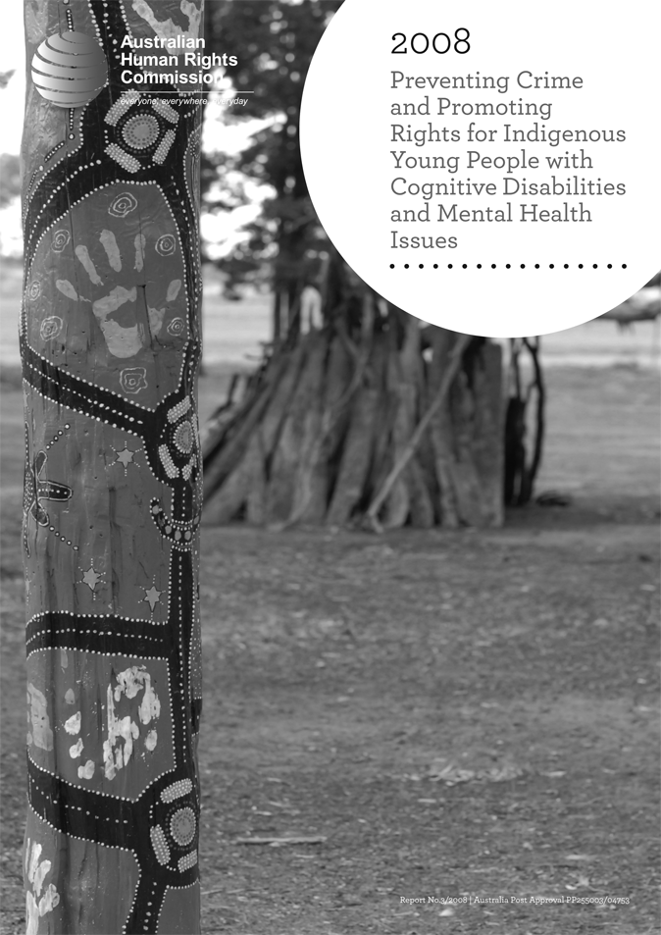
The Freedom of religion and belief in the 21st century discussion paper was released on
17 September 2008. The Commission has partnered with the Australian Multicultural Foundation, RMIT and Monash Universities on this project.

- Freedom of religion and belief in the 21st century project: For this project, the Commission is partnering with the Australian Multicultural Foundation, in association with RMIT University and Monash University, to prepare a report. This team will also consult with a range of organisations including the Australian Partnership of Religious Organisations. The objective of the project is to revise the Commission’s 1998 report on freedom of religion and belief given, since that time, the complexity and prominence of faith-based issues that have emerged (including faith-based violence) in global and local affairs.

9.5.2 Additional, related, policy development work
The Commission is using the opportunities provided by the Community Partnerships for Human Rights initiative to refocus on the critical issues that relate to religious harmony. The human rights impacts of religious belief, cultural practice and spirituality in a globalised world need to be closely examined. The Commission is contributing to policy development and to international reports on these issues.
For example, the Commission prepared a detailed report to the Office of the United Nations High Commissioner for Human Rights on General Assembly resolution 62/154 on combating the defamation of religions, submitted July 2008 (www.humanrights.gov.au/partnerships/religiousdefamation/index.html) and the Director of the Commission’s Education and Partnerships Section attended inter-faith related seminars in Auckland, New Zealand, in August 2008; in Brisbane in November 2008 (arranged by the Commonwealth Secretariat on Respect and Understanding to review the Civil Paths to Peace report from an Australia-Pacific youth perspective), and in Phnom Penh, Cambodia, in May 2009, to share the Commission’s experience in promoting community harmony in a multi-faith, multicultural society.
Similarly, the Commission is using the opportunities provided by the Community Partnerships for Human Rights initiative to focus on the critical relationship between societal harmony, social inclusion, human rights, ‘race’-related discrimination and culture. For example, the Education and Partnerships Section coordinated two submissions to the Commonwealth Department of the Environment, Water, Heritage and the Arts, supporting the ratification of two important international treaties: the UNESCO 2003 Convention for the Safeguarding of Intangible Cultural Heritage (www.humanrights.gov.au/legal/submissions/2008/20081024_UNESCO.html) and the UNESCO 2005 Convention on the Protection and Promotion of the Diversity of Cultural Expressions (www.humanrights.gov.au/legal/submissions/2008/20081105_UNESCO.html).

9.6 Speeches
The Race Discrimination Commissioner delivered a number of speeches during the reporting period, a selection of which appear below. Full transcripts of the speeches are available on the Commission website at: www.humanrights.gov.au/about/media/speeches/race/index.html.
Human Rights, Multiculturalism and Indigenous Rights – the Multicultural Development Association, Reconciliation Strategy Launch, Brisbane,
30 July 2008.
Keynote speech – International Unity in Diversity Conference, Townsville,
14 August 2008.
Like Oil and Water? The Intersection of Freedom of Religion and Belief with Human Rights – Launch of the Freedom of religion and belief in the 21st century discussion paper, Canberra, 17 September 2008.
Indigenous Issues in the Durban Review Conference – Castan Centre Public Forum: ‘Can the UN Combat Racism’, Melbourne, 20 February 2009.
Research Hopes to Offer Insight into Experiences of African Australians – Victorian Equal Opportunity and Human Rights Commission’s Human
Rights Conference, Melbourne, 16 March 2009.

